4.12 Chart System

4.12.01 Applying Standard Charts
Projectile contains many standard charts. The charts are grouped by topic in the chart blocks and contain between one and up to 13 individual charts.
The charts can be be opened in the work area by using the functionality “Charting”.
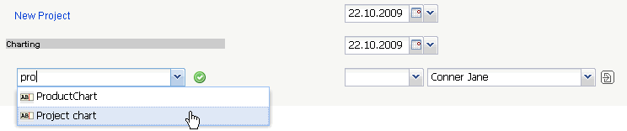
In the following example various project-related charts are displayed. Included are the charts: project overview chart, project structure diagram, target/actual comparison chart for projects and jobs, milestone-trend-analysis (MTA) chart, completion chart, employee occupation chart, skill-matrix, and perform report for resource planning chart.
After opening the chart type (here, the project chart) a chart document is opened. In the document selection criteria and options for the chart can be configured.
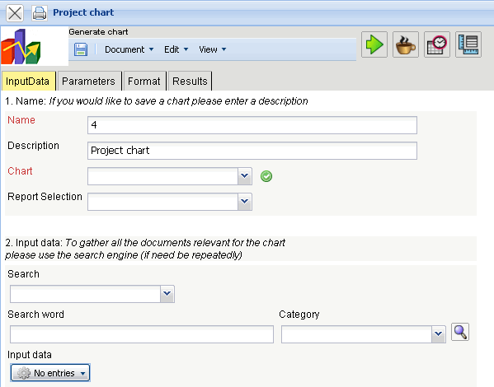
In the first part (1. Name) a name can be given for the chart if the chart is to be saved. Saving the chart is useful if the selection criteria of the chart remains constant, for example a list of all active projects for the current quarter. The saved chart can then be saved are copied to the personal clipboard or it can represent the basis for time service in order to automate the chart evaluations. Also, the charts can be generated in the background. To view the results of the chart, the evaluation must also be stored.
In the second part (2. Input Data) the input data of the chart is determined. In the third part (Main parameters) the input data can be limited through a time span.
In the first example the selection criteria for the input data for two projects are selected from the personal clipboard:
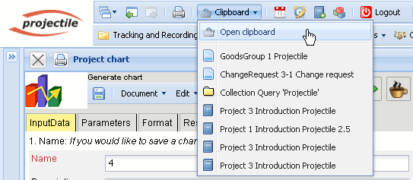
These projects are marked in the clipboard, ...
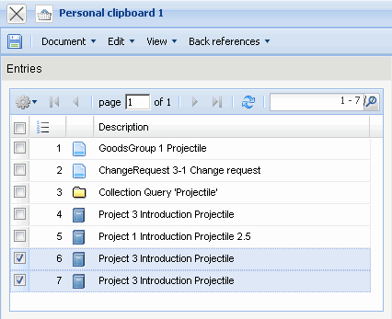
... copied and ...
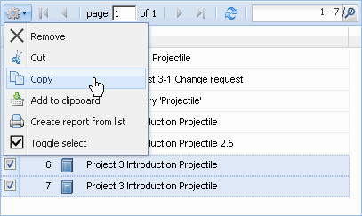
... pasted into the input data.
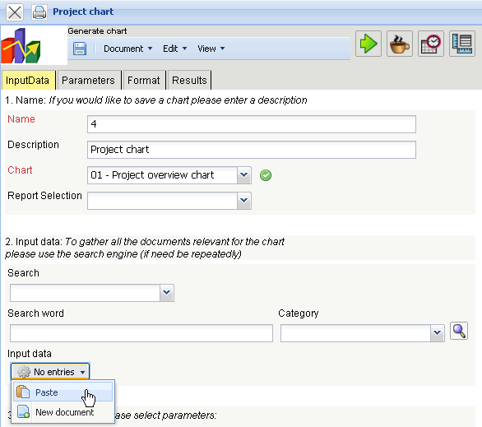
This process can be performed repeatedly (or with multiple entries). In the example below are ...
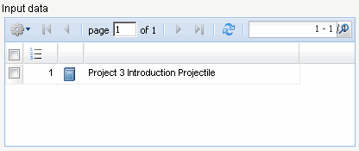
... Project 3 is the selected criteria, which is referred to in the chart.
Finally, the chart period is selected ...
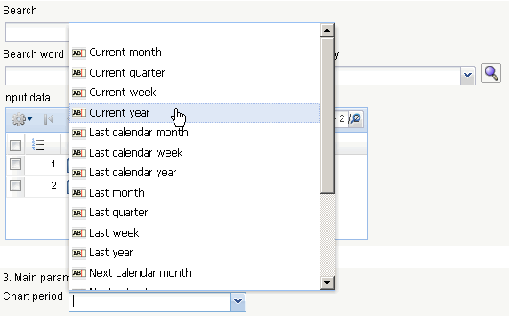
... the time span limited to the current year ...
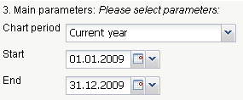
... and the chart “job chart target/actual” generated using .
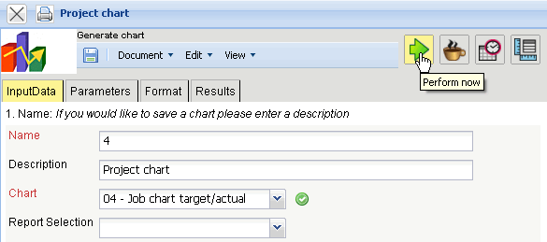
If the chart results are generated, the system presents the results in the browser. This chart includes information about the projects, activities and/or jobs and agents, the estimated and actual times with remaining time/effort and the corresponding difference (planned - actual), the estimated processing period (start / end) and the status information (status, completion date and completion of the task).
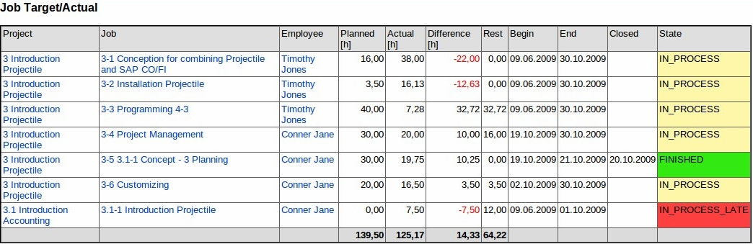
After closing the chart results, the chart block project chart is displayed again.
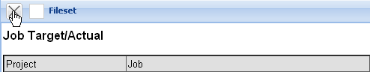
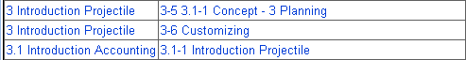
If the chart block is saved, the chart block can be applied as the basis for time services or for chart evaluations in the background.
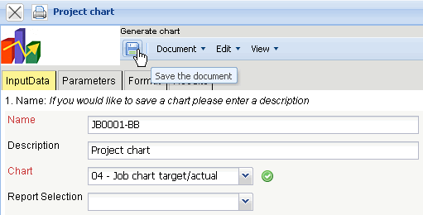
Using  the charts can be started in the background.
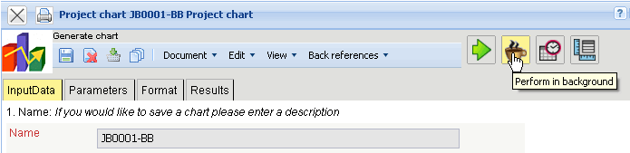
The system informs the user of the background process ...

.. and generates ...
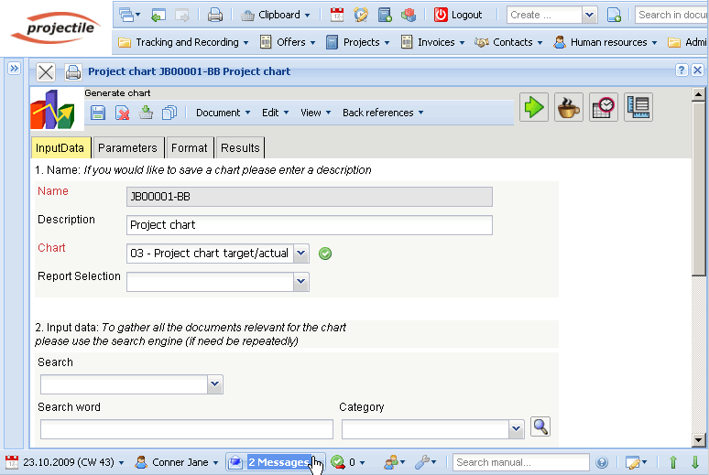
... an internal message, as soon as the chart results are generated.
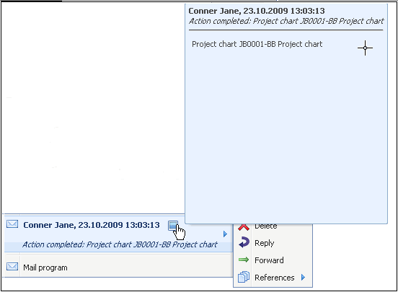
The message appears in the mailer and the user can access the chart results through a link:
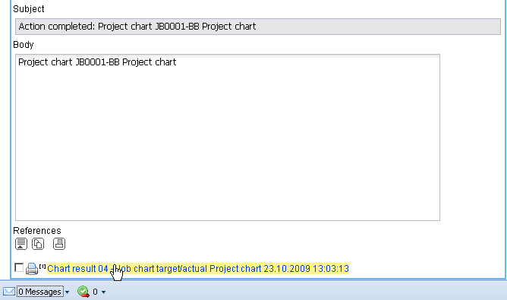
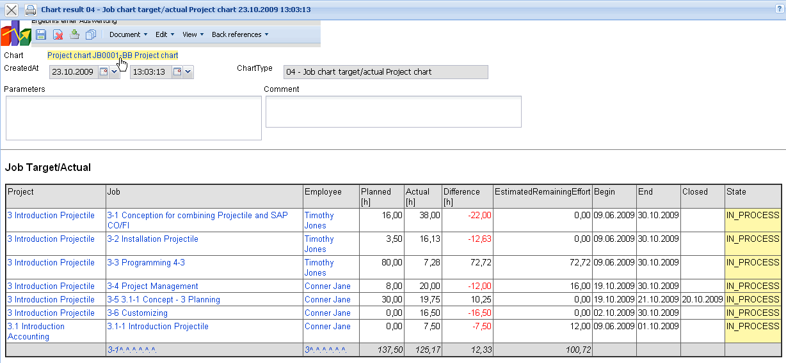
In the second example, the standard search engine is applied for selecting the input data. Here, for example, all projects (selected category), ...
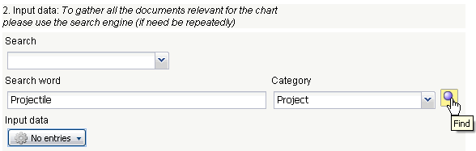
... which contain the term “Projectile” ...
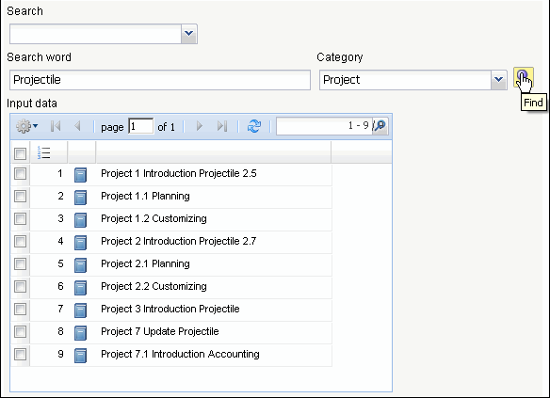
... are applied as input data. Entries, which should not be applied as selection criteria are marked, toggle selected ...
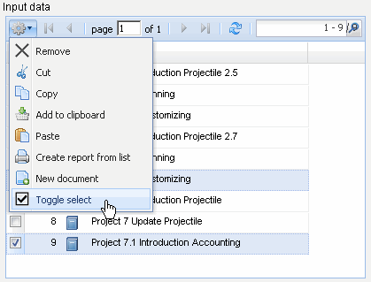
... and the entries are removed from the input data:
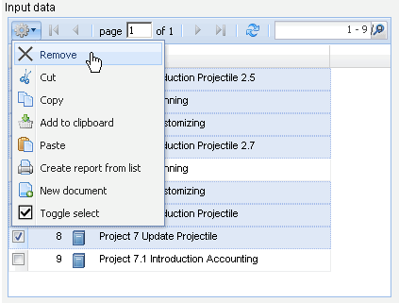
All entries from the selection are evaluated (not only the marked one)!
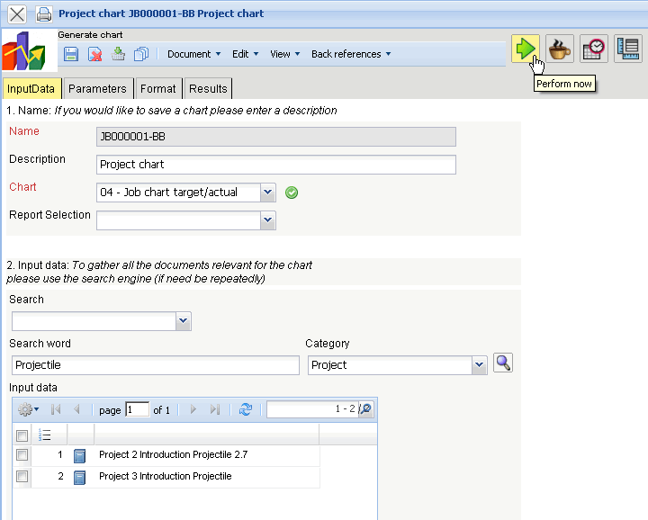
This process can be performed a several amount of times (with various categories). Afterwards, the chart is generated again (in the example, job target/actual comparison for the projects 2 and 3):
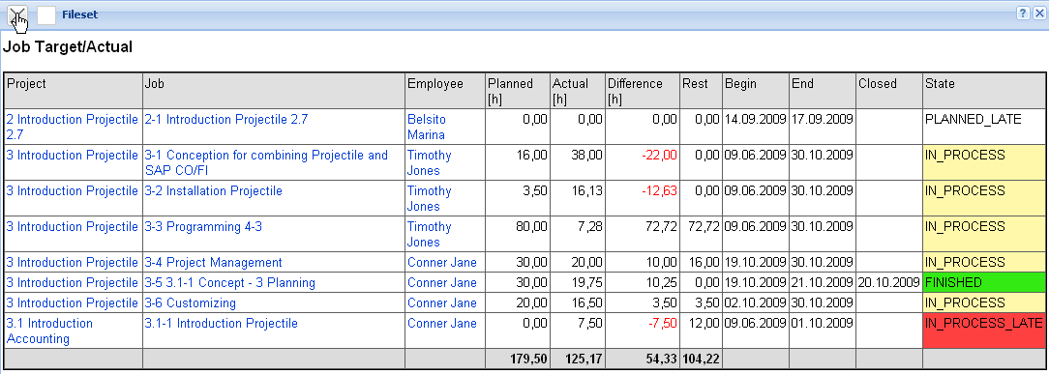
The third possibility to select the input data is the advanced search. The appropriate search queries are stored here, which can be immediately applied.
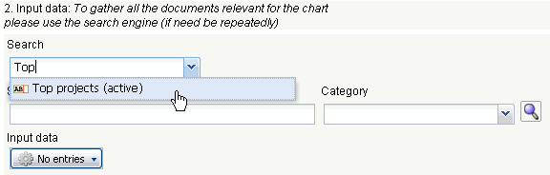
In the example, all top projects with the status “active” are transfered to the input data.
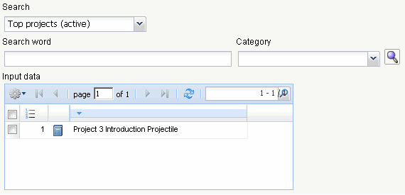
Then, the chart period (3. main parameters) and the other criteria can be used (4. parameters) to usefully limit the chart results. These parameters include for example, the cost center of the project, the project type, project status, priority, and marked whether the project is an external order or not.
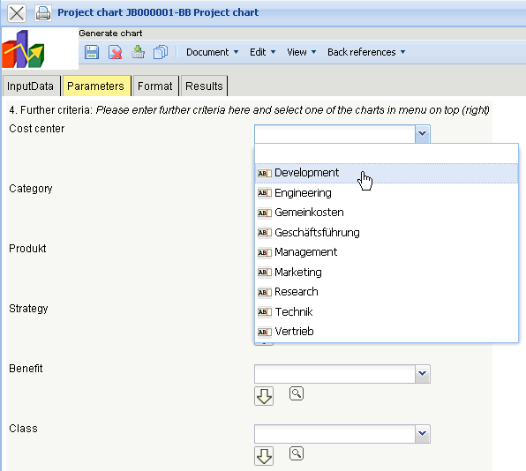
The further options refer to filtering the results.
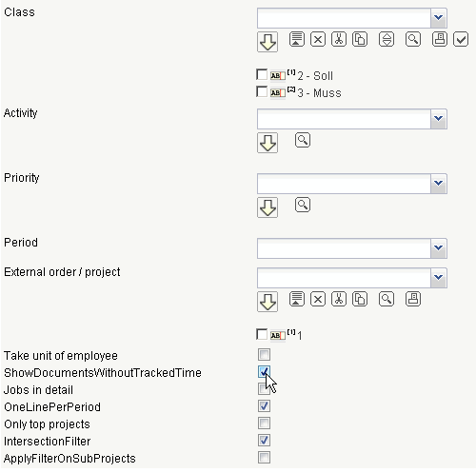
In the example, all projects are evaluated, which are applied to the cost center “development”, a project class as a must/shall project ...
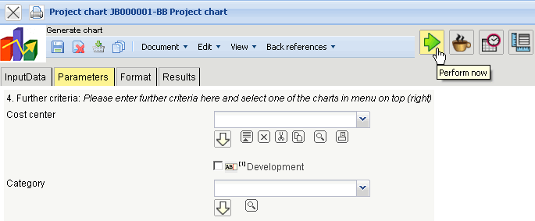
... as well as marked as an “external order”.
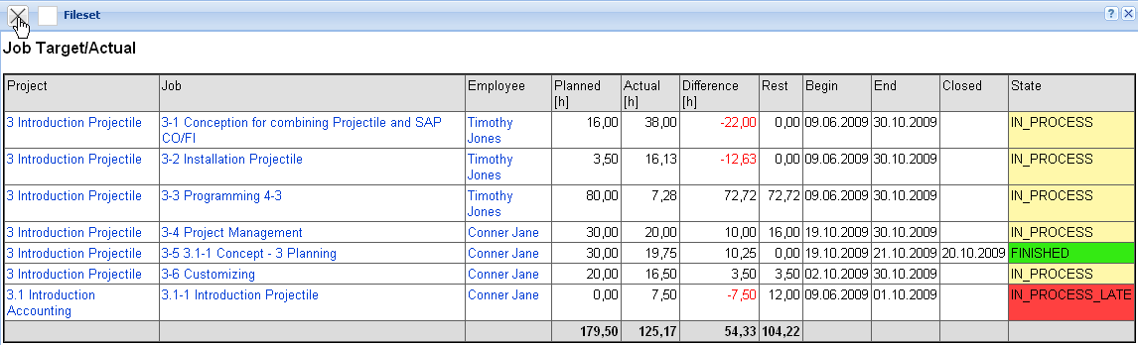
On the “Format” tab (5. Adjustment of chart display) for example, the width of the image in pixel and the diagram type can be selected.
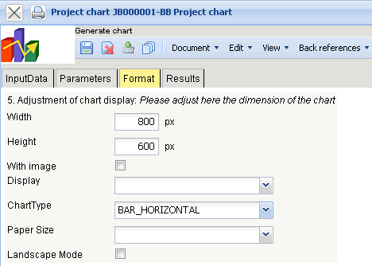
If an alternative output format is needed (by default, all charts are generated in HTML within the application), the output format can be selected in the element “Display”.
In the following example, the chart job target/actual with the image (chart type “bar horizontal”) ...
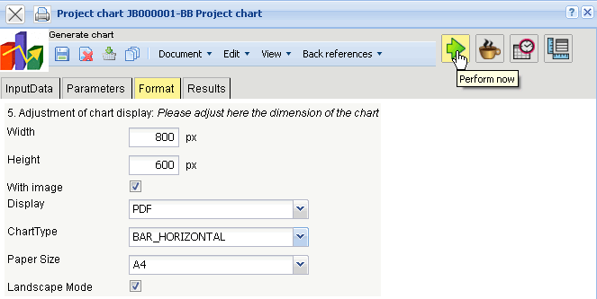
... can be generated in pdf format.
Depending on the system settings, the generated chart is opened in the browser ...
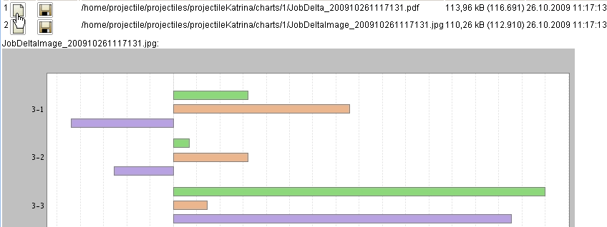
... or in the appropriate display program ...
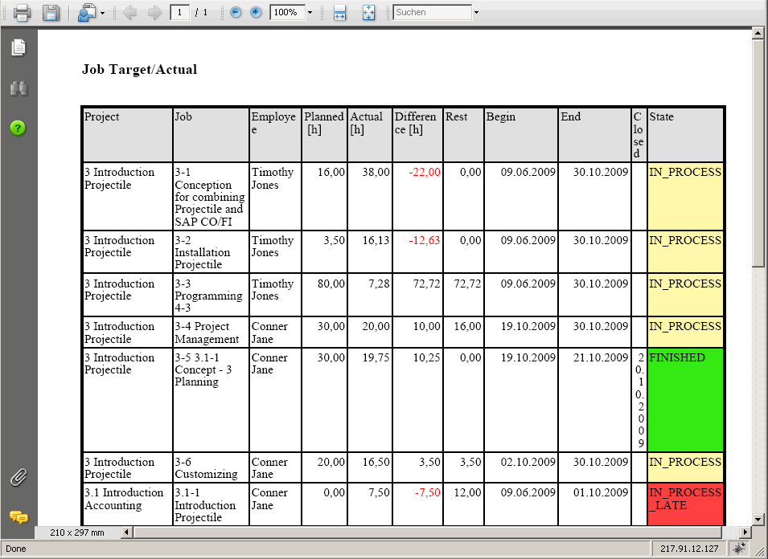
... (here in Adobe Reader).
In the “Results” tab, the chart results are administered.
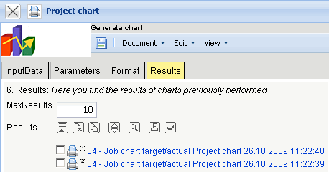
Notes: The chart results are stored permanently only if the chart block is stored. The number of results can be set in the field “Max Number of Results”.
(c) 1998-2009 Information Desire Software GmbH. Alle Rechte vorbehalten!

