4.10 Create Invoices

Create
The incoming invoice document provides the administration of the incoming bills. These incoming invoices can integrate into the own outgoing invoices. Beyond that, related outgoing payments can be administrated. After opening a new document of the type “incoming invoice” ...
...some fields are pre-set. Afterwards the remaining fields should be filled out...
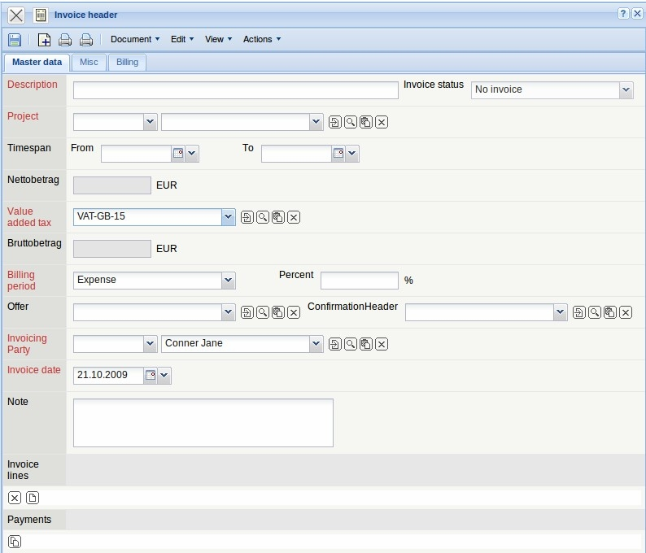
... and the document is saved.
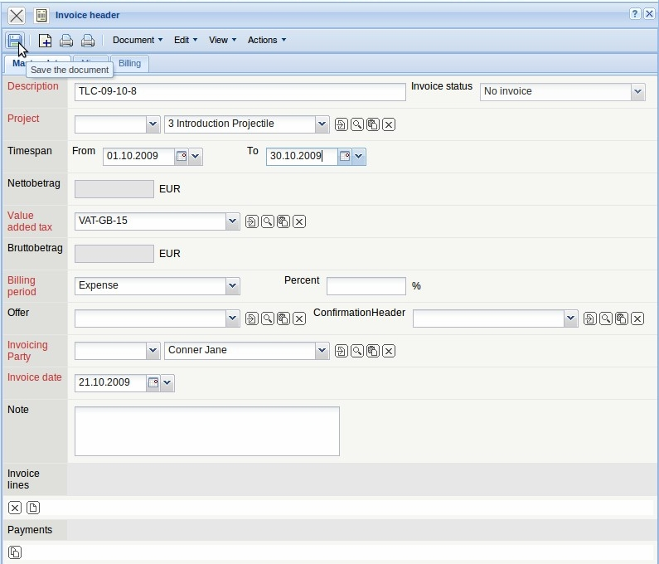

Invoice Positions
The individual incoming invoice positions (lines) can be created by using the action “New document” ...
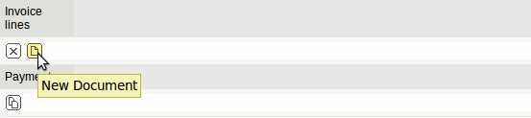
in the element ‘invoice positions (lines).
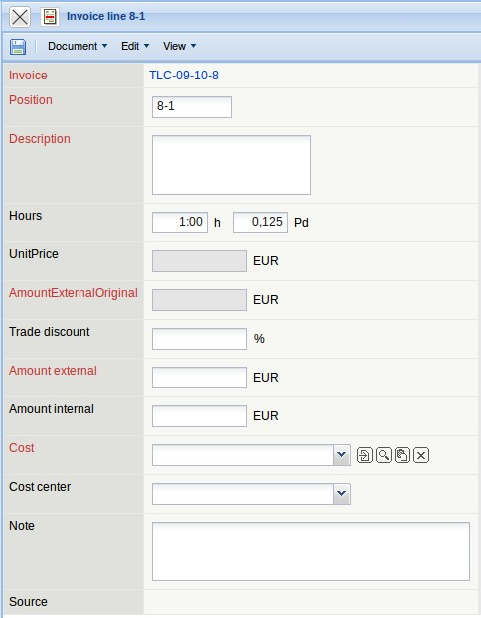
All relevant information for the incoming invoice/invoice header positions should be recorded also here...
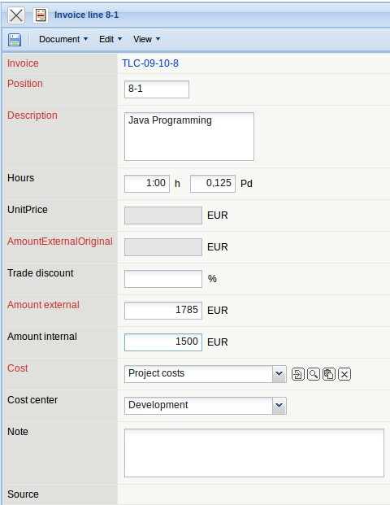
...and the document is saved. Afterwards a second position (as a copy of the first position) is created and...
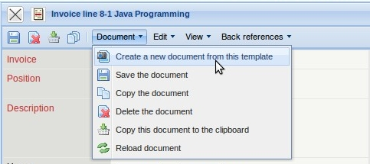
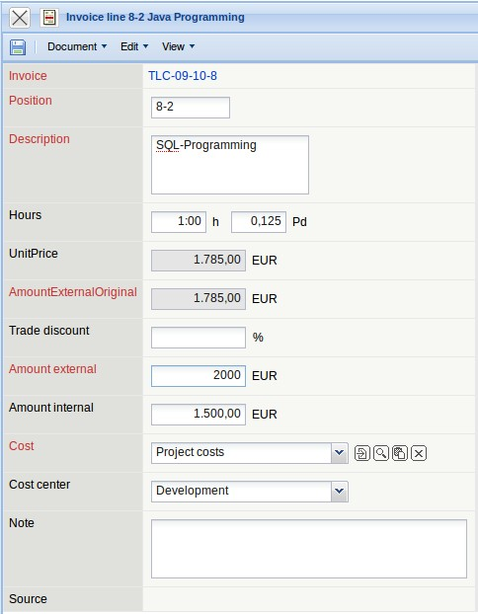
...it is saved. If with a position the invoice amount exceeds the total budget for the supplier, the system warns with an appropriate message.
Afterwards both positions are closed.
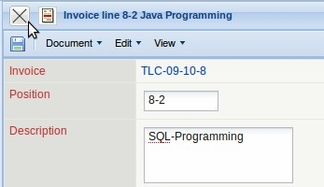
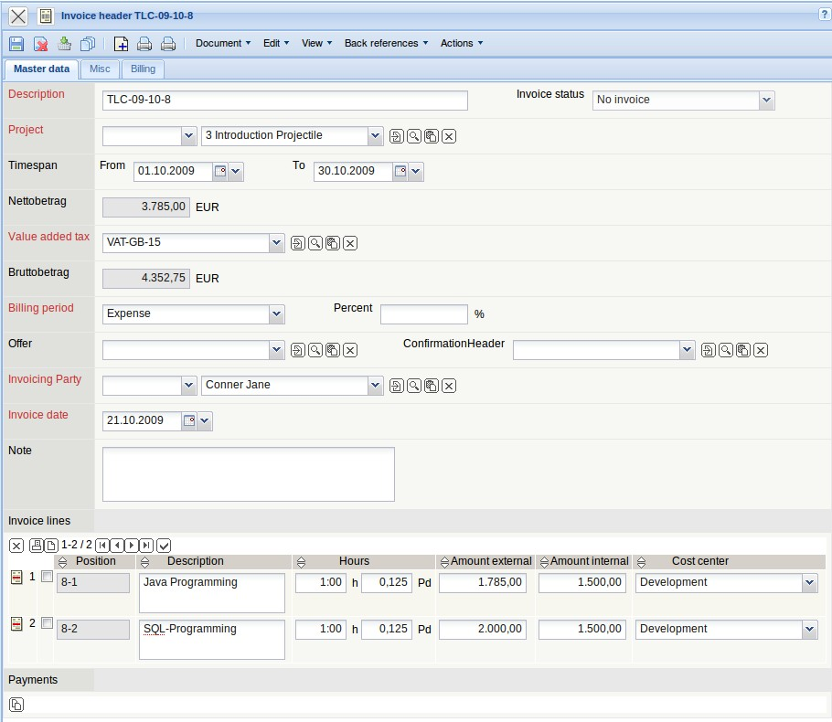

Include Invoice
After the definition of all positions, the invoice is defined as booked by using the action “Finalize invoice“.
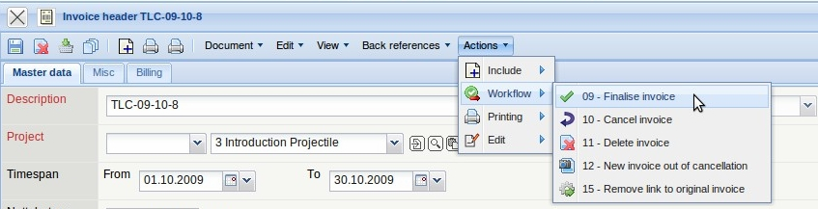
Note: By interfaces for the financial accounting, appropriate accounting records can also be created here.
After this action the status changes (from no invoice to invoice billed). The invoice is write-protected and a data record for the outgoing payments is created.
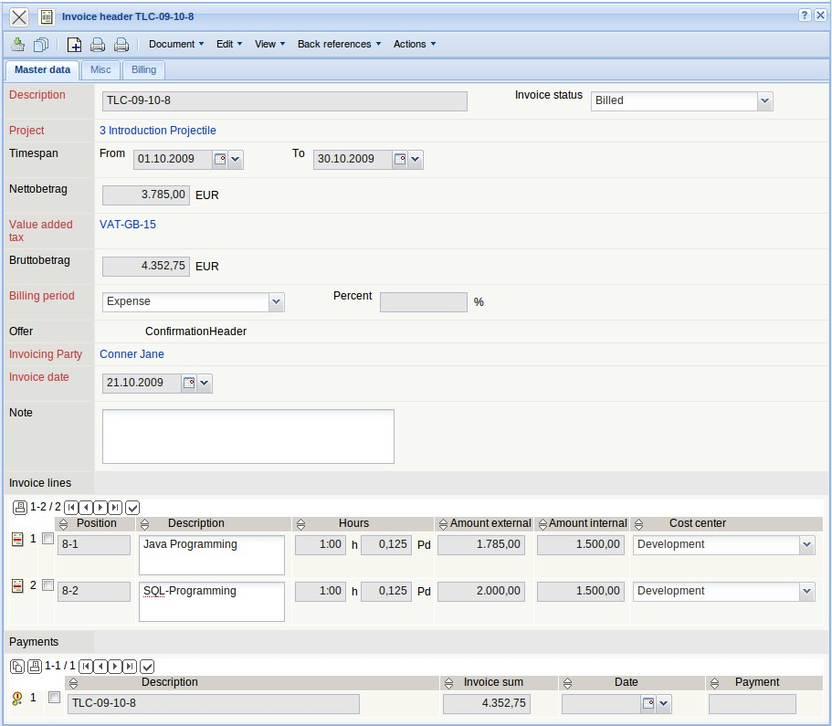

Outgoing Payment
By clicking on the blue highlighted link, you will get to the document outgoing payment and the appropriate outgoing payment can be booked here (a click on the green check mark puts in the current date and the total amount automatically)...
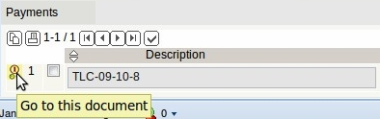
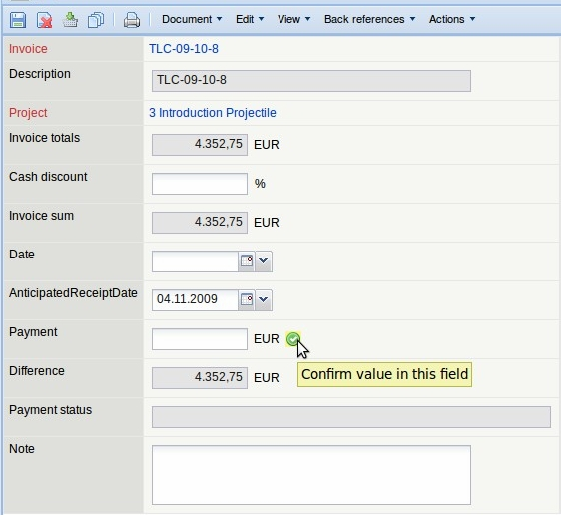
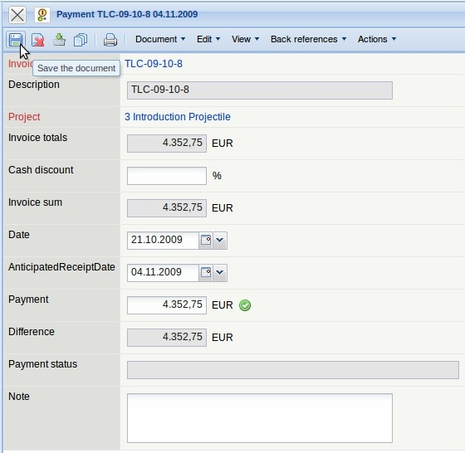
.. and then saved.
(c) 1998-2009 Information Desire Software GmbH. Alle Rechte vorbehalten!

