4.09.02 Travel Expenses

Recording
Recording of travel expenses refers to, in the trips document, directly to the definition of the trip and the assignment of the daily expenses and accommodation expenses. Other costs/expenses in connection (with) to the trip (for example journey and return, accommodation cost/expenses or flight costs/expenses) are assigned to the appropriate document or link.
After entering/creating the travel expenses, various fields are pre-set, ...
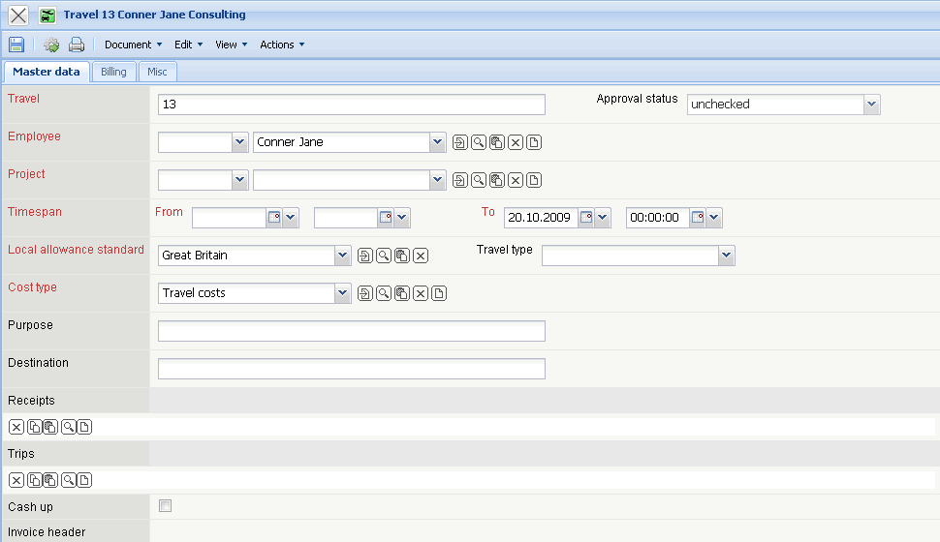
...the remaining information should be filled out and the trip should be saved.
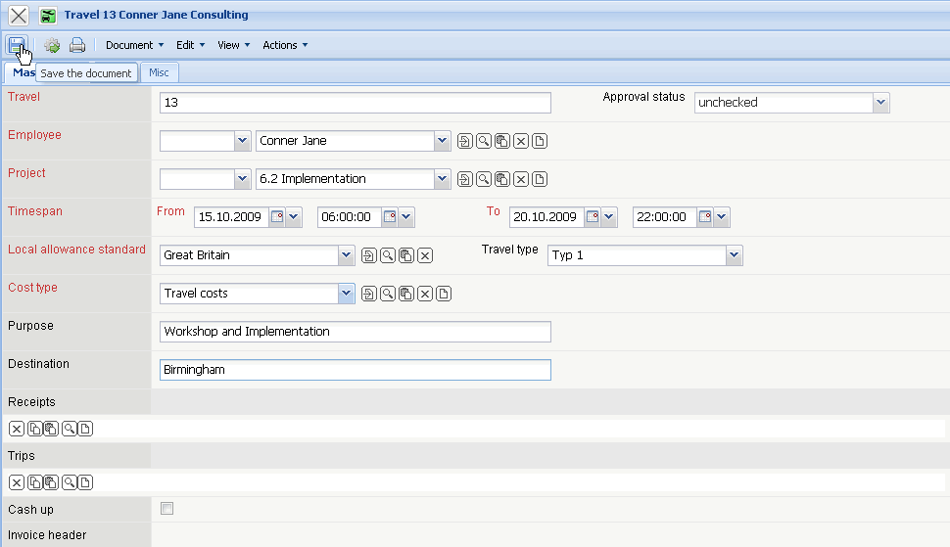
The system defines the value for the allowances (here EUR 190.00) from the time span of the trip.
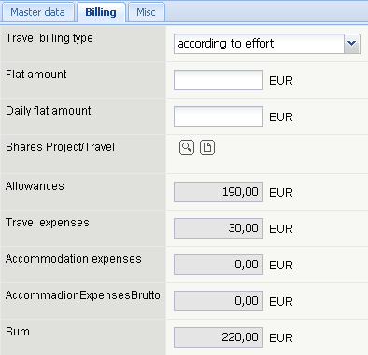

Trips
After the key values of “travel” are defined, it is possible to define trips by using the functionality “New Document” in the element trips.
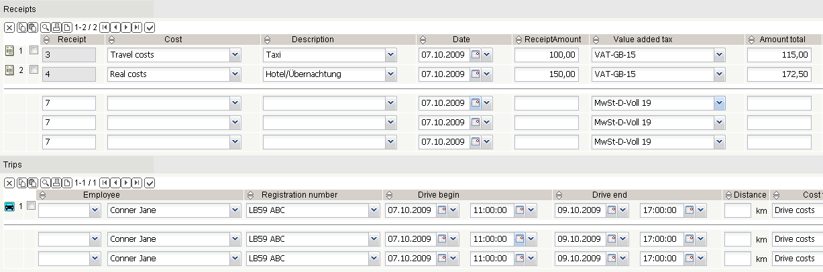
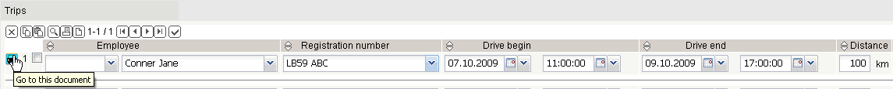
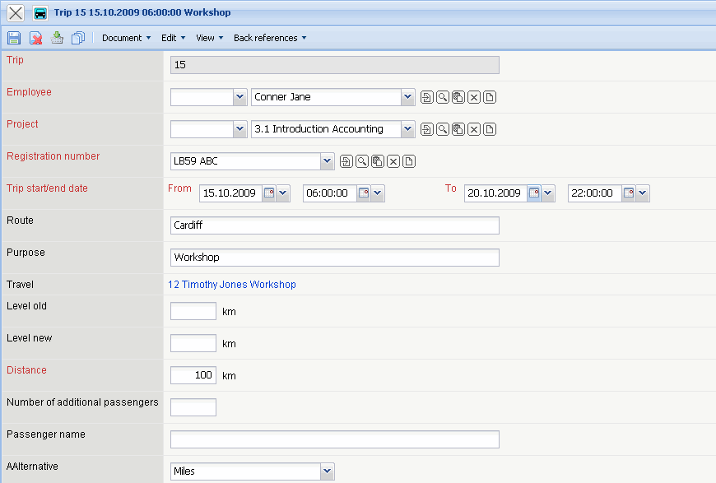
A new document of the type trips is opened.
After entering the distance and after saving the trip...
...the value of the trip is calculated (distance x Km-rate).
After closing the trip, it is assigned to the travel document and the costs of the trip are automatically increased.

Receipts
The documents for the trip (accommodation, airfare, taxi, ...) can be recorded ...
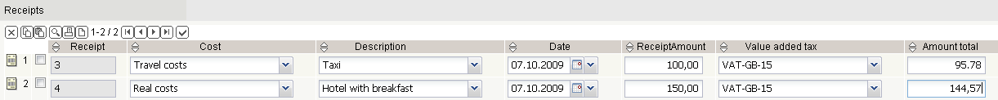
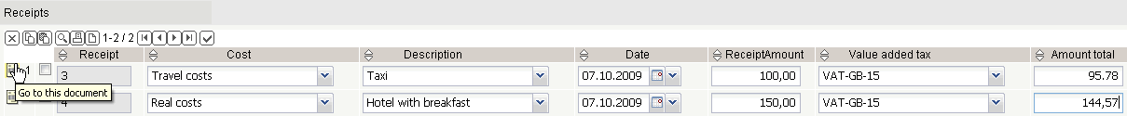
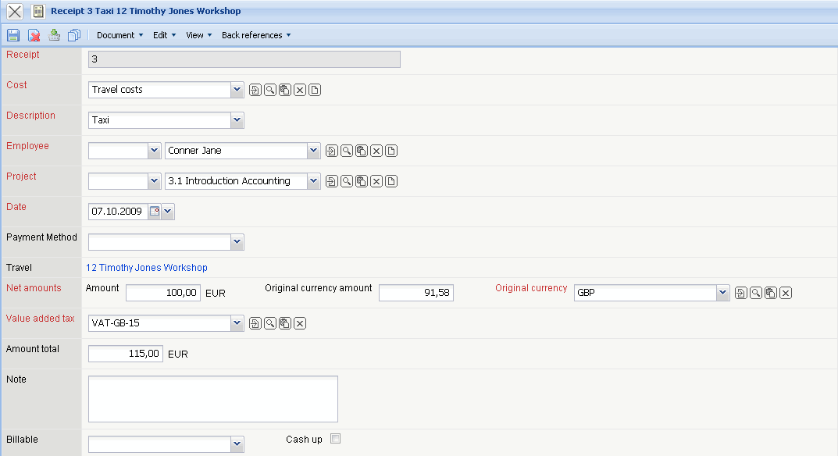
... and assigned to the journey.
AFter entering the description, cost type and amount, the receipt should then be saved.
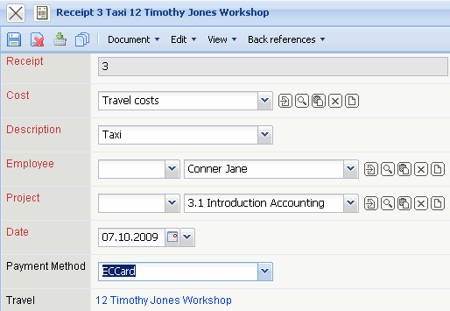
The system fills in the net amount automatically after the total amount has been entered and vice versa.
In the example, another receipt is created by using the functionality “Create new Document from the template”.
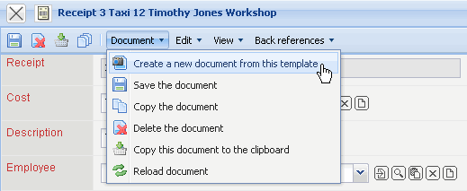
After entering all values ...
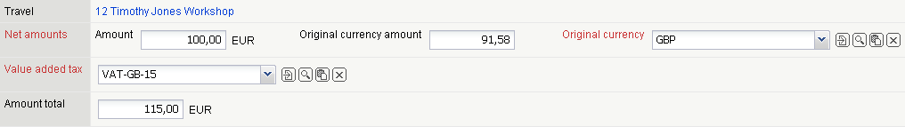
... the receipt should be saved.
After closing of the receipts...
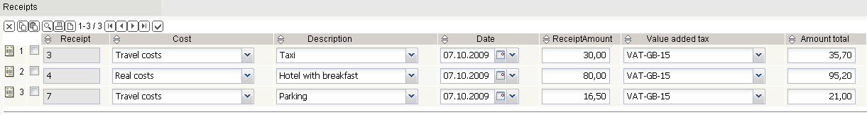
...the recorded costs are also displayed here in the document.
On the “Billing”, tab, rules for the external billing of the trip can be defined and the trip can be assigned to several projects.
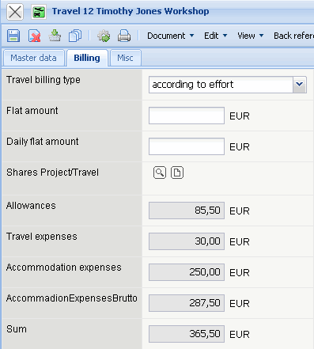

Meals
On the “Misc” tab, the fiscal exceptions (accommodation flat rate, deduction of meals) can be stored. This data is used, if in the hotel expenses or if in the business lunch/dinner, meals are included, which will be deducted as a non-cash benefit from the meal additional expenditure.
In the example the hotel bill contains breakfast (2 accommodations).
After closing the form ...
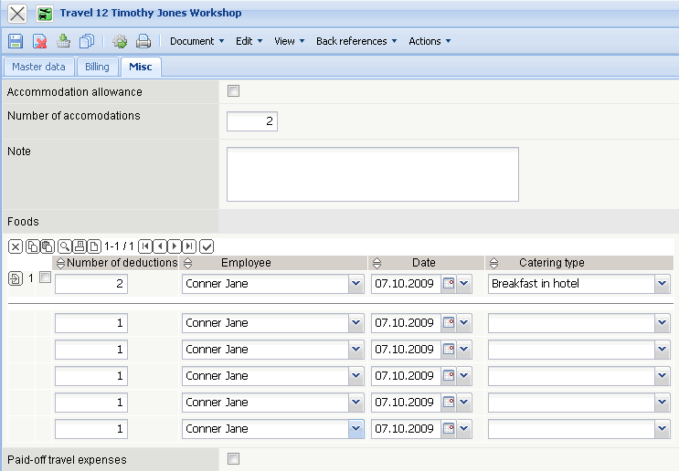
...the non-cash benefit will be deducted from the flat rate (meal allowances).

Travel Expense Billing
Afterwards traveling-expenses billing can be...
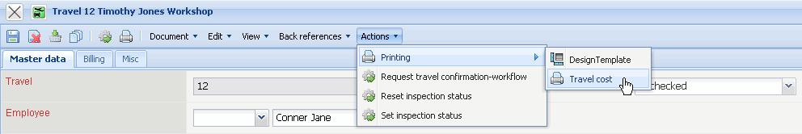
...generated by the system.
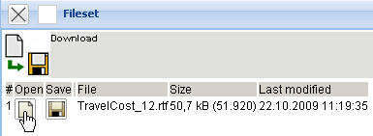
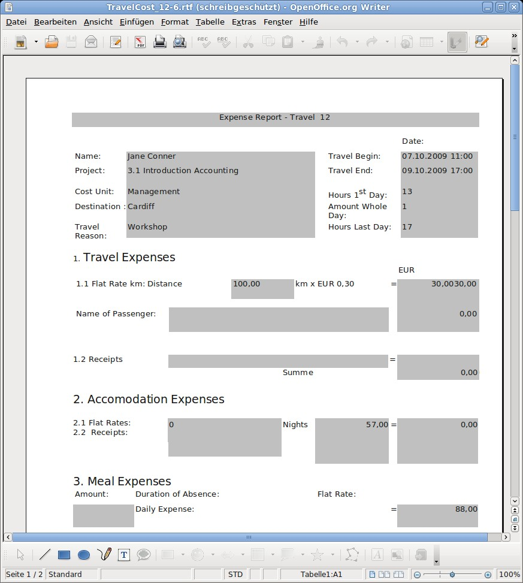

Traveling Expenses inspection
After the inspection of the traveling expenses, the trip is approved for billing (accounting).
The inspection of the trip can be set by using the action “Set inspection status”...
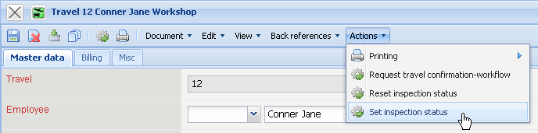
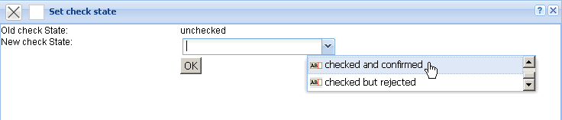
... or ...
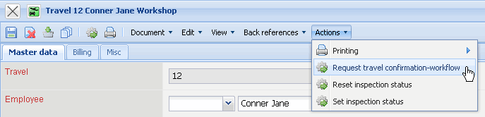
... using confirmation-workflow.
In the example, a member of the group Finance (Timothy Jones)...
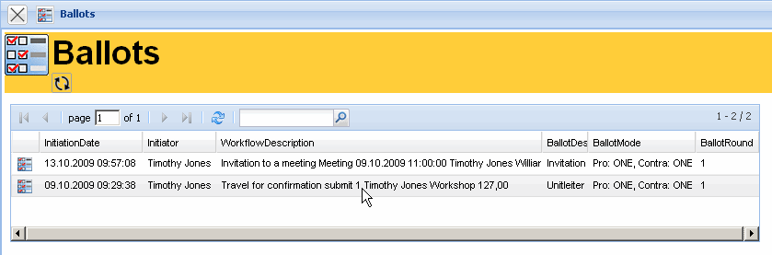
...is informed and receives a voting.
In the Workflow-Engine in the menu item “vote”...
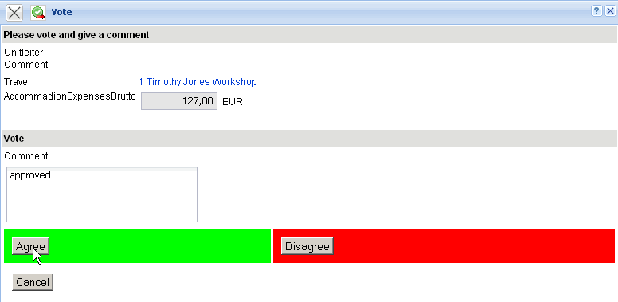
...the trip can be approved or refused.


