4.08.02 Recording Absences

Central Absence Recording
The absences can also be centrally recorded in the document working times/absence or by using the functionality “Tracking and Recording => Absences”.
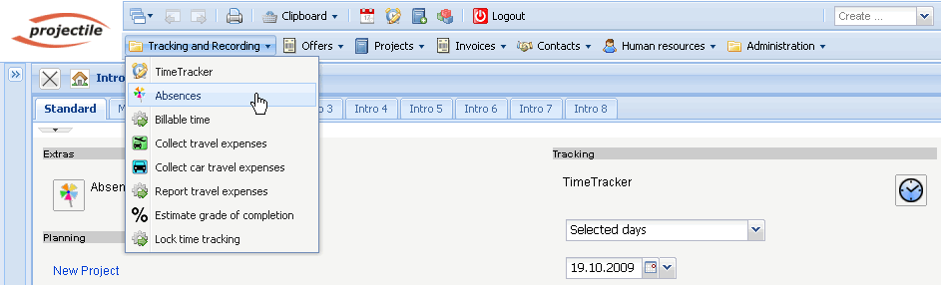
Here, first the employee/employees or the unit (all employees of the location or of the department) and the period of time are selected.
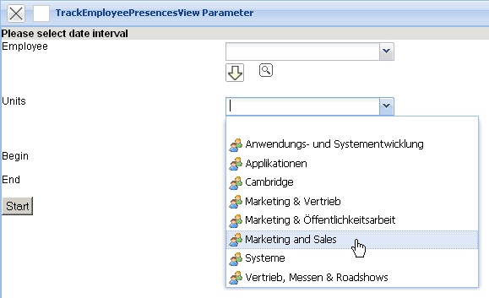
In the example the attendance recording for all the employees of the unit Marketing and Sales for the period of time 01.10.2009 to 31.10.2009 is opened.
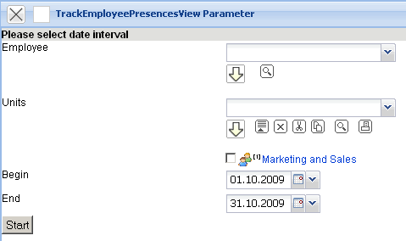
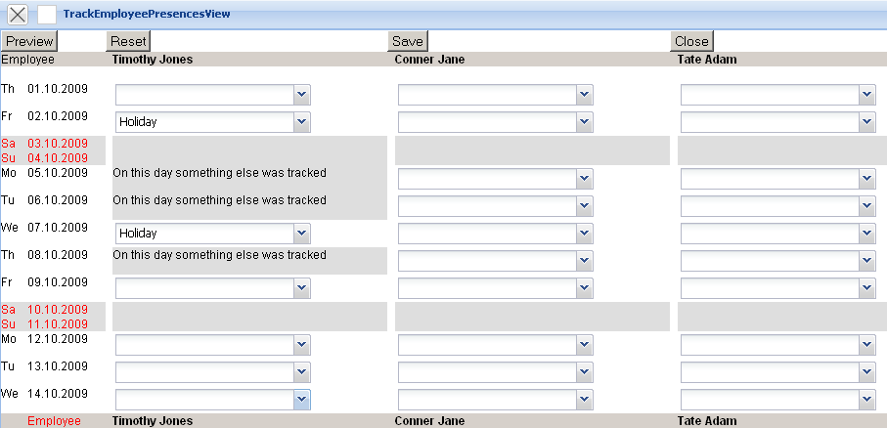
In the component all the defined absences and blocked days are displayed. The blocked days are days, for which the employee has already recorded the time or for which a time-recording is no more permitted.
In the example two weeks of holiday for the employee Timothy Jones (from 02.10.2009 - 07.10.2009) are defined.
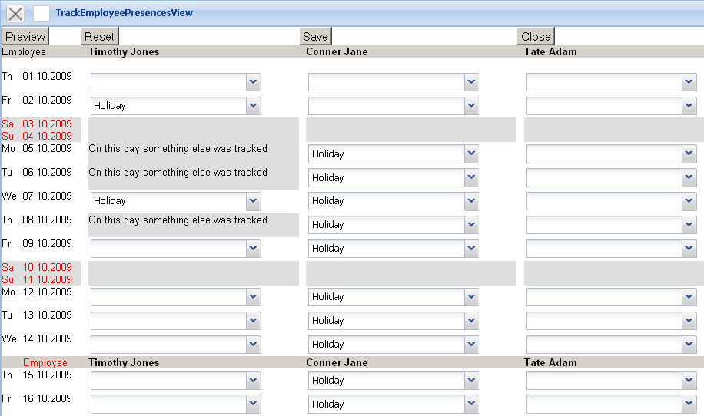
After saving all changes are transferred in the system.
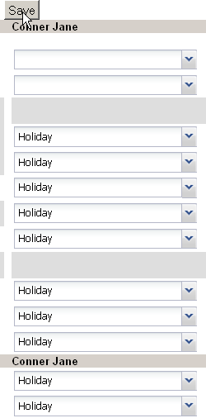
In the next example the holiday of the employee Jane Conner from 05.10.2009 to 14.10.2009 are entered...
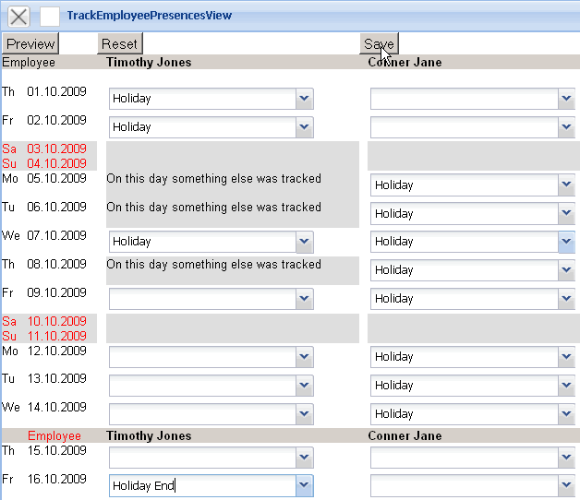
... and then the holiday from 16.10.2009 bis 30.10.2009 ...
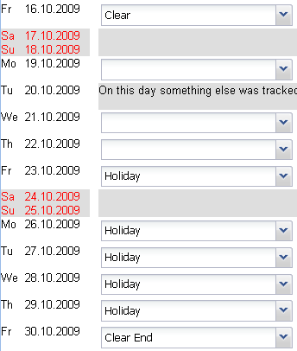
... is cleared.

Applying for Absences
If the employees have to register their own holiday, the functionality “Absence Application” can be used. This functionality works analog to recording absences, but it will not allow any options/choices by the employee or the unit.
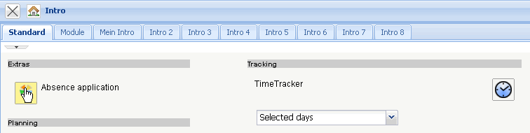
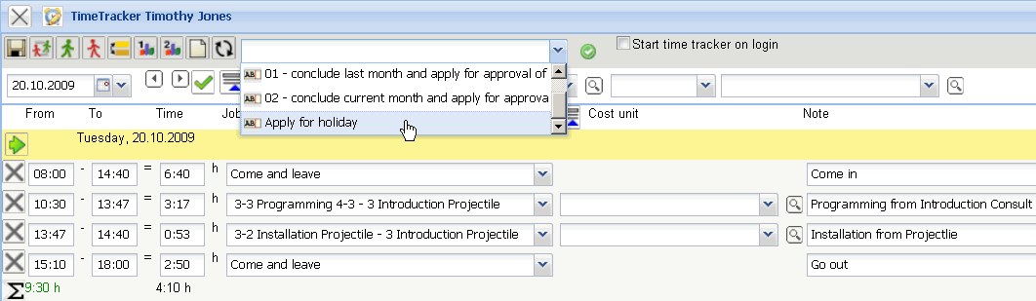
Note: The absences can be also recorded in the work area, in the module attendance/absences or in TimeTracker.
In the TimeTracker different Workflows for handling of time can be applied (period-end closing, application for holidays...). The following example shows the implementation of a holiday application. After performing the action in the TimeTracker...
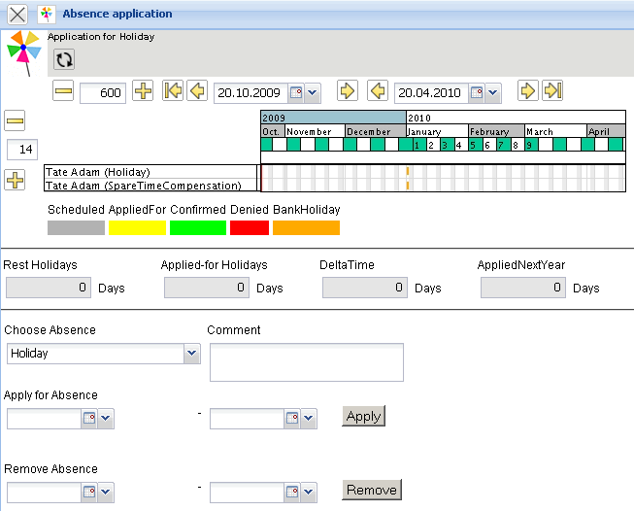
...a dialog for holiday application opens. Here the user can apply for absences (free time compensation, holiday and special leave). The user can also cancel applied or approved absences.
In the following example the employee Adam Tate applies for a holiday from 10.11.2009 until 24.11.2009.
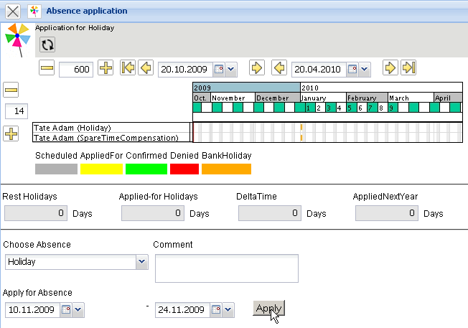
After confirming the application...
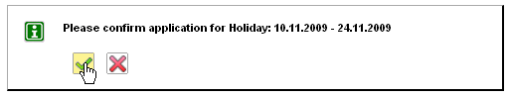
...the applied holiday is visualized...
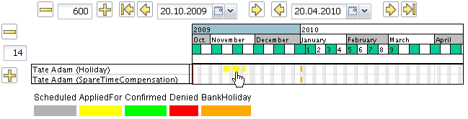
...and the supervisor (manager, human resources manager, the project and the unit manager) receives an internal message. In the example the unit manager of the applicant (George Williams) ...
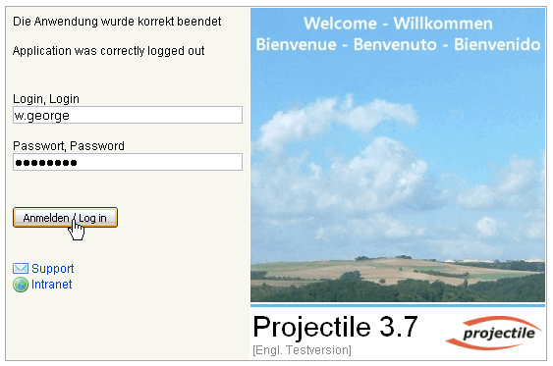
... is informed and receives a vote.
The employee is informed about the voting through an internal message.
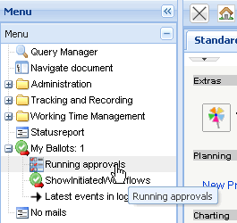
In the Workflow-Engine in the menu voting (Running approval)...
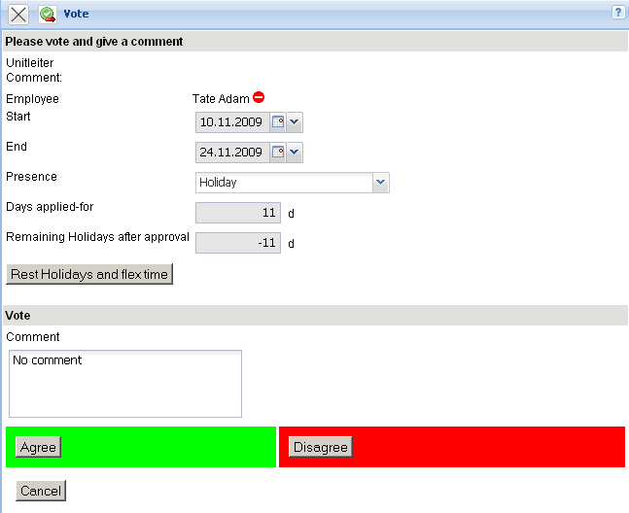
...the holiday can be confirmed or denied.
The applicant gets a massage about the voting from the system.
In connection with the voting results the holiday is displayed graphically in the absence application of the TimeTracker as holiday or as denied holiday.
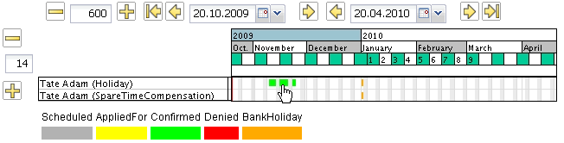

Charts
The calendar overview displays the attendance/absence of selected employees from freely defined time spans (see also Charts).
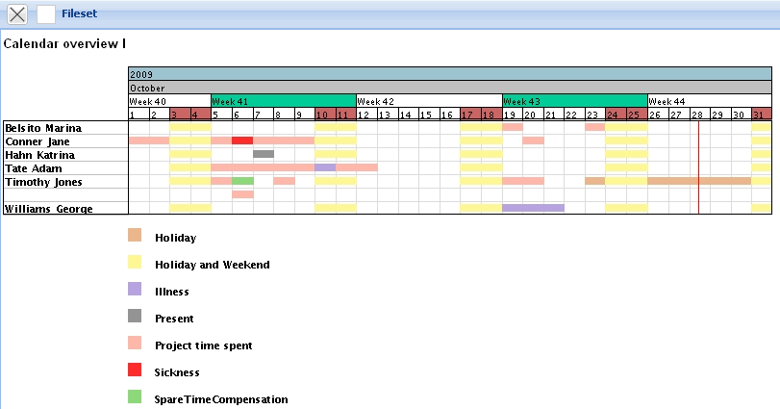
Note: The absences in the system are the basis for the complete resource management. In all the resource charts (here capacity overview III) and with suggestions the planned absence of the employees will be considered.


