4.07 Modify Project State
When the project is completely planned and commissioned, it must be activated. This can be done by using the action “set project status”. This action changes the status of the complete project structure (including all the sub-projects).
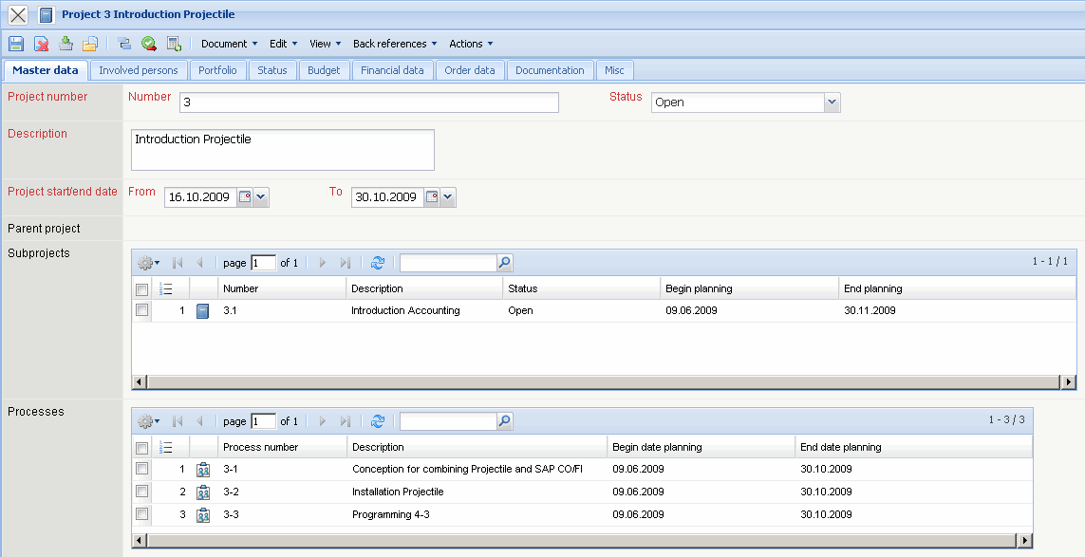
This action can also be used for individual sub-projects, for example if only one particular project is assigned.
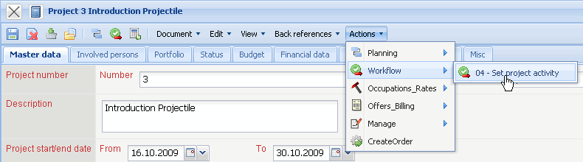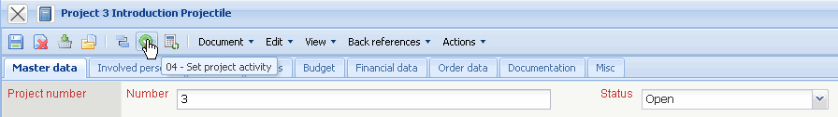
The action sets ...
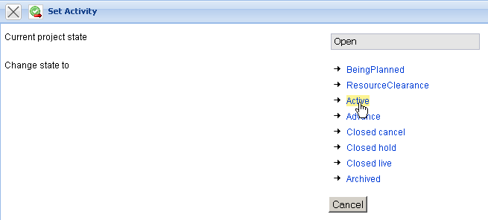
...the project status to “active” and...
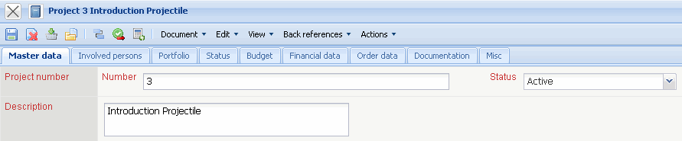
...from now time and costs on the project can be entered and recorded.
The complete project is now active, but the second sub-project’s realisation is still in the status “open offer” (that means it is not released for recording).
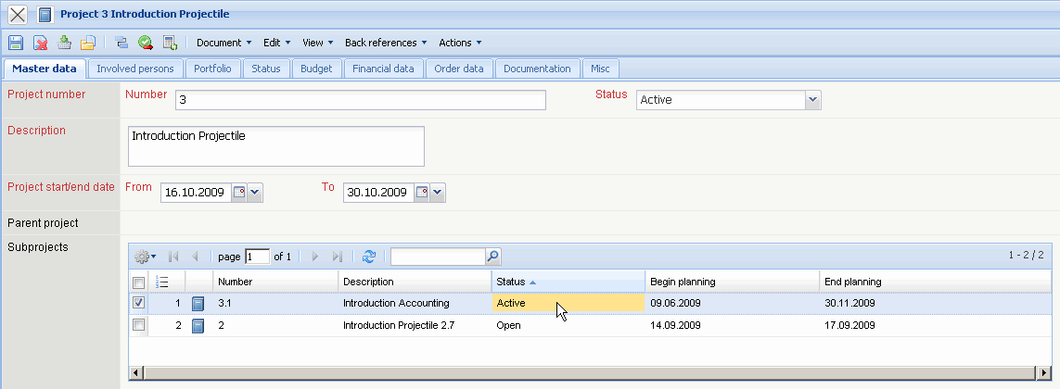
By using the action “set project status” further status changes can be applied for the project.
After a project or a sub-project is completely finalized (for example by response of all the tasks/jobs for the project and for the achievement of the milestone goals) the status closed should be used.
Note: By setting ‚status completed’ all the running tasks/jobs are closed!
Note: Every completed project shall be marked on time with the appropriate status, otherwise the status information in the status information in the chart system will not be up to date.

