4.04.02 Creating a Project using Templates
Project templates can be used in recreating a complete project structure from Projects, Milestones, Jobs, order relationships and Budgets. A project template is defined in a text file with a *.projectTemplate extension, which is in the config directory in Projectile.

Creating a Template
Using the action “Creating a template”, a template can be created from an existing project. This template contains the complete project structure (sub-projects, jobs, jump sequences, milestones and budgets) in parametrical form. The absolute dates (plan start and plan end) become relative dates dependent on the parameter generated from the project assistant.
Using the action “Create project template” ...
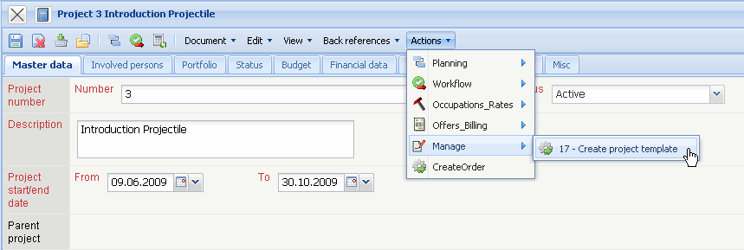
a dialog is displayed. The name of the template can be changed here.
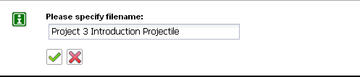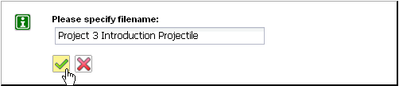
After confirming the input, the template is created and stored on the web server. The template is then available for further use (creating a new project with similar structure).

Creating a New Project using a Template
The functionality “New Project” is used for defining a new project.
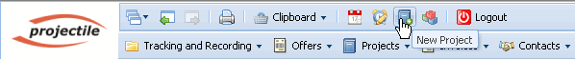
A dialogue is then opened with the selections Manual Project Creation or Template. If one (or more) import interfaces are available, it is then possible to import projects.
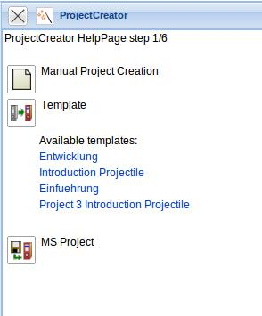
After selecting a template, continue with step 2. In the drop-down box, a list of all available templates is displayed.
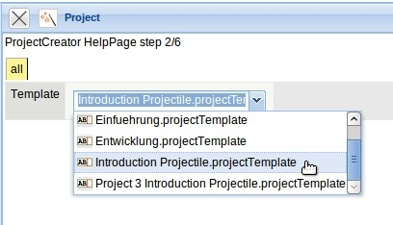
After selecting a template (here Development) the appropriate project template with the stored project structure is loaded.
Using the project assistant (step 3 to 5) all relevant project values can be entered. These key figures correlate mainly to the values from the manual project definition.
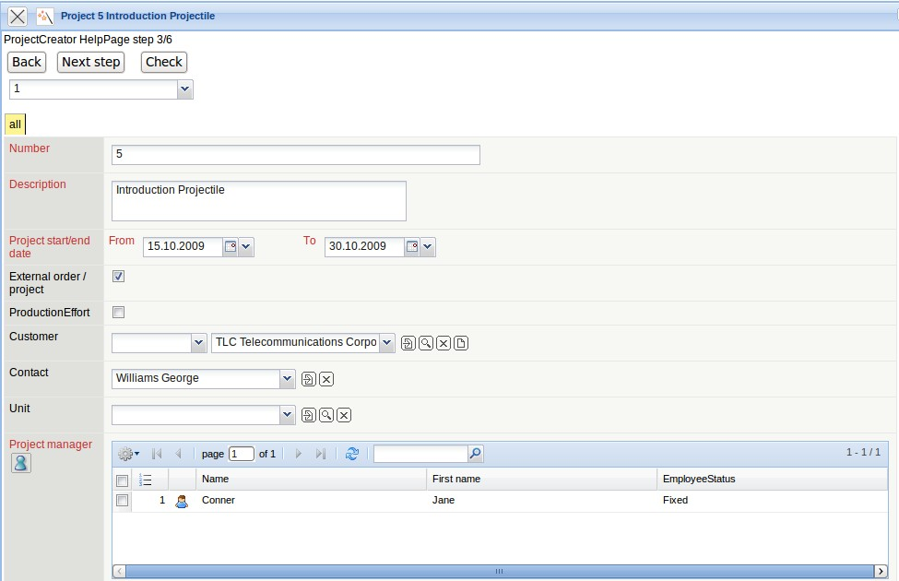
After modifying the project's key figures, the option for the next step, if and when the start date and end date should be changed is selected. After entering all necessary values, it can be proceeded to the next step using the next button.
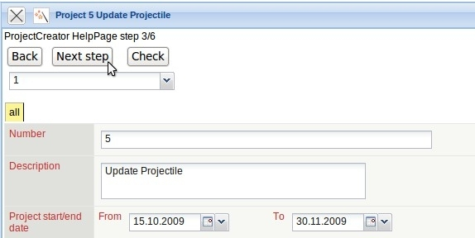
In the fourth step the modifications are listed in the project structure.
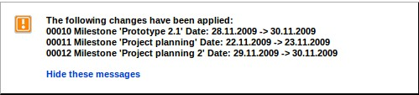
Note: In the template the key figures for the (sub-)projects, tasks and milestones are stored in a parameterized form. If the system then defines the dates for the project to be generated, the dates can also be on weekends or holidays.
Before the last step, an option for the suggestion theme should be chosen.
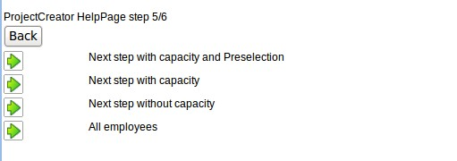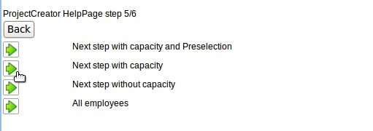
The option “with capacity and pre-selection” displays all employees for all jobs in the next dialogue step, who have the appropriate skills and preselects the employee with the least utilised capacity in the planned time span. The option “with capacity” displays all employees with the appropriate skill and their utilised capacity into the given time span. The option “without capacity” only considers the skill management and ignores the utilisation capacity. The last option “all employees” ignores the utilisation capacity and the skill management.
In the last step, the project planning is completed. All jobs of the project structure with the planned times, the appropriate skills, the assigned sub-project (stored in the template) and the time span is displayed. In the following example the option “with capacity” is applied.
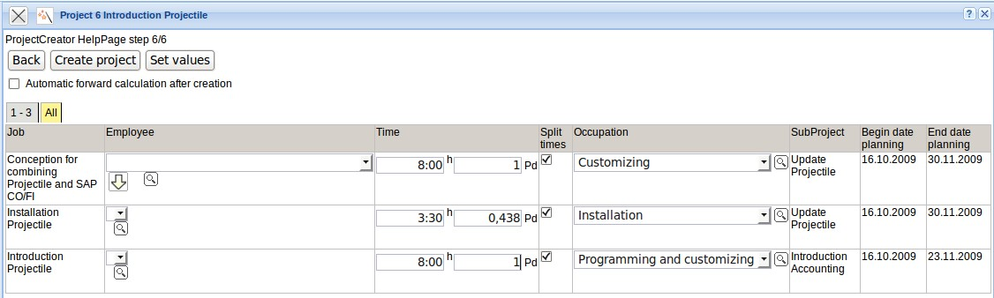
In the dialogue all employees for each job, who are qualified for the task (using the skill management) and the appropriate percentage of the utilisation capacity is displayed. Example: The employee Jane Conner can be planned for the task “Customizing” at 100% (value in the parenthesis) and has a capacity utilisation of approx. 12,5% and 12,5% in the time span of 16.10.2009 to 30.11.2009.
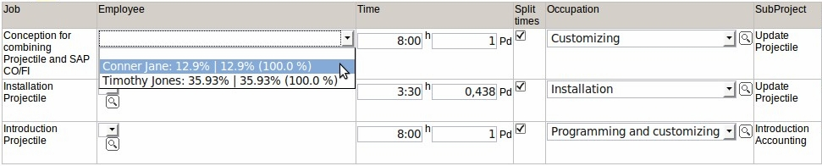
Explanation of the select box: Employee: The capacity utilisation of all projects | capacity utilisation considering the project probability of the planned project (maximum capacity of the employee).
After the employee is selected, the entry must be confirmed (if javascript is not enabled) by clicking on the green check mark. This mechanism can be applied repeatedly:
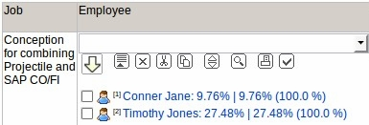
This way, for each job, between 0 and n employees can be planned (possibly jobs cannot be applied to the template; a warning is displayed and the job is then not generated).
For tasks with several employees the option “split times” can be applied. Using this check box, it can be specified if the employees split the defined planned time or if each employee utilises the given amount of hours for his/her job. Also, the assigned occupation of the job can be modified. Modifying the start dates and end dates is not possible here. This and other modifications with the structure can be directly applied after generating the project.
After clicking on the “Create project” button ...
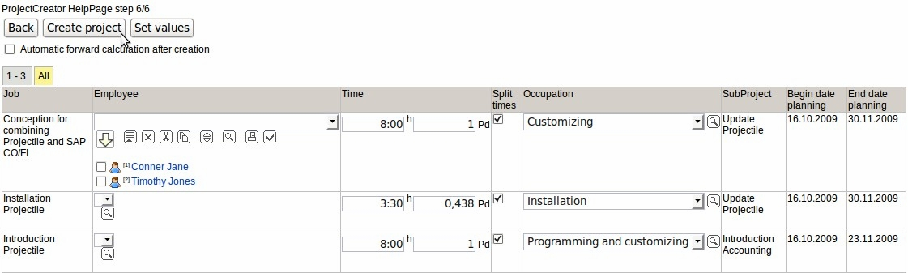
... the complete project structure is created. Using action “01 - Project shaping and evaluating” the structure can be displayed and modified.
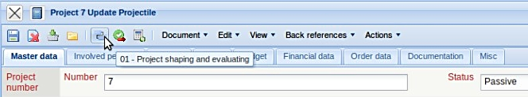
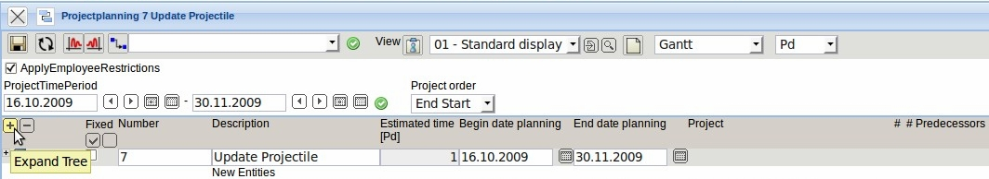
In the example, a parent project and a sub project, various jobs and milestones, as well as order relationships between the tasks have been created. Using the function “Expand Tree”, the complete structure can be displaye:
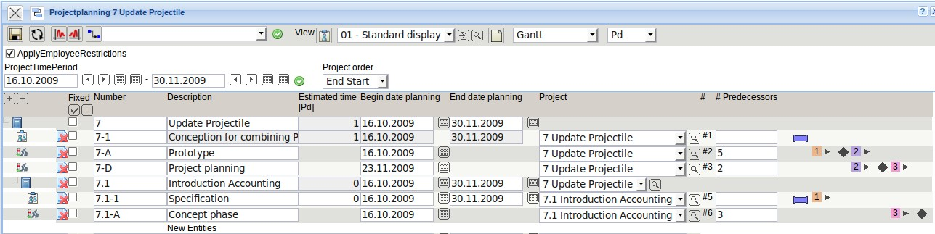
Afterwards, the structure can be modified and calculations can be performed.

