5.03 General Usage

Create Documents
Creating a new document in the work area is described using the document type receipt. After selecting the document type ...
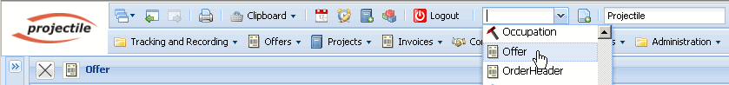
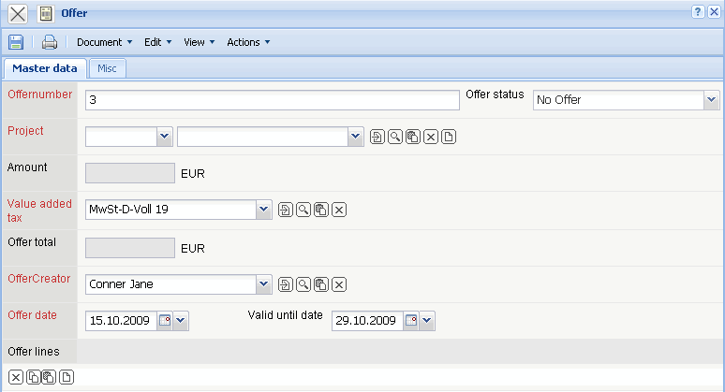
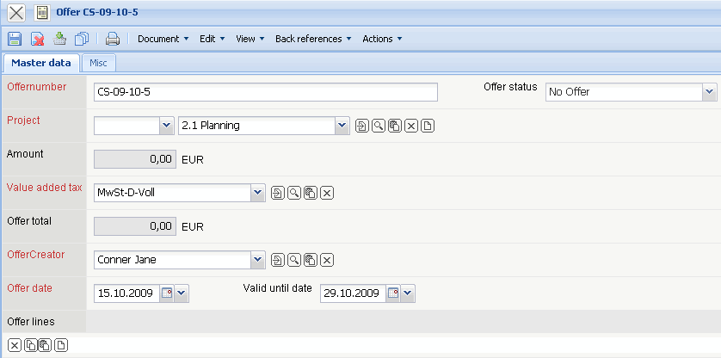
... an empty document form from the selected document type is displayed. In the example, a new document with the type offer is displayed. The form contains initially only the default values (here the offer number, the employee who created the receipt, the current date, value-added tax, the vadility and the status).
Note: In the standard version all required fields in the form are marked red.
In the next step all information fields of the document are filled (Description and Project) and the document is then saved.
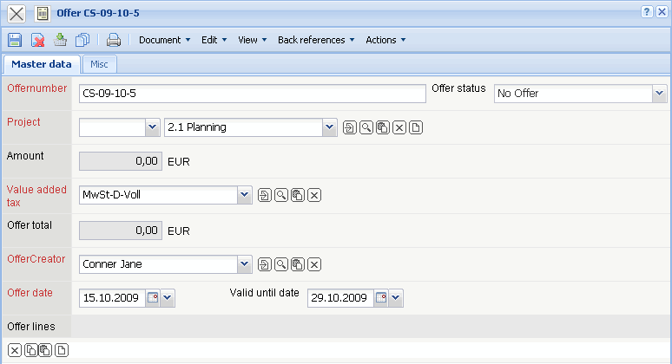

History
Each modification (here offer date and validity) are logged when history is activated.
Using this function, modifications in the form (with the appropriate access permissions) are displayed.
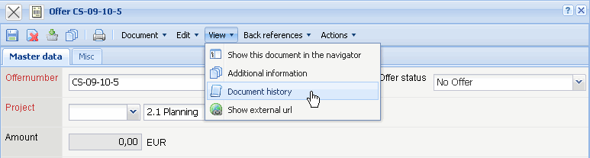
In the example two modifications are logged: Creating the document and two modifications ...
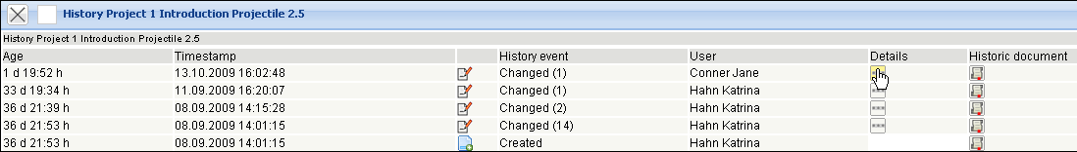
... in the fields offer date and validity.
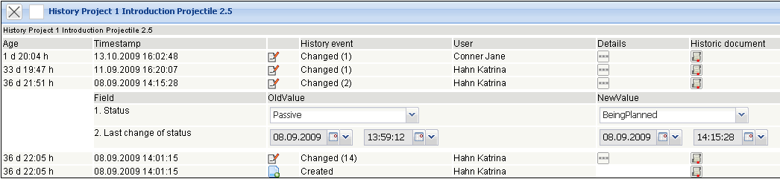
History can be closed with as with every form.
To copy a document, the functionality “Create new document from template” is used.
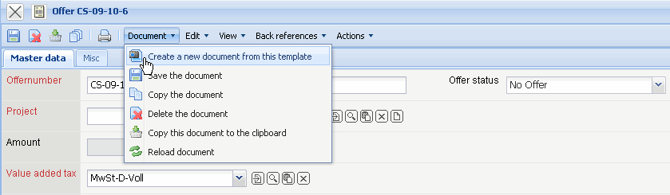
This functionality copies the existing document and pre-sets the default values. Here, offer 5 becomes offer 6.
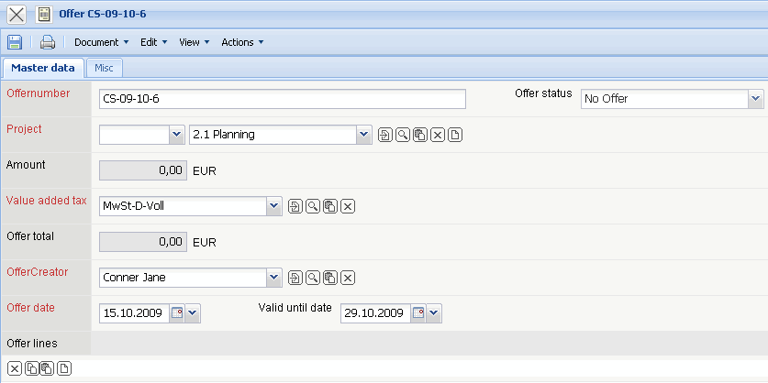
Finally various values are modified and the document is then saved.

Delete Document
If a document is not needed, clicking on ...
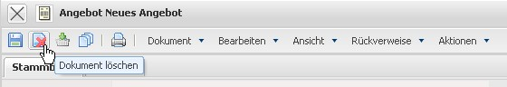
... deletes the document.
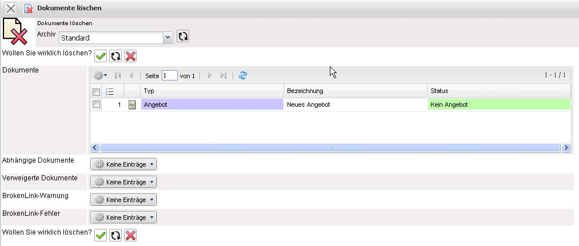
Before the document is deleted, a dialogue asking if the document should be deleted is displayed.
This dialog is a precautionary measure, as only selected users can reactivate this deletion process (see also trash/archive). If data with references are deleted (as in the project example), all data is displayed in the delete dialog, which will also be deleted.


