5.02 Search and Find

Search Machine

Non-constraining Search
The search machine is used for finding data. Entering a search string in the search box and selecting a catagory, all documents in the catagory are searched using the string on the basis of a full text search. Using the category field limits the selectable document types.
Searching the complete data pool without selecting a category is also possible. Because these searches can take longer, a warning appears when no selection has been found.
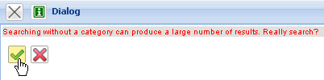

Result List
The following illustration shows a possible result list with the search query: In the result list all documents are listed, in which the defined search string “Projectile” has been found.
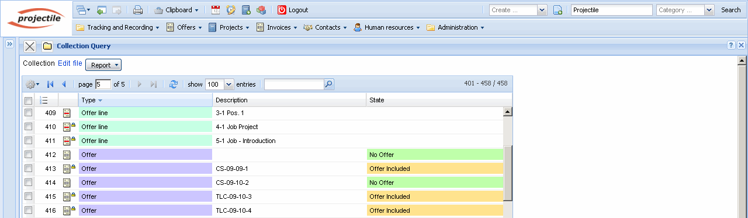
This result list can also be modified for later usage ...
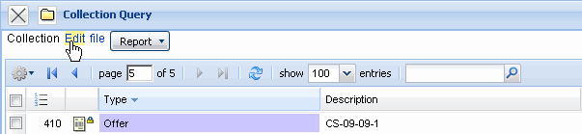
... and saved (“Query Projectile”).
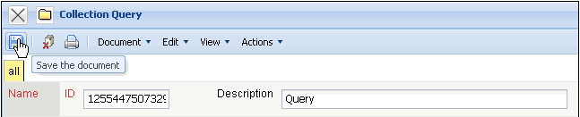
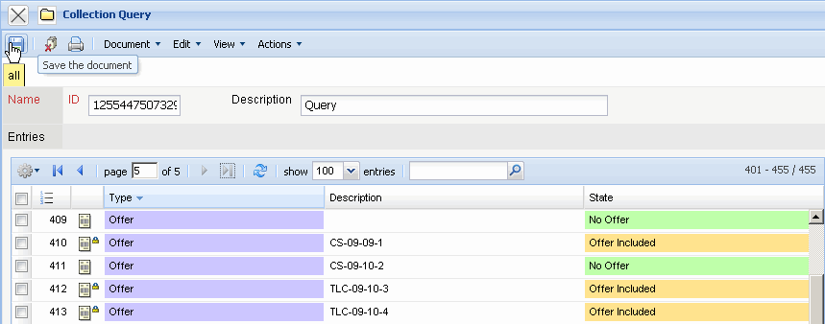
In the result set, using the navigation menu pages can be changed to the previous or next page and/or to the first or last page. Here a result list is displayed with 471 entries, in which the first 100 documents are visible.
Change to next page:
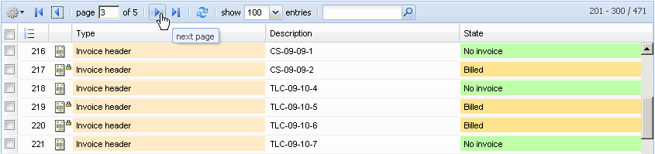
to the last page:
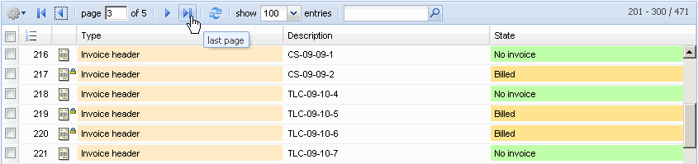
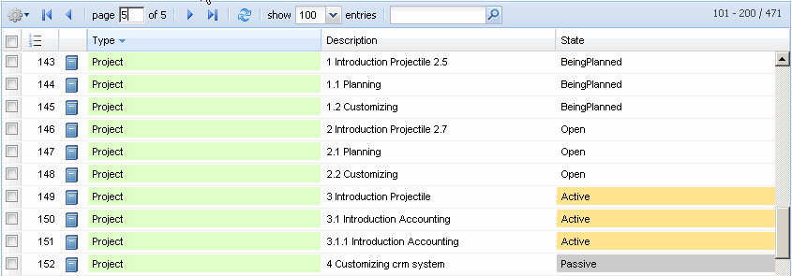
The amount of displayed results can be set.
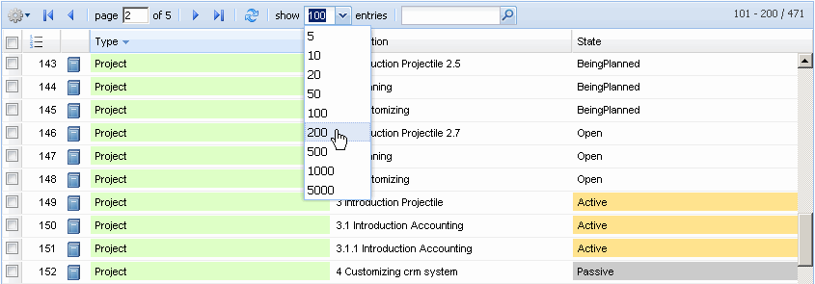
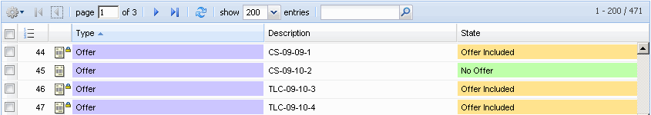
The columns of the list can be changed and the size can be modified.
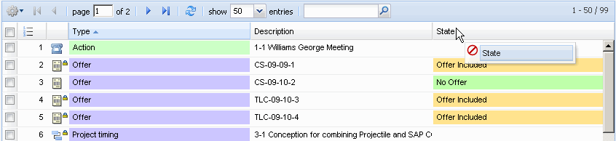
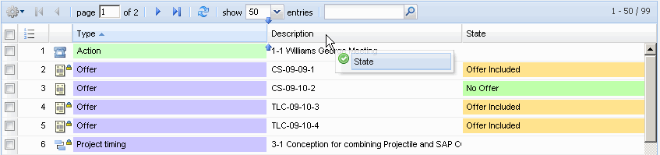
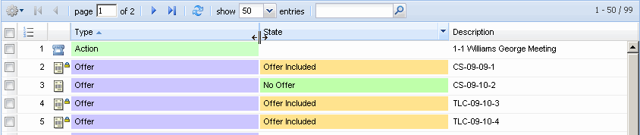
Through clicking on a document in the result list, it can be navigated directly to the appropriate document.
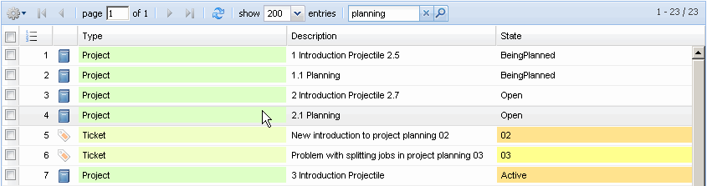
Using the functionality in the window bar, an opened form can be closed again.

Constrained Search (advisable!)
The second example for using the document search displays the possibility to search for a certain string within a document type (category), which means, further limiting the search: in the example the user would like to list all documents with the top/parent project type where the string “Projectile” exists ...
... and in the result list all offers are displayed, which contains the string CS. It makes no difference if this string is in the description or in another element of the document.
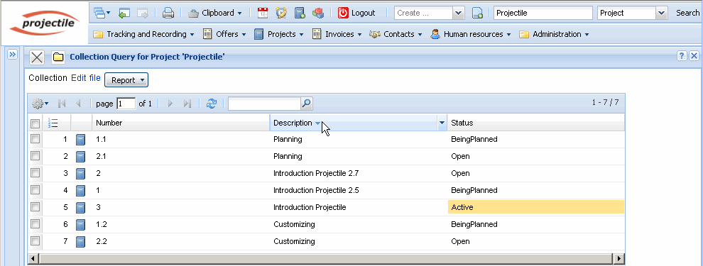
The result list can be sorted...
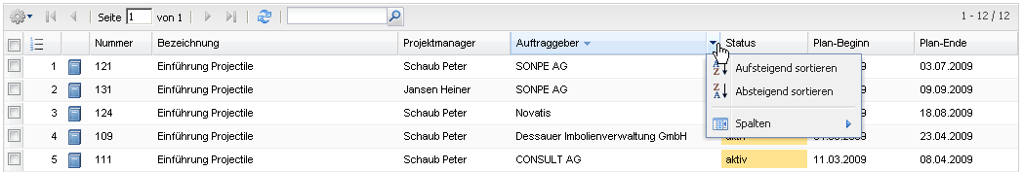
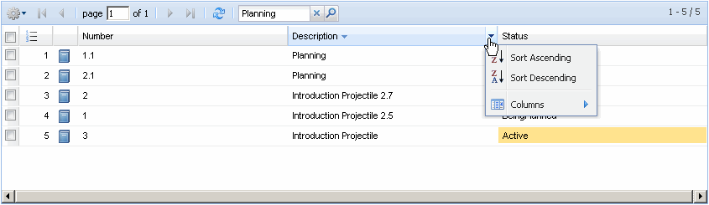
and columns can be displayed/hidden.
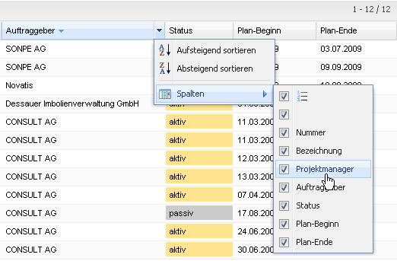
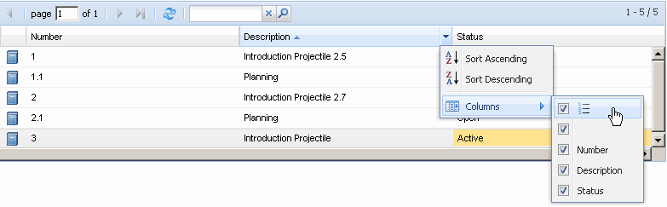
Within the result list the search can be further limited. In the navigation bar a string can be entered in the input field.
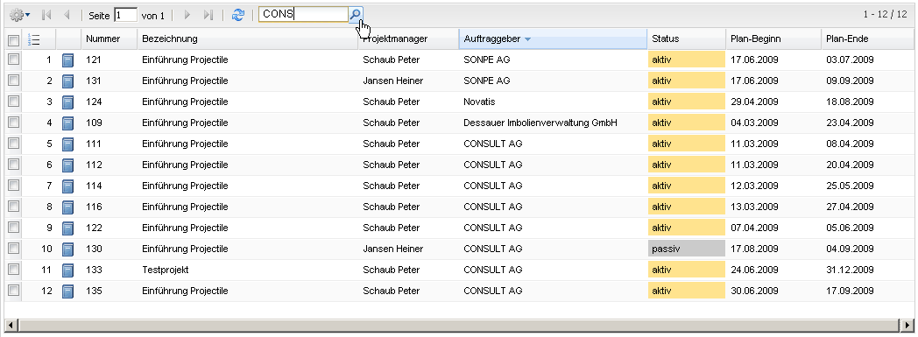
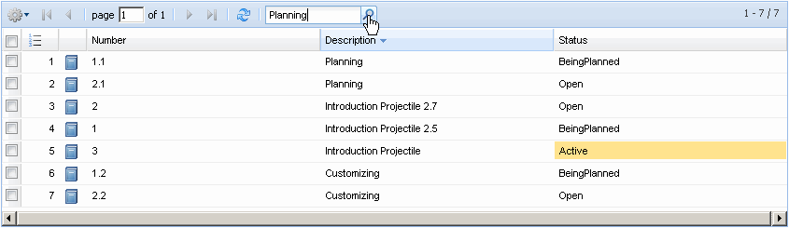
After clicking the magnifing glass symbol the system searches within the search list.
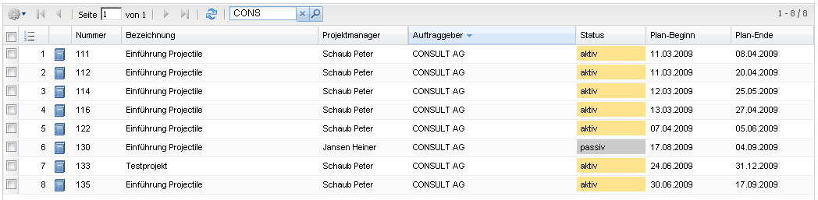
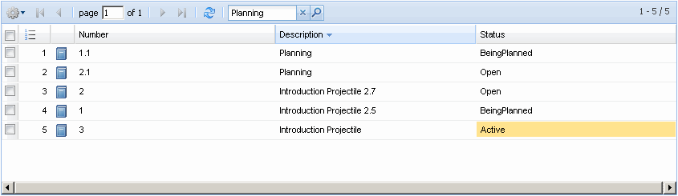

Personal Clipboard
The personal clipboard offers a further possibility to find and open a document.
Documents can be transfered to the personal clipboard ...
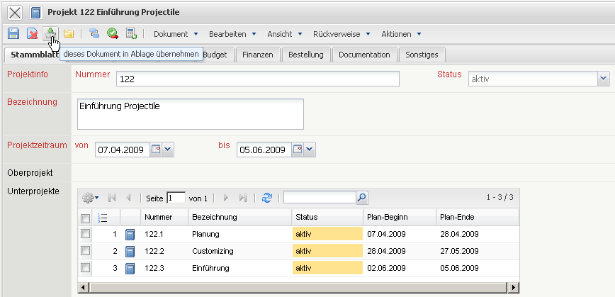
and documents can be directly opened with a mouse click on the link from the personal clipboard.


