Array Array

3.06 Reportgenerator "ReportMaker" (Fortsetzung)

Generate Reports:
The ReportMaker offers a variety of formats as output options.
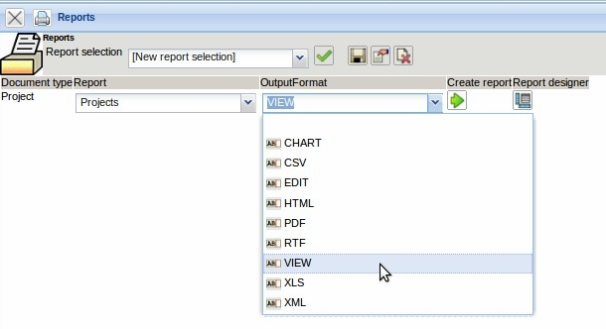
The option “VIEW” ...
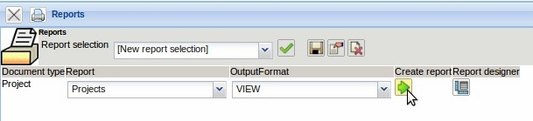
... creates the report directly in the application ...
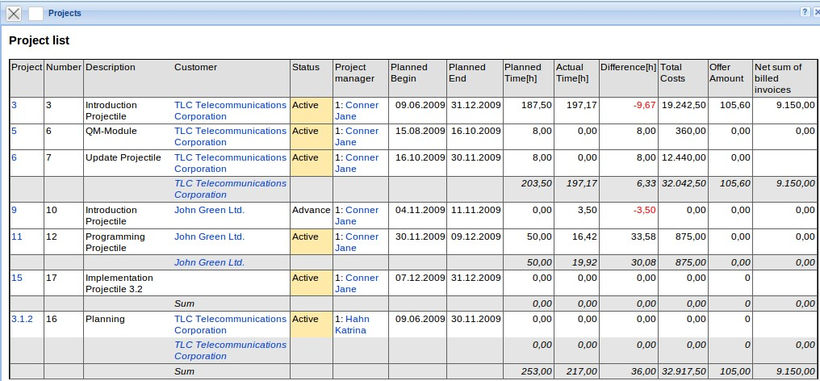
... with the possibility to link from the chart to the master data.
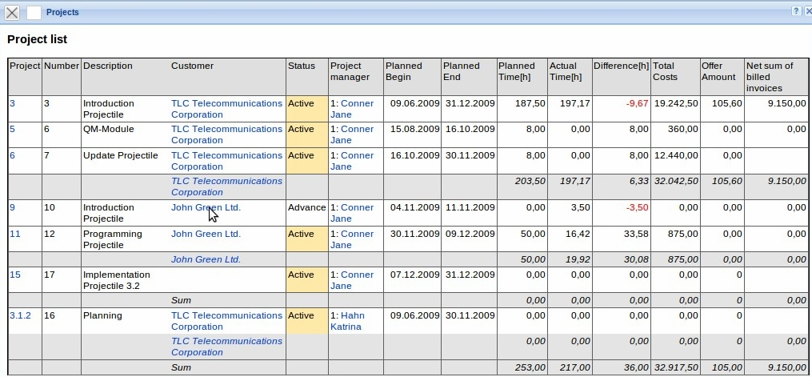
This functionality is, of course, completely subject to the authorization system, which means, a link is only created for records with the appropriate authorization (more information about the authorization system in the administration guide).
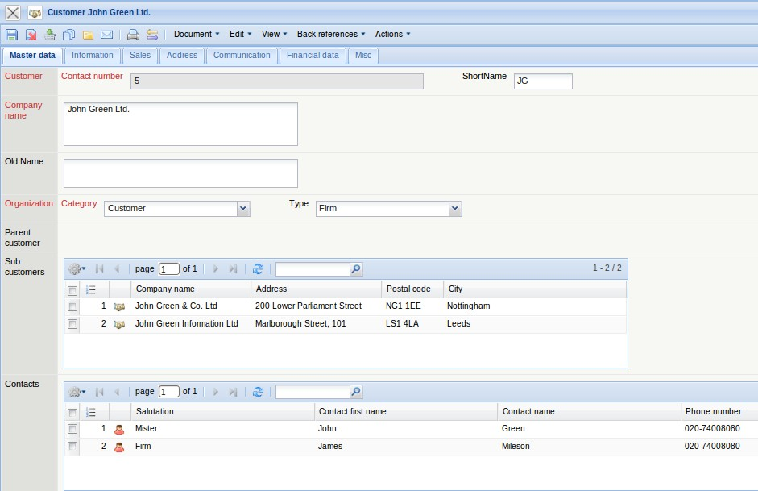
Another output option is “CSV”. This output format is mostly used for spreadsheets (e.g. MS Excel) and standard letter functionality (data source for standard letters).
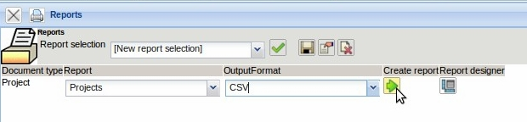
In the following dialog, the generated file can either be saved locally ...
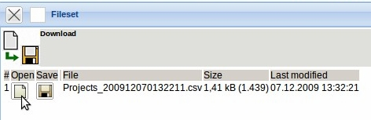
...or can be opened directly.
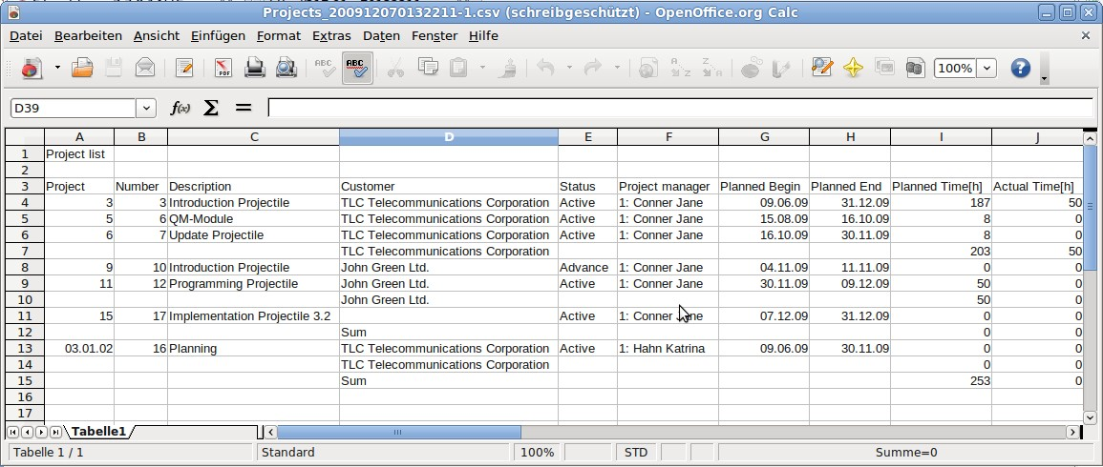
Further output options are “PDF”, ...
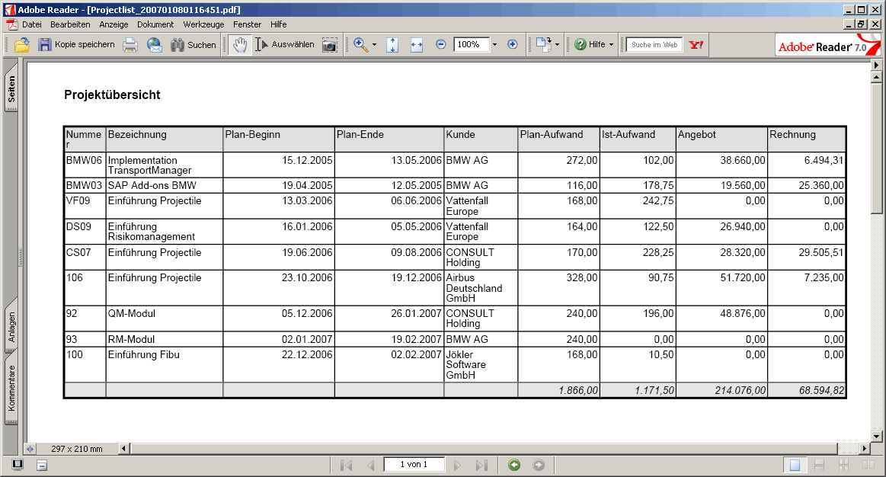
... “RTF”, ...
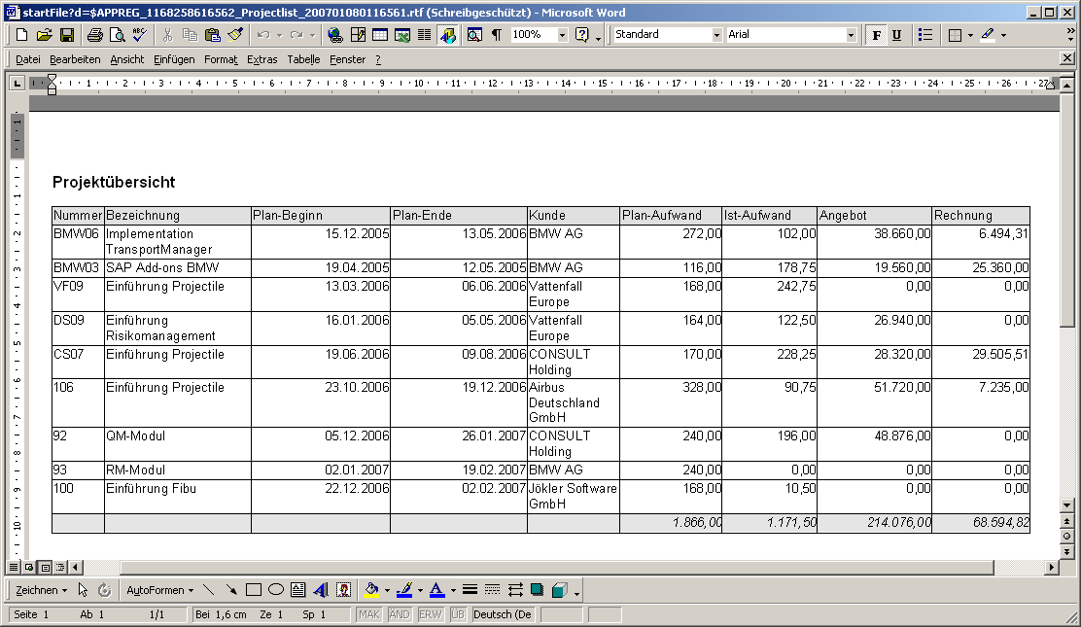
... “XLS” (for MS EXCEL) and ...
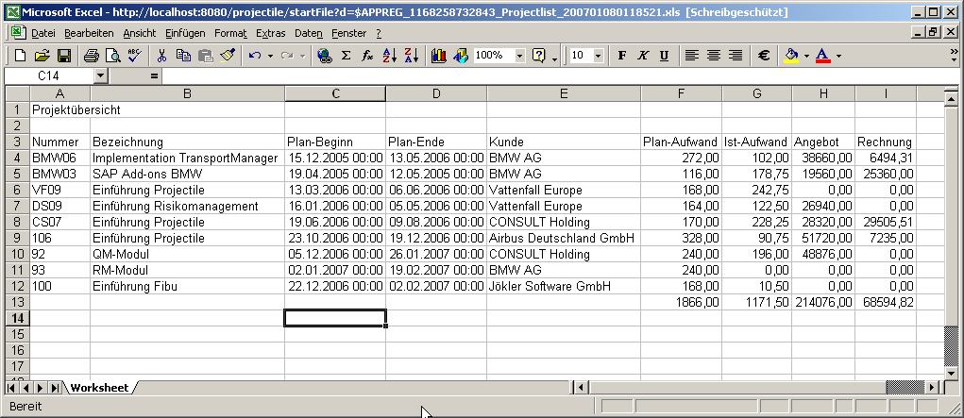
... XML.
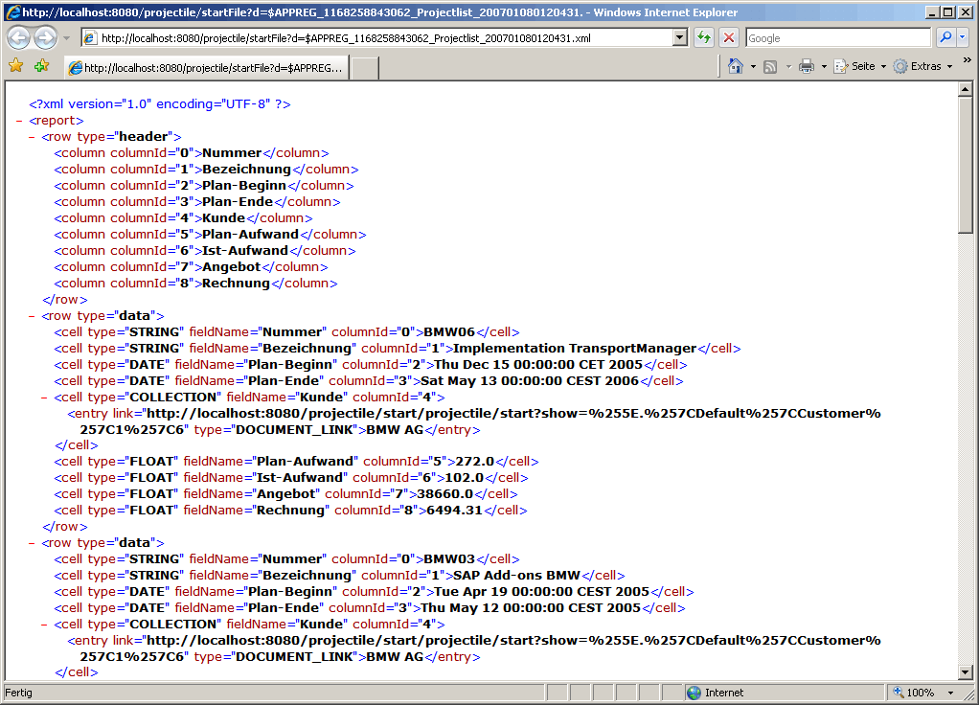
In the ReportMaker information/data can also be changed. By using “EDIT”, the results of the reports can ...
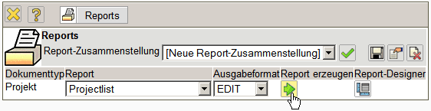
... be conveniently edited .
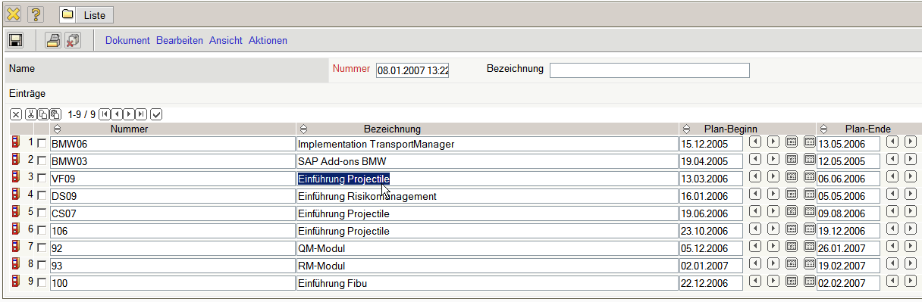

Setting Access Rights
By default, only the user, who creates the ReportMaker, has access to the report. Each report can also be fitted with different authorizations (see also administration guide). In the following example, for the project list ...
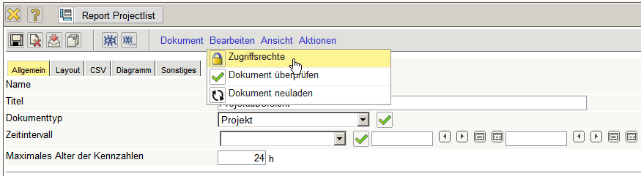
... an authorization for the user group...
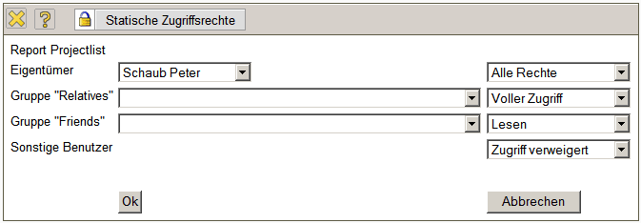
... manager and project manager is assigned. All the other groups (with the exception of the owners) do not have access to this report.
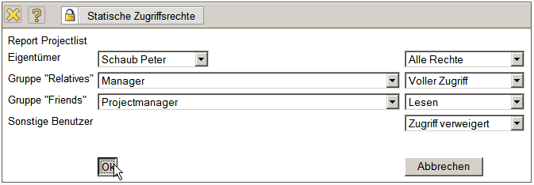
Note: The change of the authorization is only active after saving the document.
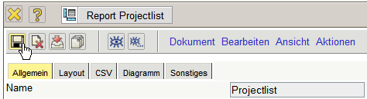

Actions in the ReportDesigner
The report includes five actions. The actions “Show preview” and “Show preview in another format” create directly from the designer the report, if the designer is accessed from a result list. The action “create standard report” sets your own report back to the original configuration (it list all the elements of the document) and the action “List available reports” displays all reports about the selected document type (here employee).
The action“create headers/footers” allows the assignment of headers and footers for the generated reports. These elements can include logos, headers and formatting information, and can be currently created exclusively by the owner.
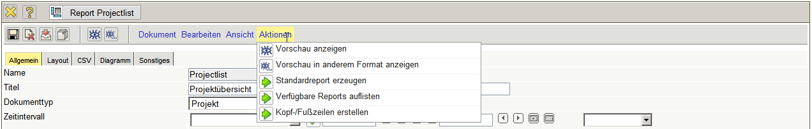
... continued

