Array Array

3.06 Reportgenerator "ReportMaker" (continued 6)
Key figures

Examples:
In the following examples, in a project overview key figures without limitation are used.
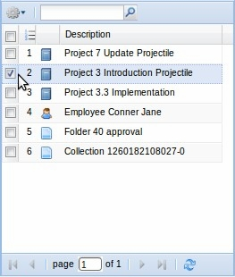
From a advanced search or result list, data will be ...
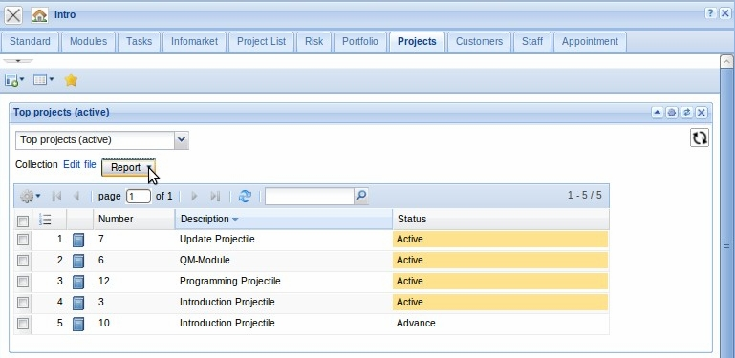
... passed to the report generator.
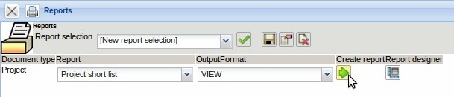
After selection of the report and the output format ...
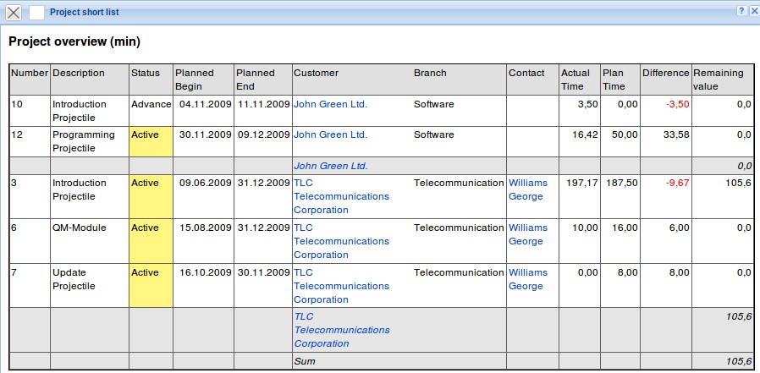
... the report is then created.
Stored queries and reports can be individually stored in the input screen (see also chapter 3.02.4 Alternative work area).
In following examples, in a project overview key figures within a time span are used. For the key figures are features of the periods defined in the last column. In the example, the key figures are periodically limited. The entry (periods) in line 8 controls the use of periodic key figures.
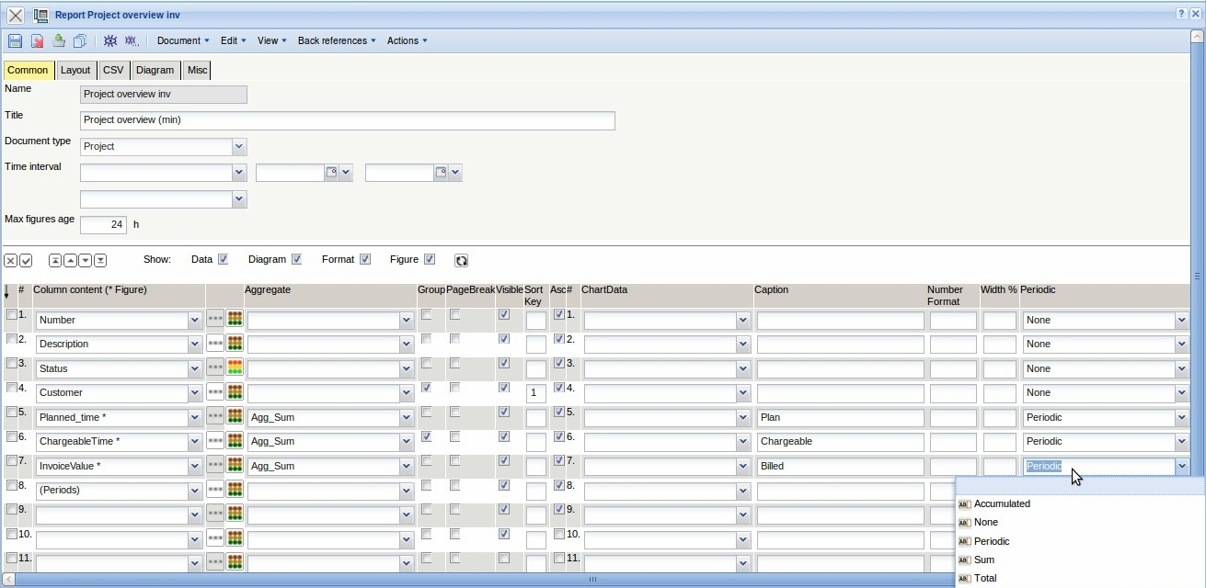
In the top part of the report definition, a time interval (this half year) and the period for the limitation (on monthly basis) can be entered. These entries are the defaults in the dialog for generating the report.
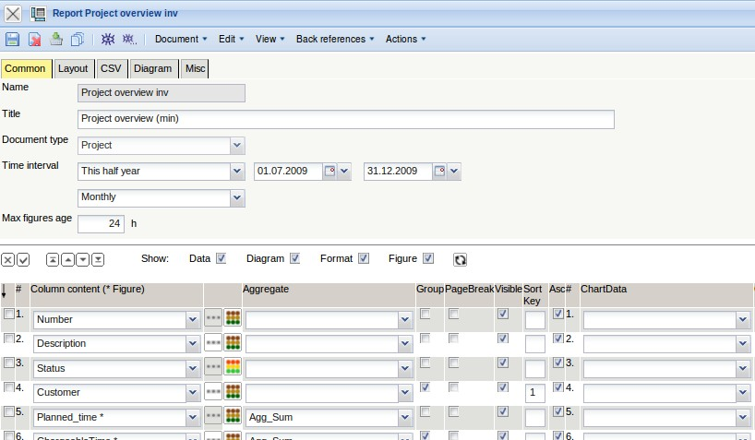
From a advanced search or result list, data will be once again ...
... passed to the report generator.
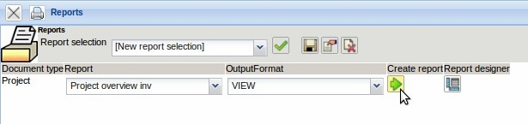
After the report is generated, a dialog with the defaults of the report appears.
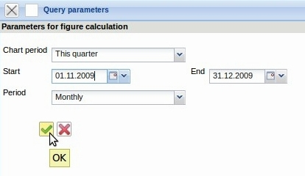
After selection of the chart period and the period, the report is then created.


