Array Array

3.06 Reportgenerator "ReportMaker" (Fortsetzung)

Functions of the ReportDesigners (continued)
Next, the field 'status' is loaded and rearranged.
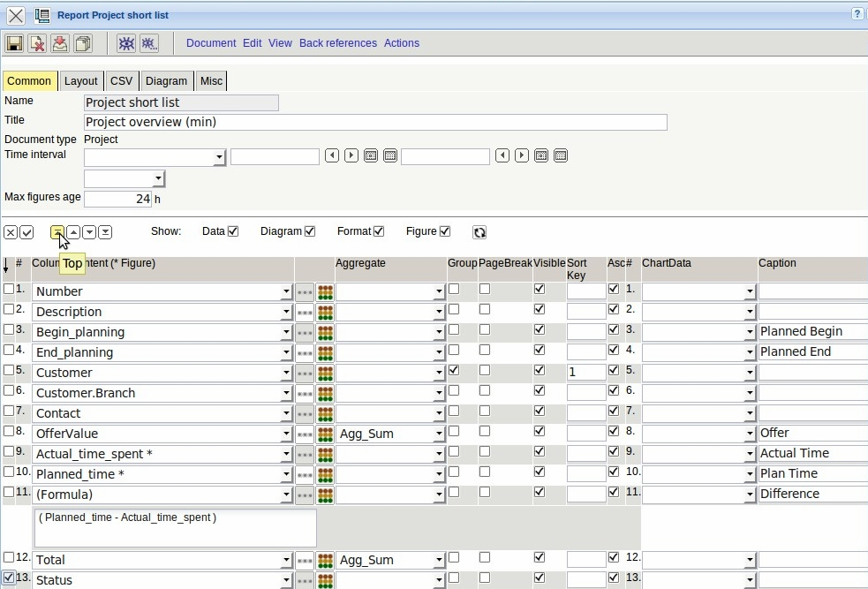
This field should be highlighted in color with the defined entries using value-based formatting .
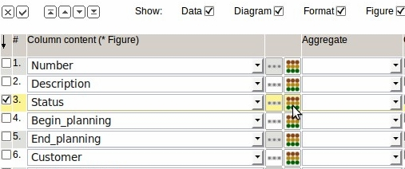
The comparison operators and the operand can be adjusted in the field “Compare” in the format dialog. The values can either be implemented textual (TEXT) or by color (foreground or background color).
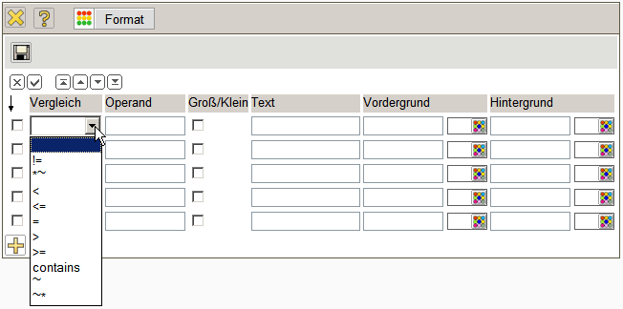
The following comparison operators are currently supported:
No. | Operator | Description
1 | != | Check field content for inequality
2 | *~ | Check, whether the field content ends with the value
3 | < | Check, whether field content is smaller than the value
4 | <= | Check, whether field content is smaller or equal to the value
5 | = | Check field content to equality
6 | < | Check, whether field content is smaller than the value
7 | <= | Check, whether field content is smaller or equal to the value
8 | contains | Field contains a multiple selection
9 | ~ | Check, whether field content contains the value
10 | ~* | Check, whether the field content starts with the value
The example for the field 'status' the value “active” (internal active) with yellow background is realized and the value “passive” (internal passive) with red background color.
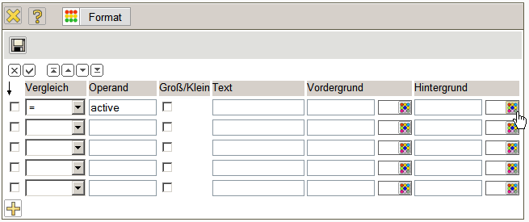
The desired color can be selected from the ...
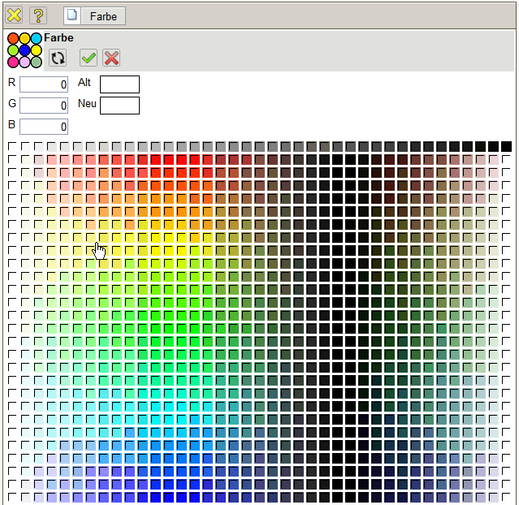
... the color palette ...
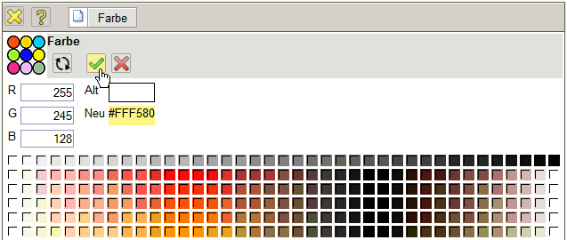
... and related (here for active and passive).
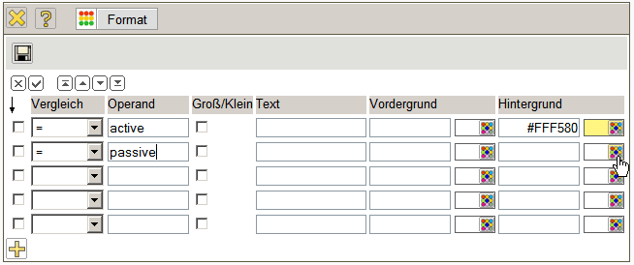
All status information, which include the value “Live” will be implemented with a green background color (all projects, which are completed).
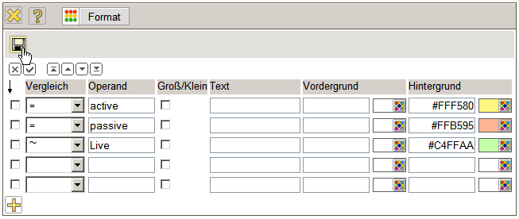
After saving and closing the dialog, dialog can be done using the action “Show preview” of the ...
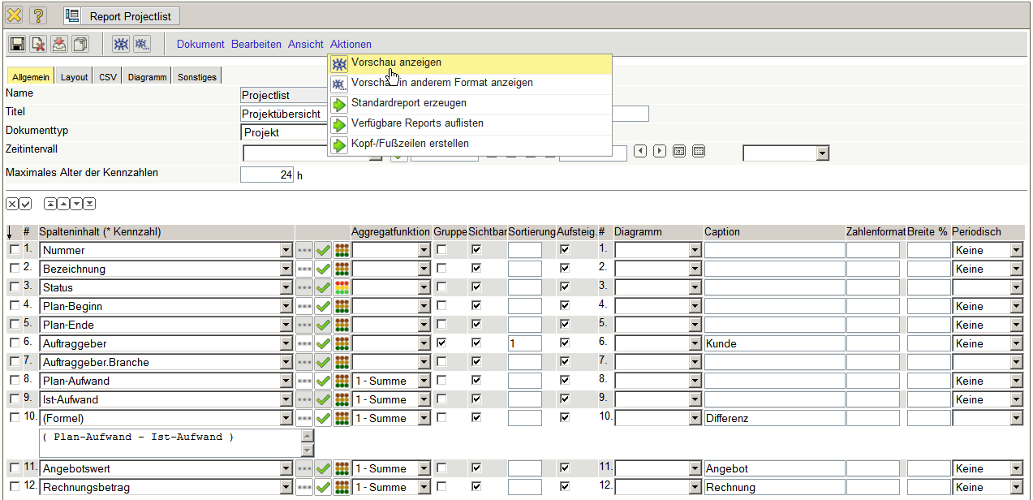
... Report.
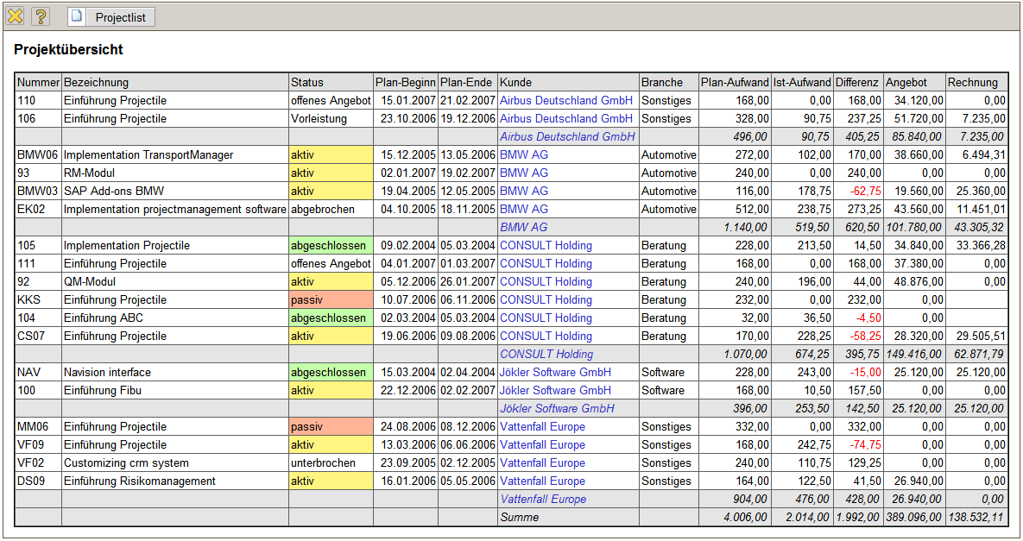
Afterwards some fields are rearranged in the report and by using of functionality a formula is defined. The new column 13 should be the result (residual value) from the difference in the offer value and the invoice amount and should be added up.
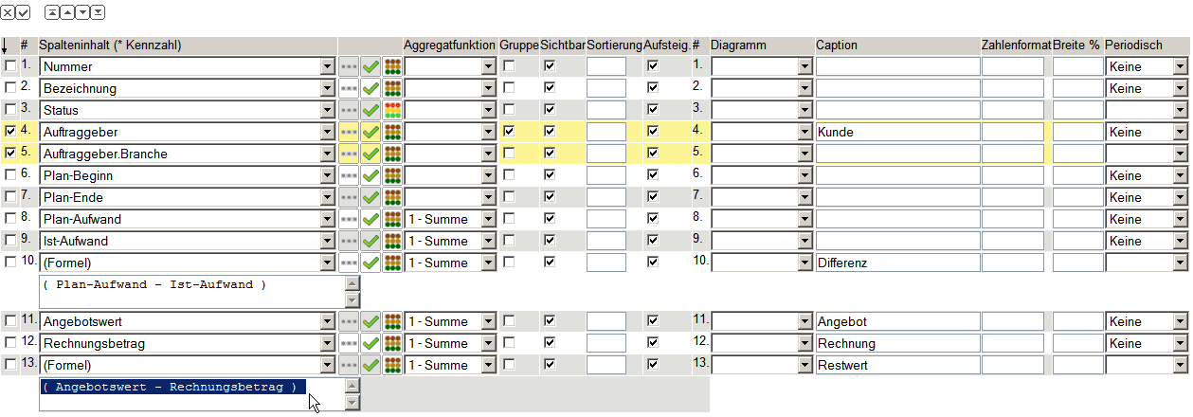
The two intermediate results (column 11 and 12) should not be listed in the report, therefore in these values can these values, the check boxes can be set “visibly” to false (not marked).
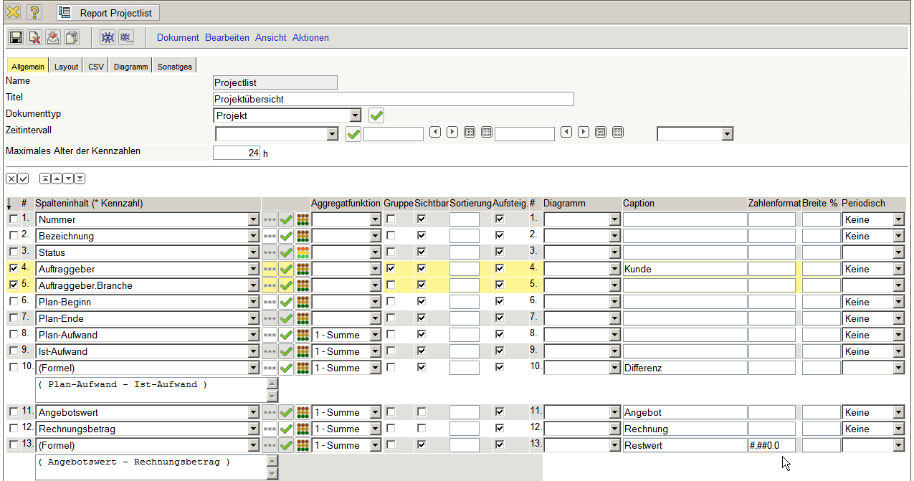
In the column number format a format for all numeric values can be enforced. In the example, enforces the notation #,##0.00 the thousands separator and two decimal places.
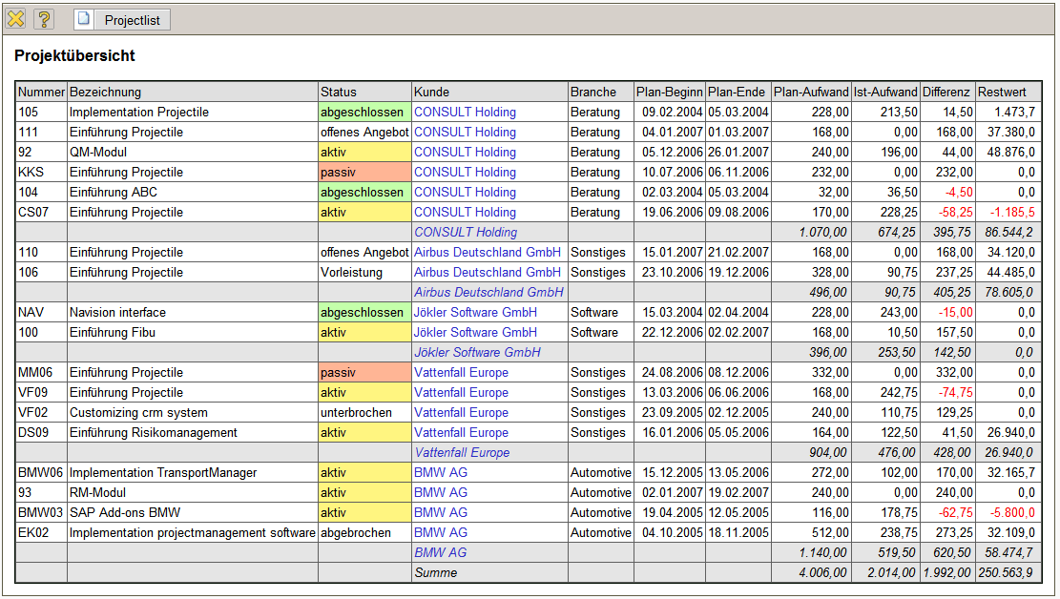
Here, the thousands separator and decimal point are set only for the installation and are still dependent on the user language. When installed with the German language setting then a point is used as a thousands separator and as a decimal point a comma is used, even if the user language is English.
Further examples of formatting:
Number Format | Value | Implementation
#,##0.0000 | 1234,567 | 1.234,5670
#,##0.000 | 1234,567 | 1.234,567
#,##0.00 | 1234,567 | 1.234,57
#,##0.0 | 1234,567 | 1.234,6
#,##0 | 1234,567 | 1.235
###0 | 1234,567 | 1235
0.00% | 0,234 | 23,40%
... continued

