Array Array

3.06 Reportgenerator "ReportMaker" (Fortsetzung)

Functions of the ReportDesigner
The following example expanded functionalities of the designer are defined with the help of “Project List”.
First, a new element for the report is created by using . In the selection list 'column contents', reference elements are available, depending on the document type. In the example for the project report the document type project is selected. The element applicant, who is pulled out of the contact system. These links can also be used in the ReportMaker. If a field within the selection box “...” may contain, you can select by using the functionality the available elements of the linked document.
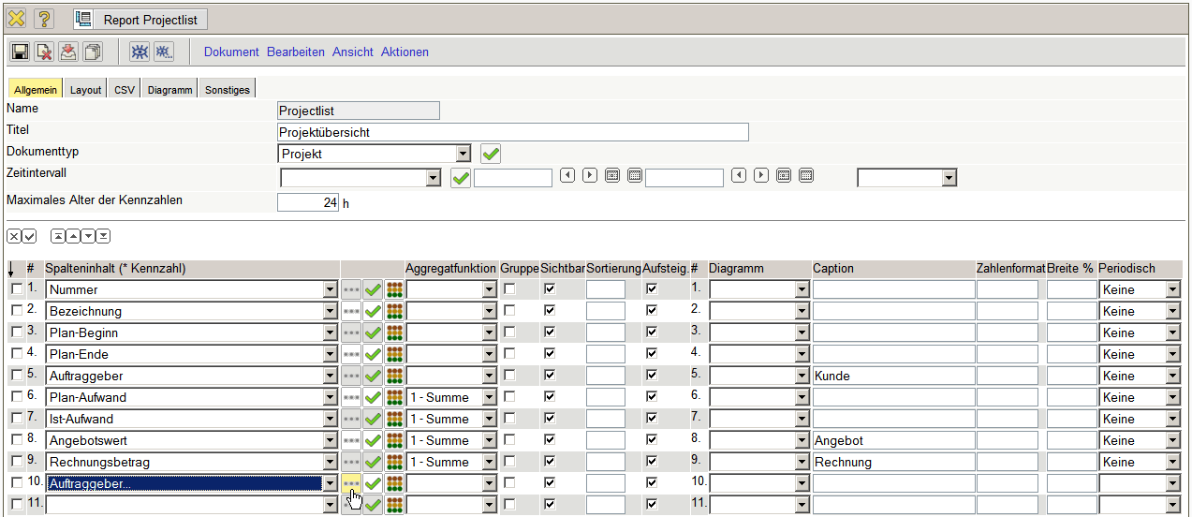
In the example, in addition to the applicant of the projects the belonging branch should also be displayed.
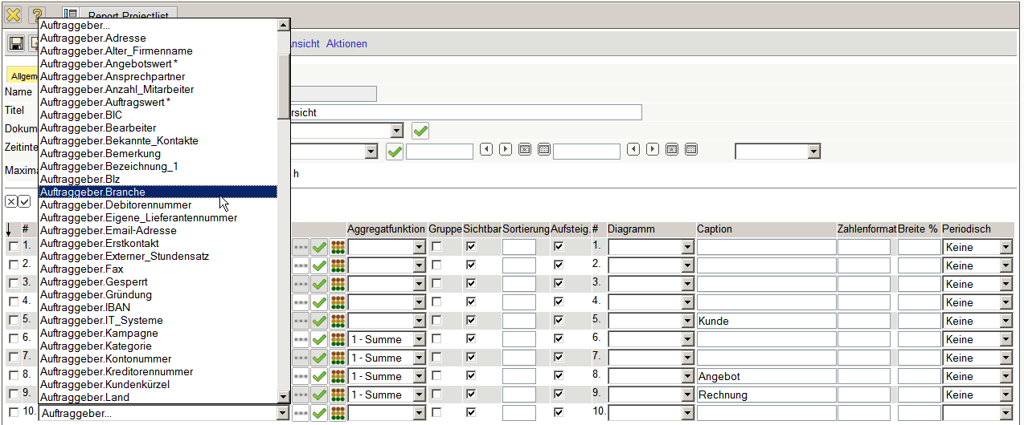
Then the field will be resordered. For this the field with 'Up' (several times) is moved to the top ...
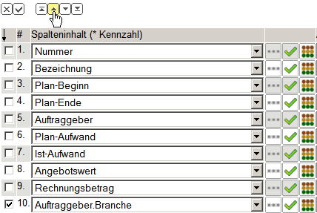
... until the desired position is reached.
By using the functionality formulas can be used.
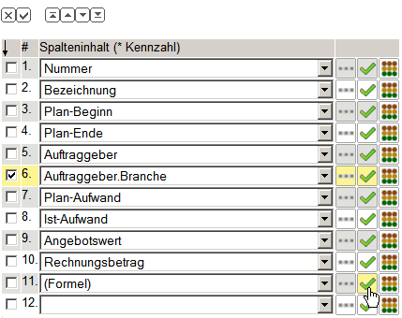
Then a corresponding input field is opened, in which the formula is defined.
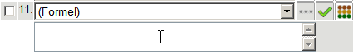
Within the formula all basic operations can be used (+,-,*,/). But in the definition of the formulas you must always respect the correct spelling (case sensitivity as well ) In the example, a new field with the name 'difference' has to be created, which is evaluated from the fields panned effort - actual effort and they should be added up (aggreagate function).
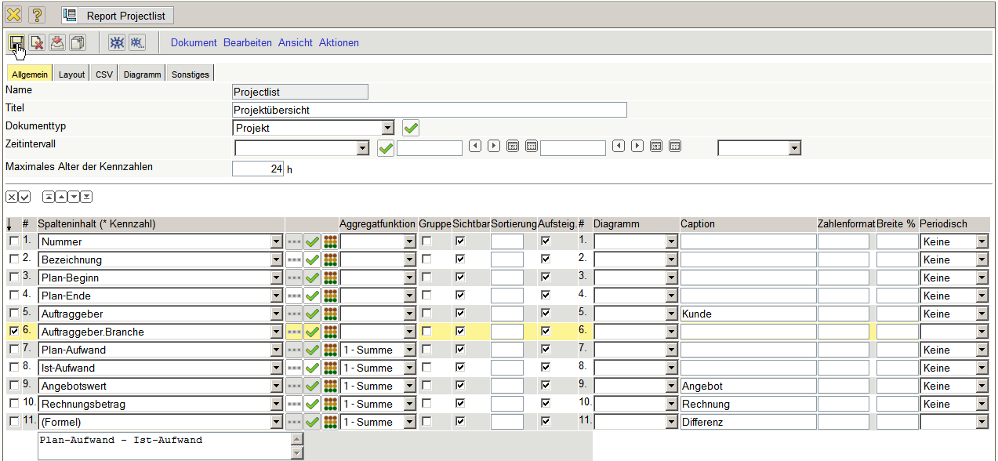
After saving, the formula for the internationalization of the report will be reformatted. The new field “difference” is then shifted two positions upward.
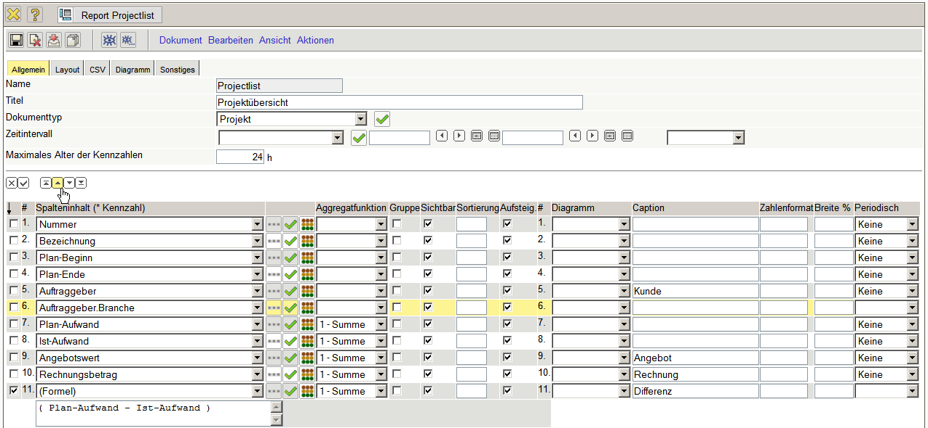
Afterwards, it is sorted and grouped by “costomer”.
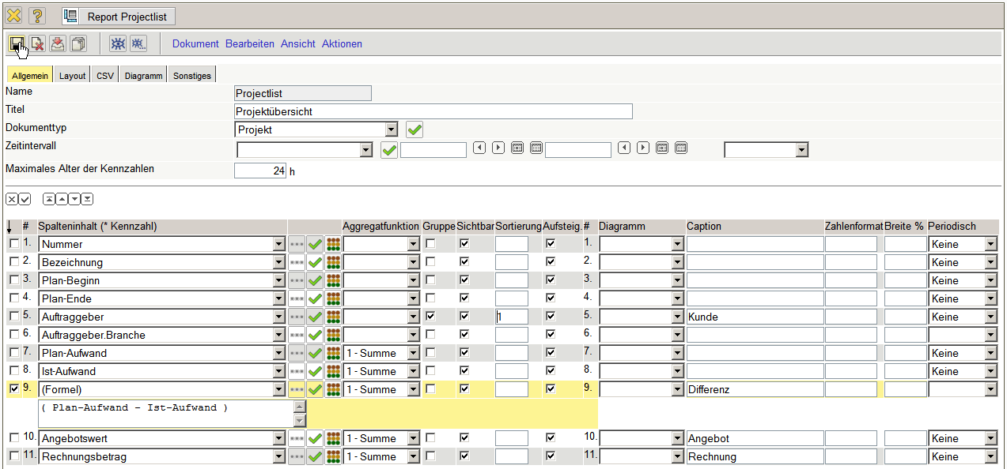
The example-report can be after saving...
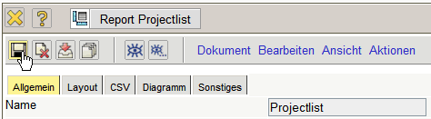
... and closing ...
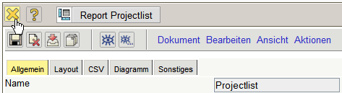
... directy used ...
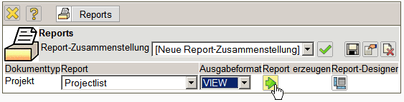
...and then delivers following analysis on all sorted by “costomer”, by “main projects”:
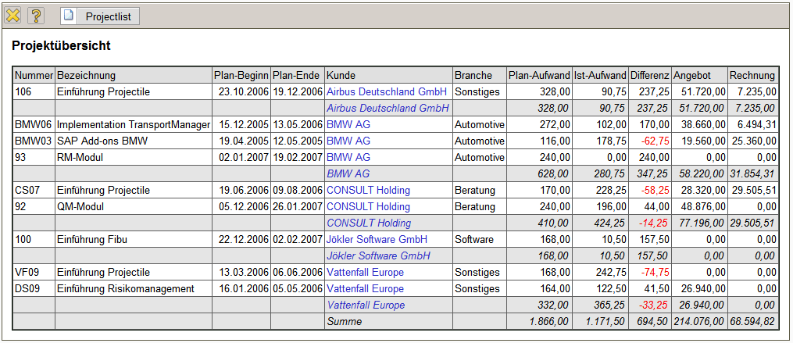
... continued

