3.12 Chart System
The charts represent the central control tools within Projectile. Here, all employee-related, cost-related and project-related information can be accessed using various criteria. The information is available as either lists or diagrams.

Applying the Chart System
Projectile contains numerous standard charts. The charts are grouped by topic in chart blocks and contain up to 14 individual charts.
The charts can be opened in the work area using the action “Charting”.
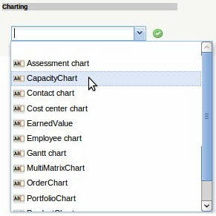
In the following example, various project-related charts are presented. The project overview, the work breakdown structure, Projekte Plan/Ist /projects plan/actual comparisons and jobs plan/actual comparison, the milestone trend analysis, the degrees of completion, time sheet and the Skill Matrix belong to this chart block.
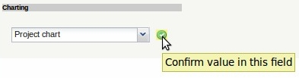
After opening the type of chart (here, the project charts) a chart document is opened. In the document selection criteria and the chart options can be configured.
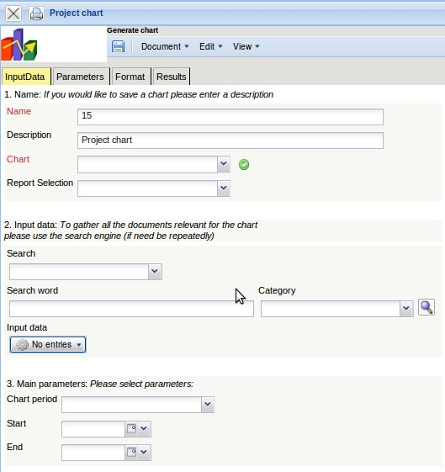
The first part (1. name) can be used for the naming the charts, if the chart is saved. Saving the chart is useful if the selection criteria for the charts remain constant, for example a list of all active projects for the current quarter. This saved chart can be copied to the clipboard or be used as the basis for a time service to automate charts. In addition, charts can also be generated in the background. To view the chart results, the charts must also be stored.
The second part (2. input data) is to determine the input data for the chart. In the third part (3. main criteria) the input data may be given a limited time span.
In the first example, the selection criteria for entering data, two projects from the personal clipboard is selected. These projects are highlighted in the clipboard, ...
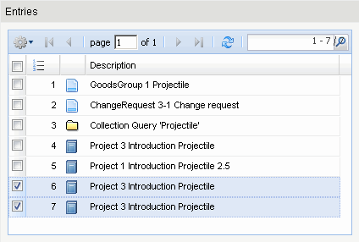
... copied and ...
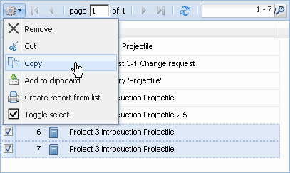
pasted in the entry data.
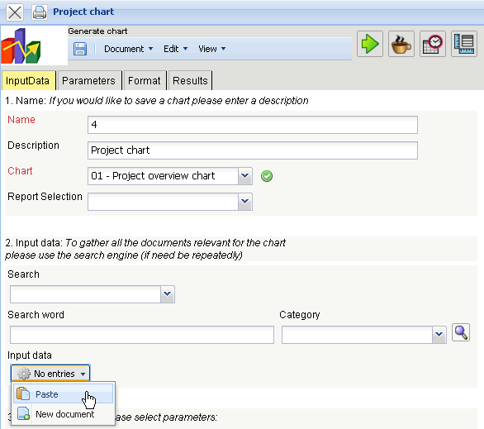
This process can be performed many times (or performed with multiple entries). In the example below ...
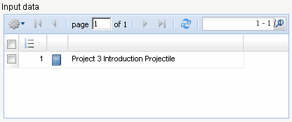
... Project 3 Introduction Projectile is the selection criteria, to which the charts are related.
Afterwards the displayed time span of the chart is limited to the current year ...
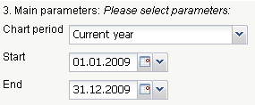
... and the chart “job plan/actual” is performed using .
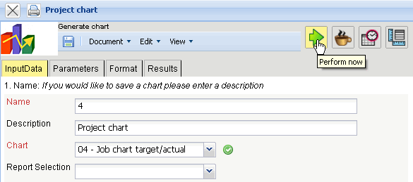
When the chart results are generated, the system presents the results in the browser. This chart contains information related to the projects, processes and/or jobs and employees, the planned and actual times with remaining time/effort and the corresponding difference (plan - actual), the planned completion period (start/end) and the status information (status, completion date and degree of completion for the task).
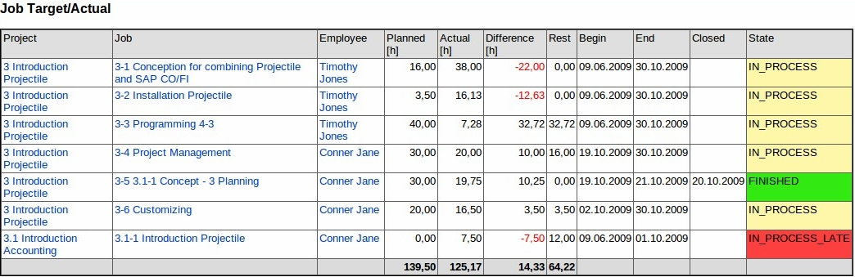
After closing the chart results, the project chart block is displayed once again.
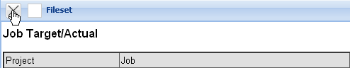
If the chart block is saved, the chart block can be used as a basis for time services or for charts in the background.
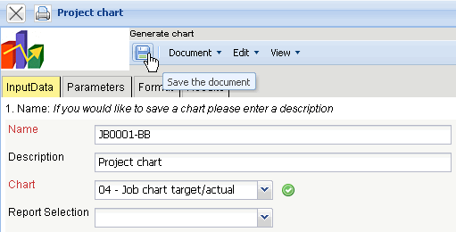
Using the  button, charts can be started in the background.
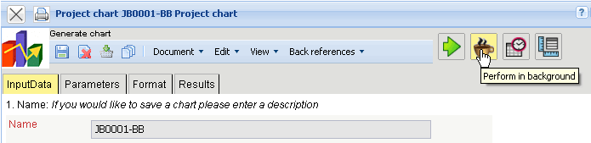
The user is informed of the background process by the system and displays ...
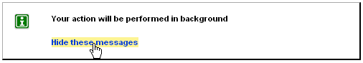
... an internal message as soon the chart results are generated.
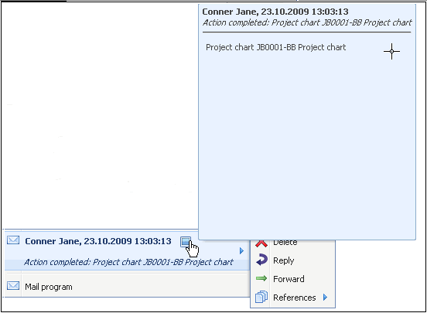
In the mailer a message appears and the user can use the link to access ...
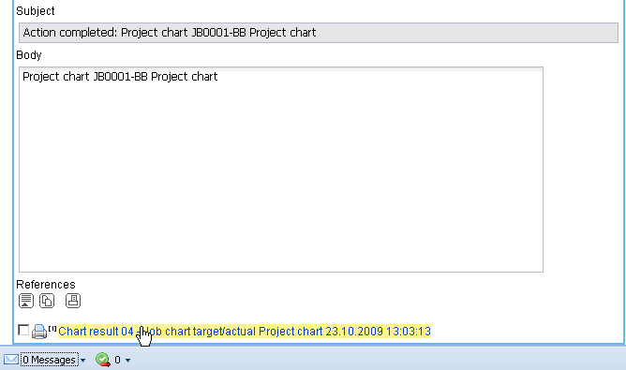
... the chart results.
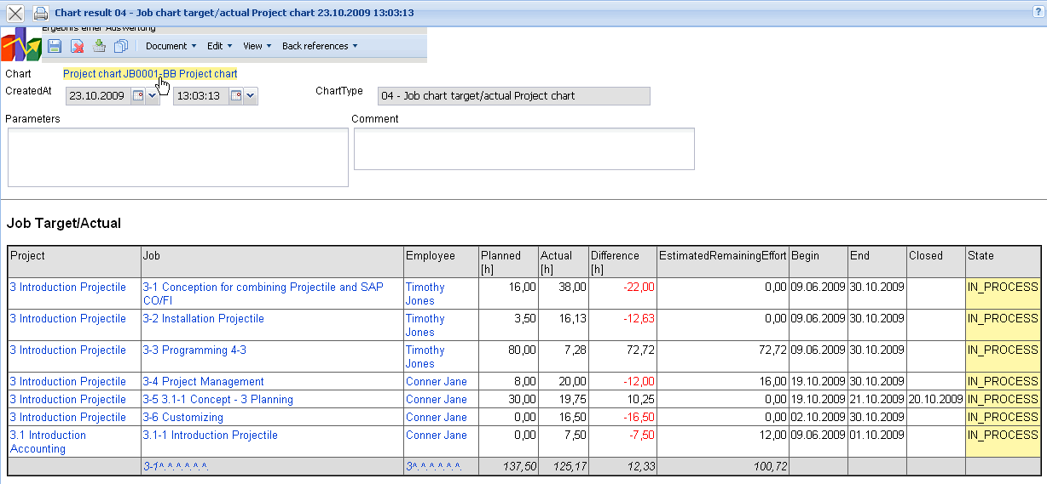
In the second example, the standard search engine for the selection of input data is used. Here, for example, all projects (selected category), which contain the term “Projectile” ...
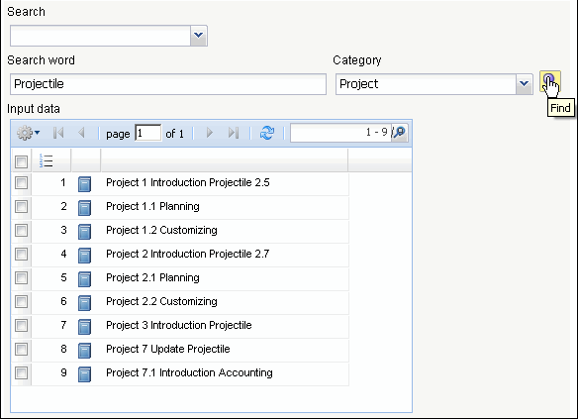
... are used as input data.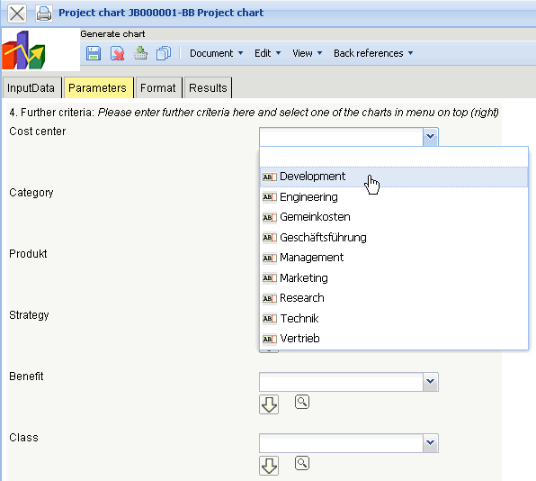
This process can be performed a multiple amount of times (with various categories).
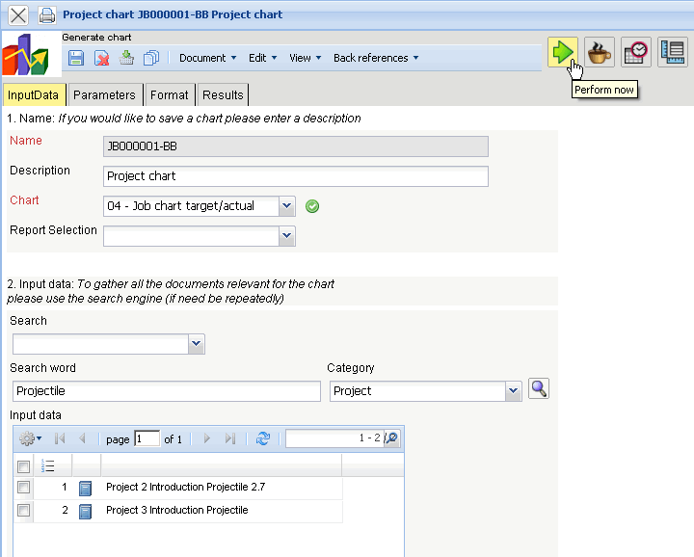
The third possibility to select the input data, is by using the advanced search. Here, appropriate queries are stored, which can be used immediately.
In the example, all top projects with the status “active” are transfered into the input data.
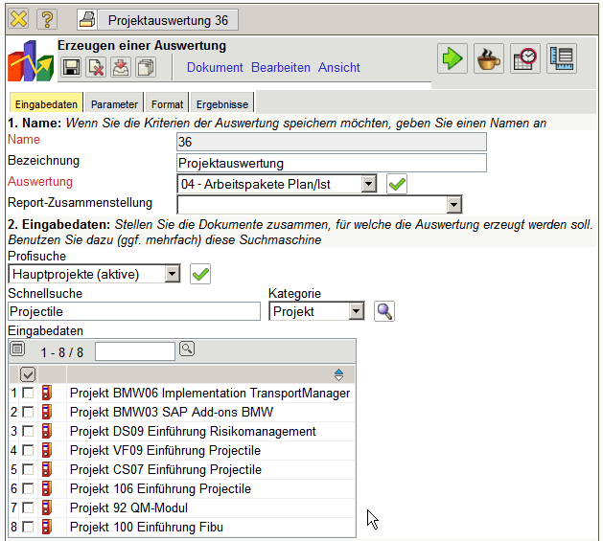
Then the view time span (3. Main parameters) and the further criteria are used (4. Parameters) to limit the results of the charts. These parameters include for example, the cost center of the project, the project type, project status, priority, and whether the project is an external order or not. The other options relate to filtering results.
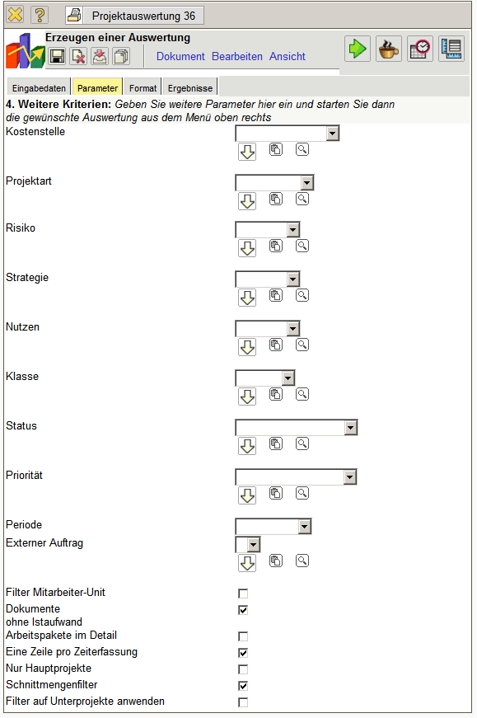
In the example, all projects are evaluated, which are assigned to cost center technology, the project type customizing or introduction are assigned, a necessary project or an optional project ...
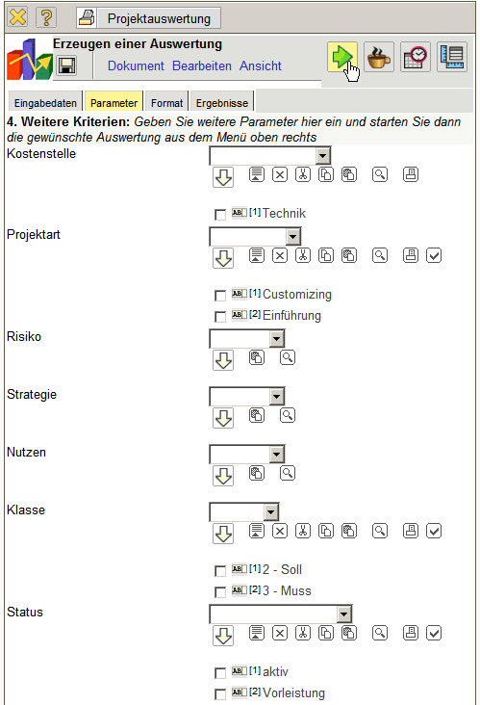
... and has the status active or advance services.
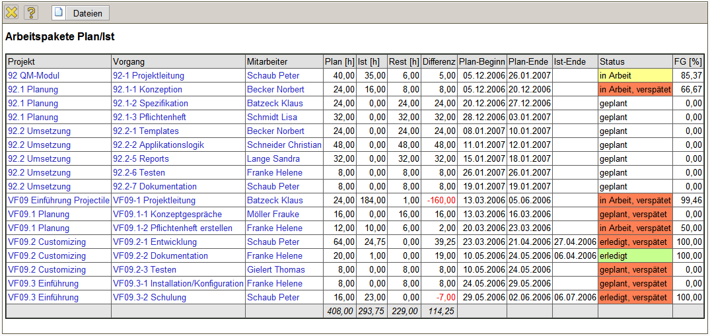
On the “format” tab (5. Settings for chart display), for example, the width of the images in pixels are selected and the diagram type is selected.
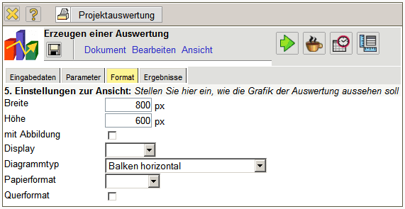
If alternative output formats are desired (by default, all reports are generated in HTML within the application) the output format can be chosen in the element “display”.
In the following example, the chart job plan/actual is generated with the illustration (diagram type “bar cahrt”) ...
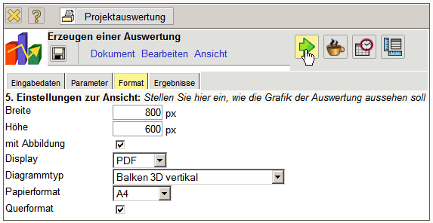
... with the pdf output format.
Depending on the system setting, the generated chart is opened in the browser ...
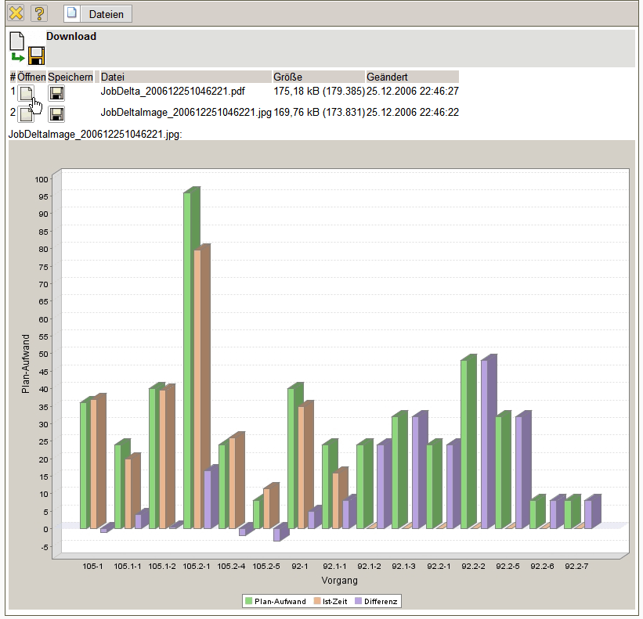
... or in the appropriate display program ...
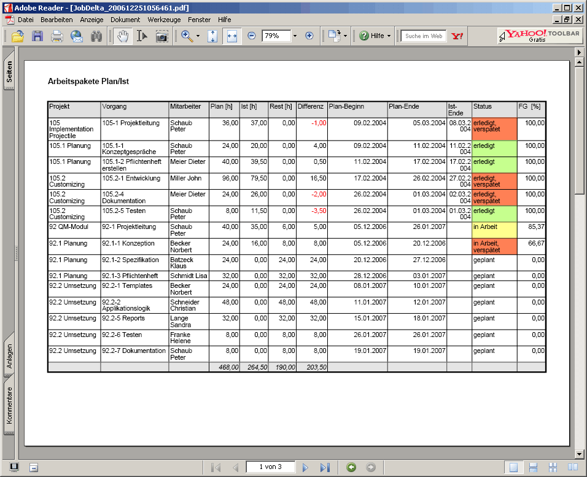
... (here with Adobe Reader).
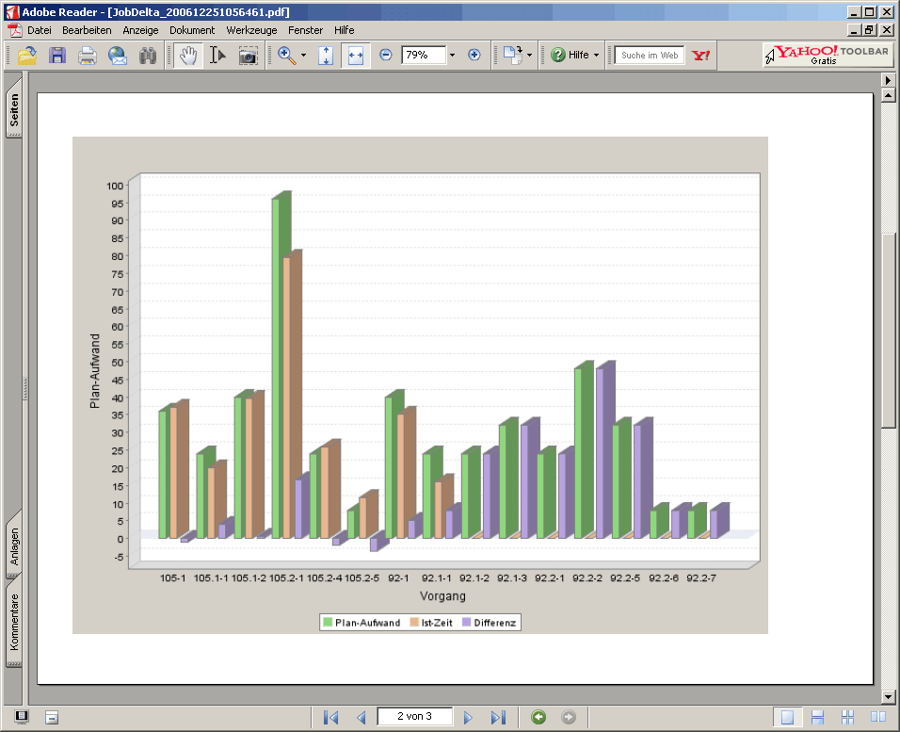
In the “Results” tab, the chart results are administered.
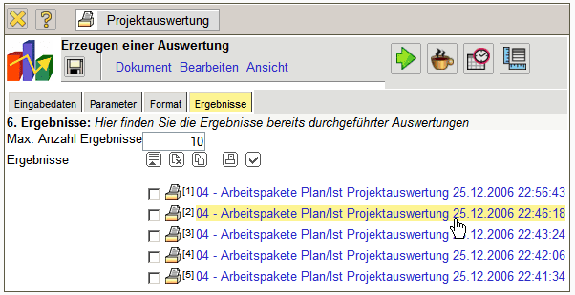
Notes: The chart results are stored permanently only if the chart block is stored. The number of results in the field “Maximum number of results” can be set.

