3.12.08 Project Chart
The project chart implements the project-related charts. This includes the project overview chart, the work breakdown structure (project structure plan), target/actual comparison chart for projects and jobs, the milestone-trend-analysis chart, the visualization of degree of completion, time sheets and a skill matrix.
The following charts can be generated here:
- Project Overview Chart
- Project Structure Plan (Work Breakdown Structure)
- Project Chart Target/Actual
- Jobs Target/Actual
- Milestone-Trend-Analysis
- Degree of Completion Chart
- Skill-Matrix

Project Overview Chart
This chart generates an overview of the most relevant key figures of the project. Here, the plan and actual time/effort and incurred costs/revenues are displayed as planned and actual values for the projects and sub-projects. Additionally in this chart, offer values and invoice values as well as degree of completion of projects and sub-projects are listed.
The planned costs specify the internal cost which are based on the planning data of the jobs and from the budget administration. The internal costs are determined from tracking and recording (TimeTracker) and cost recording. The project budget is, if necessary, defined in the project and the planned revenue is calculated from the external evaluation of the jobs and budget administration. The external revenue specifies all billable services in the system (time and costs).
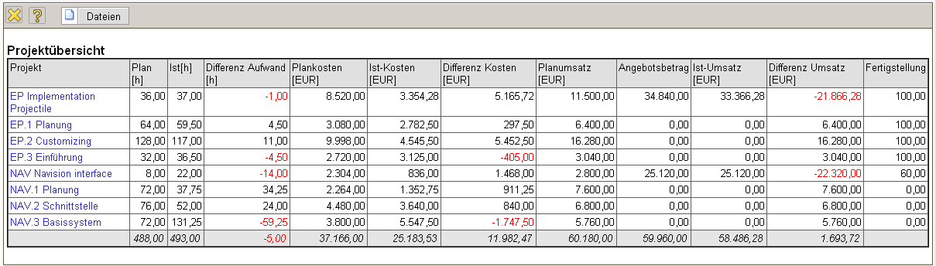

Project Structure Plan (Work Breakdown Structure)
The Work Breakdown Structure diagram illustrates the project structure. The Work Breakdown Structure (project structure plan) in Projectile displays the relationship of the project and the sub-projects with the corresponding jobs. The logical structure of the project (project structure/project hierarchy) down to the jobs level is visualized graphically. This chart also contains important planned and actual data of the projects, sub-projects and jobs.
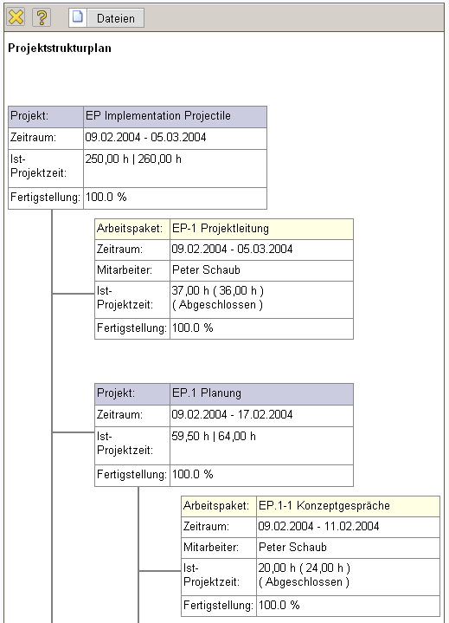

Project Chart Target/Actual
The project chart target/actual provides an overview of the work services of the individual projects including the corresponding sub-projects. The target times and actual times for the project are displayed as a diagram and as a list. The planning data is determined directly through the assignment of the jobs to the project or sub-project and the actual times are used through tracking and recording in TimeTracker.
The chart also contains information for planned-start and planned-end, of the project status and the estimated degree of completion.
The chart can display the planned data and actual data graphically, if the option “with image” (format tab) is set.
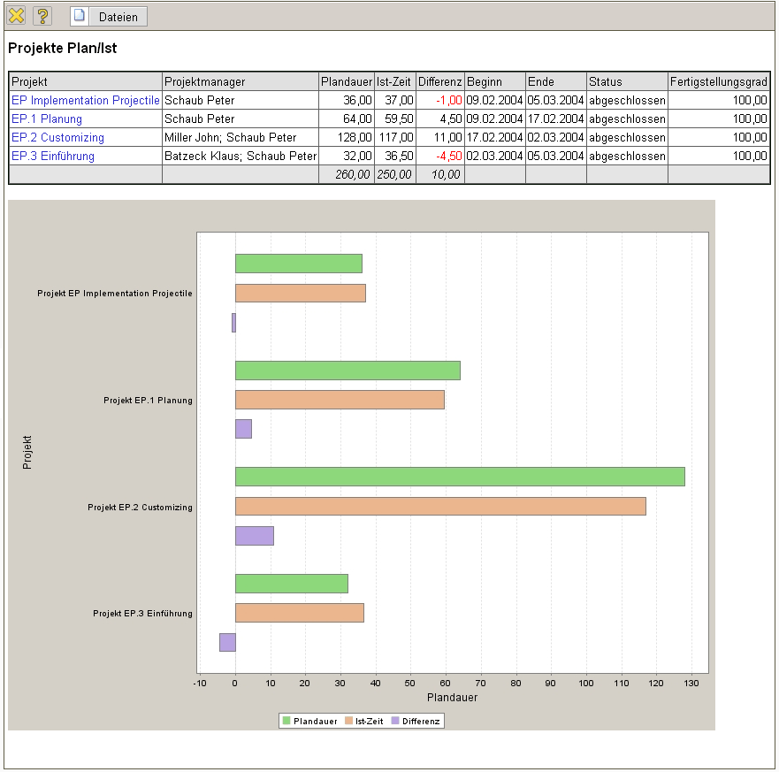

Jobs Target/Actual
The chart jobs target/actual provides an overview of the work services of the individual jobs of the selected projects. The planned times and actual times for the work packages are displayed as a diagram or as a list. The planning data is determined through jobs and the actual times are used through tracking and recording in TimeTracker.
The chart also contains information for planned-start and planned-end of the jobs, of the status (including the due date) of the jobs and the estimated degree of completion through TimeTracker.
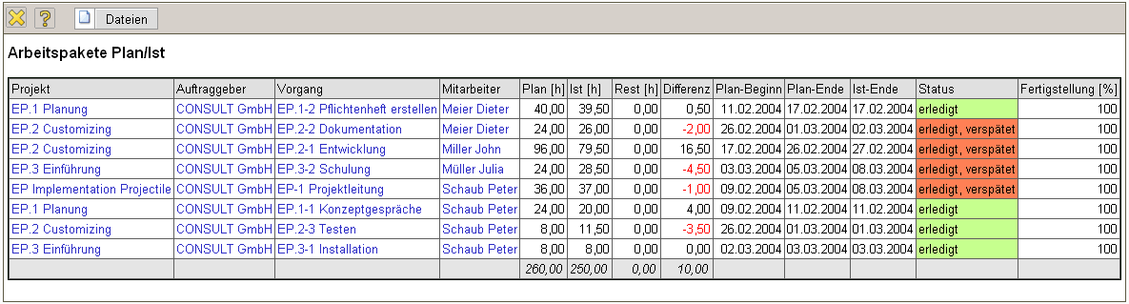
The chart can display the planned data and actual data graphically, if the option “with image” (format tab) is set.

Milestone-Trend-Analysis
The Milestone-Trend-Analysis (MTA) chart displays trends for completing the defined milestones. The milestone-trend-analysis is a future-based instrument used for controlling deadlines of a project: On regular reporting dates, the project scheduling is estimated through a query of trend data for the probable time of achieving the objective.
Die Auswertung Meilenstein-Trend-Analyse zeigt die Trends für die Erreichung der definierten Meilensteine an. Die Meilenstein-Trend-Analyse ist ein zukunftsbezogenes Instrument für die Terminkontrolle eines Projektes: An regelmäßigen Berichtszeitpunkten wird die Terminplanung des Projektes durch die Abfrage von Trenddaten der voraussichtlichen Zielerreichung neu geschätzt. Aus dem Kurvenverlauf läßt sich ein Trend über die Termintreue des Projektes ableiten. Die Trendtermine für die Meilensteine können im Dokumenttyp Trendtermin verwaltet werden.
Der Verlauf der Kurven dieser Analyse wird wie folgt interpretiert:
- steigender Kurvenverlauf bedeutet eine Verzögerung => Das Meilensteinziel wird/ist verspätet erreicht,
- Kurvenverlauf waagerecht bedeutet Termintreue => Das Meilensteinziel wird/ist rechtzeitig erreicht und
- fallender Kurvenverlauf bedeutet: Das Meilensteinziel wird/ist verfrüht erreicht.
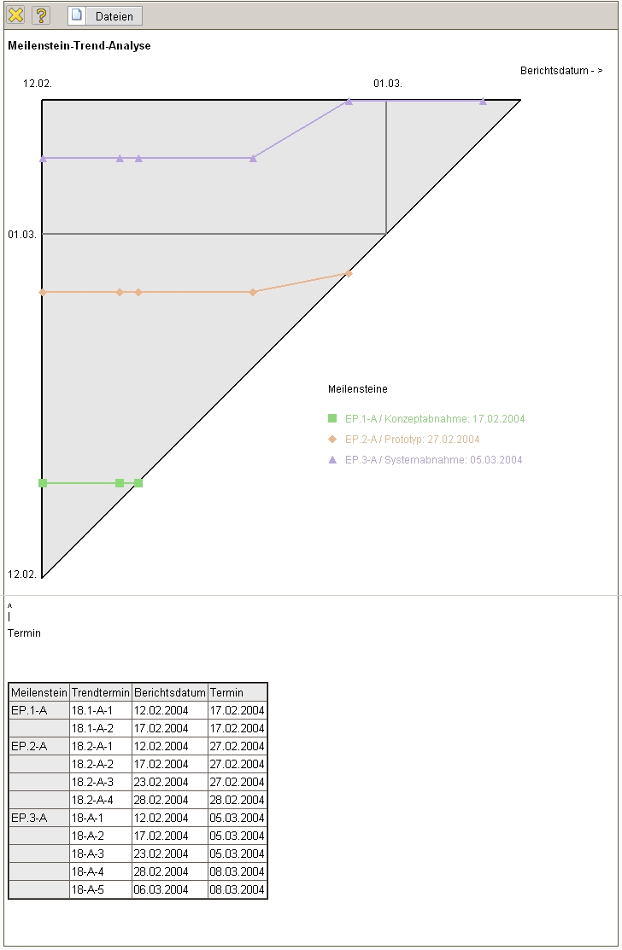

Fertigstellungsgrad
Die Auswertung Fertigstellungsgrad zeigt eine graphische Übersicht über die bisherigen Schätzungen für die Projekte und Arbeitspakete an. Diese Schätzungen können in den Projekten bzw. Unterprojekten oder im TimeTracker für die einzelnen Arbeitspakete vorgenommen werden. Weitere Informationen befinden sich im Abschnitt 4.2.7 Schätzungen.
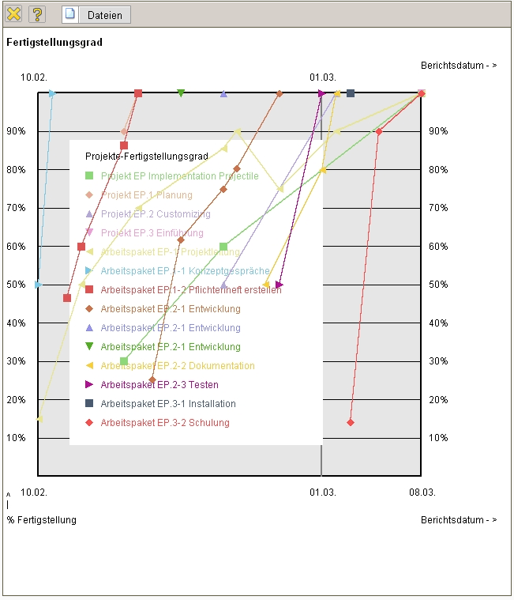

Skill-Matrix
Die Auswertung Skill-Matrix liefert eine Übersicht über die Projektleistungen für die selektierten Projekte und Unterprojekte in Bezug auf die einzelnen Tätigkeiten.


