3.12.06 Employee Chart
The employee chart includes the employee-evaluation charts and overviews regarding capacity utilization and capacity. These include general overviews, time sheets and occupation sheets, plan/actual comparison, capacity utilization and capacity charts and overviews of absences (vacation, illness, ...).
Here, the following charts can be generated:
- Employee Overview
- Time Confirmation
- Occupation chart
- Time Sheet
- Project Time External/Internal
- Presence-/Absence Charts
- Employee Evaluation Target/Actual
and the capacity charts (described in chapter Capacity Charts):
- Capacity Utilisation Evaluation I, Capacity Utilisation Evaluation II and Capacity Utilisation Evaluation III
- Capacity Evaluation I, Capacity Evaluation II and Capacity Evaluation III
- Calendar Overview Evaluation I and Calendar Overview Evaluation II

Employee Overview
The employee evaluation chart provides an overview of the assignment of staff, project and occupation. Information of which employee is working at what time for which project is available here. This chart is based solely on the plan data (including start and end) of the Jobs.
The Time Confirmation chart, based on the actual data in the system provides the appropriate chart.
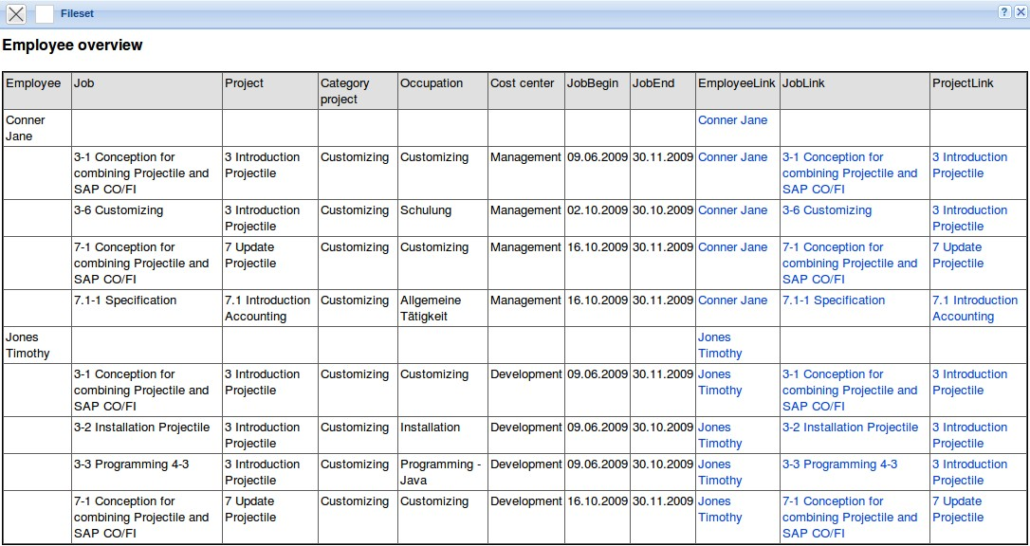

Time confirmation
The time confirmation chart provides an overview of the project services/items of the employee and a list of individual occupations with comments from time recording. This chart generates an overview of the total and individual time confirmation of an employee based on the recording in the TimeTracker for the Jobs of the employees. The chart is typically used for internal confirmation for controlling or as external confirmation for invoicing.
The Employee Overview chart, based on the plan data in the system provides the appropriate chart.
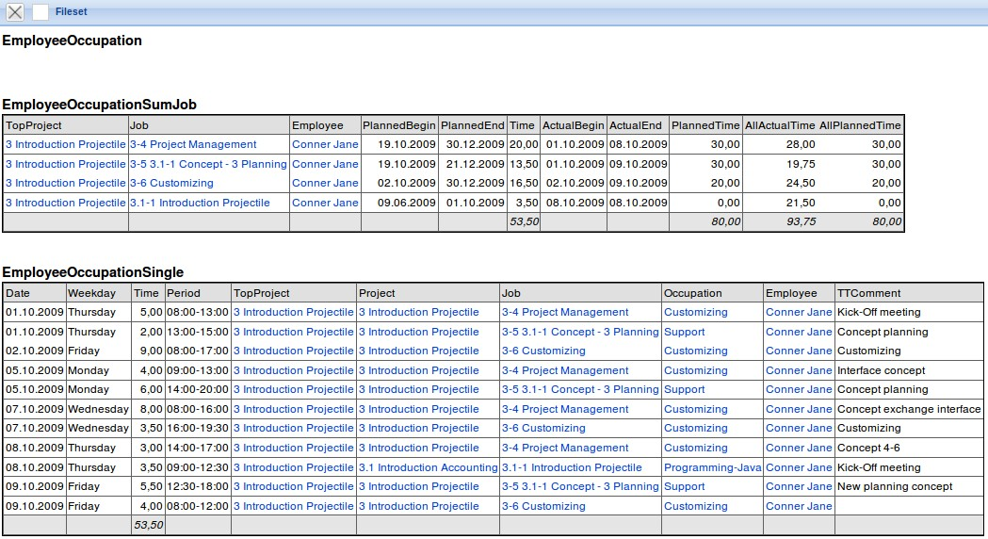

Occupation Chart
The occupation chart provides an overview of the project services and working hours of employees in the selected time interval. The project services are based on manual data entry in the TimeTracker for the Jobs of the employees. The working time data is entered in the TimeTracker as “come-leave” or can be determined automatically by the system with the help of an option as the sum of the project times. The absences (vacation, illness, maternity leave, ...) can be defined decentrally in TimeTracker or defined centrally in Absence Recording.
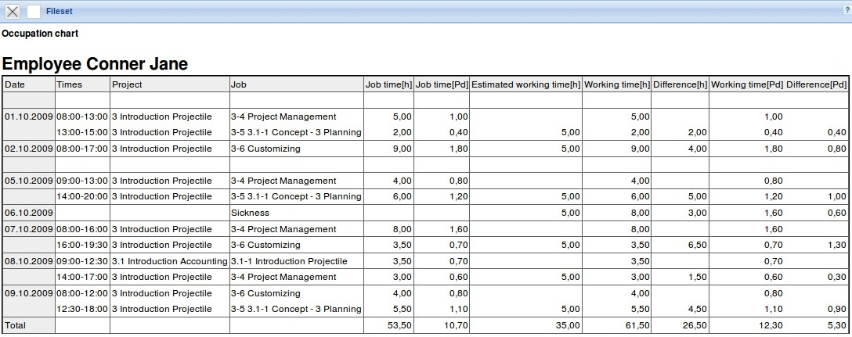

Time Sheet
The chart time sheet provides an overview of the project efforts and working hours of the employees in the selected time interval. The project efforts are based on the recording data in TimeTracker for the Jobs of the employees. The working hours are entered in TimeTracker as “coming and leaving” or they can be determined automatically by the system by using an option as the sum of the project times. The absences (holiday, illness, maternity leave, ...) can be defined either decentrally in TimeTracker or centrally in Absence Recording.
In contrast to Occupation chart the comments of TimeTracker are here displayed and the information of Working Time Administration (holiday accounts, illness and flexi-time) are listed. Optionally, the postings from the working time accounts and a listing of the posted jobs can be displayed.
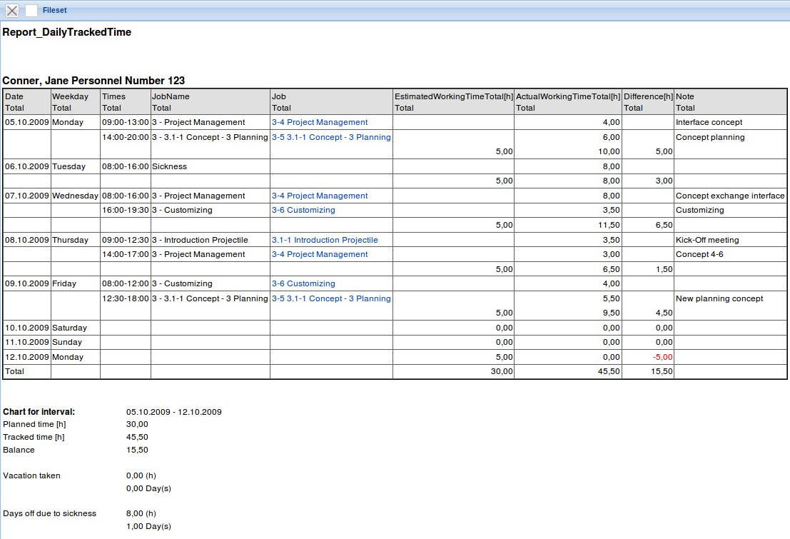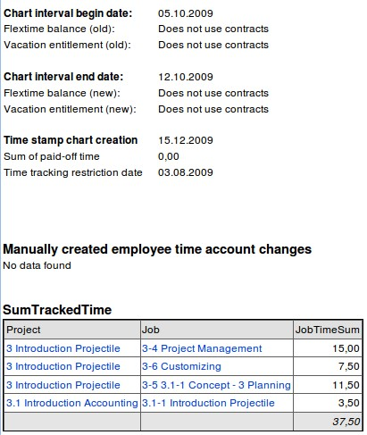

Project Time External/Internal
The chart Project Time external/Internal provides an overview of all relevant working hour information of the employees in the selected time interval. In addition to this information, further information are also provided from the Billable Time, the Invoice and the Travel.
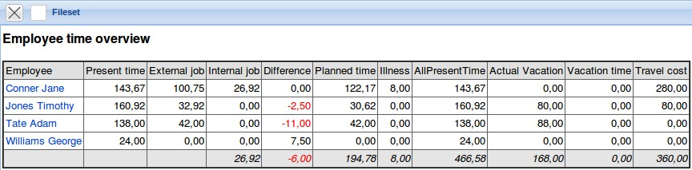

Employee Plan/Actual
The chart Employee Plan/Actual provides an overview of the planned and the achieved project efforts and working hours of the employees in the selected time interval. By using this chart, the proportion of project time to working hours (column capacity) can be illustrated. The capacity refers to the “net-working hours”, i.e. working hours without the absences.
The chart can also illustrate the 'plan and actual time' graphically, if the option is set “with image”.


