3.12.05 Contact Chart
The contact chart provides an overview of all contact data in the system. Here, all actions are displayed using the defined selection criteria (for example, all uncompleted business contacts). In this chart, all contact data ( employees, customer, contact person, and telephone number of the contact person) and the action data ( action, project, comments on the actions, closing key figures and creation date) are listed.
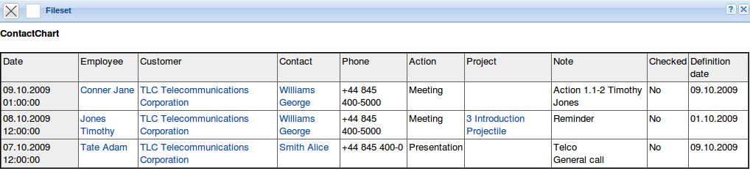
Tip: As an alternative to this chart, a query using the ReportDefinition is stored on the intro screen, to immediately access all resubmissions. The query “Action : ( ( Checked = “0” ) AND ( ( ( Employee.Name LIKE $userlastname ) AND ( Arranger -> Employee ) ) AND ( DueOn <= $Datum ) ) ) SORT DueOn DESC” displays a list for the logged on user ...
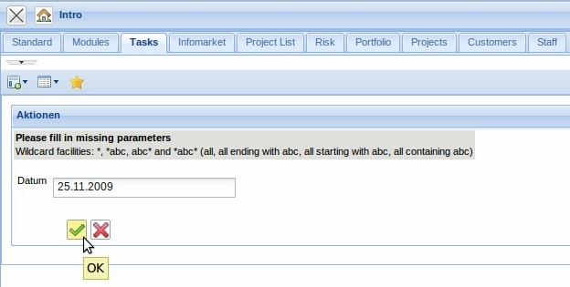
... of all open actions for the entered due date:


