3.12.04 Capacity Chart
The capacity chart contains the charts and overviews regarding utilization, capacity and calendar. These include general overviews, capacity utilisation and capacity charts and calendar overview charts.
The following charts can be generated:
- Capacity utilisation evaluation I
- Capacity utilisation evaluation II and Capacity utilisation evaluation III
- Capacity evaluation I
- Capacity evaluation II
- Capacity evaluation III
- Calendar overview evaluation I und Calendar overview evaluation II

Capacity Utilisation Evaluation I
The Capacity Utilisation Evaluation I chart generates an overview of all tasks of the employees, which are employee-related and lists them according to the priorities. That is, in this chart variation, the processing periods of jobs are partially ignored (if the employee has no task for the time period, the next job is chosen). The prioritization of projects is higher than the priority of the individual jobs. Jobs without a project have the lowest priority. In this chart, all already recorded times, holidays and absences of employees are taken into account. Furthermore, it is displayed, when the employee will be finished with the tasks planned for him/her, if all jobs are consistently processed one after the other.
This applies to the calculation of the period:
When degree of completion is recorded: The estimated duration of the job is assumed to be the total time. The remaining work time for the job is calculated as total time - total time * degree of completion. The following applies: if no duration for the job is specified, the plan for this employee is canceled and the a message is displayed.
When jobs are recorded: Should additional degrees of completion be recorded, the total time is: the sum of recorded times/degree of completion and the remaining time = total time - sum of recorded times. If no degree of completion is recorded, the estimated duration of the job is used as the total time and the remaining time is calculated as total time - sum of the recorded times.
If no duration for the job is specified, the plan for this employee is canceled and a message is displayed.
Note: Unlike the variants II and III, this chart does not take into account the planned periods of work packages! This chart is used for disposition of employees without any assignment to projects (for example, for support).
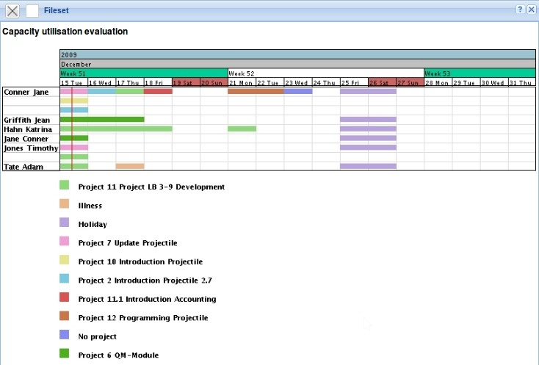

Capacity Utilisation Evaluation II
The Capacity Utilisation Evaluation II chart generates an overview of all tasks of the employees, which are employee-related and lists them according to the priorities. In this variant, the priorities as the first level are ignored and the plan period is considered as a criterion of the sequence. A further difference to variant I is information is displayed, when the tasks due to lack of capacity can not be completed on time.
Note: The algorithm of this analysis is described in capacity evaluation I.
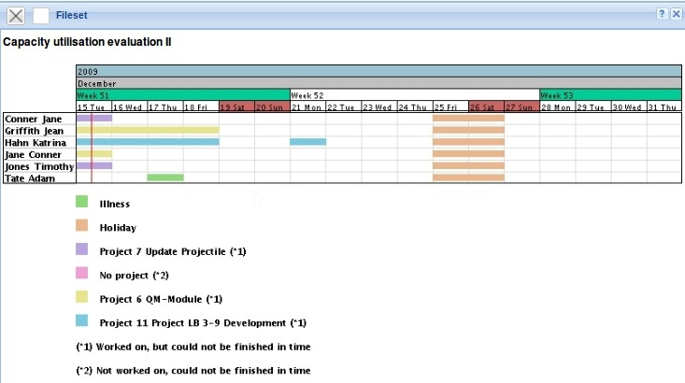

Capacity Utilisation Evaluation III
The Capacity Utilisation Evaluation III chart generates an overview of all tasks of the employees, which are employee-related and lists them according to the priorities.
In the first row of the employees the utilisation capacity of the employees are in three categories (red - overloaded, yellow - busy and green - normal usage). The threshold values can be set by the user (upper and lower capacity utilization capacity limit). In addition, the first row of each employee contains also the planned absences (in the example, holidays).
In the rows under the name of all employees, all jobs of the employees are displayed, in order to resolve resource conflicts by capacity overloads.
Note 1: The algorithm of this chart is described in capacity evaluation I.
Note 2: Periods without utilisation capacity or planned absences is for the evaluated employee absolute under-utilisation!
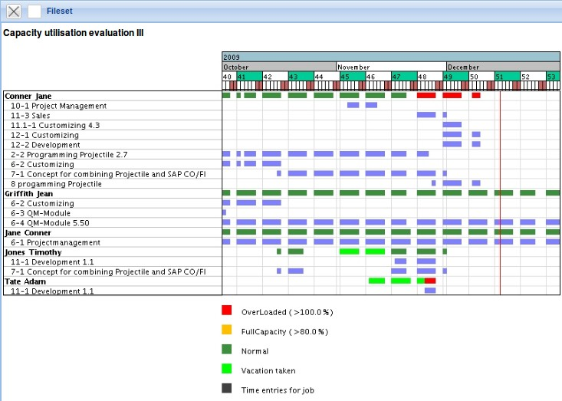

Capacity Evaluation I
The capacity chart I generates an employee-based list of all planned tasks of the employee. These holidays and the absences of the employees are taken into account.
The project periods resulting from the sum of all scheduled tasks of the employee during the view period. Determing the individual plan periods in the viewing interval, the plan times of jobs under the assumption of uniform distribution are determined. The actual times or remaining time/effort or degree of completion are considered.
The working hours resulting from the planned working time of the employee, taking into account the planned absences (vacation, sick leave, maternity, ...).
The maximum capacity is then the quotient of the planned project time and the scheduled working time in the given interval, under the assumption that the planned projects will also be active. The value of the probable utilization capacity also takes into account the project probability of the passive projects and plans the project times for these tasks only proportionally. The spare capacity is calculated as the difference between the maximum utilization of an employee (from the master data) and the maximum capacity utilization in the given period.
The chart can also graphically illustrate the planned capacity, if the option is set to “with image”.
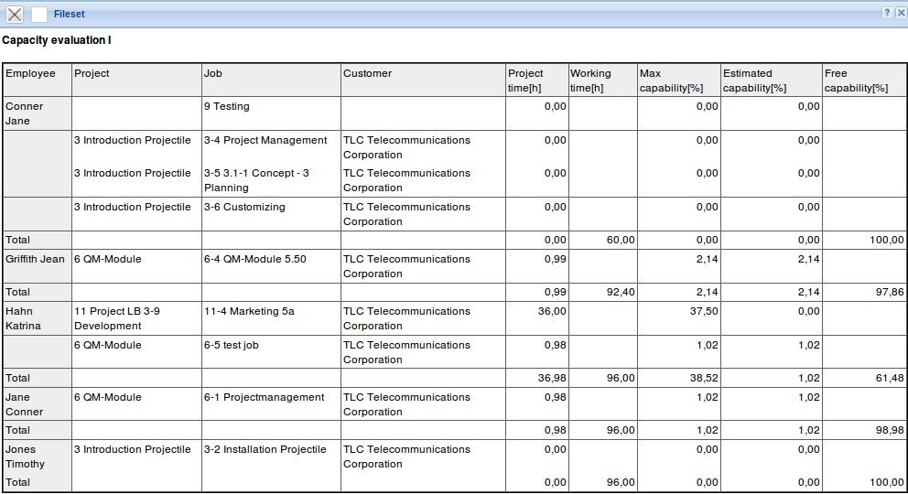

Capacity Evaluation II
The capacity chart II generates an employee-based overview of all planned tasks of the employee (in contrast to variant I) for any period in the given time span. In the tabular display, however, only the planned percental project times of the employee are listed of the periods. The periods can be selected by the user in the “Parameters” tab (default is weekly).
The project times and working times are calculated analogue to variant 1.
The chart can also graphically illustrate the planned capacity, if the option is set to “with image”.
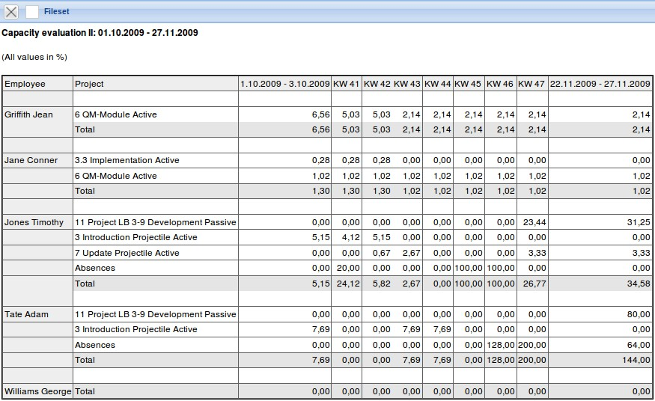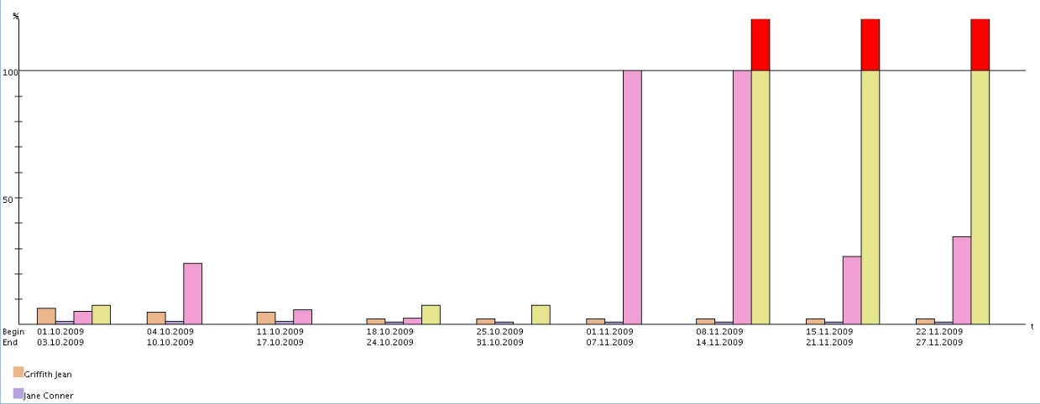

Capacity Evaluation III
The capacity evaluation chart generates an employee-based overview of all tasks of the employees (in contrast to variant I) for any period of the given time-span. In the tabular display, the planned absolute project times of the employee of the periods are listed. The expenses are multiplied by the system with the respective internal hourly rates and yield the projected cost per period, the planned expenditures with the external hourly rates resulting revenue. The periods can be selected by the user in the tab “Parameters” (default week).
The project times and working times are calculated analogue to variant 1.
The chart can also graphically illustrate the planned capacity, if the option is set to “with image”.
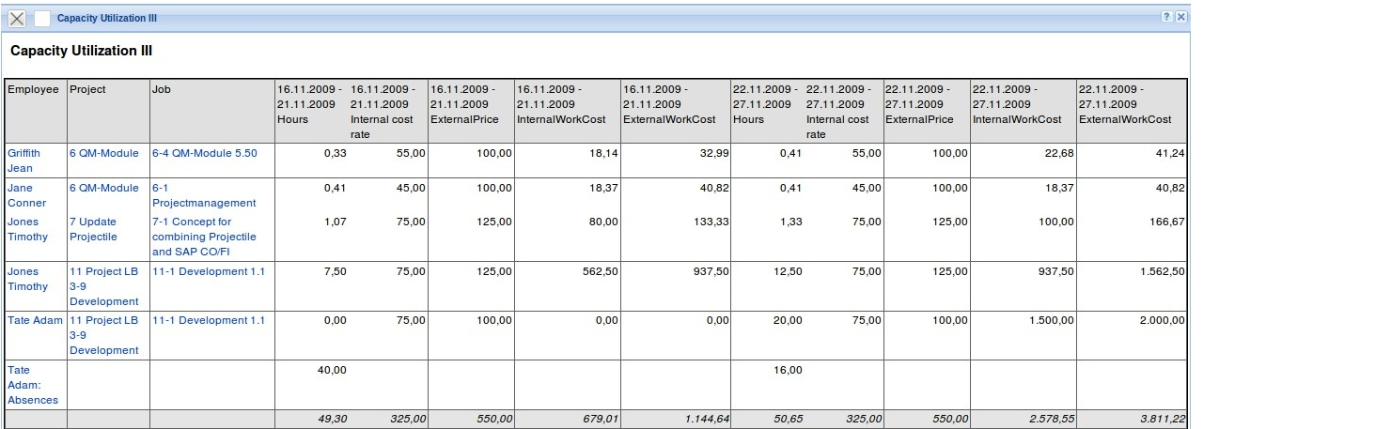
The following version is often made accessible for the project manager by the administrator (without internal and external rates, configured in the ReportDesigner):
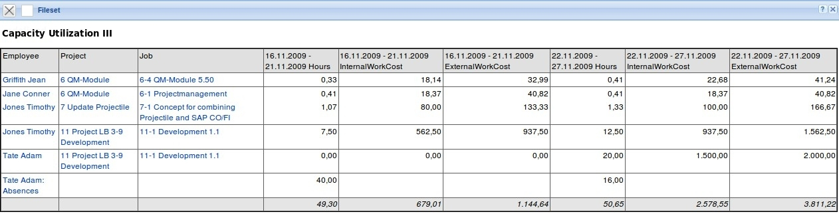

Calendar Overview Evaluation I
This calendar overview generates an overview of the presence and absence of selected employees of the given time span. This variant displays all absences (vacation, illness, maternity, ...).
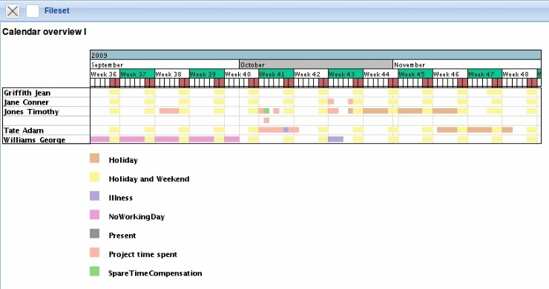

Calendar Overview Evaluation II
The calendar overview II generates a summary of the attendance and absence of selected employees during the period. This variant displays the absences only in general terms and does not differentiate in the absence types.


