3.12.02 Assessment Chart
The assessment chart generates financial charts in the system. These include, cost evaluation (planned/actual comparisons, budgets for costs and an in-depth cost chart), general assessment charts (offers, budgets, invoices, expenses, cash flows and profit contribution, including in-depth charts), overviews on billable and billed services, a list of open items and of result charts.
The following charts can be generated:
- Cost Evaluation and Cost Evaluation In-depth
- Commercial Invoice Evaluation and In-depth Commercial Invoice Evaluation
- Billed Time Evaluation and Invoiced Times (Projects)
- Result Evaluation
- Open Items
- Billable Project Times and Billable Customer Times
- Bonus Evaluation, finished and unfinished efforts, Internal Projects Evaluation (not in standard version)

Cost Evaluation
The chart cost chart provides a complete overview of the budget and the actual internal costs as plan/actual comparison. Here the budgets and costs will be grouped in cost types. The internal budgets specify the internal costs based on the plan data from the jobs and through the budget management. The (internal) costs are determined from time/effort recording ( TimeTracker) and costing.
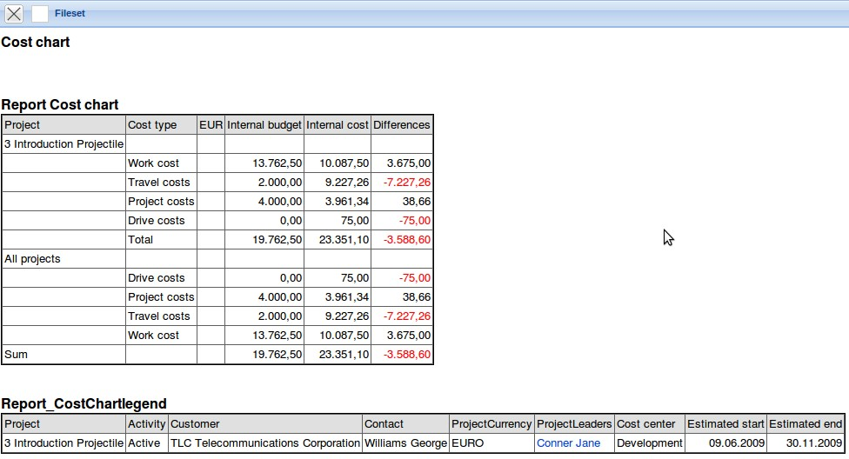

Cost Evaluation In-depth
The detailed cost chart provides a detailed overview of the costs of the chosen selection criteria. Here, the travel costs, driving costs, receipt costs, external costs, foreign invoices and working costs (on the basis of jobs) can be listed in detail. With other costs, the net amounts are displayed and with working costs the internal hourly rate of the employee is used to determine the working costs.
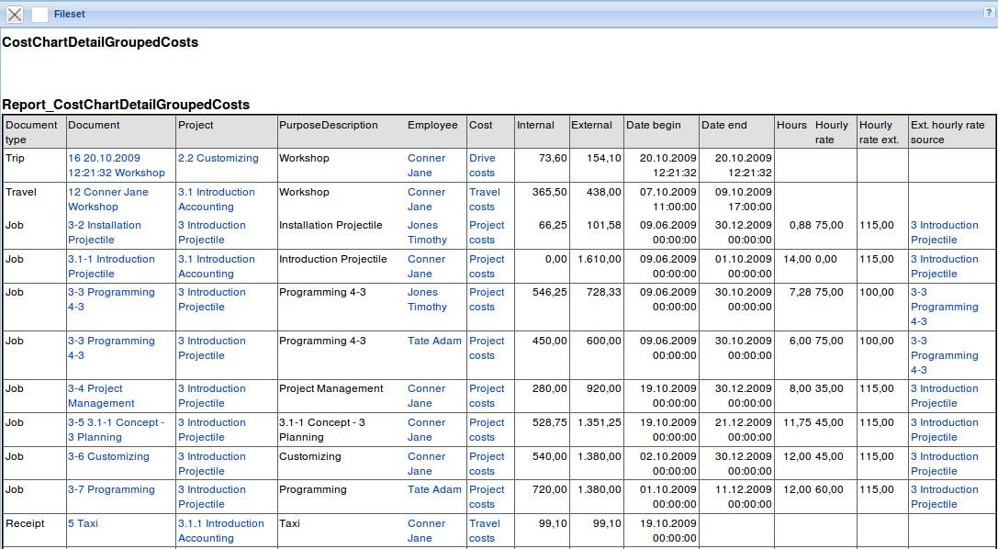

Commercial Invoice Evaluation
The commercial invoice evaluation chart generates an overview of all invoice data and of costing.
Invoice data: Here all offer values (external net/external total) and the internal offer values (offer based on these internal costs), the internal and external budgets (from jobs and budget management), the invoice amounts (external net/external total), and the internal invoice value (billable services), incoming payment and claim requests are listed.
Cost data: Here all direct costs from time and cost recording are listed: (travel costs, driving costs , receipt costs and foreign costs) and foreign invoices including outgoing payments and possibly, open liability.
For determining the working costs in the column “direct costs”, the internal hourly rates of jobs used in the order employee contract (internal hourly rate dependent on the contract; time dependent), employee (main data, which is not time dependent) and occupations (not employee-related).
The marginal return is as follows:
- DB I := Invoice (net) - direct costs - foreign invoice (net) and
- DB II := Incoming payment (net) - direct costs - outgoing payment (net).
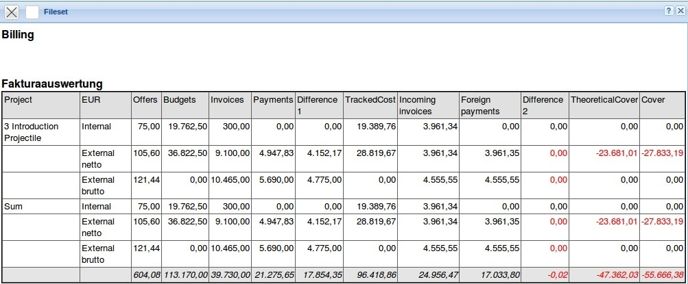

In-depth Commercial Invoice Evaluation
The chart In-depth Commercial Invoice Evaluation provides a detailed overview of the chosen selection criteria. Here, every position (offer positions, order confirmations, invoice positions, foreign invoice positions and cash flow) is listed in detail.
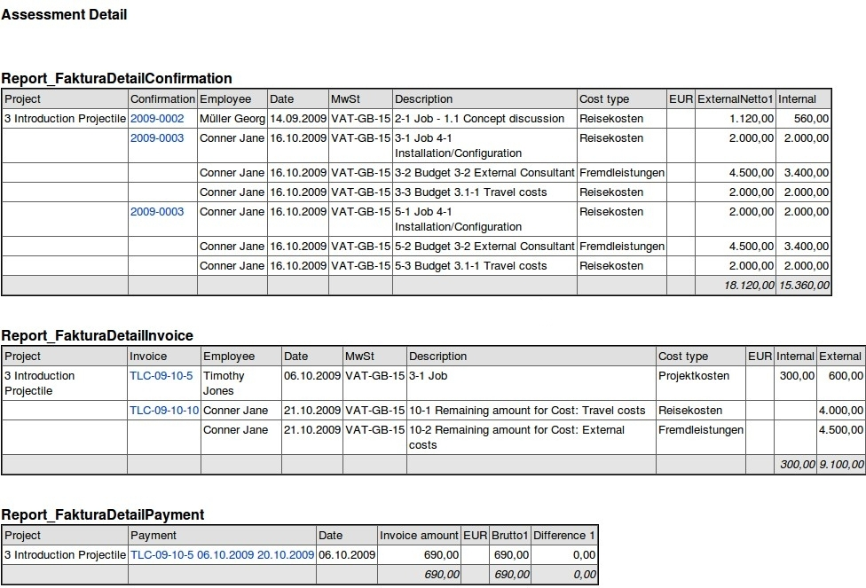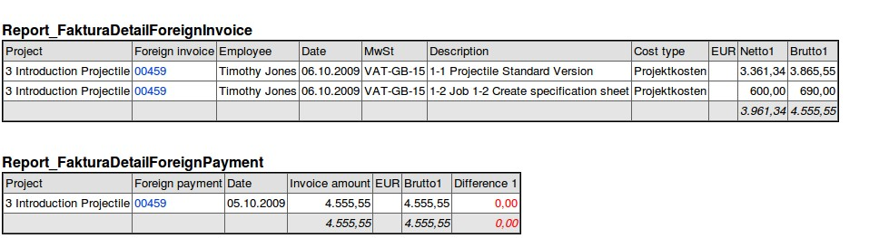

Billed Time Evaluation
The chart billed time generates a detailed overview of all planned, ordered, yielded, billable and project services already invoiced on the basis of the recorded and billed times. This chart is based on the jobs and determines the plan time directly from the tasks, the actual times from the time/effort entry (TimeTracker) and billed times from the invoicing data.
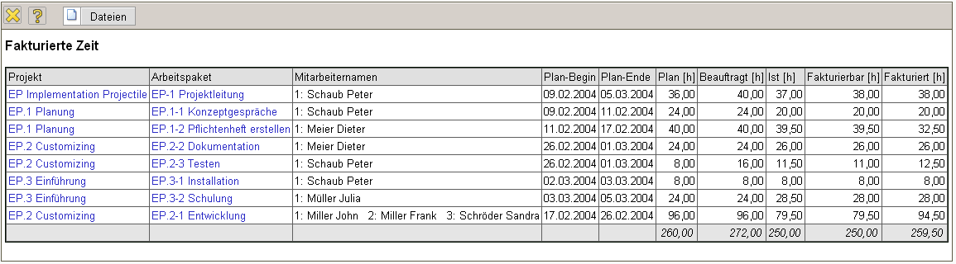

Invoiced Times (Projects)
This chart generates an overview of all planned, ordered, yielded, billable and project services already invoiced on the basis of recorded and billed times and costs. This chart is based on projects.
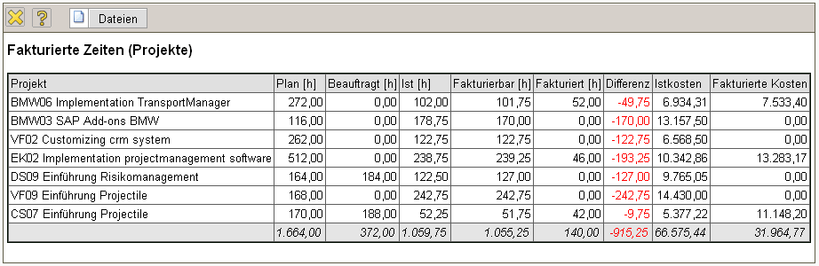

Result Evaluation
The chart result evaluation summarizes all internal costs and revenues and calculates the project result. If no restriction regarding the projects is defined, the overhead costs are taken into account and deducted accordingly. Determining the invoice values and actual costs is analogous to the commercial invoice evaluation.
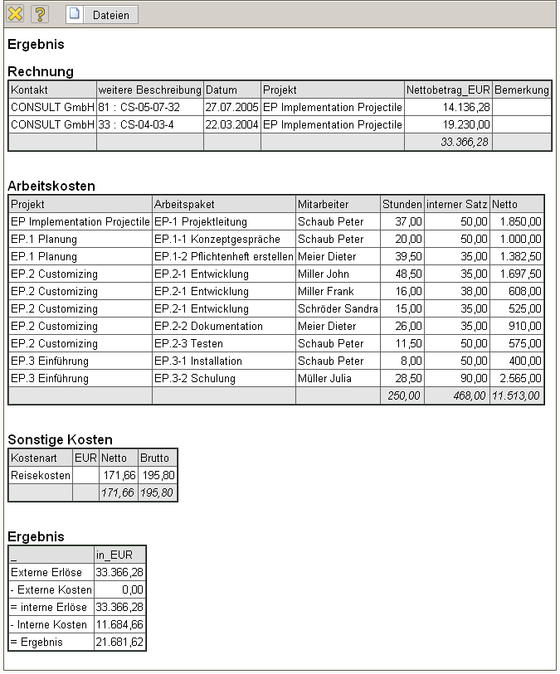

Open Items
This chart generates a list of all remaining (partial) open items. This list displays both the incoming payments as well as outgoing payments is still (partially) open items.
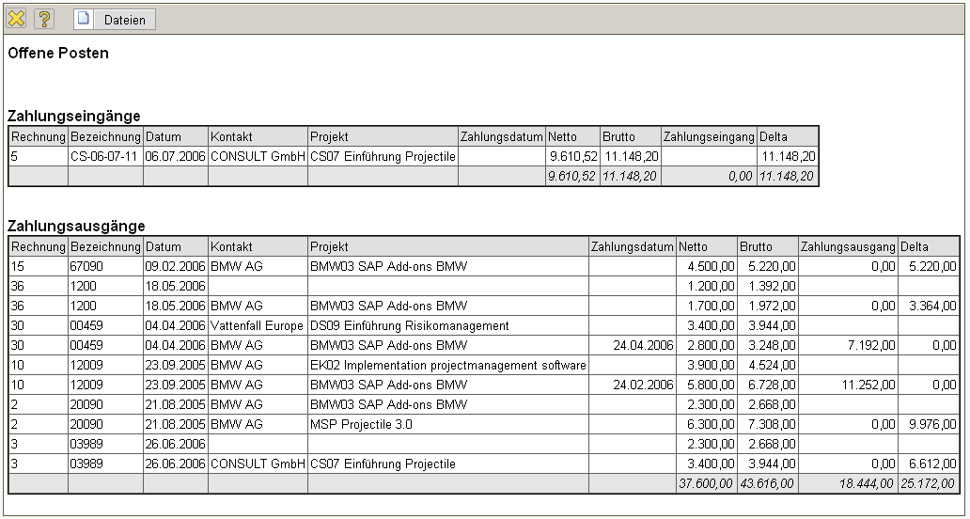

Billable Project Times
The chart billable project time generates a detailed overview of all recorded and billable hours. The actual time/effort comes directly from the TimeTracker, the values for the billable time either from the TimeTracker (if the option is active) or the functionality of billable hours. This variation lists the project times project-based and displays the individual time sheets with comments in the lower part.
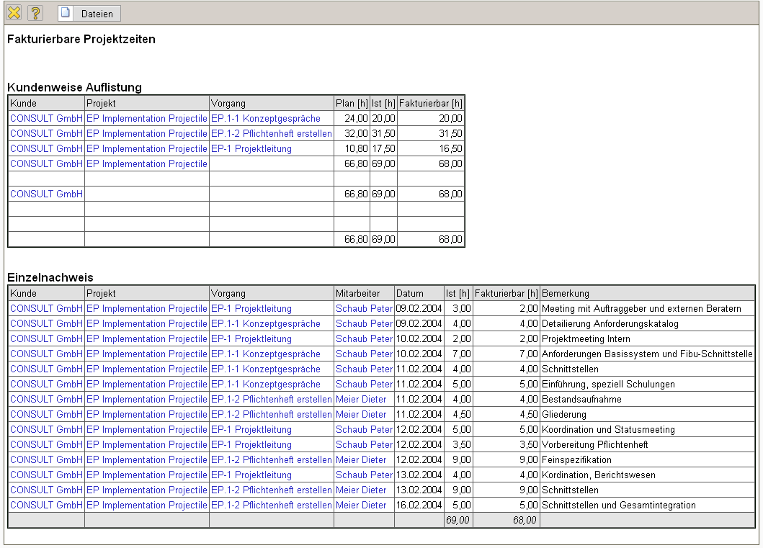

Billable Customer Times
This chart is a variation of the chart billable project times.


