3.11.09 Item Administration
Projectile offers optionally the possibility to administer foreign services or items and to bill this project-related. Assigning the foreign services or items to the project, can be performed in the document type item sheet.
When creating a new item or external service, various field are automatically pre-populated. In the standard version of Projectile the following fields are pre-populated:
- Item: Pre-defined with a consecutive number.
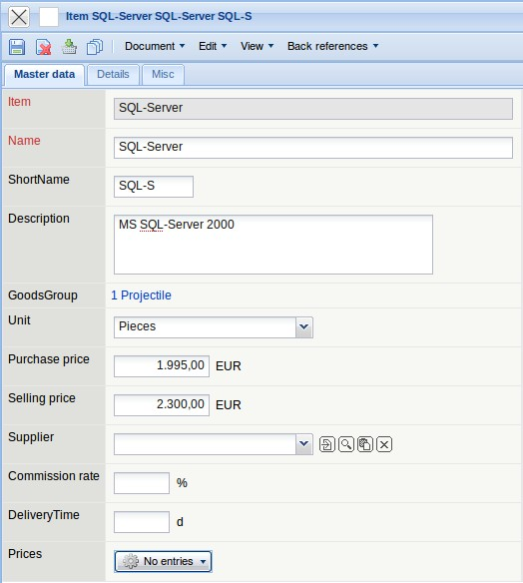
Required fields: Item, Name
Characteristics:
- The description of the item or external service is used from the field short name and name (long text).
- The category of the item can be used to classify the item or service.
- The purchase price which should be entered for the own products are internal cost accounting, the product costs or development costs. As a rough rule of thumb, the total development costs are divided through the planned sales volumn.
- The suggested retail price of the external services should be entered as the selling price without any deductions. This selling price is pre-defined in the document type item sheet and can then be modified.
- In the field “Stock” the stock of the item can be entered. When assigning the article to a project, the extracted quantity of the article is considered and automatically recorded from the stock.
- In the field Min. stock the smallest quantity of the item which must be available is entered.
Note:
External services can be administered using purchase/foreign invoice. This approach is recommended even if the cash flow ( incoming payments and - foreign payments) should be defined through Projectile.
The same external services should be either defined through external services or purchase/foreign invoice, so that the costs are not defined twice in the system.

Defining New Items
To define a new item, the functionality “Create” with the document type “Item” is applied.
After confirming the action a new document is generated.
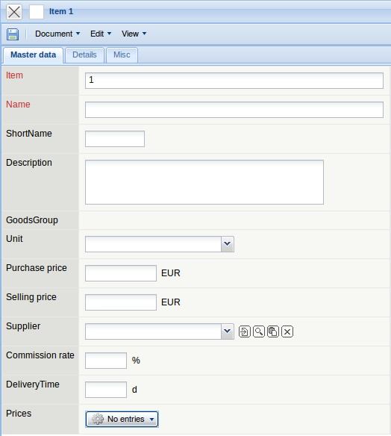
After all information is entered, the document is saved using . In the example a new item “QM-Module 1.2” is created. This “external service” is based on internal development, which should be sold at EUR 2.200,00 each. Here, the internal price/purchase price is the calculated rate from the product development.


