3.11.07 Working Time Administration (continued)

Administering Accounts
After defining the employee contracts, the working time administration is ready for use. The corresponding data for time accounts (working hours, holidays, special hours) are taken from the working time recording. The information from work time recording uses the conditions of the valid employee contracts by using the action “Create time booking”, which can be recorded at any given time.
In the following example, the time and vacation account of the employee Jean Griffith is edited. The employee was hired on 02.11.2009 and has entered the following times up to 16.11.2009 (or entered from another person when absent):
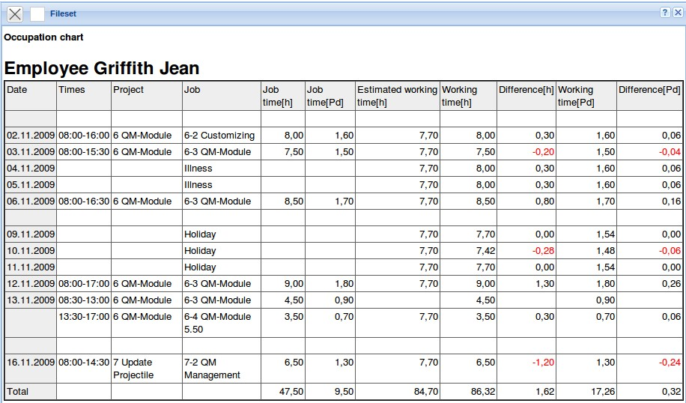
After activating the action “Recalculate time accounts” the dialog ...
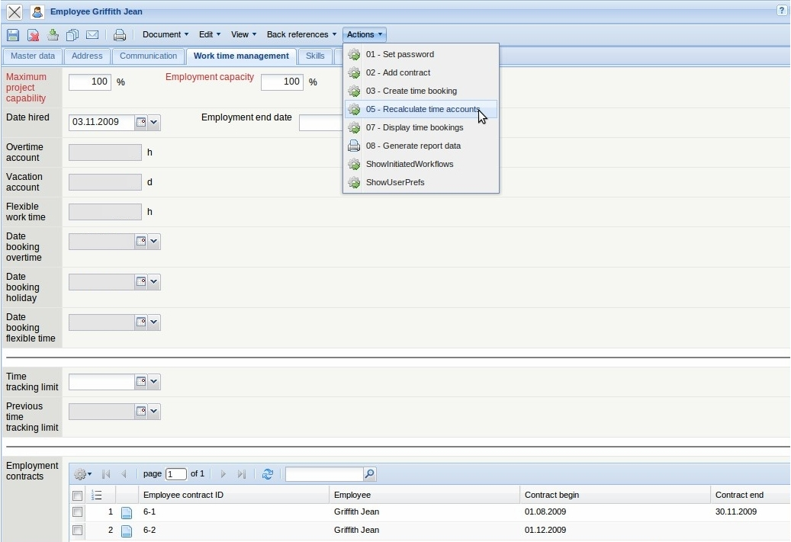
opens.
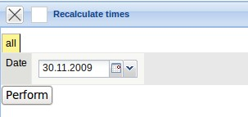
The date to be used for the recalculation is entered and after clicking “perform” the calculation is newly performed.
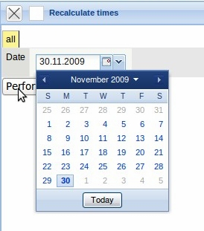
In the example: The employee Jane Conner (contract begin on 03.11.2009) has 28 days of vacation per year, no remaining vacation and one day of vacation recorded in the system.
The state of the vacation account for 03.11.2009 amounts to 8 days. The employee has accumulated 1,3 hours of overtime and no special hours up to the given deadline, i.e. the difference of the actual working hours between 03.11.2009 and 30.11.2009 is greater than the planned working time of the employee.
In the working hours administration, Projectile determines the target time of the employee, taking the defined holidays, the calendar and the deviations from the contracts into account.
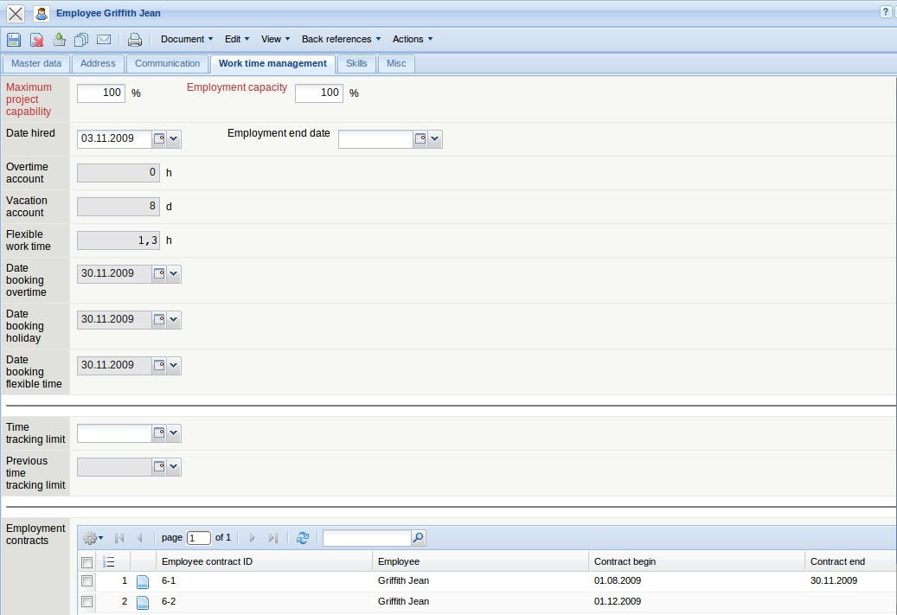
Note: After these entries are performed the time cannot be recorded for days before or on the posting date in TimeTracker or absence recording. If the time must be entered for the individual employees after these times have been posted, the time account for the employee must be deleted. After the new times entries have been completed, posting can be recalculated once again.
The working time administration is equivalent to a book entry system, which determines the account balance from the contract data and the tracking and recording data. Posting between the two accounts can be performed here. This function is used for example, by payment of vacation entitlement or overtime. Using the action “create time booking” ...
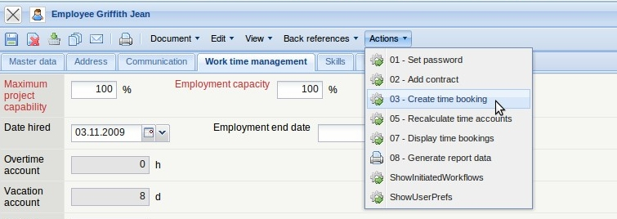
... the appropriate dialog is opened.
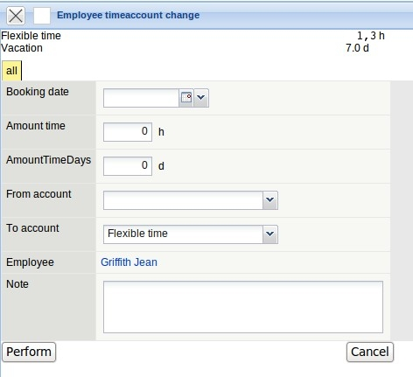
In the following example, an employee is paid 1 overtime hour on 01012009. This amount must then be debited from the flexible time account.
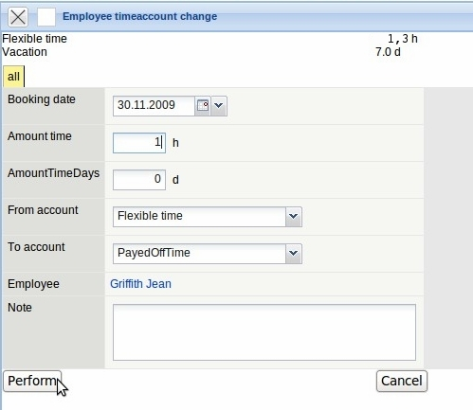
After clicking “Perform”, the flexible time account is reduce from 1,3 hours to 0,3 hours.
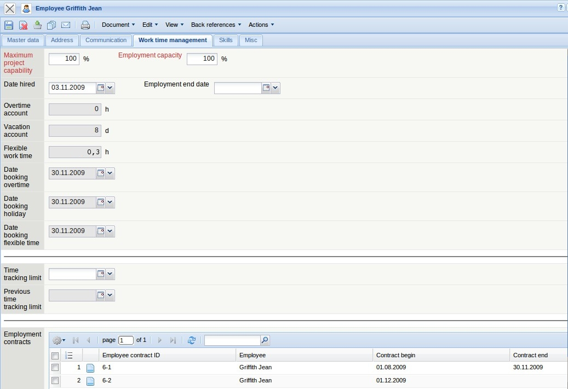
The individual posting can be displayed using the action “Display time booking” in ...
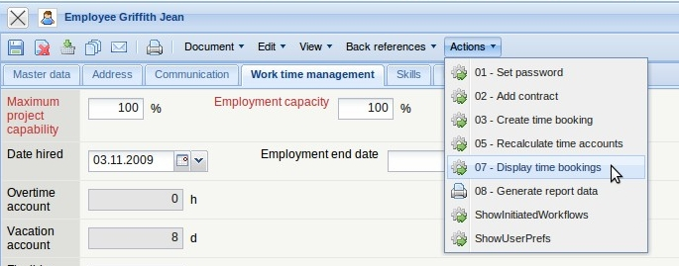
... a return list.
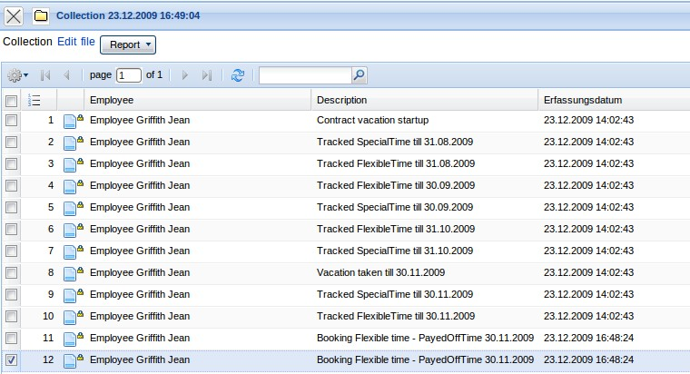
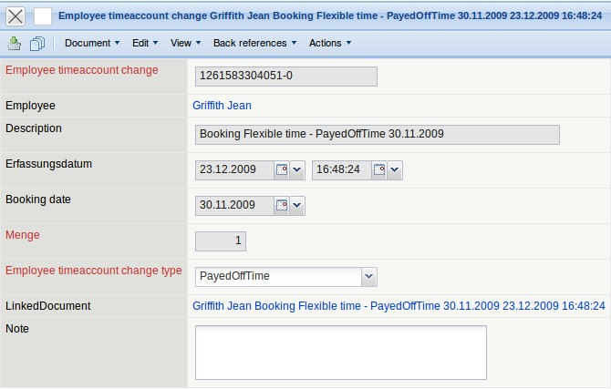
The account balance which refer to the accounts vacation, flexible time and special hours can be viewed centrally in a function. Each employee can check this data in the Time Tracker and thus has direct access to the remaining vacation entitlement and the overtime/undertime.
On the function bar in the menu item “Working Time Management”, the functionalities “Show Time Accounts” and “Book Time Accounts” can be performed.
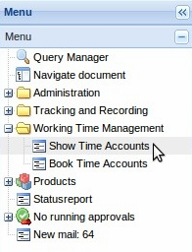
In the following example, for various selected employees,
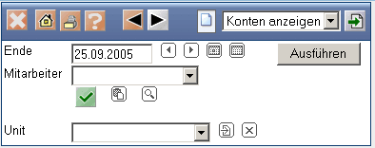
... the account balance for 01012009 can be displayed.
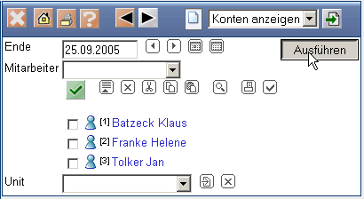
In the overview, the account balance for flexible time and vacation can be displayed for selected employees.
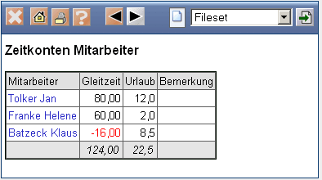
Posting time accounts can also be performed centrally for all employees. Using the timed action service, all posting for the employees can be performed periodically and using the functionality 'book time accounts“ posting can be performed manually.
In the following example, posting for a selected employee is performed on 01012009.
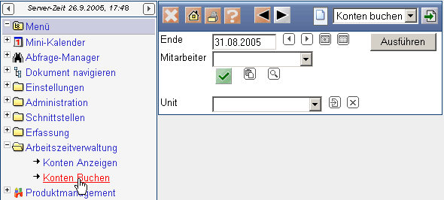
After clicking the “Perform” button, a dialog for ...
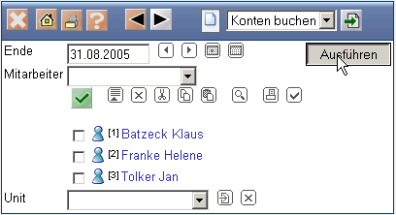
the posting status of each employee is displayed.
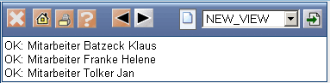
Note: If the stored date in the calendar “vacation entitlement expires” is reached, the excess amount of the annual vacation entitlement is cut off (the appropriate posting is created and recorded). The procedure for overtime or special hours is the same for which the limit of the permitted maximum is exceeded.

