3.11.06 Employee Administration
In Projectile, the employees are members of the project teams. The document type employee, administers information about employees, their access permissions in the system, and cost rates and cost accounting, overtime and vacation entitlement.
When creating a new employee, some fields are automatically pre-populated. In the standard version of the Projectiles these are:
- Active User: Pre-populated with “Yes”
- Employee Status: Pre-populated with the status fixed employee
- Location: Pre-populated with the location of the company
- Language: Pre-populated with the language of the location
- Country: Pre-populated with the country of the location
- Maximum Capacity: Pre-populated with 100%.
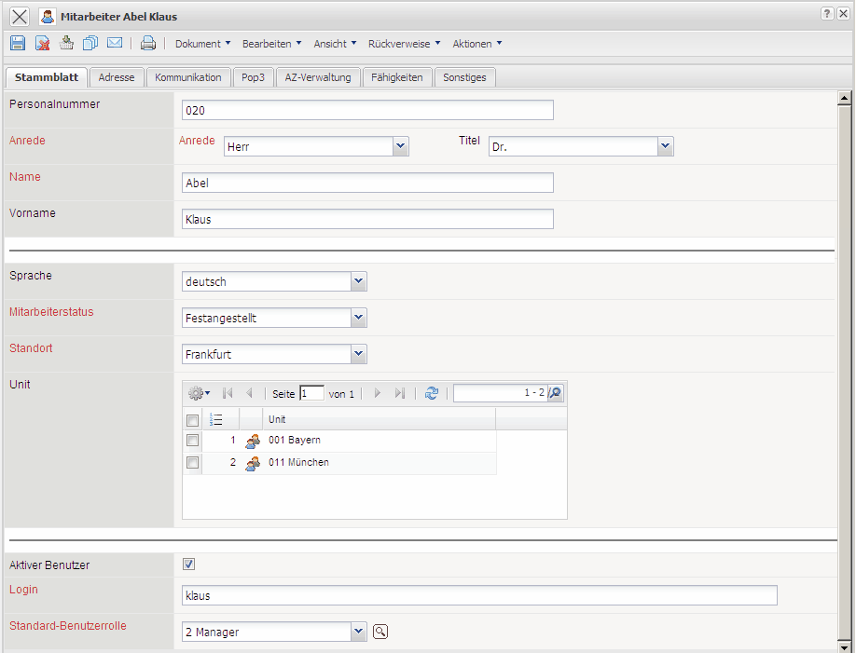
Required fields: Employee, user group, login, employee status, location, salutation, name, max. capacity, max. working hours
Characteristics:
- Only active employees (activity=“Yes”) can log on to the system.
- The occupations should be maintained so that the suggestion scheme has a reasonable foundation.
- The information in the charge rate field is used for internal cost accounting. If this field is not filled out, the system uses the internal hourly rates of the occupations for cost accounting. These internal hourly rates usually differ from work costs because the costs are directly influenced by the salary of the employees and not primarily by the occupation.
- The e-mail addresses should be filled out by at least the active users, so that the timed actions (mail messenger) can be used.
- Further elements and actions are described in working time administration.

Defining New Employees
The following example, a new employee is created. First, the functionality is activated using “Create” and with the selection “Employee”.
A new document is then opened with various pre-populated fields:
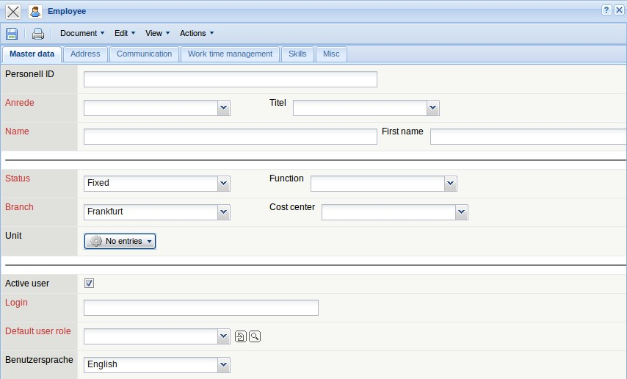
After all the information of the first tab is entered, the document is saved with 1). In the example, a new employee Jean Griffith has been newly created. This employee must be active (is able to log on to the system) and belongs to the user group manager (see also Administration Guide) and is assigned the login “jean”. The user must log in with this identification. The status “fixed” is required for costing and cost accounting. Here, salaried employees are considered, but external or contract employees are not (they are usually billed through foreign invoices). The language has not only informal character, but determines the language in Projectile.
After defining the fields on the tab “master data”, the document is then saved.
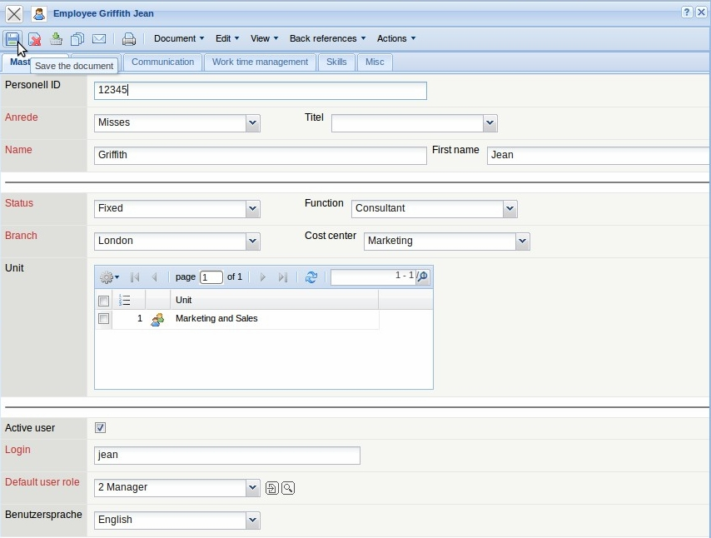
The employee's address can be entered on the “Address” tab:
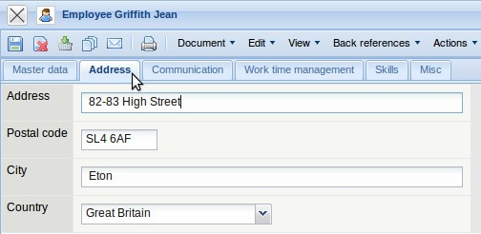
On the “Communication” tab, the telephone numbers for work, home and cell phone and the e-mail address ...
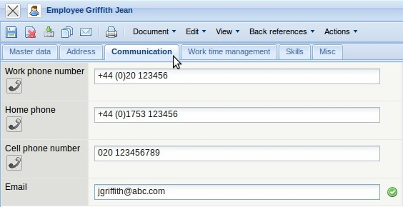
... can be entered for the employee and then saved.
The link to the e-mail address ...
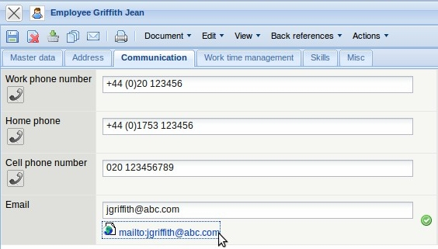
... open the standard e-mail client of the user.
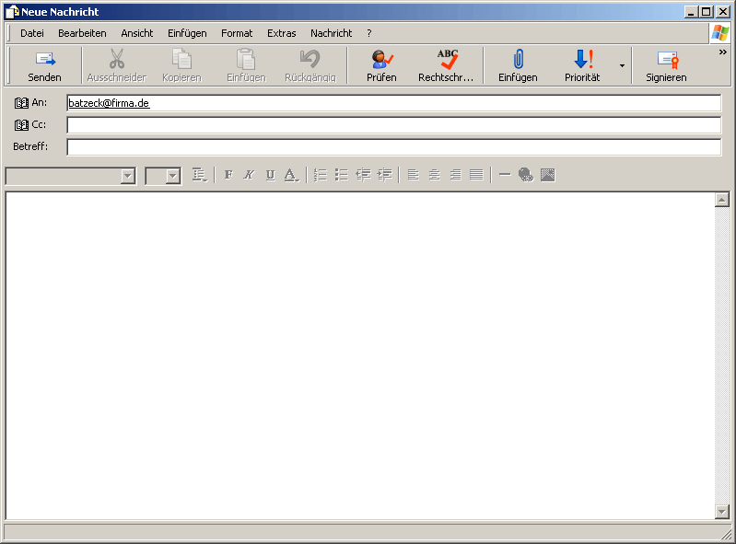
Falls das optionale Mailsystem mailer verwendet wird, kann auch aus der Funktionsleiste der Mailer ...
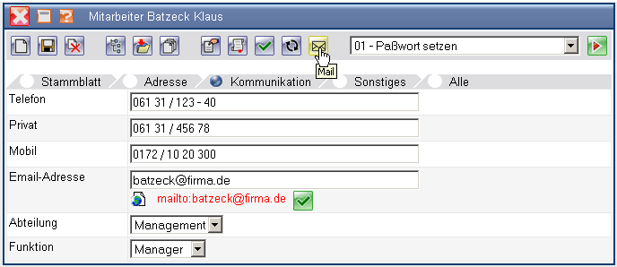
... mit der entsprechenden internen Mailadresse geöffnet werden.
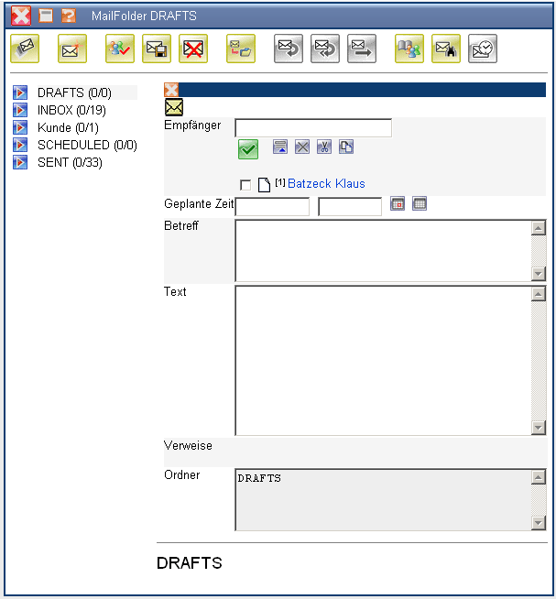
m Reiter “Sonstiges” können für den Mitarbeiter noch die Kostenstelle, die Ver- und Berechnungssätze, Kapazitäten und weitere Angaben definiert werden.
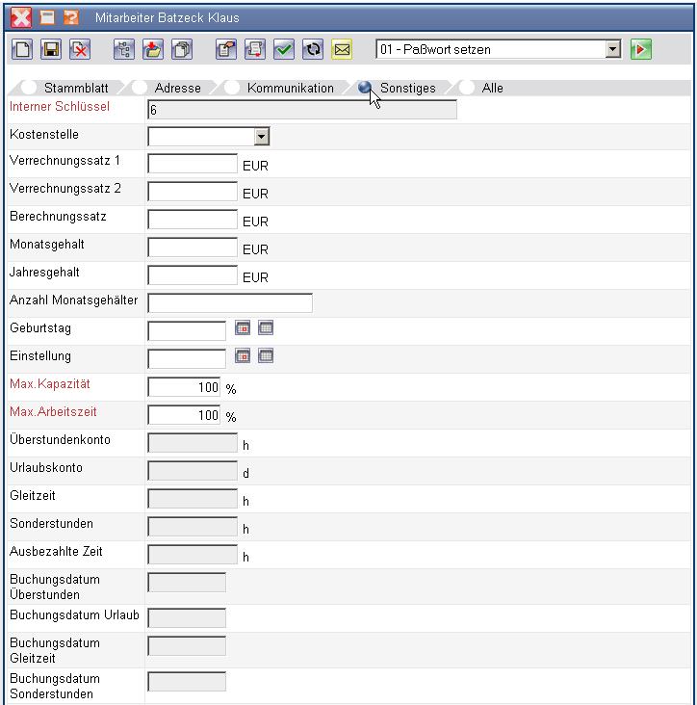

1)

