3.11.04 The Customer System (... continued)
For each contact person any number of actions can be defined. Actions can, for example be requests, appointments, reminders, etc. These actions will log important events with (history) and can furthermore be used for the acquisition and public relations.
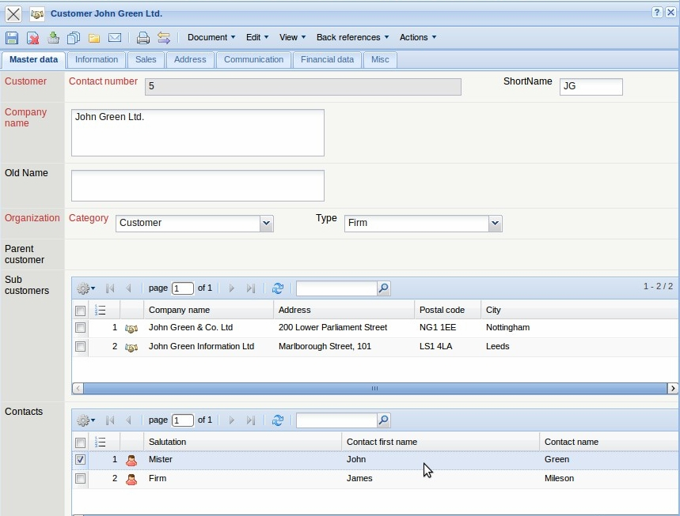
These actions are defined using the function “New document” in the document type “contact person”:
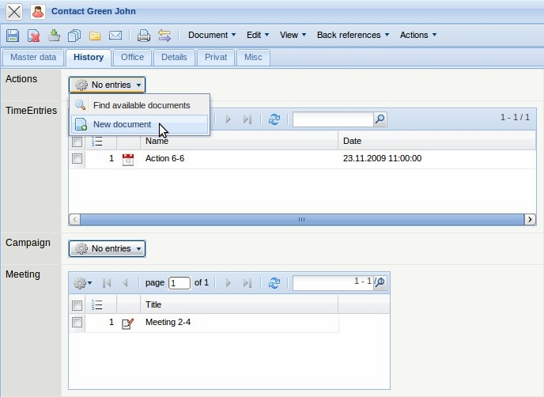
The system generates a new document with the type “action” and populates the contact person and other various values automatically.
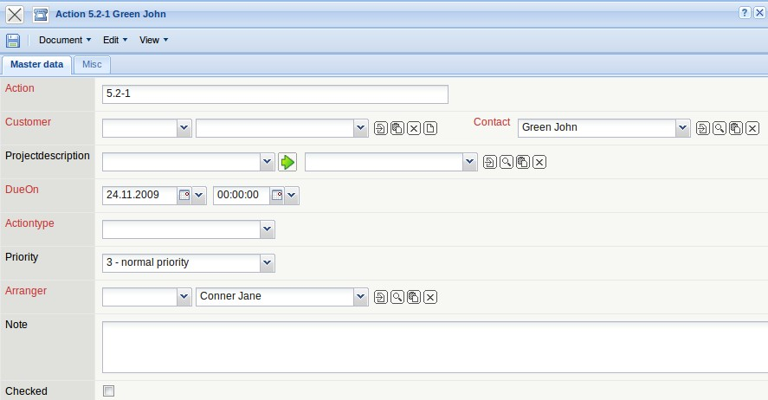
After filling out the relevant fields, the document can then be saved.
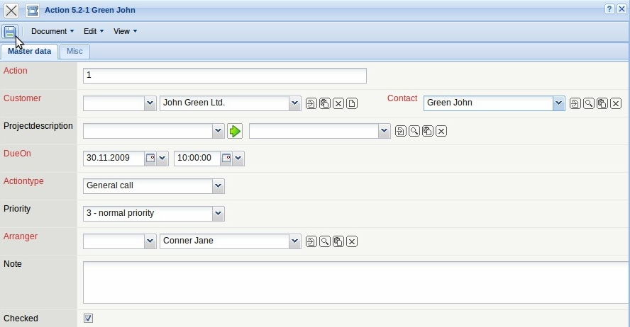
Further actions can be generated using the functionality “Create new document from this template”.
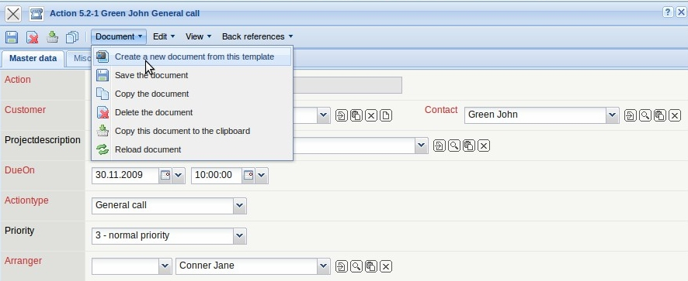
This next action is sending information material through a request. This action is marked as completed. The check box “checked” indicates a completed action. If this flag is not set, the defined action is a resubmission, which can be displayed in the contact chart.
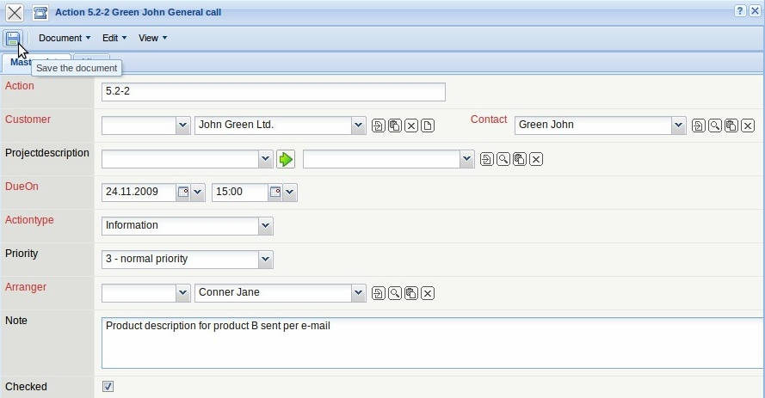
In the next action ...
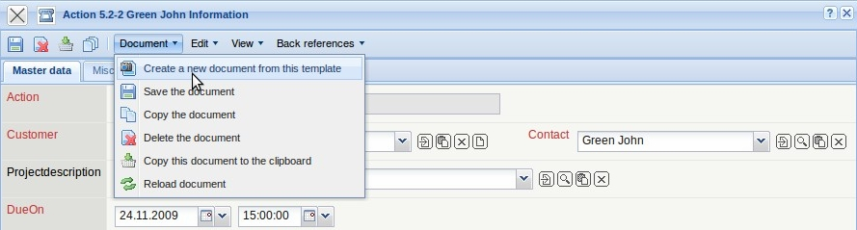
... a presentation is offered on 30.11.2009.
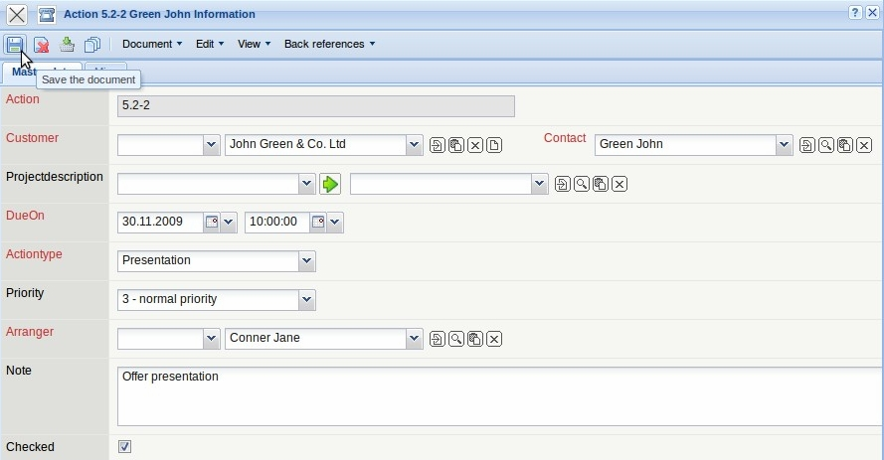
If the optional component mailer is used, the system generates automatically an e-mail message for this action on the given day ...
.. using the appropriate link.
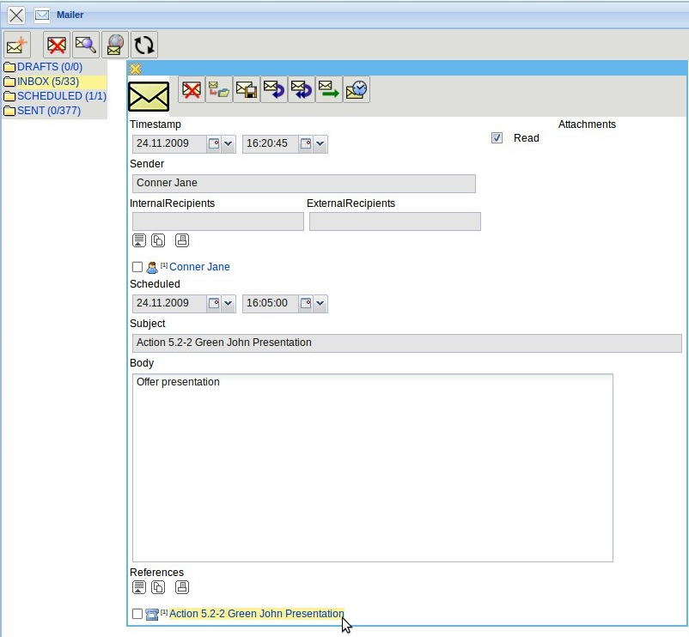
If the optional component TeamCalendar is used, this action is also displayed in the group calendar (here presention with John Green on 24.11.2009 ) and can be opened here.
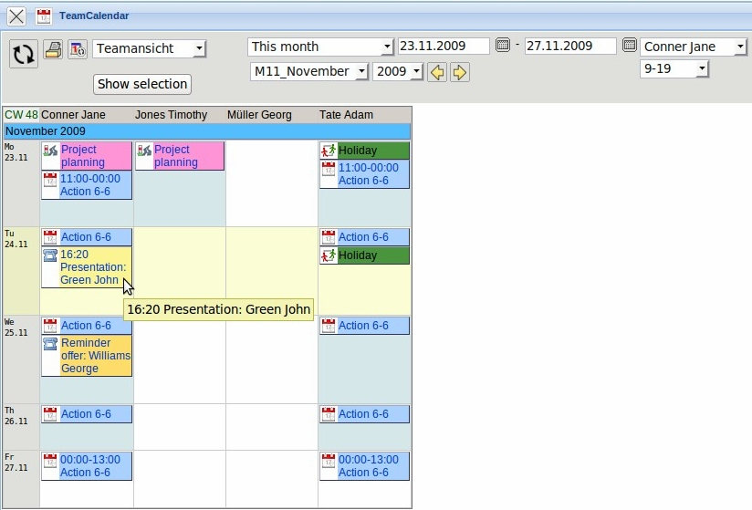
Appointments can also be defined for the contact persons here.
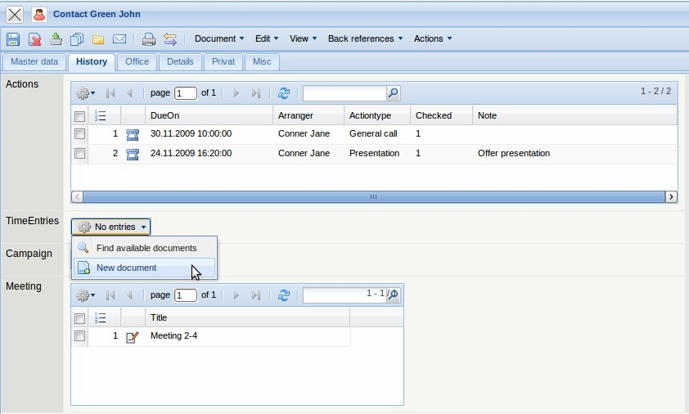
In the example, an appointment (time entry) for John Green ...
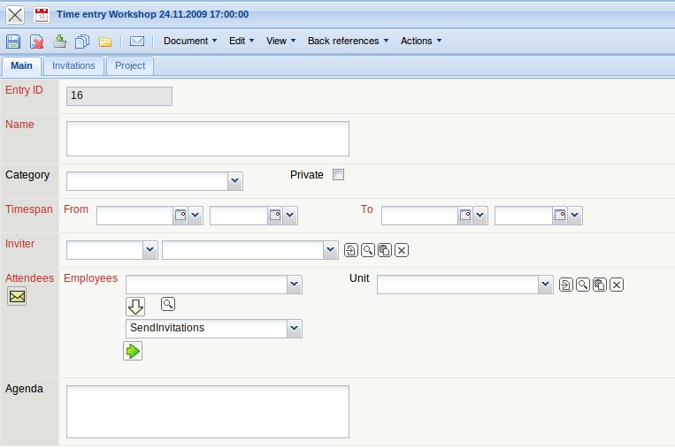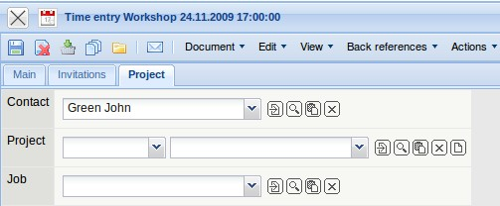
is created for 24.11.2009 from 17:00 - 19:00:
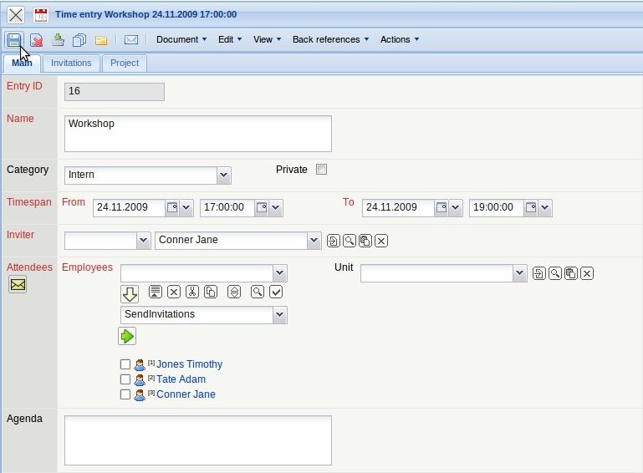
This appointment (time entry) is then transfered to the group calendar. Note: if the group calendar is not used, the appointments can be used alternatively as actions with to-do appointments or similar.
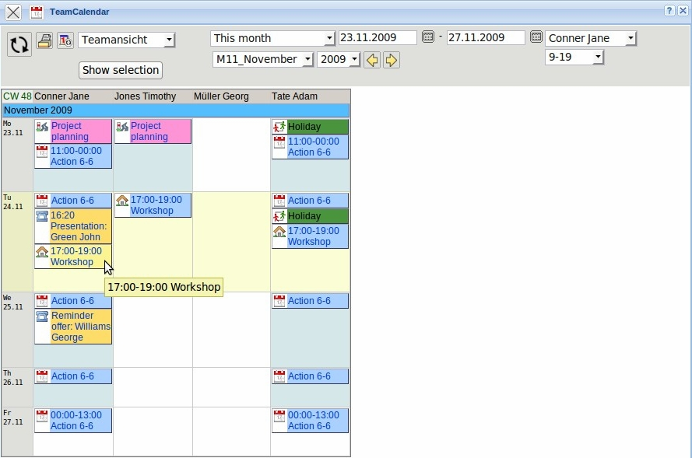
The defined actions can be evaluated in the standard charts and in the optional ReportMaker
In the following example a contact chart is opened ...
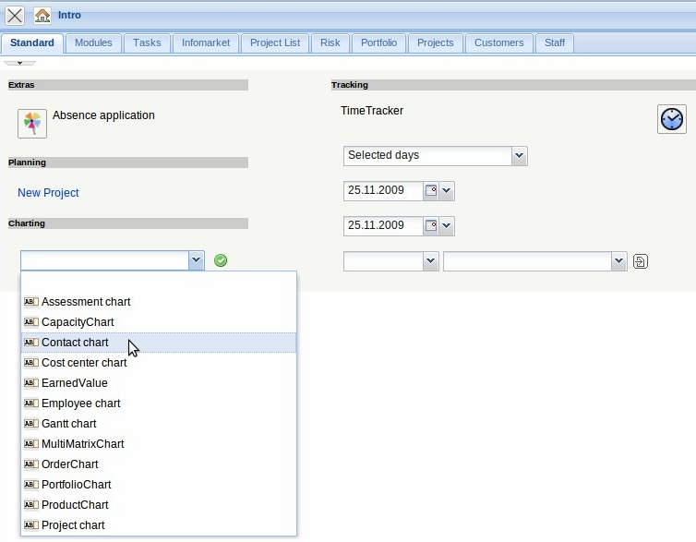
... and a chart ...
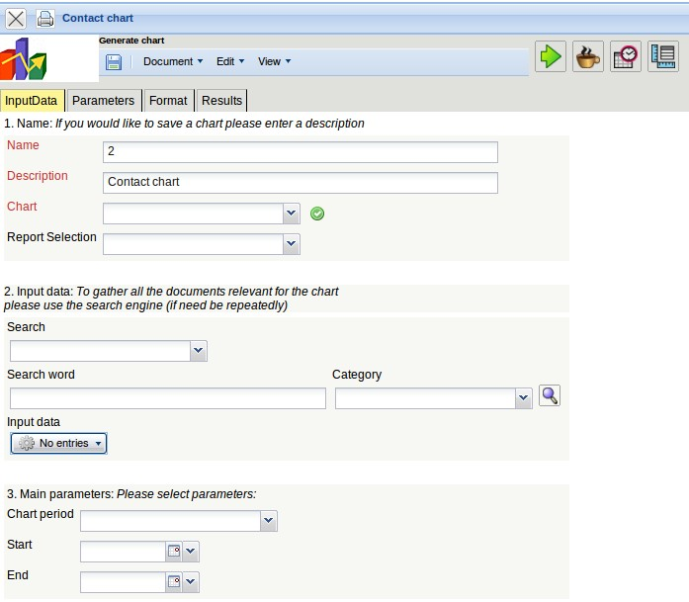
with all actions in the year 2009 ...
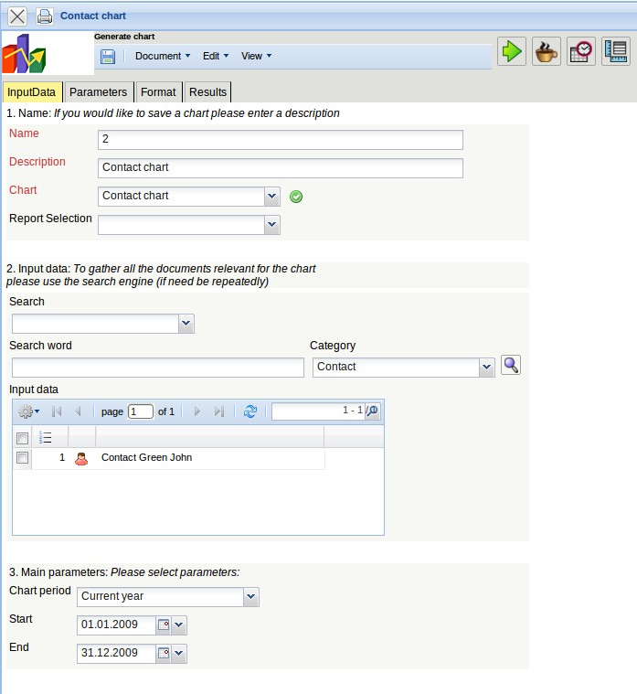
... is generated.
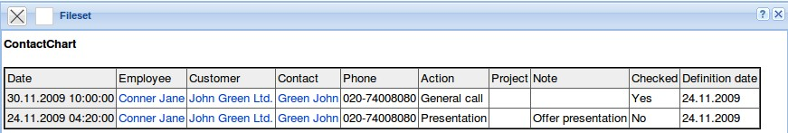
If the optional component ReportMaker is used, your own report in combination with the advanced search can be used.
In the example, the query “All open actions” is used. This query lists all actions, which are not yet completed ...
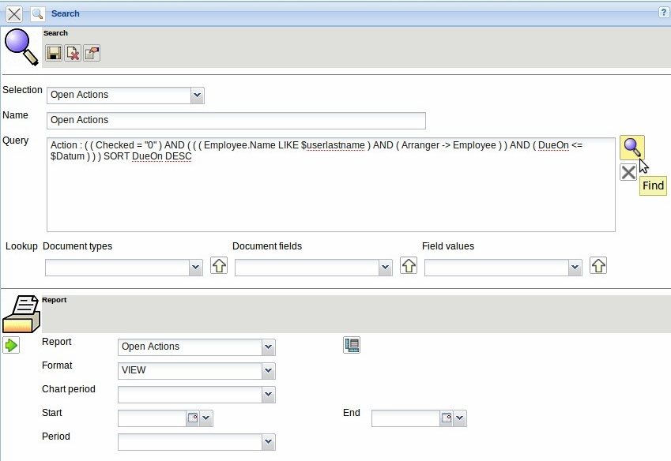
... and sorts them by the descending date.
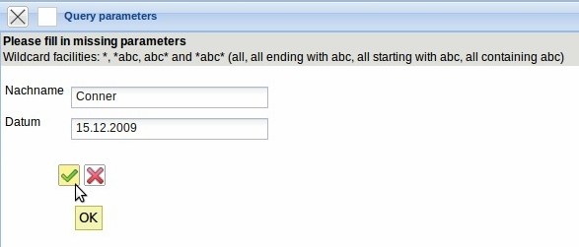
Die Ergebnisse der Abfrage werden in einen Report “Action” dargestellt. Dieser Report listet für die Aktionen ausgewählte Kontaktdaten auf.


