3.11.03 Cost Type Administration
The cost elements are the basis for grouping in the budget management and costing. The system distinguishes between project costs and overheads, which can be sub-divided arbitrarily. Several project costs (travel expenses, driving expenses, foreign services) are mandatory and should (as the top cost types, project costs and overheads) not be deleted. The cost types can also support (with linkage for financial accounting) allocations to finance-accounting accounts.
In the following return list all top cost types and sub-cost types are displayed.
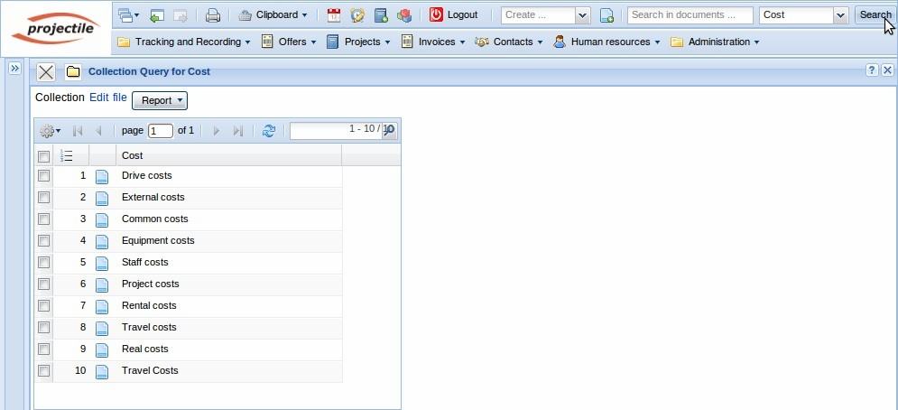
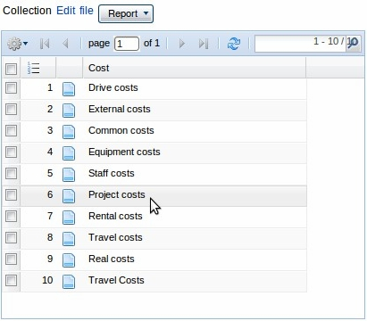
Project costs are sub-divided in four sub-cost types
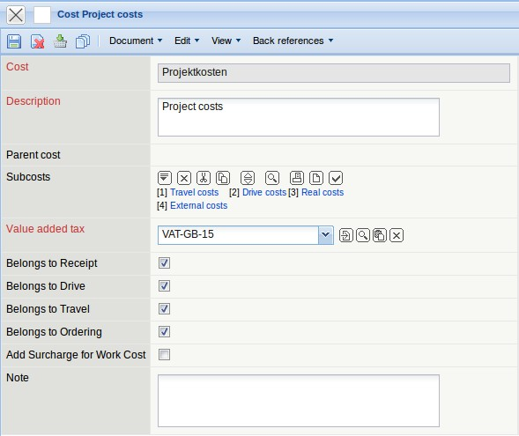
Required fields: cost type, description

Characteristics:
- The parent cost types “overhead” and “project costs” are the only parent cost types which are (in the standard version) permitted and can not be deleted.
- Several project-related sub-cost types should not be deleted, because they are necessary for the system. E.g. travel costs, driving costs and foreign services.
In the following example a new sub-cost type “Misc. cost types” are created for the cost type “project costs”. Using the function “create” in the element sub costs ...
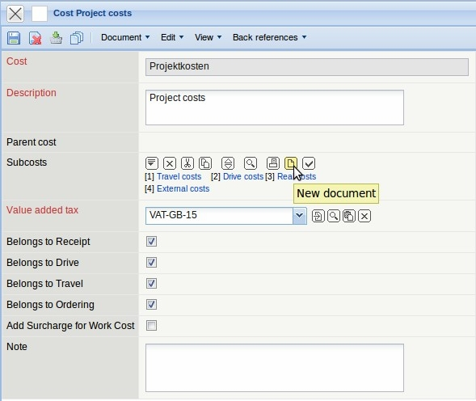
... a new sub-cost type is created for the project costs.
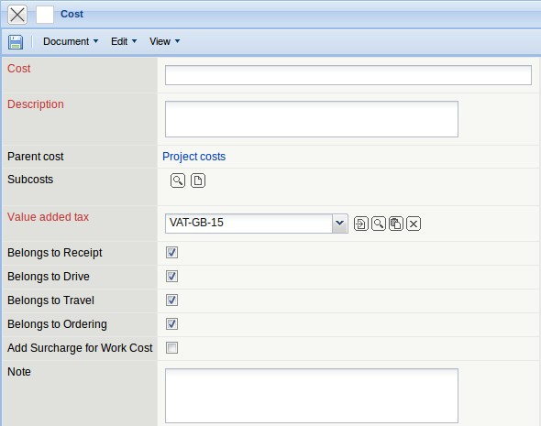
The system generates a new document of the type “cost” and pre-populates the parent cost automatically with “project costs. Then, the remaining entries are defined ...
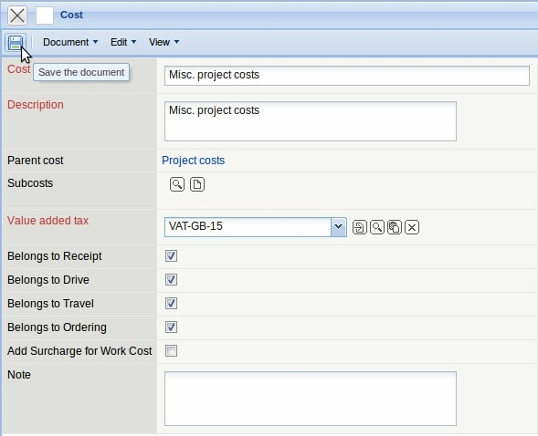
... and the document is saved.
These sub-costs are then transfered automatically the the parent costs.
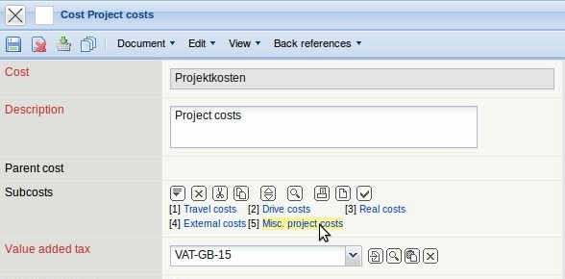
At the same time, the overhead costs can be modified and extended. But, this cost type is only used in the component “overhead”, which is not obligatory for the system.


