3.09 Workflow-Module
The workflow engine enables illustrating work processes within Projectile. Unlike a business process that describes a sequence of activities with the objective of service performance, a workflow is a predefined sequence of computer-aided flow of activities. The workflow engine in Projectile supports a business process, provided with necessary data and processes, according to the specifications stored in the system. The goal here is not a documentation for an organization or its employees, but rather the ability to automate the process.
Projectile's workflow engine is based on OSWorkflow from OpenSymphony and is part of the standard version.
Implementations example “Absence application”
In TimeTracker various workflows for the handling time periods (period-end closing, vacation application, ...) can be stored. The following example shows the implementation of a holiday application. After performing the action in the Time Tracker ...
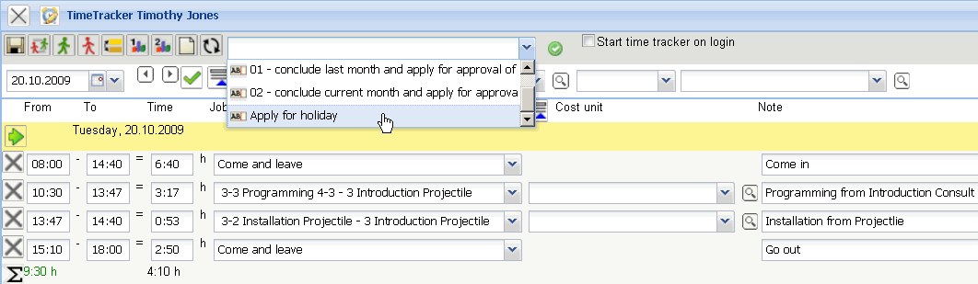
... a dialog for absence application is opened. Here the user can apply for absences (overtime compensation, recreation and special vacation) and cancel absences applied for or cancel approved absences.
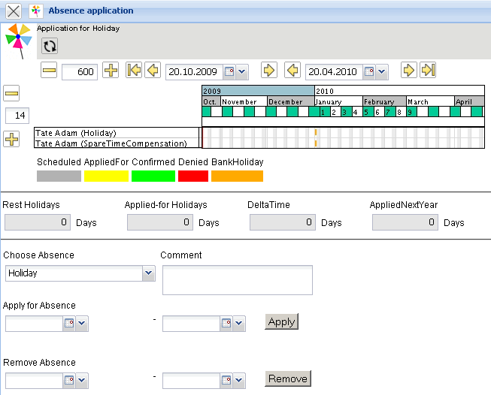
In the following example the employee has applied for vacation.
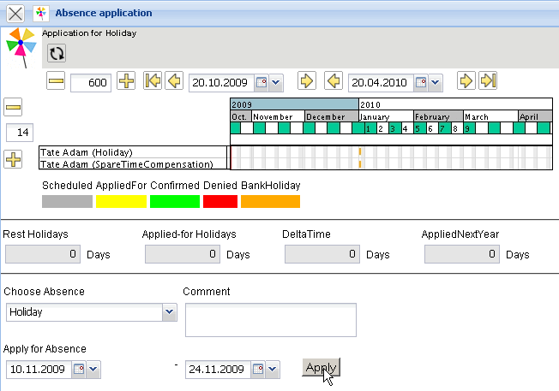
After confirming the application ...
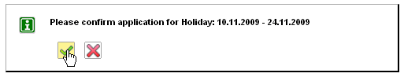
... the applied for vacation is then visualized ...
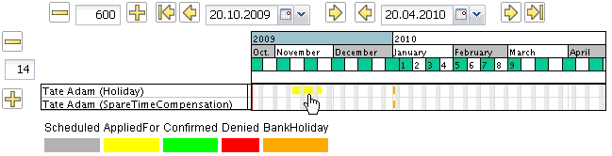
and the supervisor (manager, personnel manager, project manager or unit manager) receives an internal message. In the example, the unit manager of the applicant ...
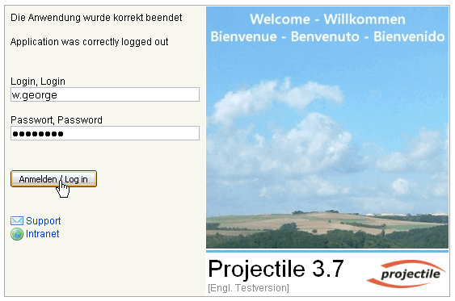
... is informed and receives a vote.
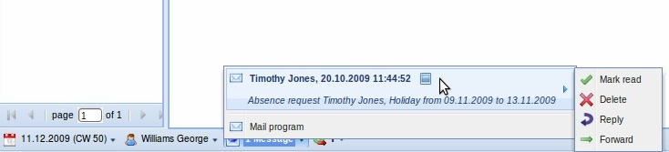
The employee is then informed of the vote through an internal message.
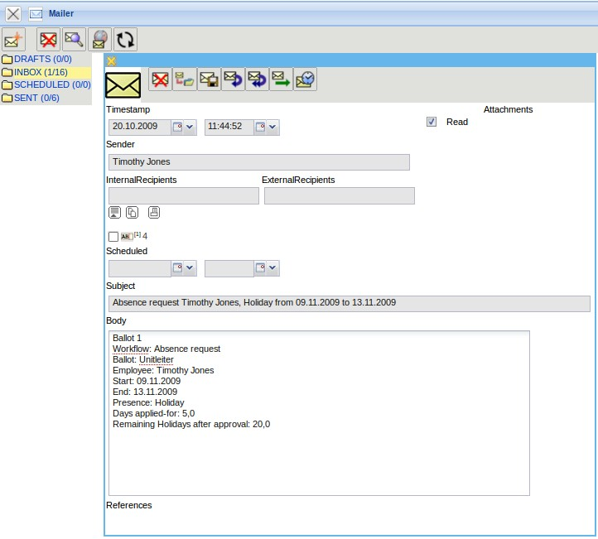
In the workflow engine the holiday can either be ...
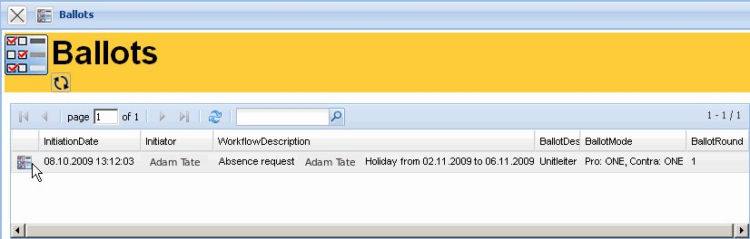
accepted or denied in the menu item “Ballot”.
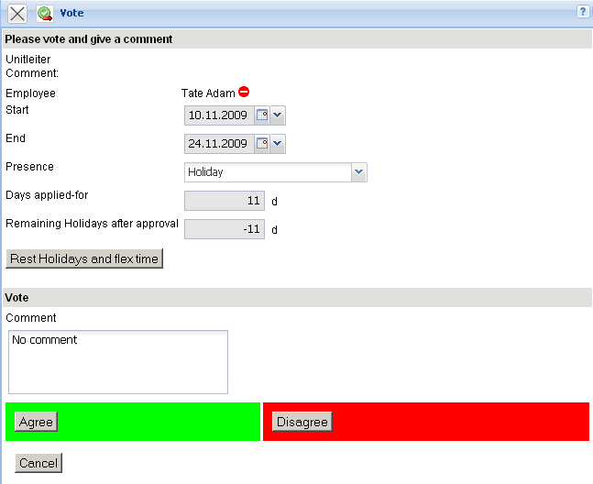
The applicant obtains a message of the vote from the system.
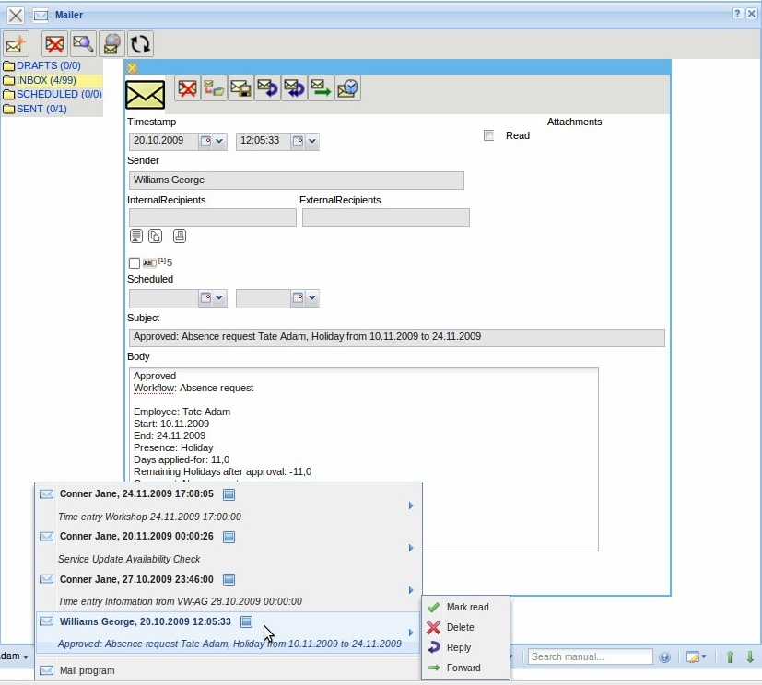
Depending on the voting results, the holiday is graphically displayed as vacation or as vacation rejected in the absence application of the Time Tracker.


