3.07 Archives und History
Projectile includes optional a trash functionality (archive) and a document-based history.

3.07.1 Archives / Recycle Bin Functionality
If the document is no longer needed in the active data pool, by clicking on ...
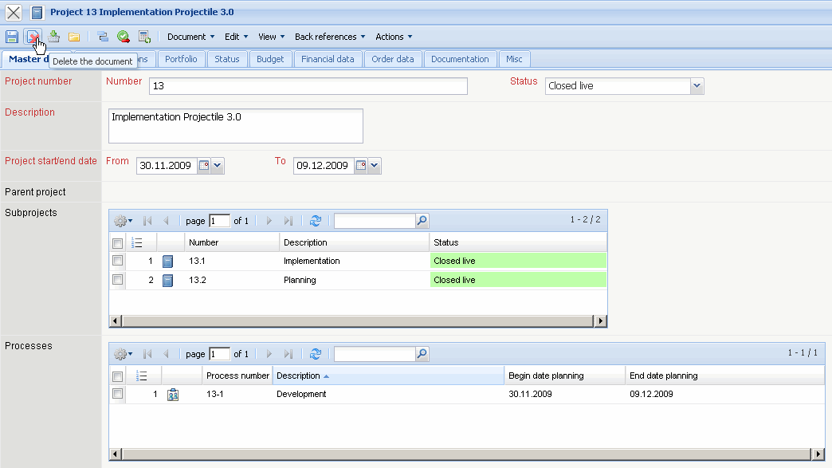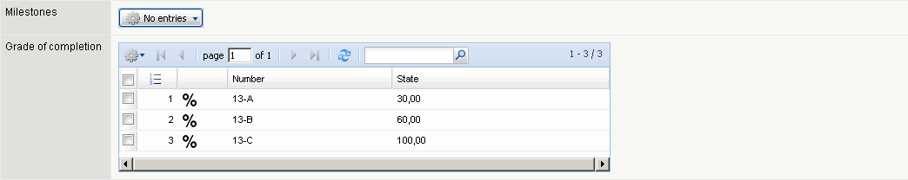
... it can be deleted.
Before the document is deleted, a dialog appears; with the question of whether we really want to delete.
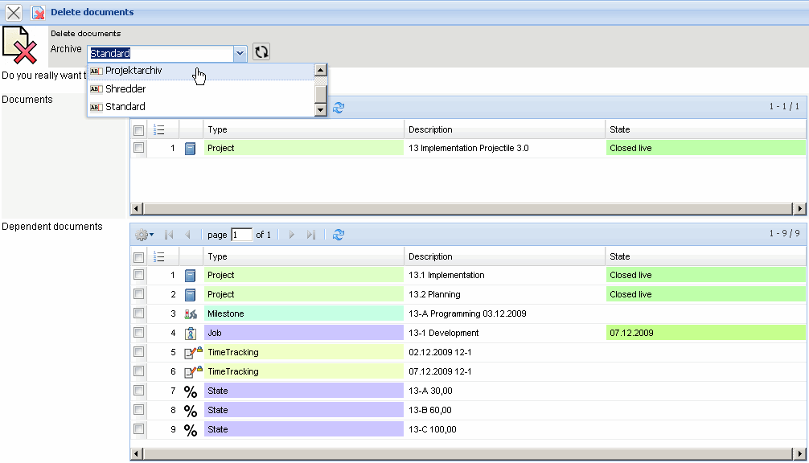
This dialogue is a security precaution, since the deletion can be undone only by selected users (see also recycle bin / Archive). If the project is deleted, it can be restored from the recycle bin. Analogically the archiving also functions for future restoring of projects or of other data pool.
In the following example, the project 105 Implementation Projectile is moved to the project archive. This process may take some time for larger structures.
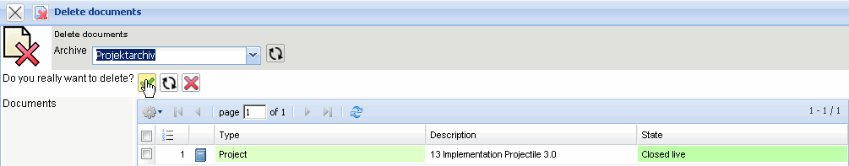
With the functionality the recycle bin or the archive can be accessed.
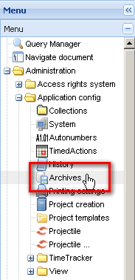
In the search dialog you can enter a search text, or a document type, date of deletion and the sort order.
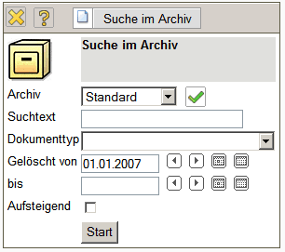
In the example you can search for all projects in the project archive, which have been deleted after 08.01.2007:
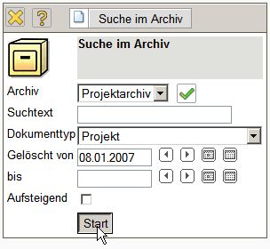
The system finds three archival projects (the upper project 105 and the two sub-projects of the project 105).
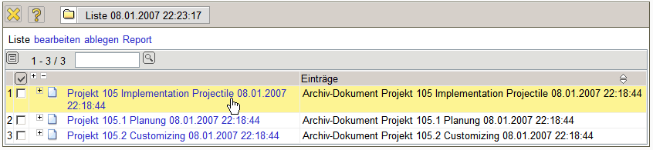
In the deleted document is the information, when the document has been deleted by which user and the contents of the deleted document. This document can be restored or deleted from the project archive as a copy or in the original condition.
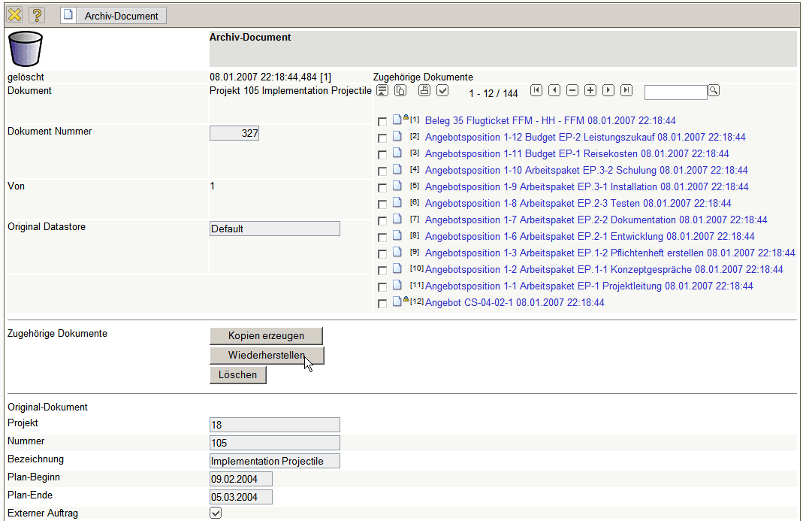
In the example the original document is restored. This process may take several minutes for larger structures.
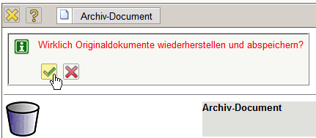
After the restoration a confirmation appears. Here, the user can select, whether the archived document should be deleted or not.
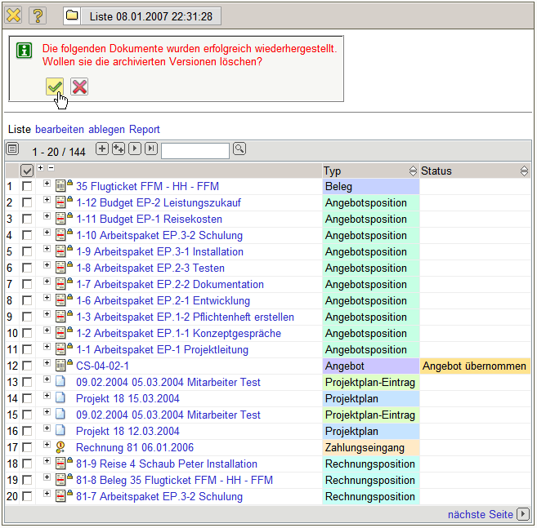
After restoration the system displays all the documents (here 144 documents with upper-projects, sub-projects, jobs, recorded time, offers, invoices,...).
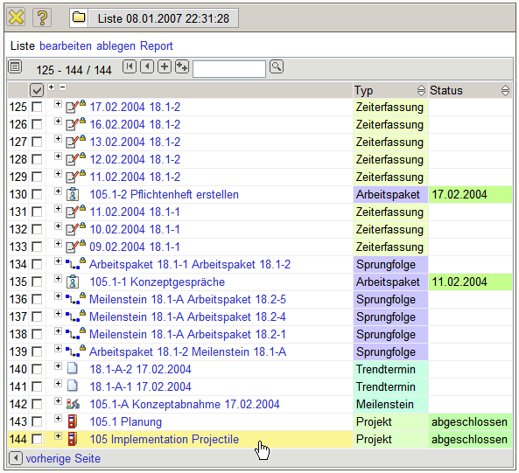
Afterwards the archival project will be accessed.
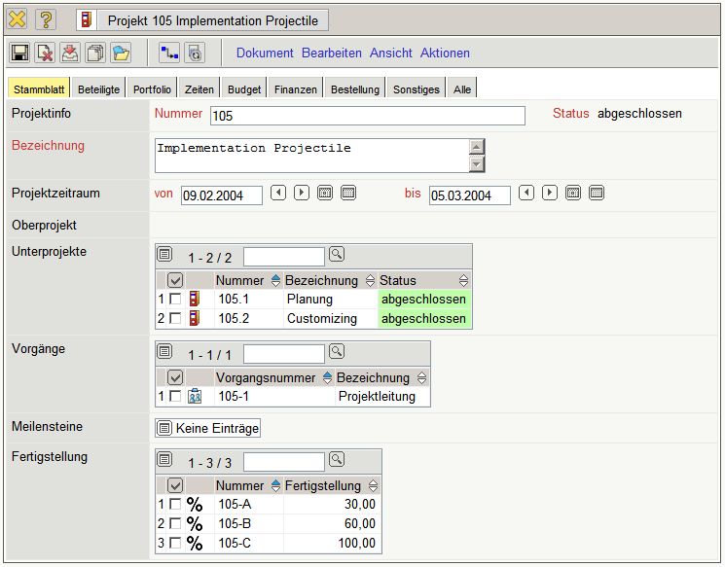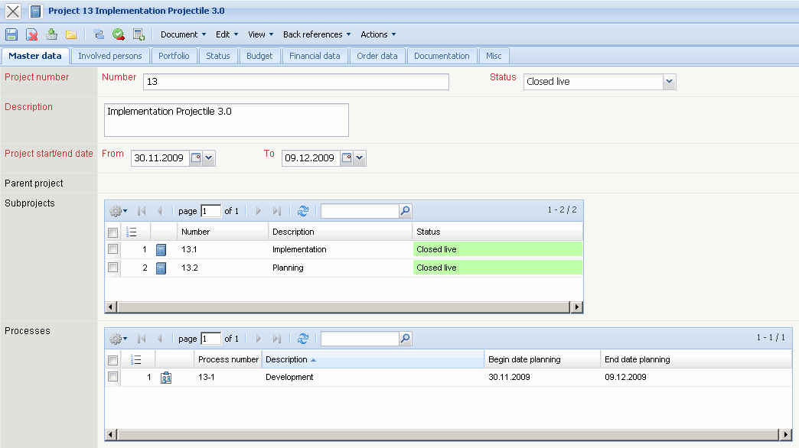
... Continue...

