3.06 Reportgenerator "ReportMaker"
The report generator provides, besides the standard charts, another possibility to evaluate the database of Projectile. It can be accessed through any search query. The output format CHART, CSV, HTML, browser view, PDF, RTF or XLS can be chosen. Furthermore, the ReportMaker provides, by using the EDIT-Mode, a convenient way of editing. To use or to create a report, an appropriate query is required (quick or advanced search of Projectile).
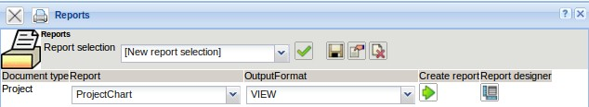
In the ReportDesigner, the results of the queries are processed. The designer consists of a toolbar, the header (name, title, document type), ...
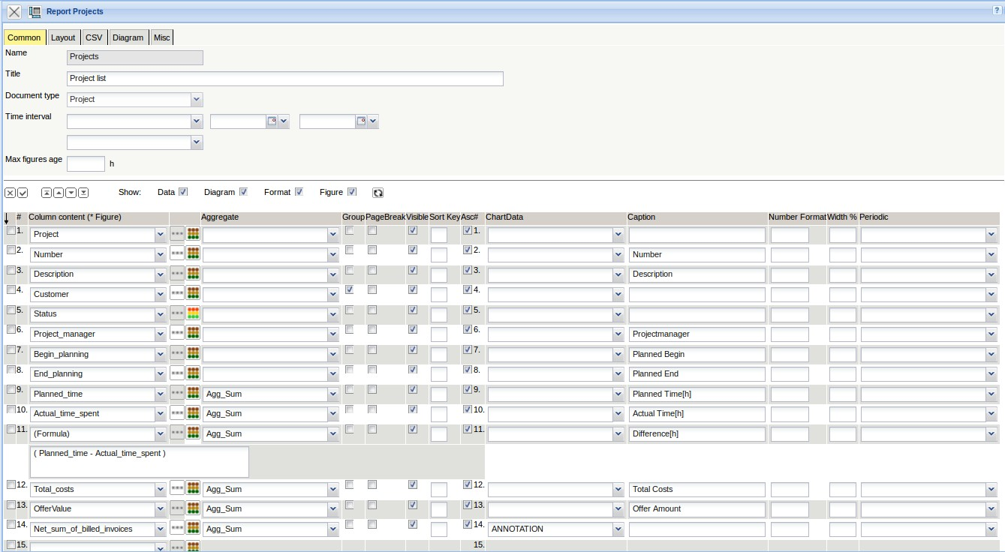
...and the edit bar.
By using these functionalities, the rows can be modified. Currently six options are available:
- Remove,
- Invert selection,
- Start (marked entries at the beginning of the list),
- Move to (move marked entries one position up),
- From (move marked entries one position down) and
- End (marked entries to the end of the list).
In the work area, the rows can be marked, column contents can be selected and modifications to the rows can be made:
- The functionality allows the selection of referenced elements (for example in project through the customer to the branch of the customer),
- The functionality allows the definition of formulas and
- The functionality allows the definition of values by text or colors.
In the column “Aggregate function” calculations can be defined. There is a possibility to choose between:
- None,
- Sum,
- Minimum,
- Maximum and
- Average
This functionality is used only for numbers (duration, amounts of money, …).
The next column ( “Group”) is used to determine groupings. For the groups appropriate subtotals are displayed. To use this function, sort in the grouping feature in the Advanced Search.
With the functionality “Visibile”, it can be determined whether the columns appear in the list or not. For example, often intermediate results are required for the function (formula), which is not relevant for the actual report itself and should be hidden.
Other functions in the ReportDesigner:
- Sorting and ascending: Using sorting, the sorting sequence can be established and with the attribute ascending controls, whether the sorting has is ascending (set checkbox) or descending (checkbox is not set)
- Diagram : Function for graphic evaluations (axis of the evaluation, description, categorization)
- Caption : Alternative column heading in the report, if the column name should not be used
- Number Format: Format for numerical values
- Width %: Scaling the column width for the output format PDF and RTF
- Periodic: Feature of the key figures for handling periods when accrual
These functionality are explained in the following example.

Create Query
In the example, on the basis of a advanced search, a project chart will be created. Note: By using quick search in the intro, Reports can also be alternatively used and created. However, the advanced search allows more complex queries of the data pool.
First, the advanced search is opened in the toolbar, and here, either a new query is created or an existing query is used.
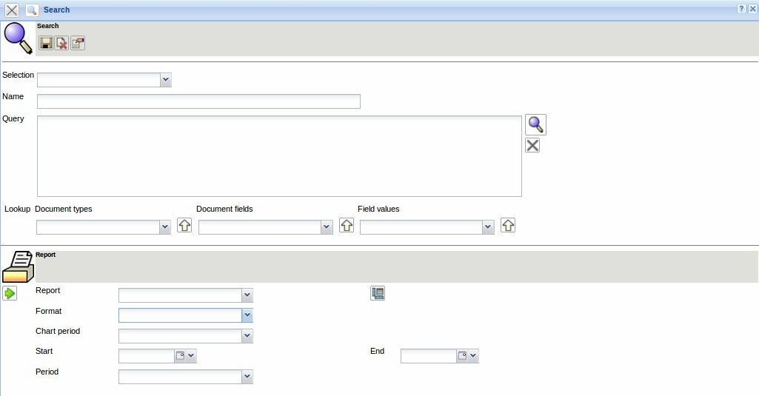
In the example, a query on the project's master data is loaded, which lists all current parent or top projects (for more information, see chapter 3.05 advanced search).
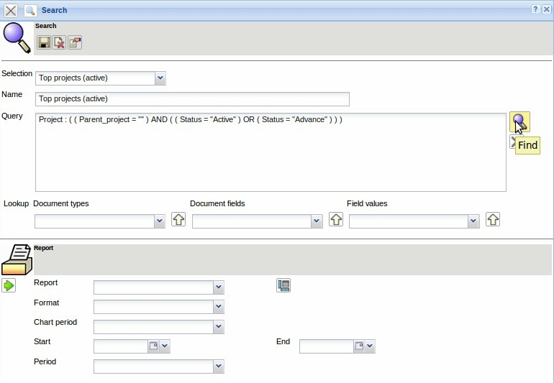
The query then displays the following results as a multiple-selection. Now, the ReportMaker is accessed ...
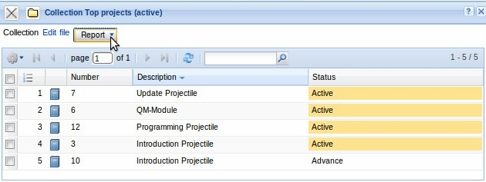
... from this multiple-selection.
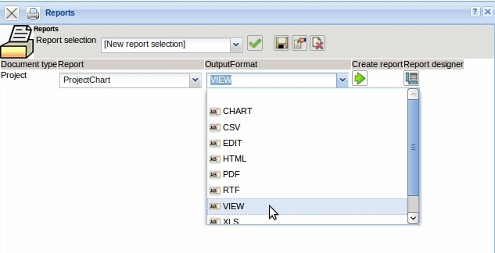
In the selection report, a standard report (a list of all available elements of the document), or (if available) a defined report can be selected. The following output format can be selected:
- CHART (for graphical evaluation),
- CSV (for example for MS EXCEL or for the use of standard letters),
- EDIT (to edit the selected data records),
- HTML,
- PDF,
- RTF (for example for MS WORD),
- VIEW (Evaluation within the system),
- XLS (for MS EXCEL) or
- XML

Create Reports
To create an new report, the report-designer can be accessed with the standard report.
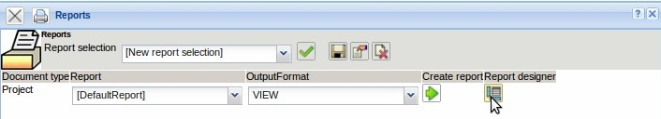
In the standard report, all elements, which are in the document project, will be listed as rows (for example project, customer, contact person, project manager, ...).
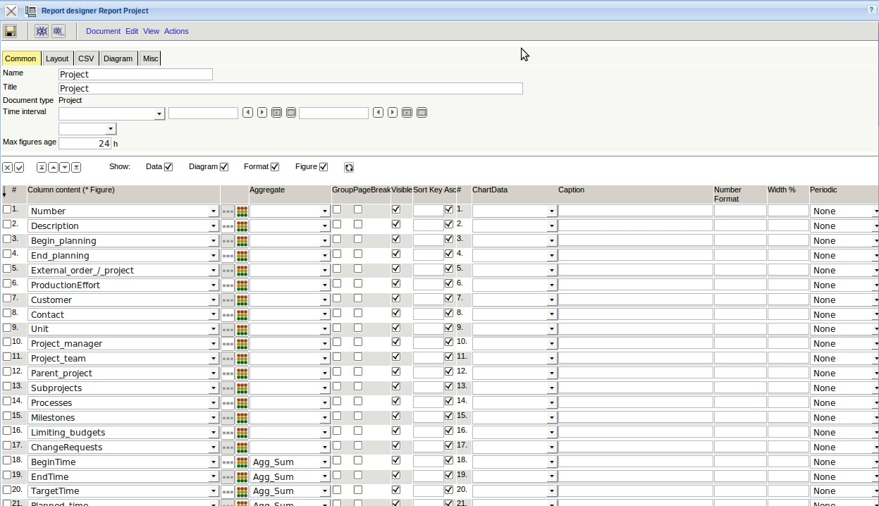
By using the selection-box, on the left side, the rows can be modified. In the example, the fields in the left check-box are now marked, which should appear in the report. Afterwards, this selection is inverted (now all lines are marked, which should not be used in the report) ...
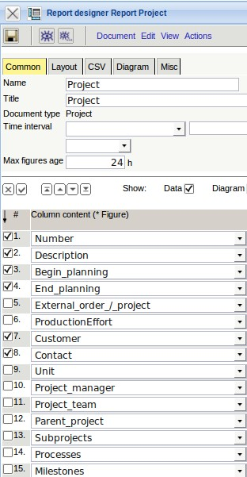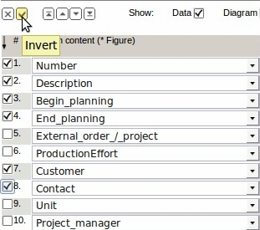
... and the selected entries are deleted.
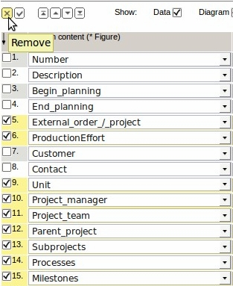
Alternatively, the rows which are not required can, of course, also be marked and deleted.
Afterwards, the report is named in the field 'name', the title of the chart is defined (headline in the report) and saved. In addition, some of the fields has been renamed in the column Caption (for example applicant in client).
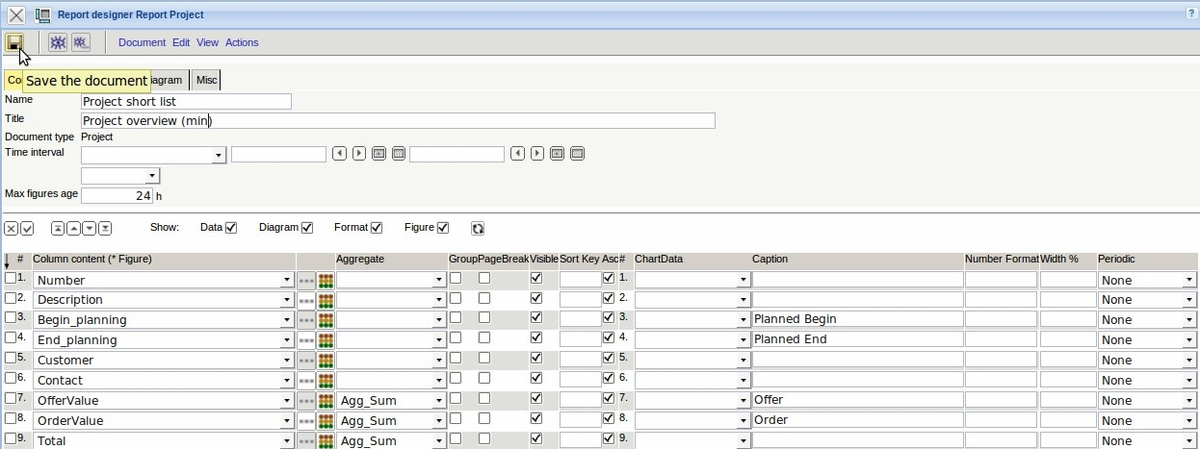
In the tab “Layout” settings can be defined regarding to the report layouts. Here, among other functions, you can specify the number of lines per page, page numbering, grouping types, head and footer layouts and page formats.
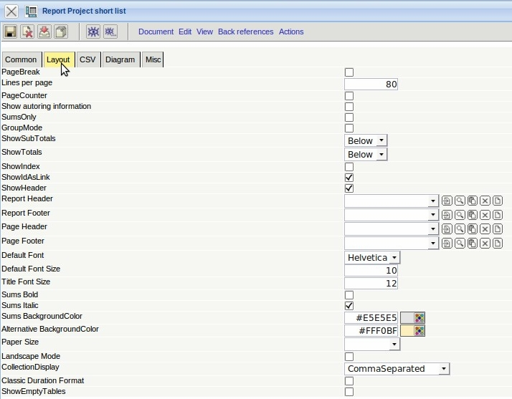
In the tab “CSV” parameter for the out put options “CSV” can be defined. This format is used for spreadsheets and interface files.
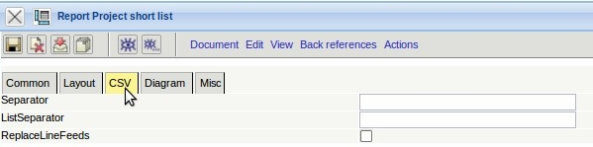
On the tab “Diagram”, options for graphic evaluations can be set (explanation follows).
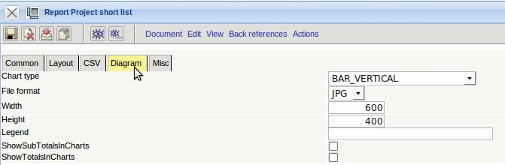
After closing the new report ...
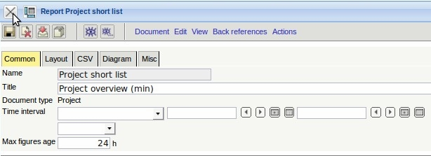
... it will be directly available in the ReportMaker.
... continued page 1

