Array Array

3.05 Using the Advanced Search (continued 2)

Assignment of Reports
Reports can also be added to the advanced search. If the ReportMaker is licensed, the reports can also be assigned to queries. In the example, an existing report with the name “InvoiceHeader” is assigned to the query, and the output format “VIEW” is selected.
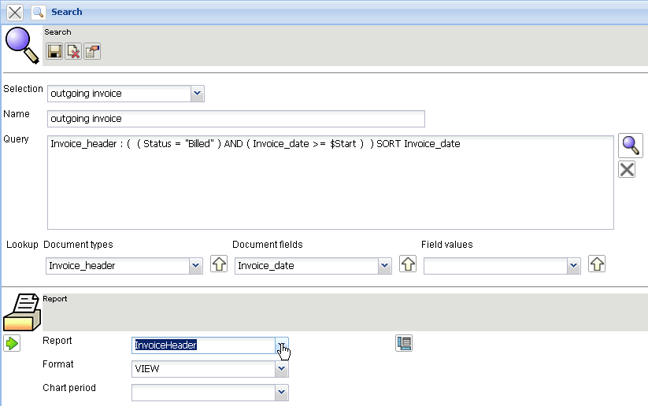
After the advanced search is performed, ...
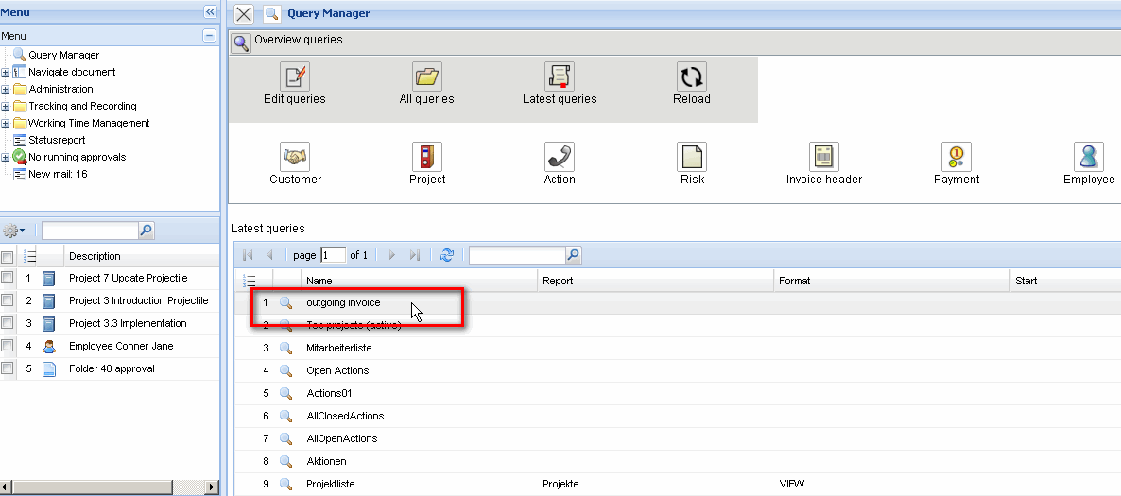
... the variables are searched for ...
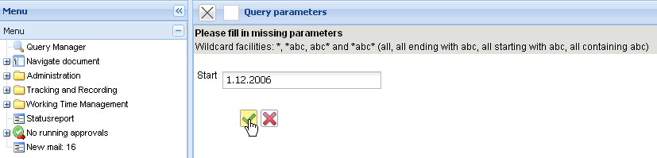
... and the results are visualized in the associated report.
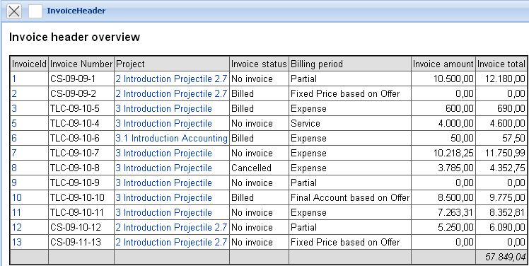
More information about the ReportMaker can be found in Chapter 3.06 ReportMaker.
The queries of the advanced search can also be more complex. The following example finds all the billed invoices during the period of start (>= $Start) to end (< = $End):
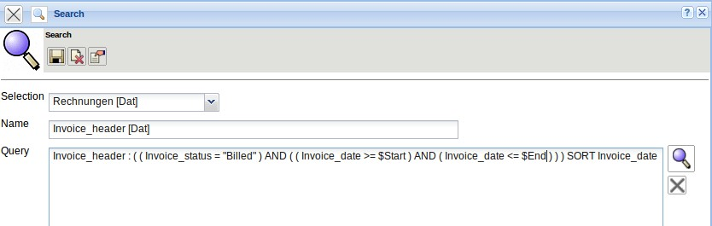
The following extension of the query searches for the assigned customer (element customer in the document project) through assigning the invoice to the project (the element “project” is part of the document “invoice header”). This customer should then contain the variable $Customer in company name.
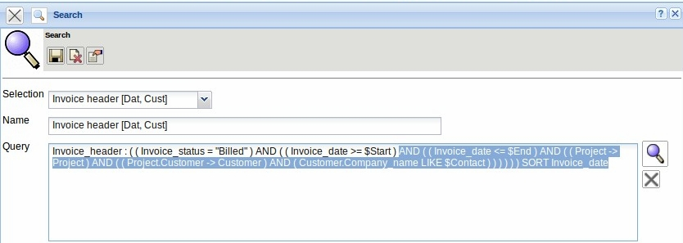
After performing the query, the variables start and end and contact can be queried ...
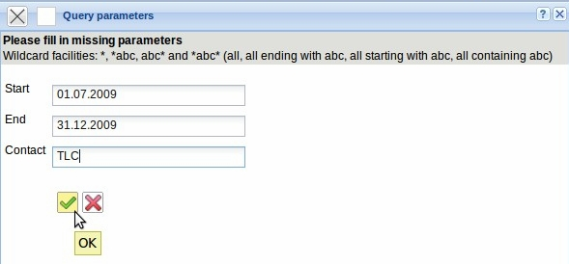
... and then all billed invoices between 01.07.2009 and 31.12.2009 prepared for all customers with “TLC” in the report.
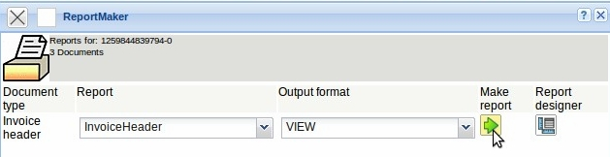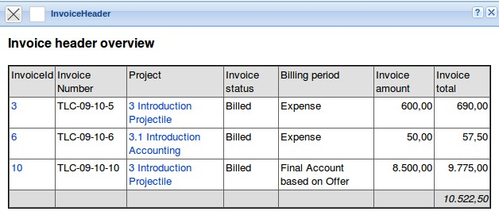
... continued page 3

