Array Array

3.05 Using the Advanced Search (continued 1)

Creating New Search Queries
Besides using stored search queries, it is also possible to create your own new search queries. To do this, select the list field of the entry “Look up Document types”. All Projectiles document types are listed. This way it can be defined, which document is searched.
In the following example, a query should be created for the invoices:
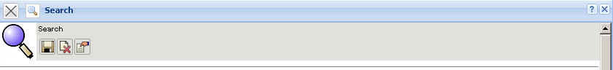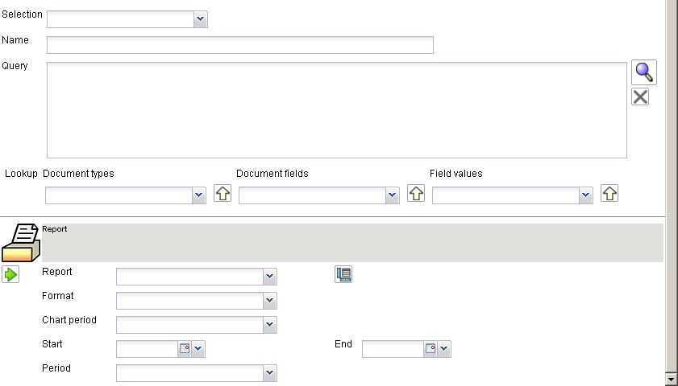
In the field “Name” the new query is named ...
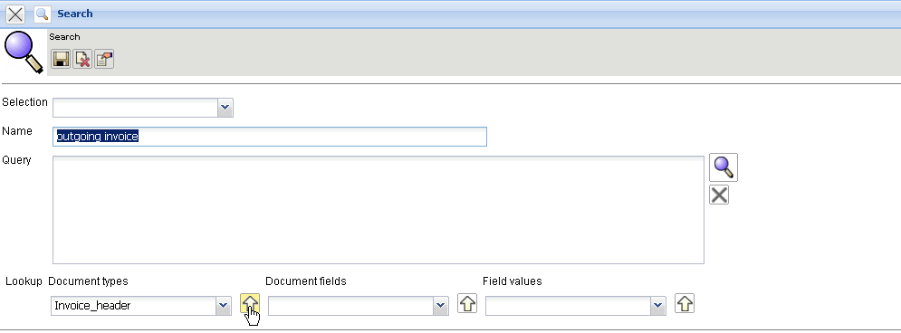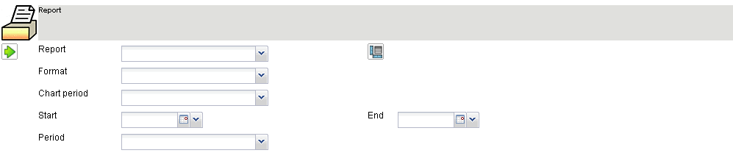
... and with the yellow arrow (look up) the entry is copied in the query. Then, the query is saved with .
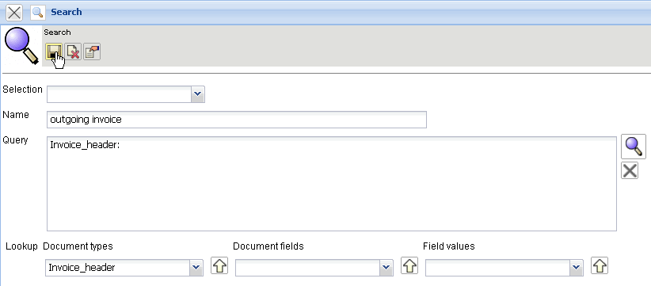
After clicking save, the advanced search is automatically available in the search query manager.
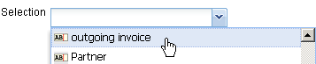
To use the advanced search, access rights (administration - actions; see also administration guide) can be assigned.
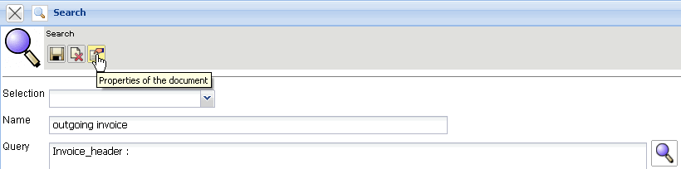
The Query
Invoice: means that the basis for this search query is the document invoice. Processing this query with Executing this query with  ...
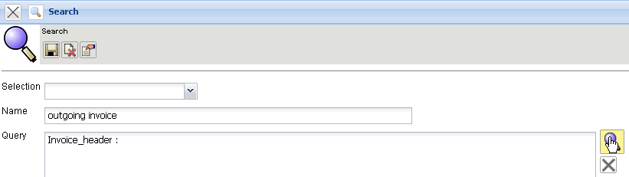
...provides a list of all invoices in the system.
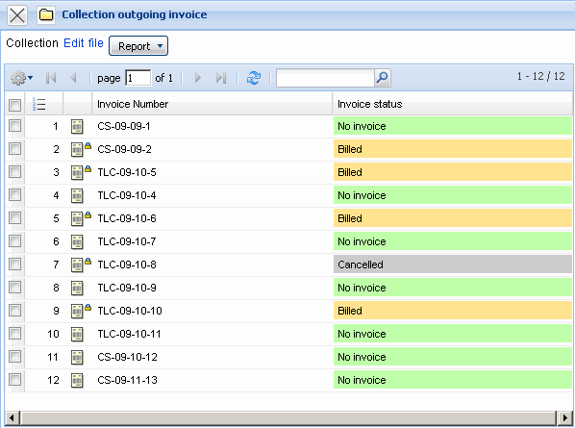
In the next step, the query is defined more specifically. Only billed invoices should be copied. This information is in the document “invoice” and the field has the name “status”. By using the assistant, the fields of the selected document can ...
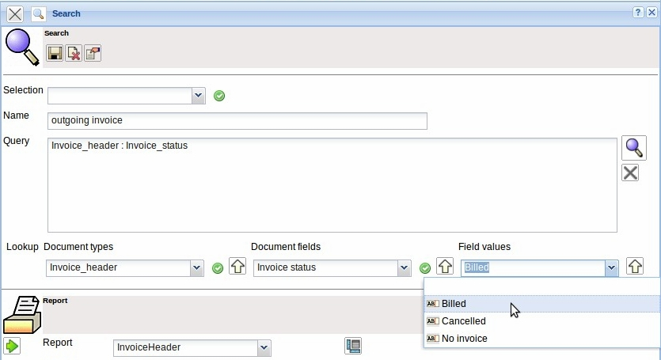
... be looked up. After selecting the status field and the field value, this condition can ...
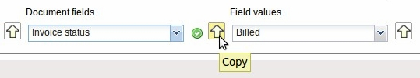
... be accepted with two mouse clicks in the query.
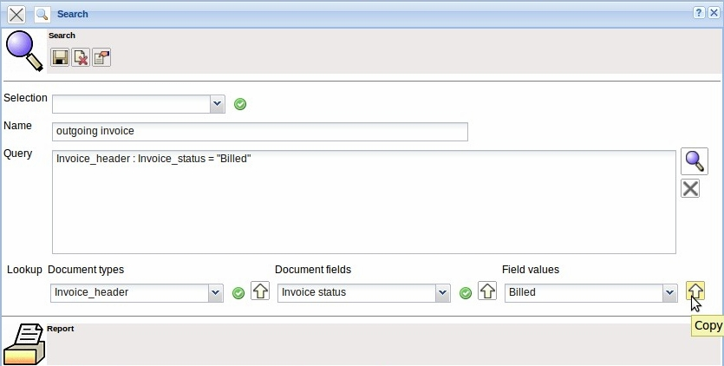
After running the query, the query is reformatted, if necessary. In the example invoice : status = “invoice billed” becomes invoice : (status = “Billed”). The system normally sets brackets and also automatically transfers collections in the expressions (here billing type). The transformation of the queries must be made by the system because of the internationalization, so the queries can function independently of the user´s language.
The Query
Invoice : (Status = “Billed”) ...
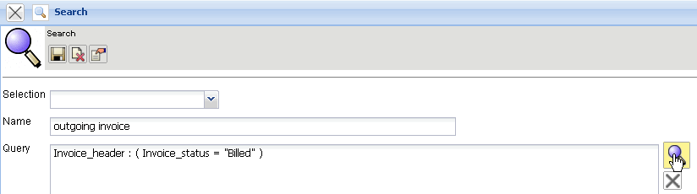
...finds all the invoices that have this field content, therefore which have already been billed.
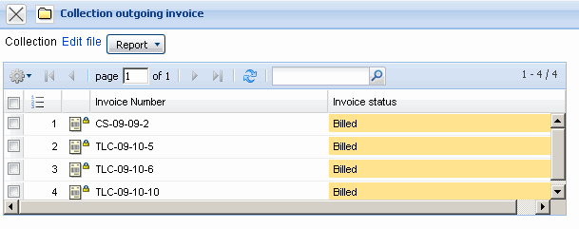
In the next step, the created advanced search will be defined more specifically. The invoice date is attached to this query.
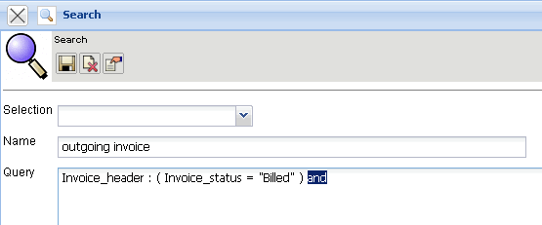
By using the assistant, the existing query will be extended with an AND-Attachment (both conditions must be met).
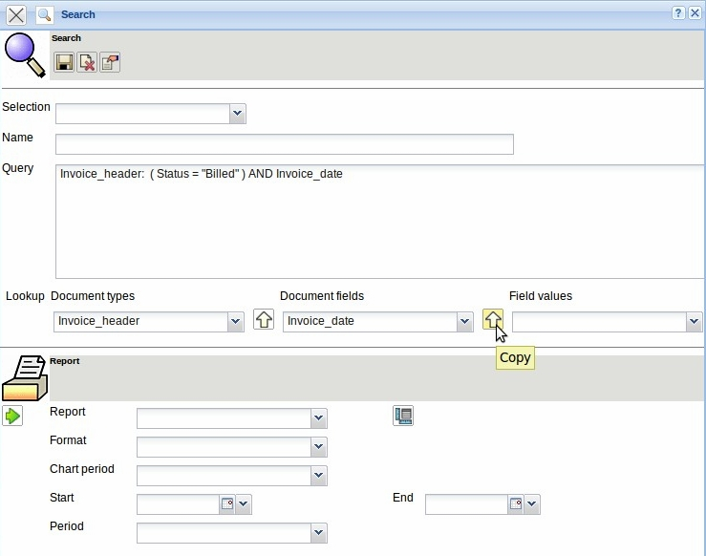
The second condition filters invoices with the invoice date from a start value (invoice date> = $Start). In a query, a value can (for example, a date “01.12.2006”) be deposited or a variable. In the example, a variable $Start is used as a placeholder for the invoice date, instead of entering this date directly into the query.
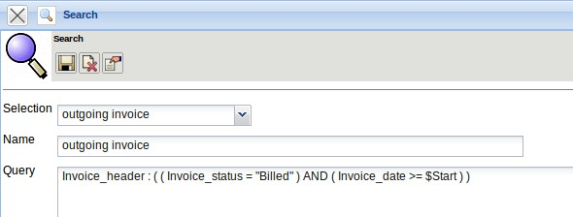
When using variables, the list of results will not open directly ...
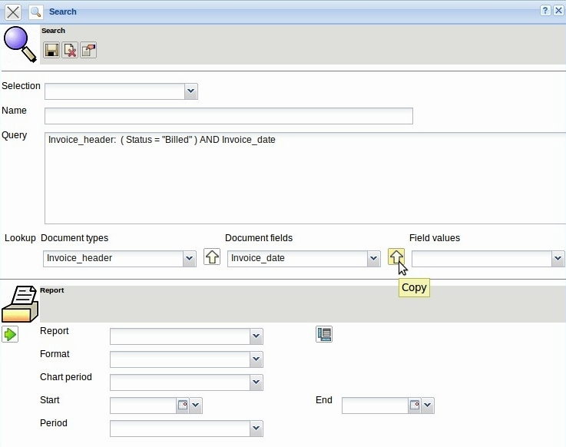
... but only after entering these variables ...
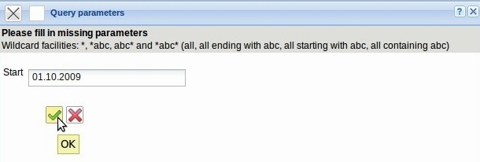
... in an intermediate dialog.
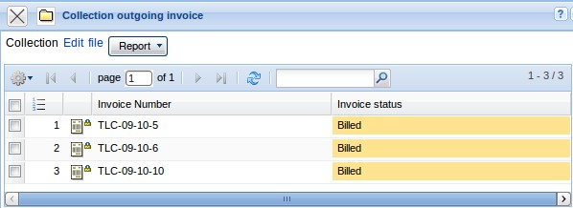
The Query
Invoice : ( ( Status = “Billed” ) AND ( Invoice date >= $Start ) )
lists all invoices that are billed from the date entered.
Finally, the query is completed by sorting the definition.
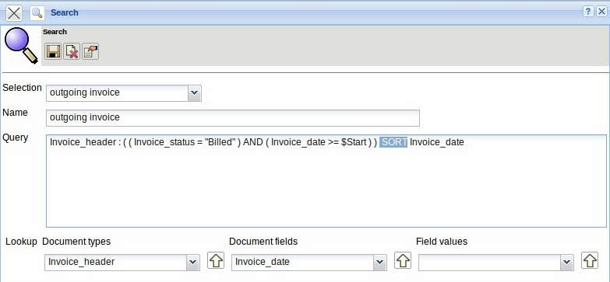
The result list is then no longer sorted according to the internal number, but it is sorted in ascending order by the name. If sorted in descending order, you must use the additional DESC. The search query is then:
Invoice : ( ( Status = “Billed” ) AND ( Invoice date >= $Start ) ) SORT Invoice_date.
... continued page 2

