3.04.3 Group Organizer "Team-Calendar"
The group organizer manages project relevant appointments (milestones, external and internal appointments, project actions) and person-related events (absences, such as holidays and illness, bank holidays, general operations, ...). The calendar can be opened for the user, the group (such as unit) or for all the employees for any period of time. With the appropriate permissions, appointments can not only be displayed, but also be defined.
Bank holidays, absences, milestones and open actions are transferred from the appropriate record data in the system. Appointments can be freely defined (with sufficient permission). In addition, the scheduled employees to these appointments can be notified through the internal mail system Mailer.
The calender is opened through the toolbar.
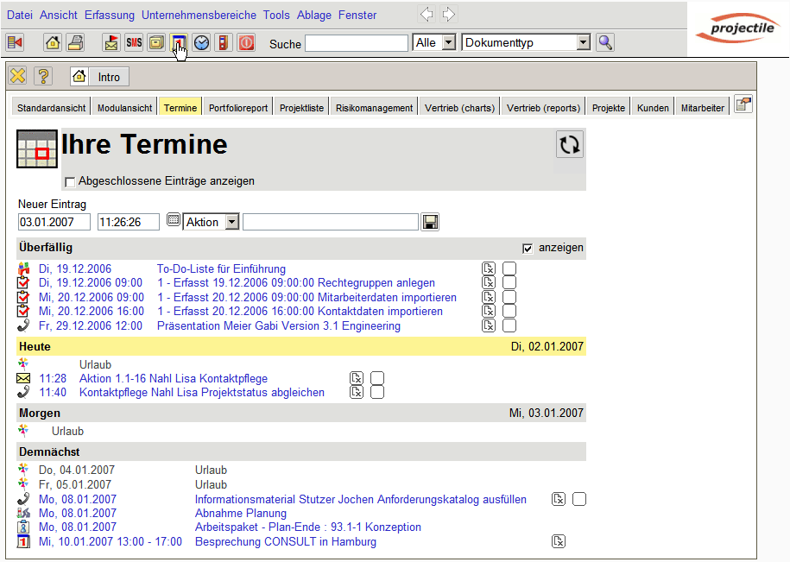
In the following example, the calender of the user !!!!!! is open for the current month.
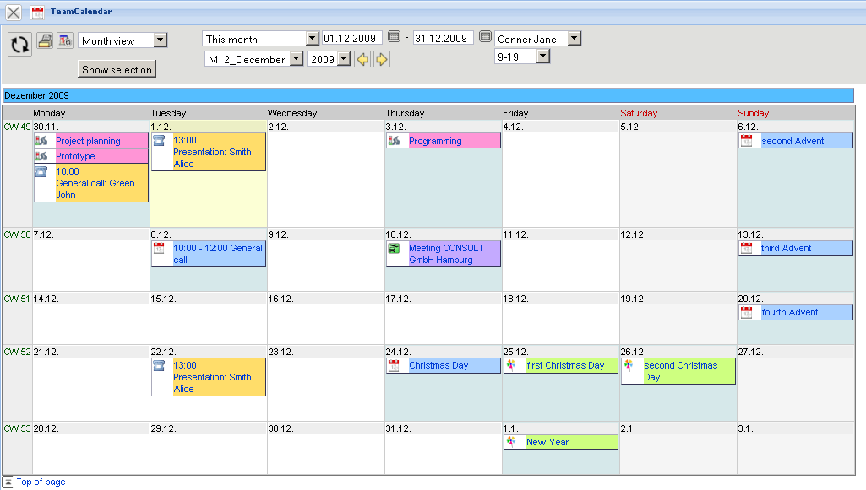
All appointment types (including milestones) are displayed, the black entries from the defined actions and the purple entries have been defined in the calendar itself.
 | Green entries are used from the bank holiday definition (see bank holidays)
 | Yellow entries are from the contact administration (see actions).
 | Blue entries are from internal appointments.
 | Purple entries are from external appointments.
 | Pink entries are personal milestones of the employee (see milestones).
The calender supports and displays (with appropriate permission) also the appointments of other employees.
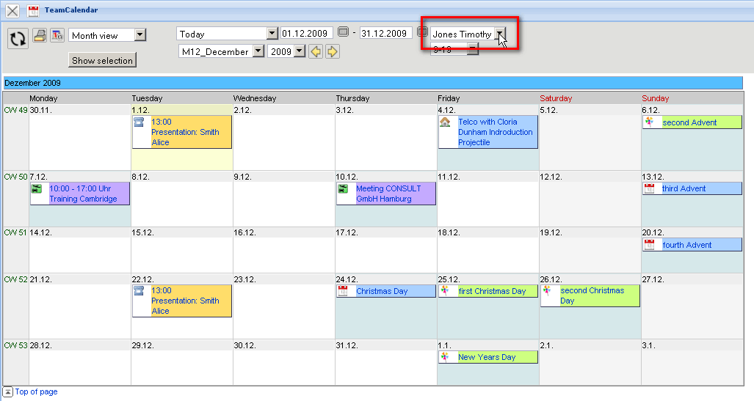
In the calendar the time interval of the display can also be changed (here in team overview).
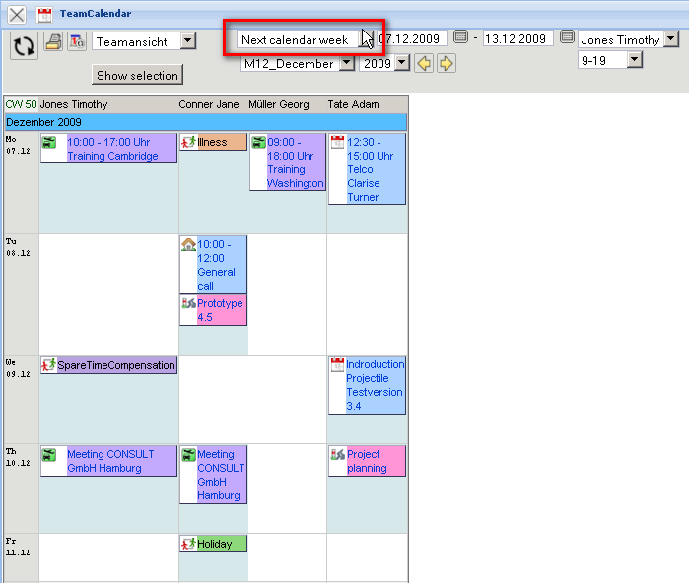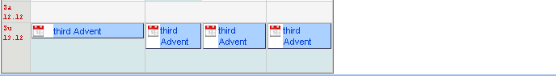
By using the action “Show Selection” the settings of the calender can be viewed and changed.
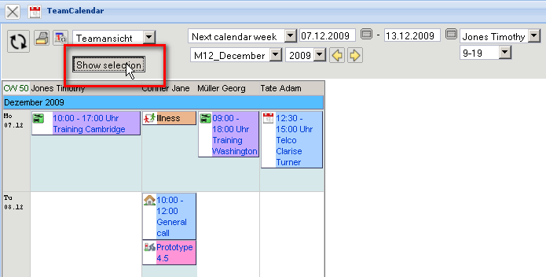
The selections “Employee” and “Units” provide filters for individual employees or units (organizational units, such as departments), and the selection “Entry” can filter the entries by the type of dates.
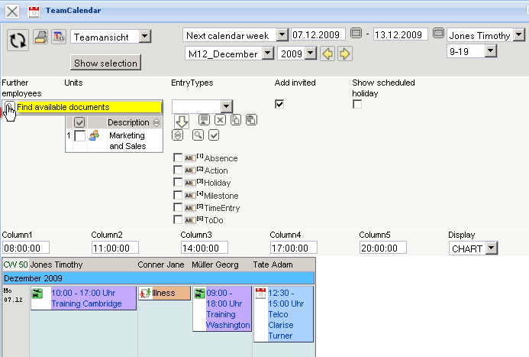
With the display of the calender is refreshed.
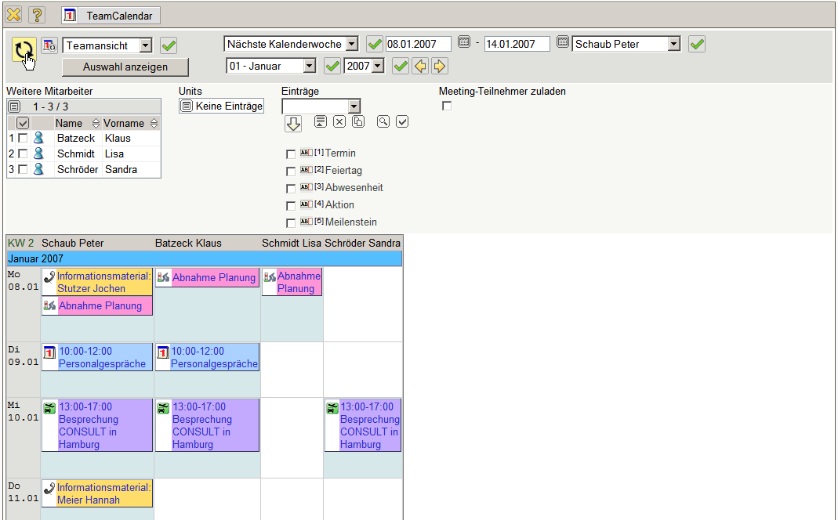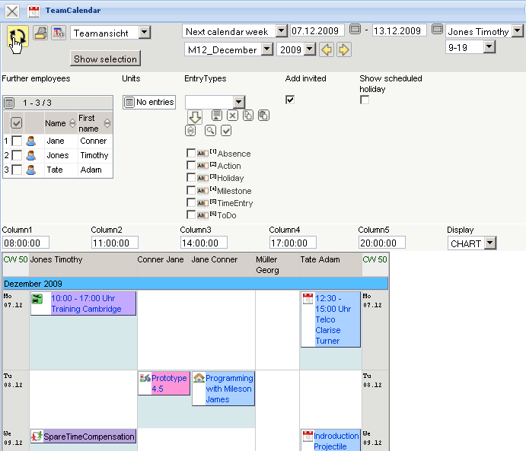
To view or change appointments, click on the appointments (here an appointment for !!! on the 10.01.2007 between 1 pm and 5 pm).
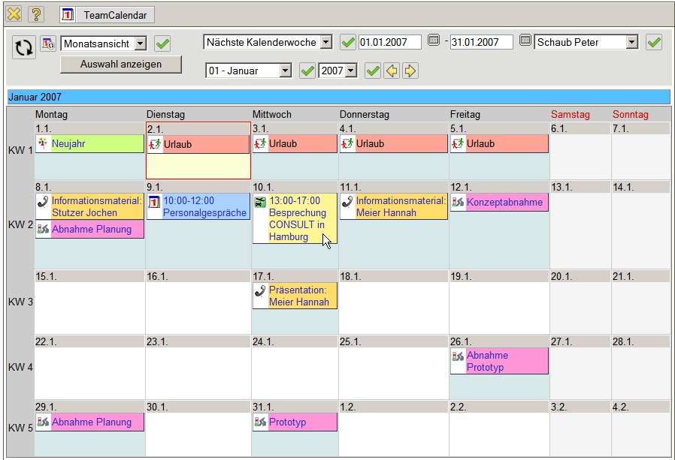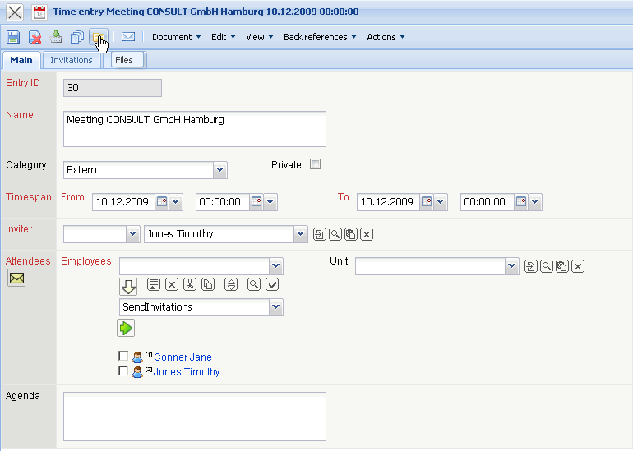
In the appointment document, the appointment, including all the information (and attached documents) can be viewed ...
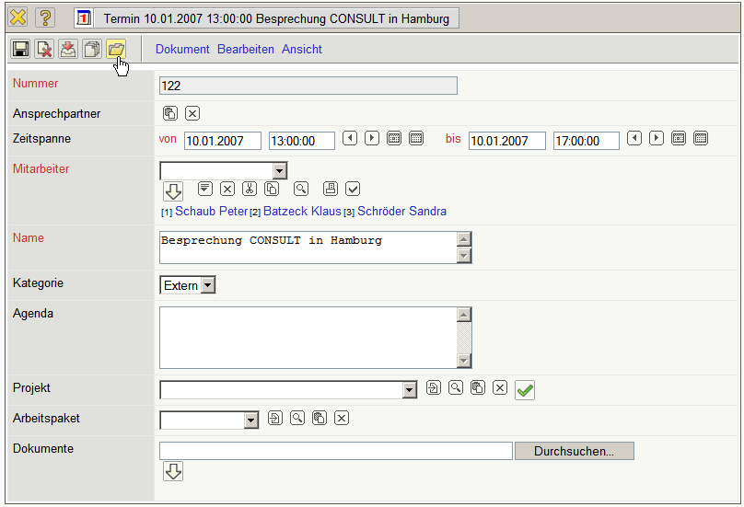
... and they can be changed (here completion of the agenda).
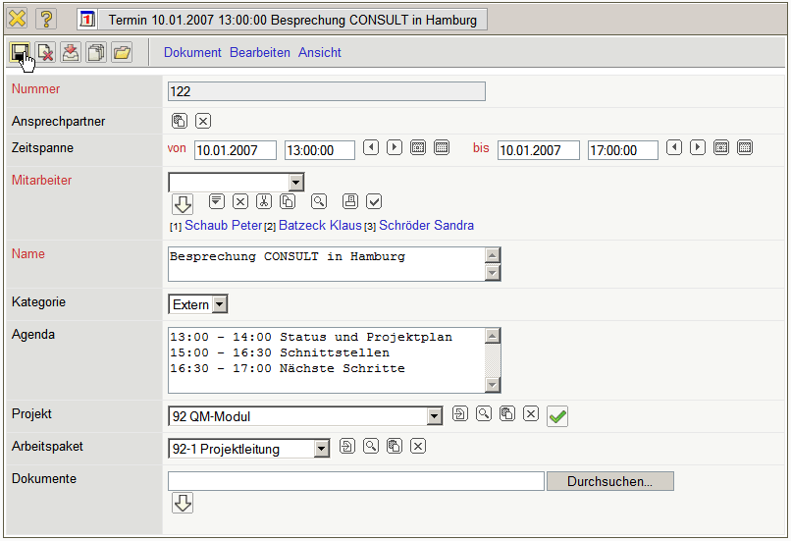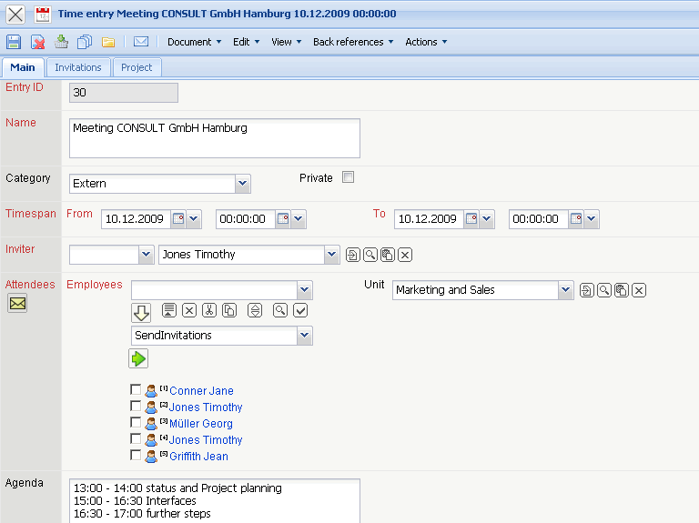
If a new appointment has to be defined, click on the check-box in the selected day. Here a new appointment for the 16.01.2007 will be defined.
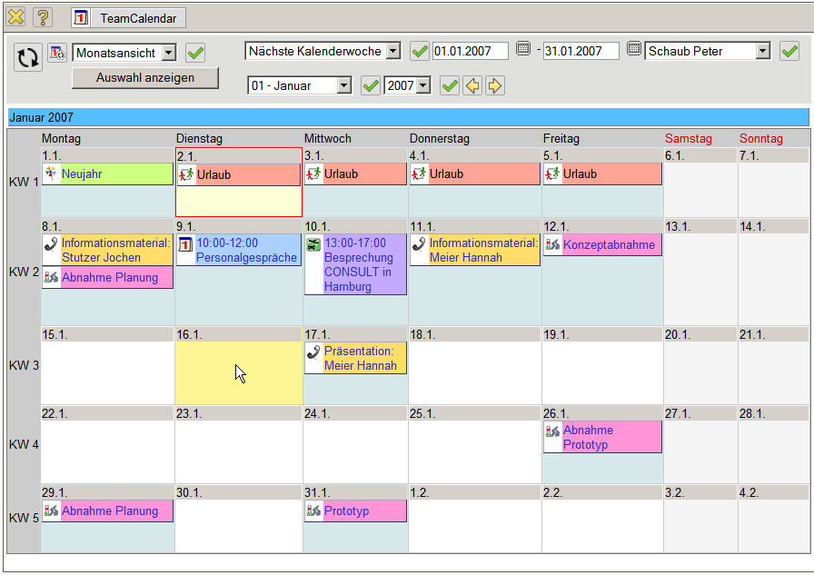
Then, a new document of the type appointment opens. Here the basic values are now defined.
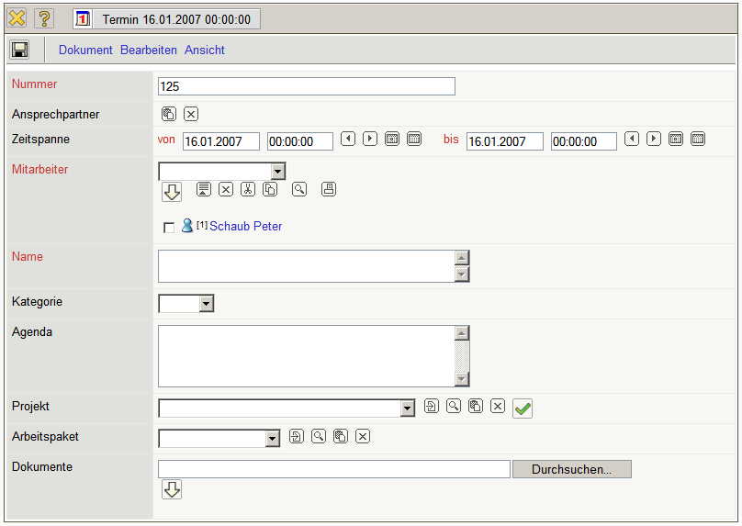
This includes the period of time (here, of 16.01.2007 9:00 to 12:00), the participants (with the possibility of multiple choice, (here the employees !!! and !!!!), the description/the name of the appointment, the category (internal/external ), further notes and possibly external documents. The appointment will be saved ...
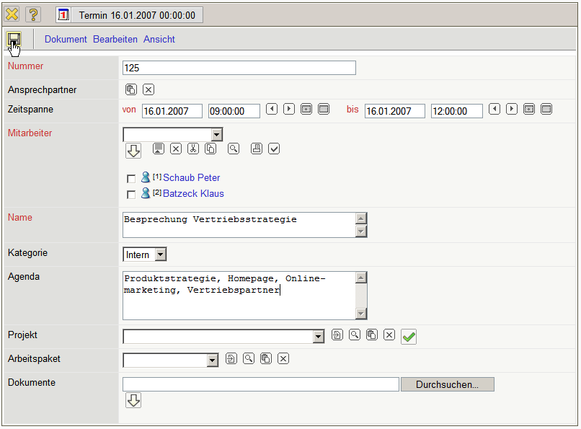
... and is automatically accessible in the calendar. The assigned employees receive a message through the internal system.


