3.04.2 Document Administration "Flyer"
Projectile contains in the optional Groupware-Module an integrated document administration. By using document administration, index structure can be created in the web-server and files can also be transferred and administrated. The document administration contains personal folders and project folders. This folder-structures are completely liable to the authority of the system.

Request of document administration
The Flyer is either requested directly from the function bar of the job field (here as a personal folder of the user) or over a project by using the button (if there are files in the project folder) or (if there are no files).
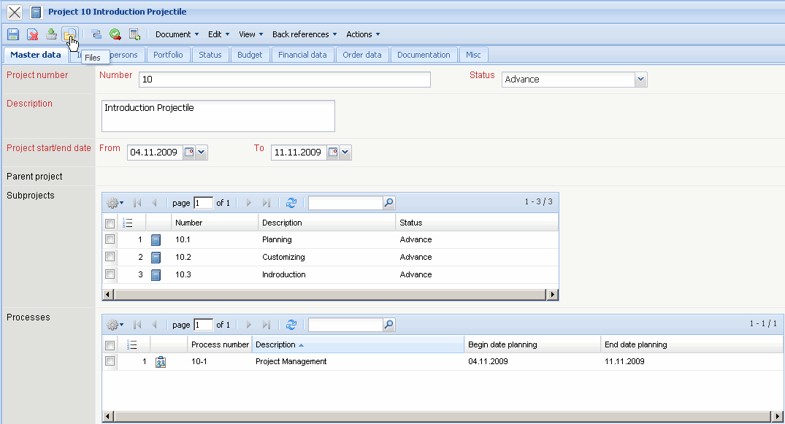
In the example the project folder for the project 106 (BS06) opens with three documents.
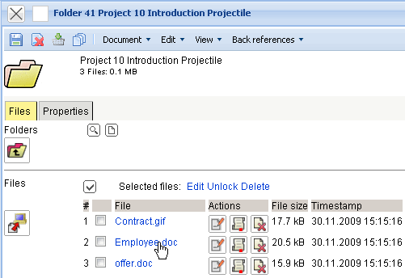

Using document administration
In the following example, four files are copied in the web-server for the project 92 QM-Modul by using Flyer .
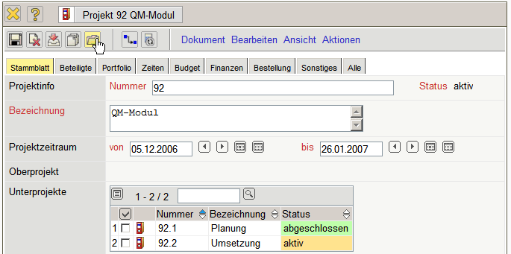
The button “Upload” opens a dialog ...
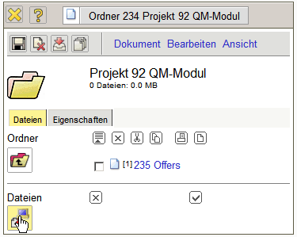
... to choose local files and to copy and administrate them in the web-server. In the upload dialog indexes can be created. In the following example, in the folder of the project ...
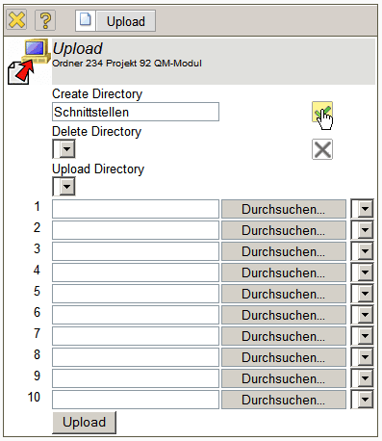
... an index “Interface” is created.
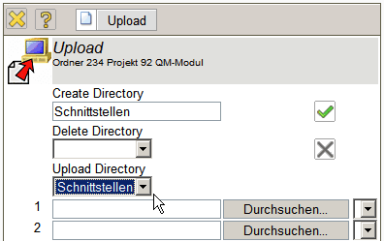
In the new index (Element Upload Directory) any files can be now copied. If this index is not chosen, the selected files are directly copied in the folder. By using the button “Search”, files for the upload can be selected in the following step.
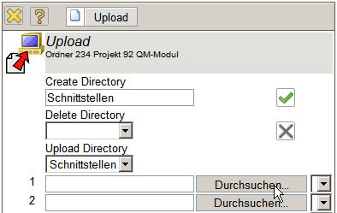
At first a standard dialog for opening files is opened.
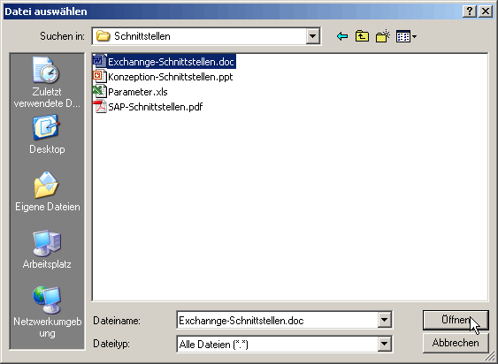
Afterwards the desired file is marked and it is transferred by clicking on “Open”. In the example the file exchange-interface.doc is chosen. Further files can be analogously selected for the upload.
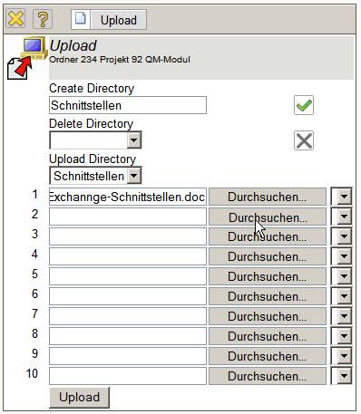
After this selection, the copying process is operated with “Upload”. The selected files are transferred by the system into the web-server in the folder (or into the associated index).
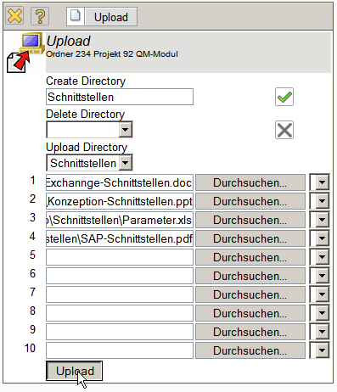
The folder of the project 92 QM-Modul contains now four files. The transfer of the files into the web-server is accordingly journalized.
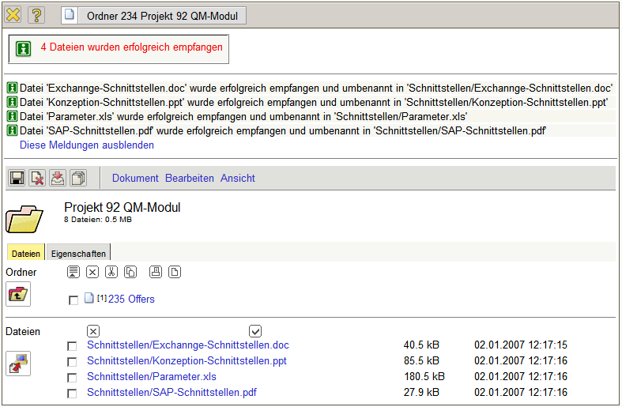
Files, which are not needed in the Flyer, can be deleted with . In the example the file Parameter.xls ist marked and ...
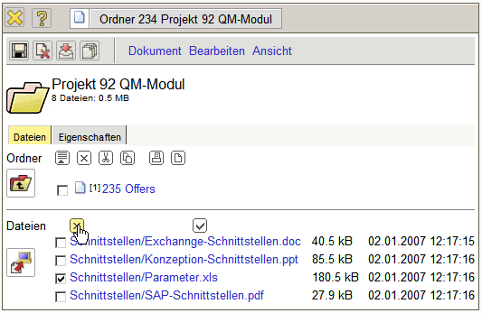
... deleted out of the Flyer.
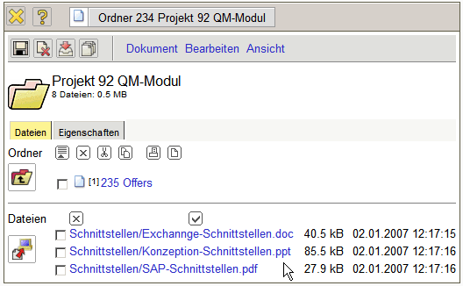
In the link characteristics the files can be provided and described with keywords.
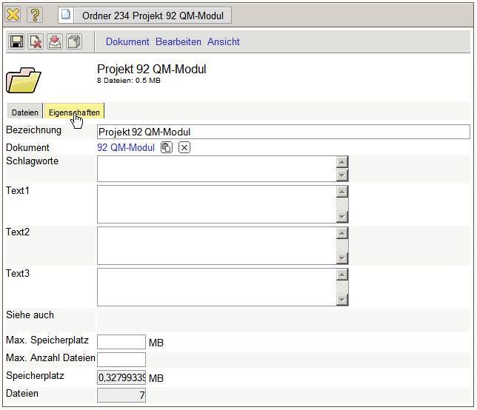
Moreover, so-called quotas can be assigned. Quotas limit the number of files per folder and the disk space
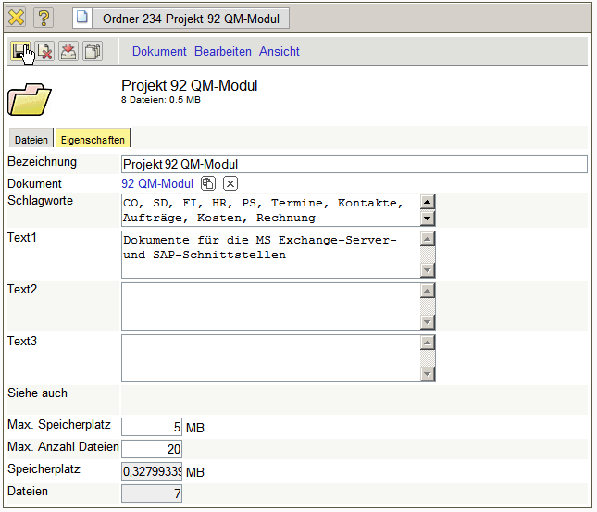
The documents, which are administrated in the Flyer, can usually be opened directly or stored locally.
Note: Depending on the operating system and used browser, some file types can not be displayed usefully (in MS Internet Explorer for example CSV- and MS Project-Files).
In Flyer, by using the magnifying glass, a folder-structure can also be searched.
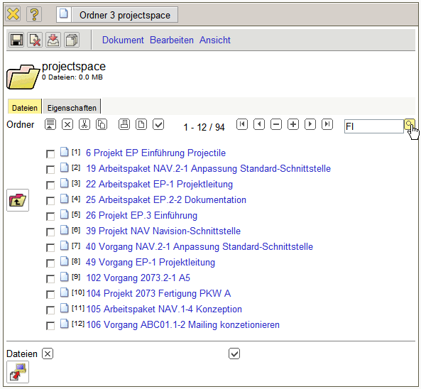
All file names and characteristics (key-words, descriptions,...) are searched. The administrated files can not be searched by the contents.


