Array Array

3.04.1 Mail System "Mailer" (Continue)

Using the Mail System
The following example will illustrate the functionality of the mail system.
Internal mail, in addition to the actual message, can include many optional Projectile forms. This form will be created as links in the mail and can be opened from the recipients of the message (if an appropriate authorization exists). In the example, the message contains a reference to an action, which the receiver ...
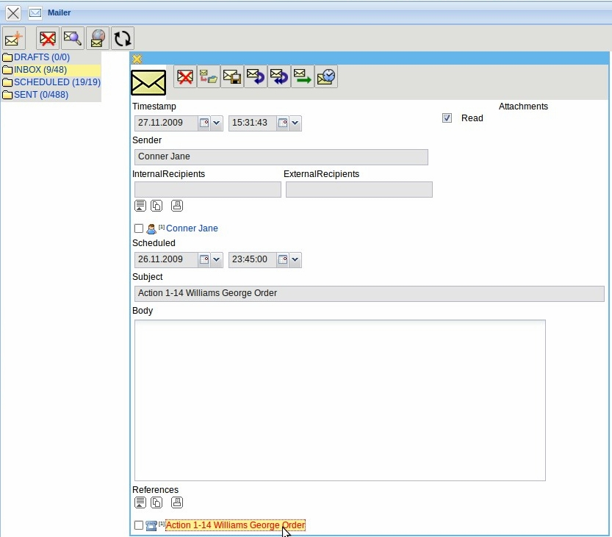
... can open through the link.
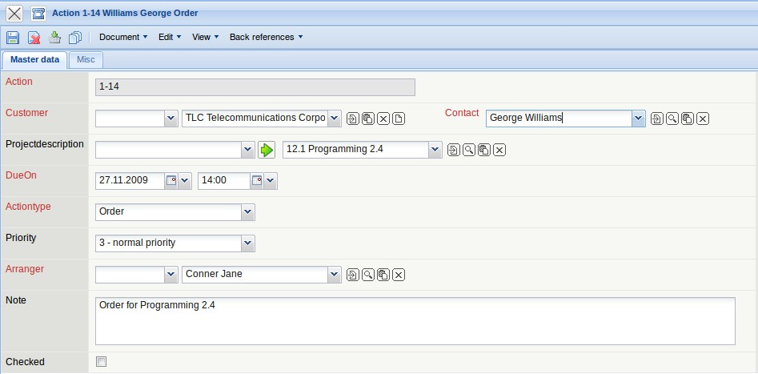
A received message can be answered by using the function “Reply”.
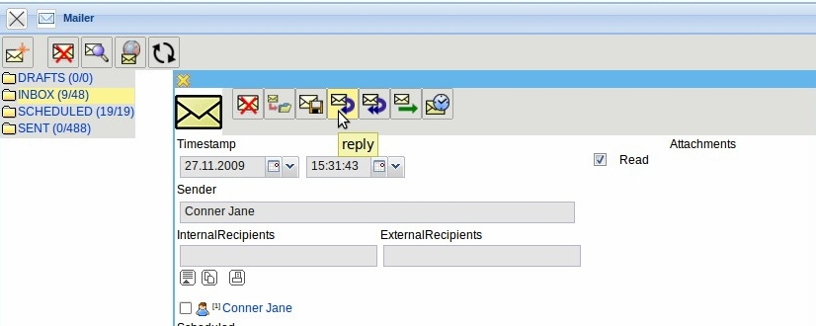
This functionality creates the response. Here the receiver of the response is entered as the sender and the subject and the text of the message is changed.
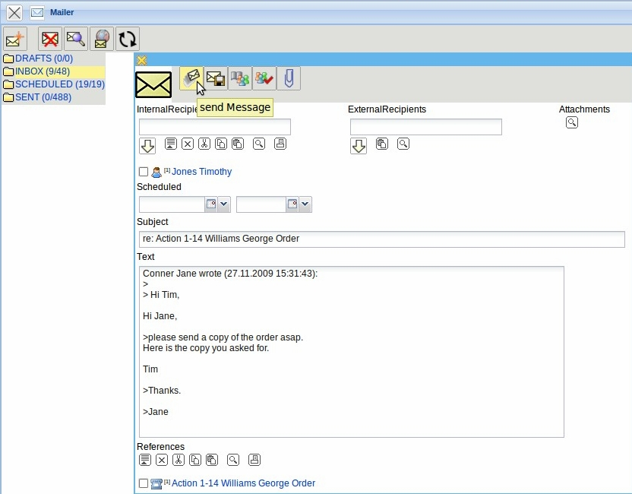
By using the functionality “Send message” this message is sent to the recipient (here Timothy Jones) and sending report is created.
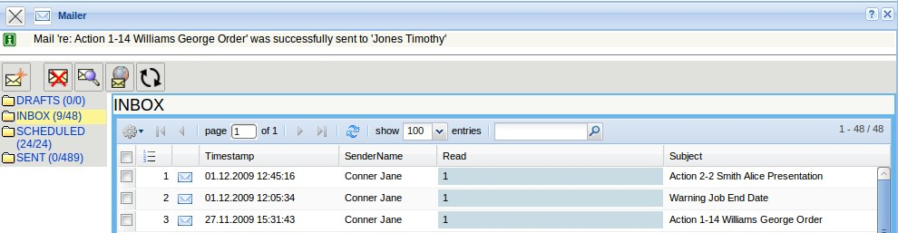
In the work area of the user Timothy Jones, the message will appear with the next action in the system. Note: The message will not appear immediately, because the user is possibly making a transaction (for example, creating an invoice or charts), which could be interrupted with the mail.
Clicking on the appropriate e-mail message row will open the internal notification.
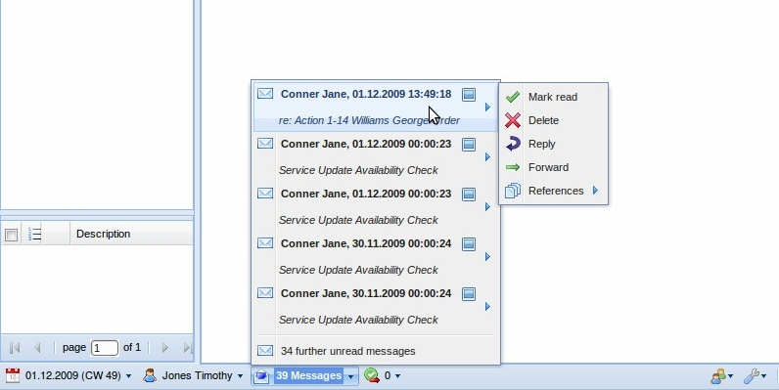
A received message can be answered by using the function “Reply All” . By performing this, not only the sender receives a reply, but also the other recipients of the message.
By using the function “Forward” the received message can also be added to the functionality “Rply” and it will be sent to a different receiver.
{{:handbuch:kapitel_3:forwardmail.gif?nolink
Messages can also be moved into selected (existing or new) folder. In the following example, the message is moved by Timothy Jones in a folder “Actions”. First, the functionality “Move” is performed.
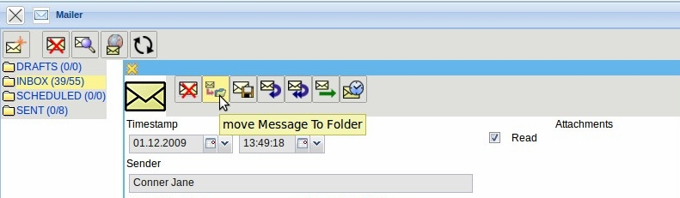
This functionality opens a dialog, where an existing folder can be selected or a new folder can be created. In the example, by using “Move”, a new folder with the name “Actions” is created...
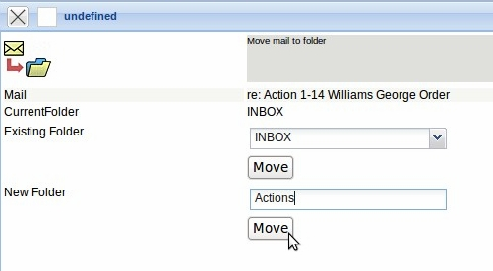
... and the mail is moved into this new folder.
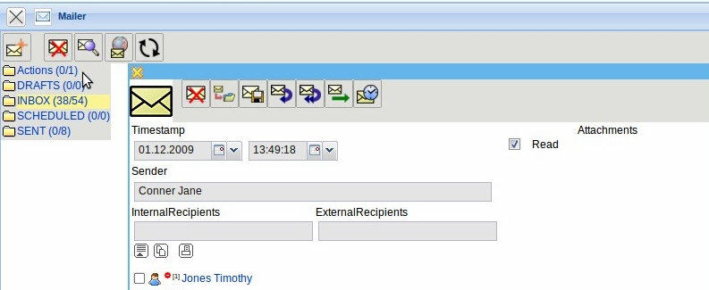
By using the functionality “New Mail”, a new message can be created.
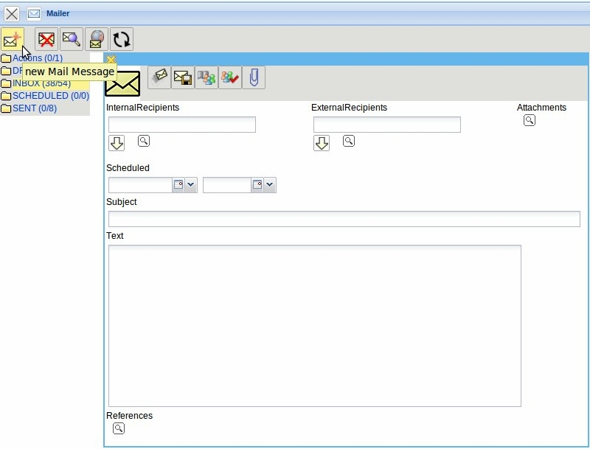
In the central area of the mail system a new message is opened. First the recipients are defined for this message. In the input field 'recipient', the recipients of the message can be entered manually or by using the address book. When manually entered, the recipient will be written into the input field and the input will be confirmed (many multiple recipients can also be defined).
By using the functionality “Check Address” , the mailing address of the recipient can be matched with the data in the system.
The address book contains...
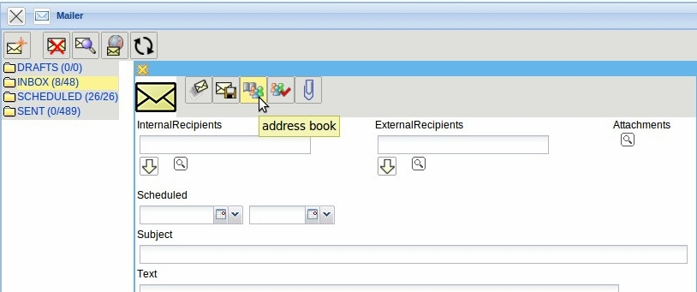
...the relevant master data in the system (contact, contact person or employee), that are loaded appropriately via the selection box.
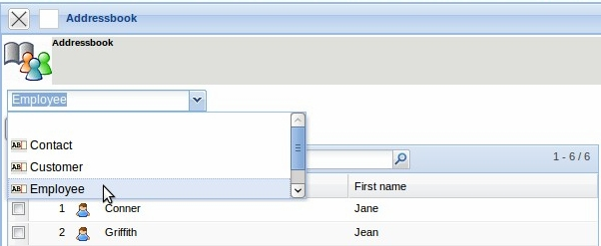
After selecting the recipients (here from the group of the employees Jean Griffith and Timothy Jones) and confirming with “Include selection” ...
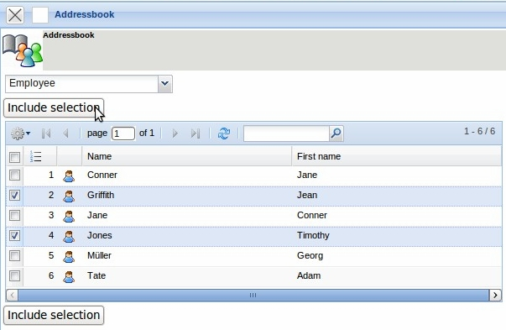
... the recipients are transferred in the new message. Afterwards the subject and the text of the message is entered. If the message defines external attachments ...
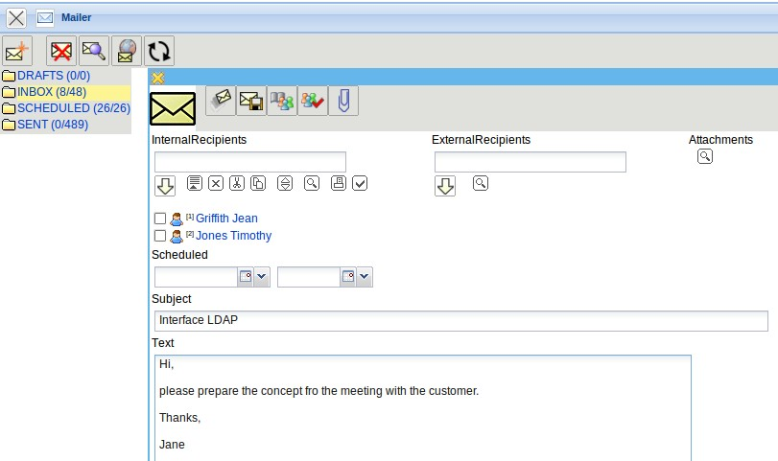
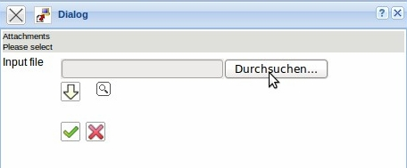
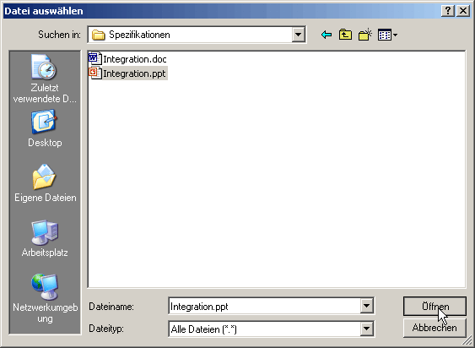
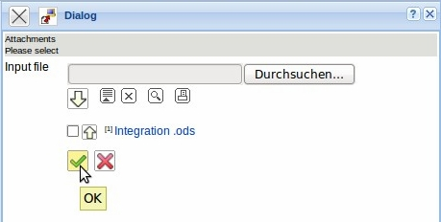
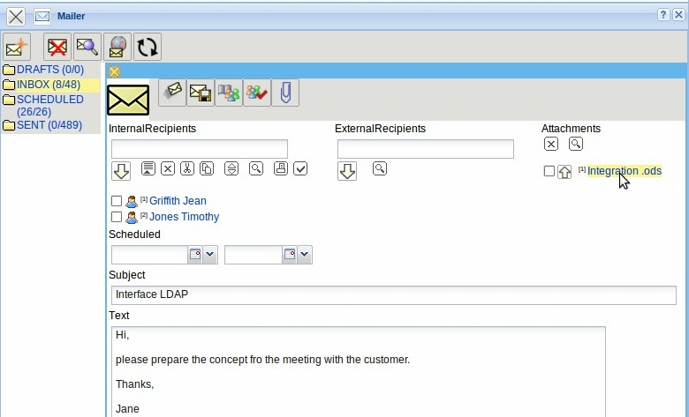
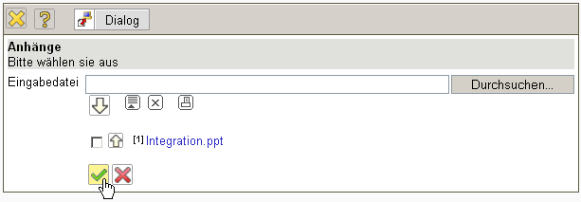
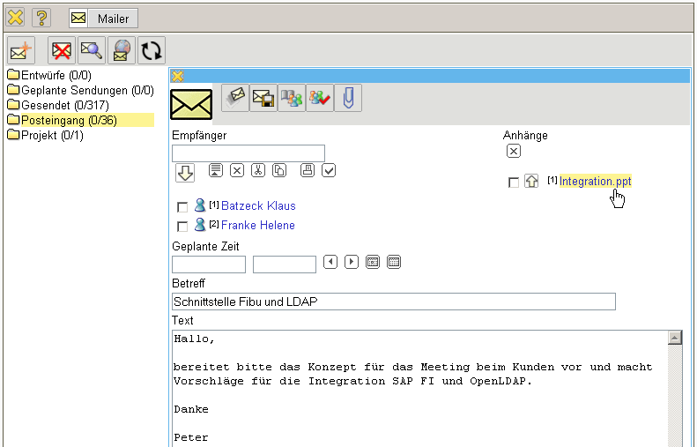
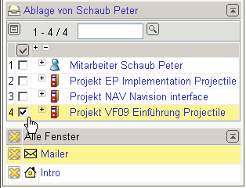
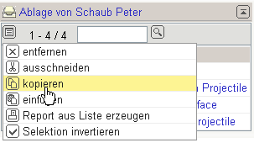
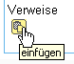
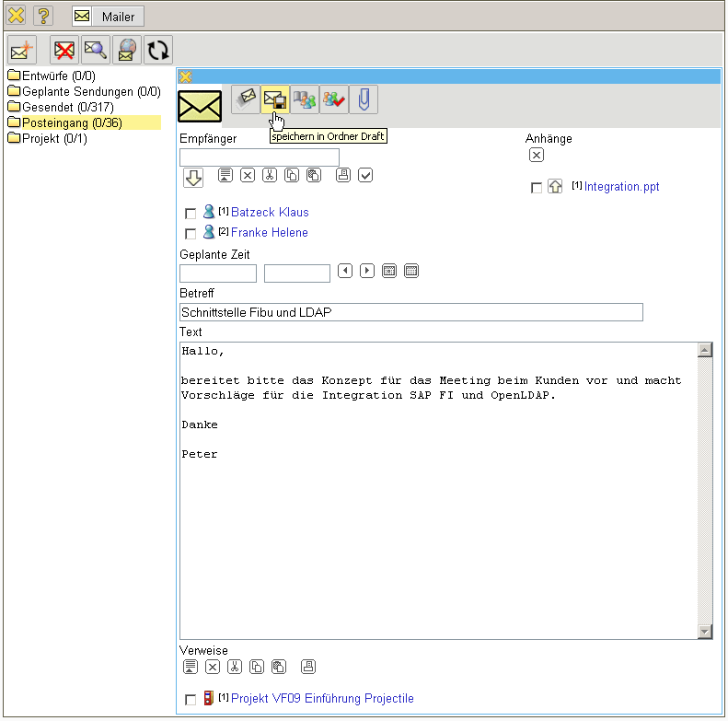
... references for the mail. These references can be any Projectile-document and can be selected for example from the personal clipboard, or by using the search engine.
In the example, the project QA09 from the personal clipboard is marked, copied and is pasted into the field reference.
By using the functionality “Send Mail” this message will be sent to the recipient and ...
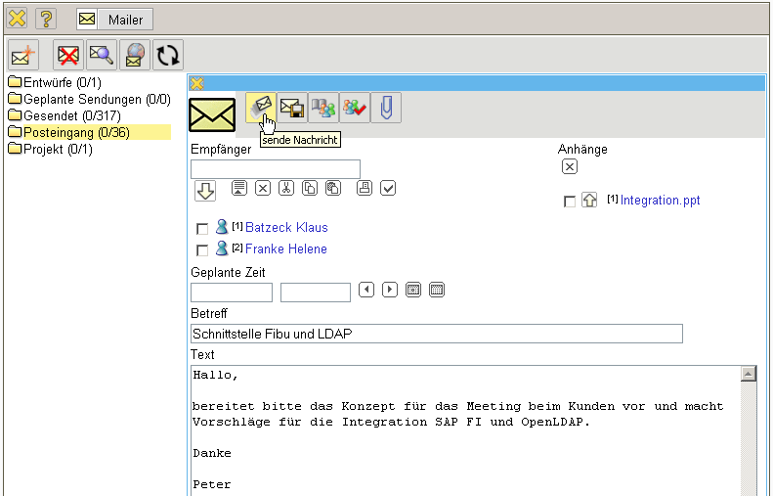
... a transmission report is created.
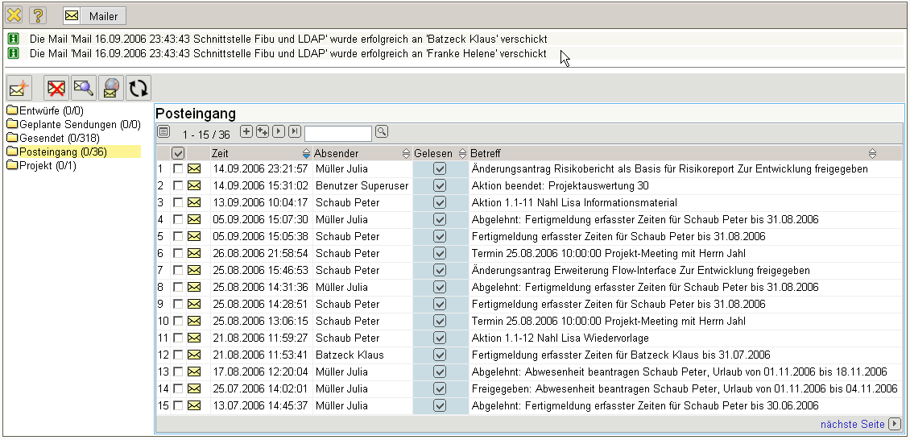
In the mail system, messages can be deleted. By using the functionality “Delete Mail”, all marked messages in a folder are deleted and ...
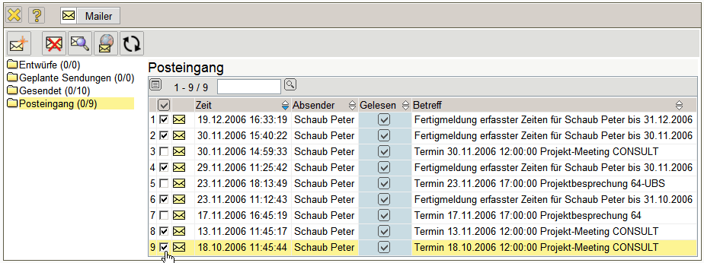
... after confirming the warning dialogue ...
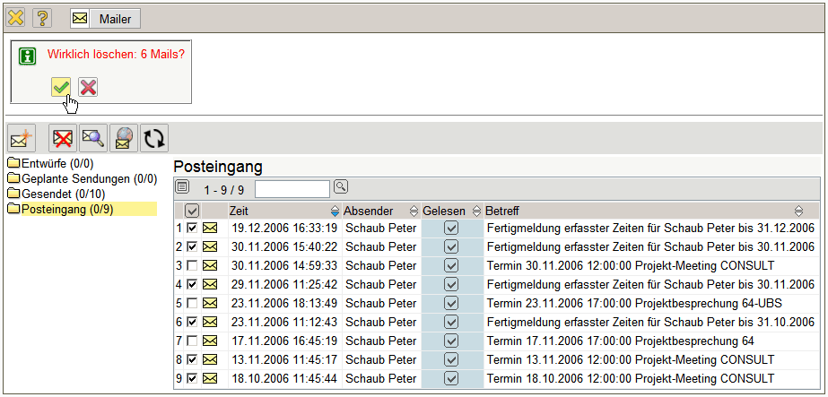
... they are permanently deleted.
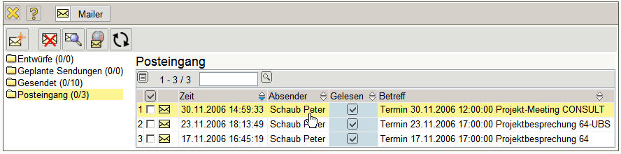
By using the functionality “Find Mail”, messages from the system can be ...
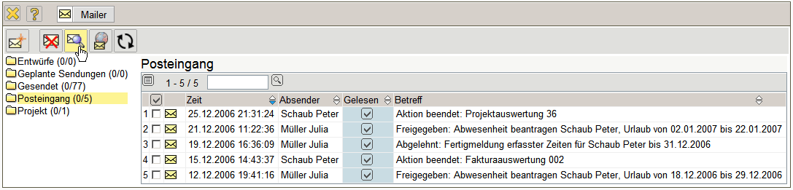
... found by using the search dialog. In the example, all messaged, which ...
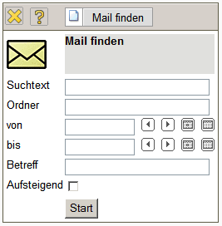
... in the subject line or the text “holiday” and it is since 15.12.2006 in any mail folder contained...
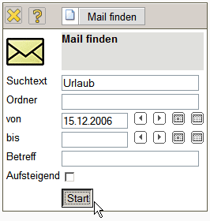
... found and listed.
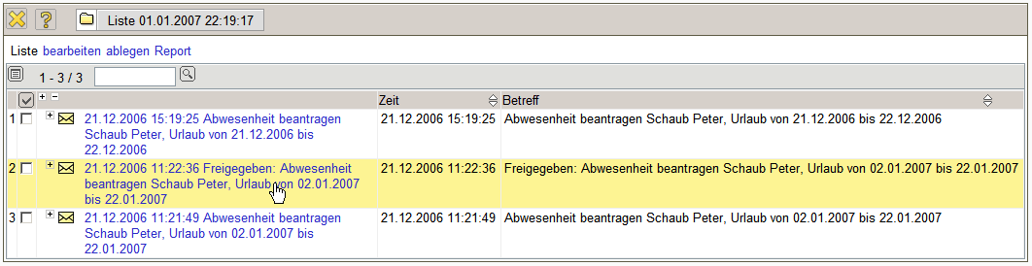
...Continued

