3.04.1 Mail System "Mailer"
Projectile contains an internal and external functionality in the optional Groupware-Module. Using the integrated mail system “Mailer”, e-mails and short messages (SMS) can be sent within the system. The internal e-mails can link directly to any document in the system and automatically generate messages for resubmission (see also contact system) or reminders for appointments (see also Team-Calendar). Furthermore, the mail system is integrated in the contact system and employee administration.

Opening the Mail System
The mail system is either opened in the navigation bar of the work area ...
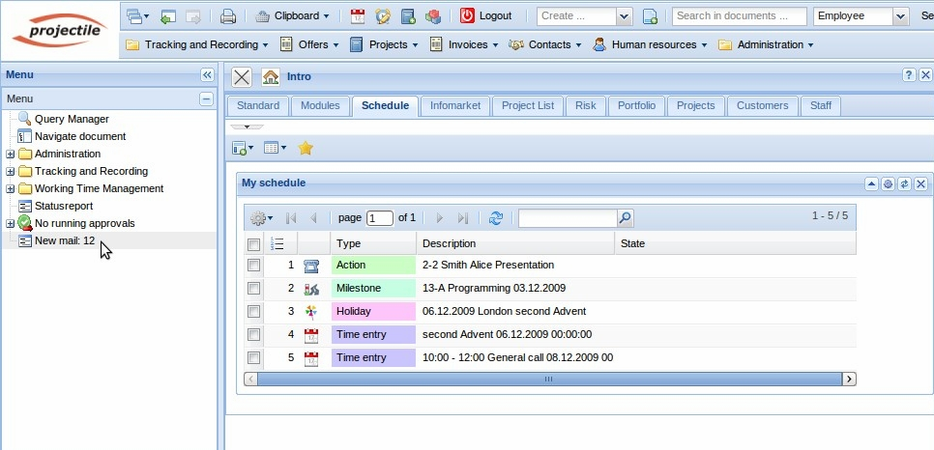
... or opened through an e-mail. Using an e-mail can be deleted unread, using an unread e-mail can be answered, using an e-mail can be marked as read ...
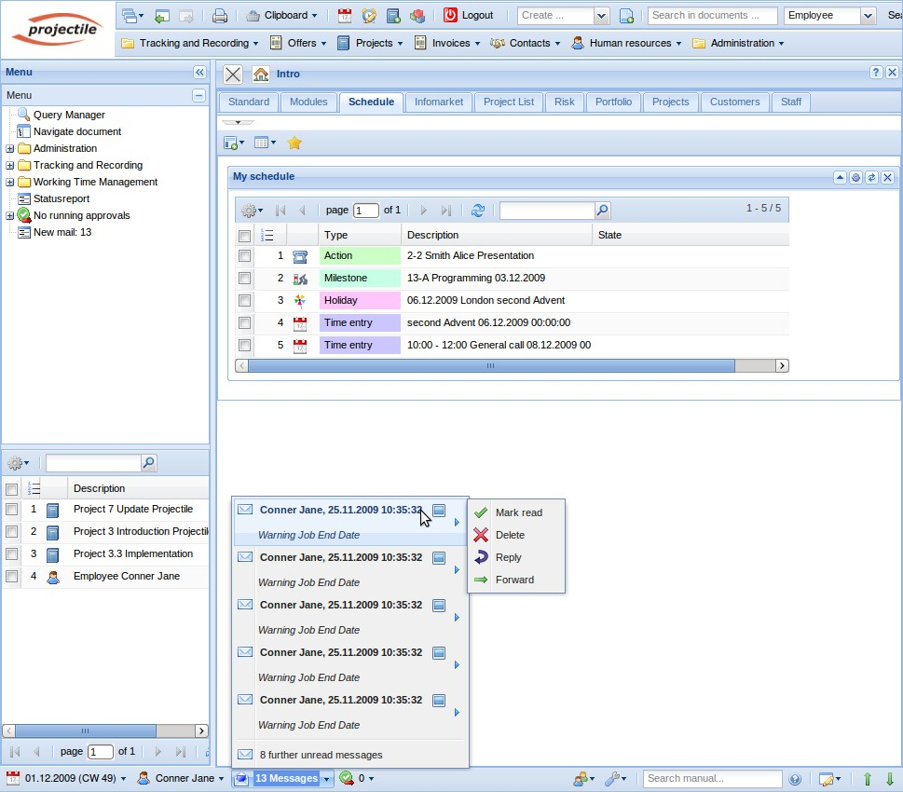
... clicking on the appropriate e-mail row opens it.
The mail system can also be directly opened through the navigation bar. If there are no new (unread) incoming e-mails, the mailer is displayed with the button and otherwise displayed with the button. In the example, there are unread e-mails in the mail system and after clicking the button, the mailer is opened with the newest unread message in the inbox folder.
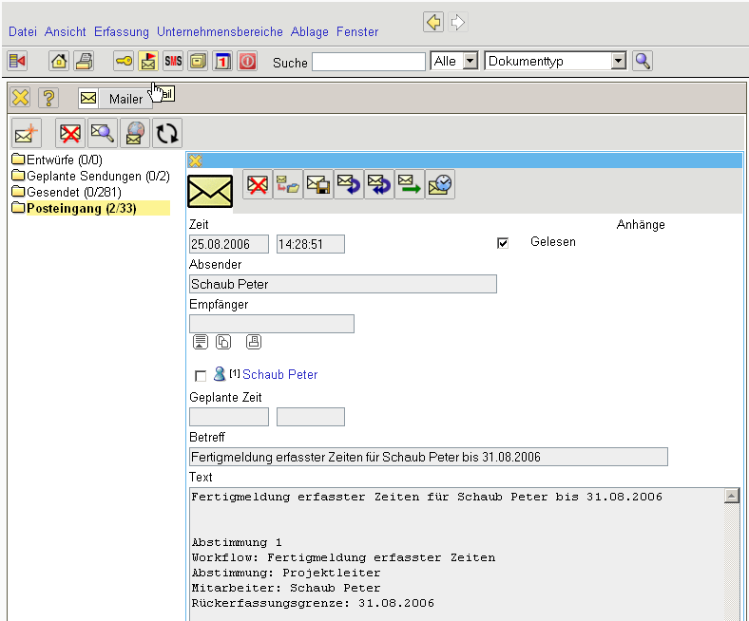
Using the e-mail can be set to resubmit. In the dialog, resubmit can be set to minutes, hours or days, as well as an absolute date element.
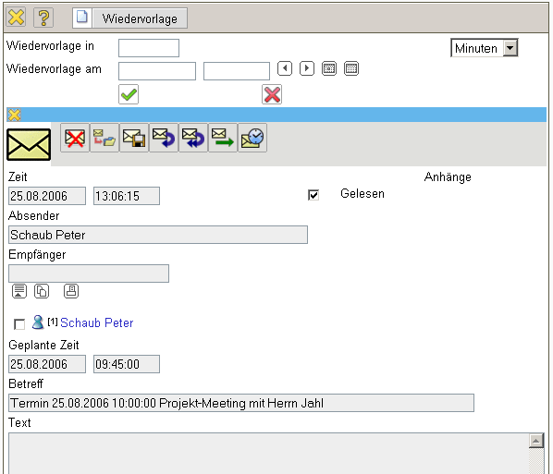
In the example, resubmit is set to 10 minutes, ...
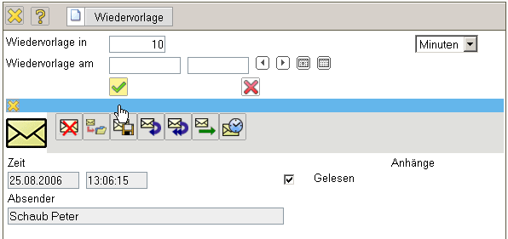
the user is then informed and ...
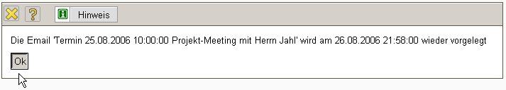
... the message is then displayed ten minutes later.
Note: The message is displayed with the first action in the system using this time, because the screen is not automatically updated.

Elements of the Mail System
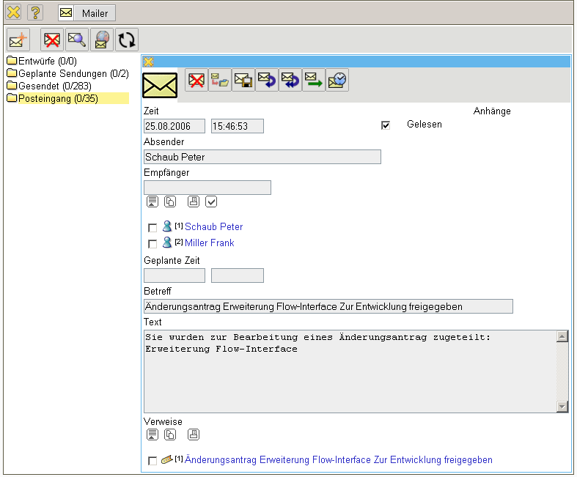
The mail system contains the following buttons in the function bar:
Function | Term | Description
 | Send Message | Using this function, the opened message is sent to the recipient. After the message is sent, a transition report is displayed.
 | New Message | Using this function, a new message is generated.
 | Check Address | Using this function, the addresses of the recipient is checked.
 | Save Message | Using this function, the opened message (usually a draft) is saved.
 | Delete Message | Using this function, an opened message is deleted.
 | Add Attachment | Using this function, one or more attachments can be assigned to an opened message.
 | Move Message to Folder | Using this function, an opened message can be moved to a (existing or new) folder.
 | Reply to Sender | Using this function, an opened message can be answered for the sender only.
 | Reply All | Using this function, an opened message can be answered for the sender and further recipients.
 | Forward | Using this function, an opened message can be forwarded to a further recipient.
 | Resubmit | Using this function, the incoming messages can be displayed in n minutes, hours or days or for defined times again.
 | Address Book | Using this function, the address book is opened.
 | Find Message | Using this function, the mail folder is searched.
 | Import Mail from External Server | Using this function, external e-mails can be called through the configured POP3-Server in “employee”.
In addition, the system consists of folders for drafts, scheduled messages and reminders, sent e-mails and received e-mails and/or inbox, and possibly user-defined folders.
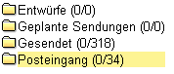
In the central area of the mail system an active message is illustrated and ...
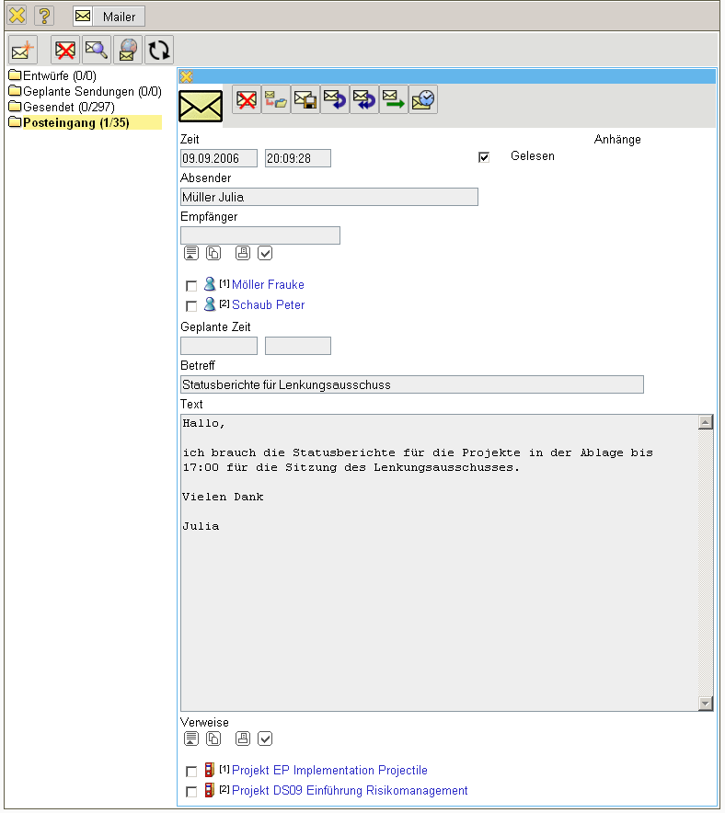
... in the bottom area the active folder with the corresponding message is illustrated (!!!!!!hier ist der aktive Ordner der Eingangsordner und es werden alle empfangenen Mails aufgelistet).
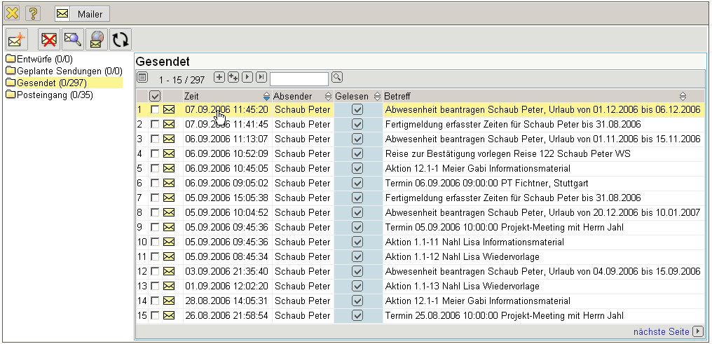
...Continued

