Array Array

3.03 Forms and Form Elements (continued 1)
The forms consists of several fields, which can contain data type ’text’, numbers, boolean values, date/time, the list of values and links to other forms. Currently, the following fields or element types are available:

Write-Protected Fields
Write-protected fields are for example with key fields (sort key of the data record...
...left (left to other documents, here to a project)...
... and with input data, which should not be changed (for example status information).

Editable Fields (single or multi-line):

ComboBoxes (Selection-Boxes) with Contents of the Documents or Collections:
Selection boxes (ComboBoxes) are filled out either through Projectile-data (as here with employee) or they are use from the Collections (see administration guideline).
These Combo-Boxes (Selection-Boxes) contain all the employees (or all active employees according to configuration) and they are listed alphabetically.
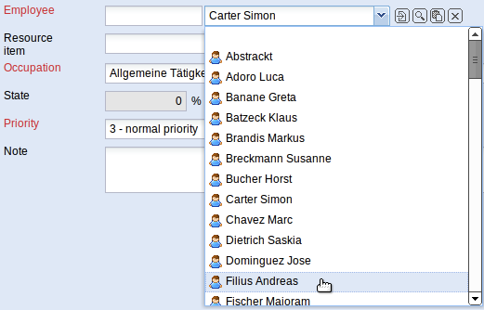
By using the link-functionalities it can be linked directly to the selected document. With . . . all data records of the type is displayed and they can be transferred as single-selection or as ComboBoxes. With . . . copied data records of the same type can be inserted and with . . . the assigned data record (input in the combo-box/selection-box) can be removed.

Checkboxes for Displaying Boolean Value:
The checkboxes have two conditions: true (check mark) or false (empty). In the example the attribute ‘Private’ is given.

Date Elements
The month elements contain (besides the possibility to enter the date manually) four further functionalities:
One month back ...
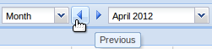
... and scroll one month ahead.
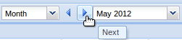
To set the current month ...
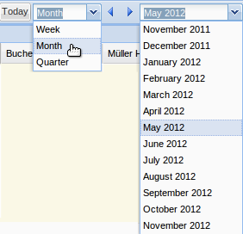
... as field content and to activate the calendar element.
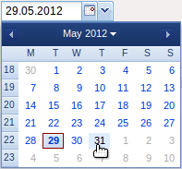
In the calendar element you can scroll one month ahead or one month back (inner arrows) or a year ahead or a year back (outer arrows).
By clicking again on the calendar element, it will be closed.

Time fields with Information about Hours and Person Days:
With this type of fields, the entry can be done either by hours (h) or by person days (Pd). After saving the document the missing value is completed.
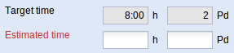
Here the estimated time/effort can be entered in person-days (2 Pd) and ...
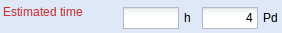
... after saving, the system completes the entry in hours (here 4pm/16:00)
If the time/effort has to be entered in hours, the system completes the number of person days after saving the document.

Currency Fields (if necessary with details in the local currency and the second currency):
With this type of fields the entry can be made either only in the local currency (here EURO) ...
... or the entry can be made in the local and second currency (here EUR and US Dollar).
In the example the second currency is changed into US Dollar (USD), the amount of 100 USD is entered and after saving the document the missing value ...
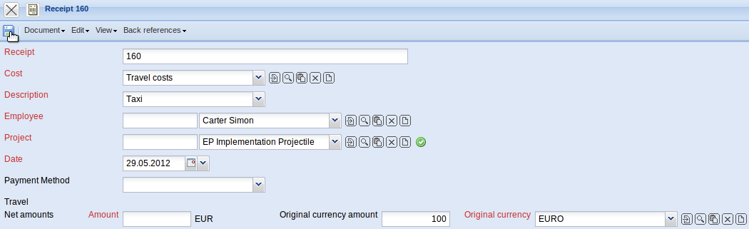
... completed (the local currency EUR).
This functionality can be also used throughout the system for all currency fields. The local and the second currency is administrated in the document configuration. The option second currency is in administration => system (see also administration guideline).
... continued page 2

