3.02.5 Search and Find
The search engine finds searched data. Through entering a search string in the quick search field (here, Projectile) and clicking the magnifying glass, the complete data pool can be searched using this string.
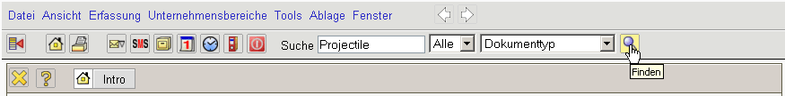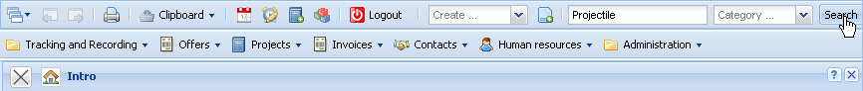
Since a query search can take some time to search all the data in the system, an appropriate warning is displayed.
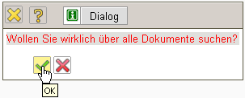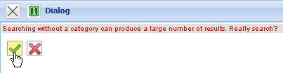
The following illustration displays a possible return list in the search query: In the return list all documents are listed, in which the defined search string “Projectile” exists.
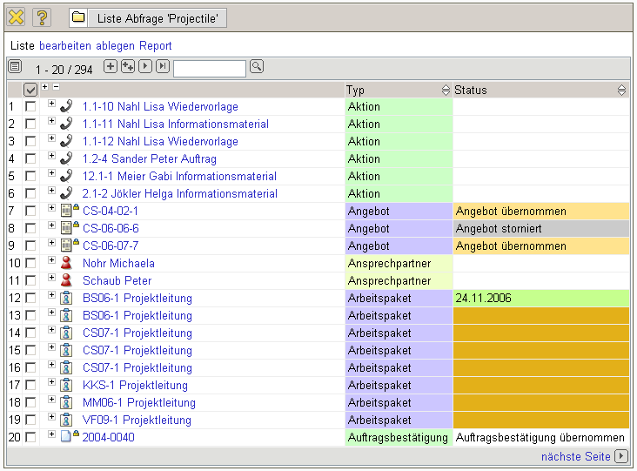
These return lists can be changed for further usage ...
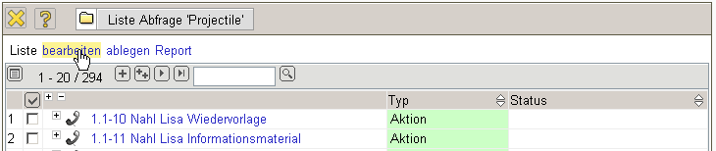
.. and saved (“Projectile Query”).
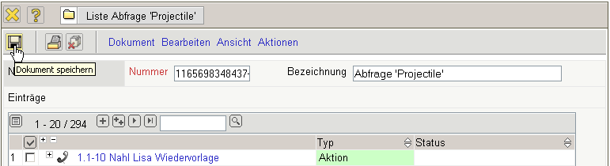
In the result set, the back and forward button and/or jump to first or last document can be found in the navigation bar. In the example, a result list of 294 entries are displayed, where the first 20 documents (1-20) are visible. Clicking the small triangle in the navigation bar ...
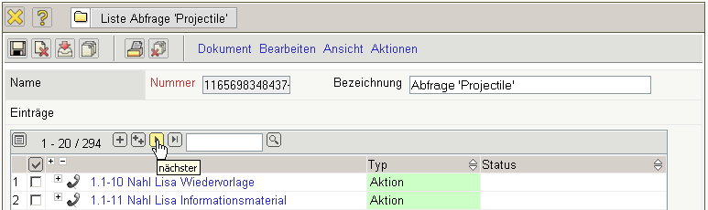
... displays the next documents 21-60 automatically.
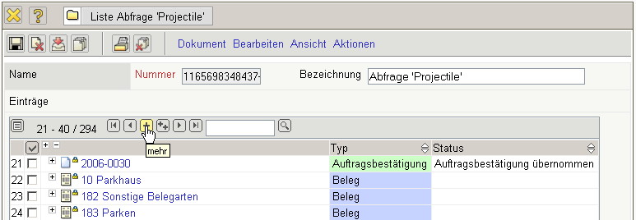
Using the function further 20 results can be displayed (i.e. 40 after the first click). Using the functionality once again further 20 results per result list are displayed. Accordingly, the functionality reduces the amount of results in the result list.
... are displayed. Clicking a link in this result list (here, Projekt EP Einführung Projectile) ...
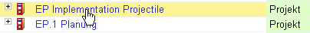
... can be direcly navigated to the appropriate document.
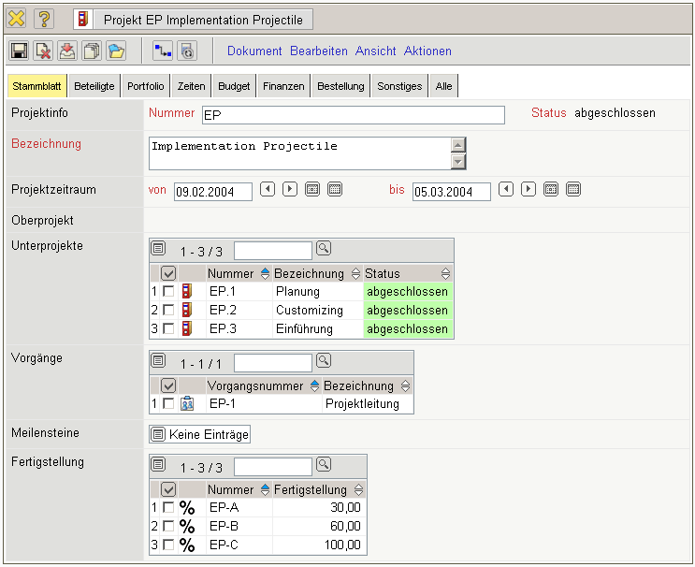
Using the functionality in the window bar, an opened form can be reclosed.
The second example for using the document search displays the possibility of searching for a certain string within a document type (catagory), which further limits the search: In the example, the user would like a list of all documents of the job type, in which the string “Development” exists ...
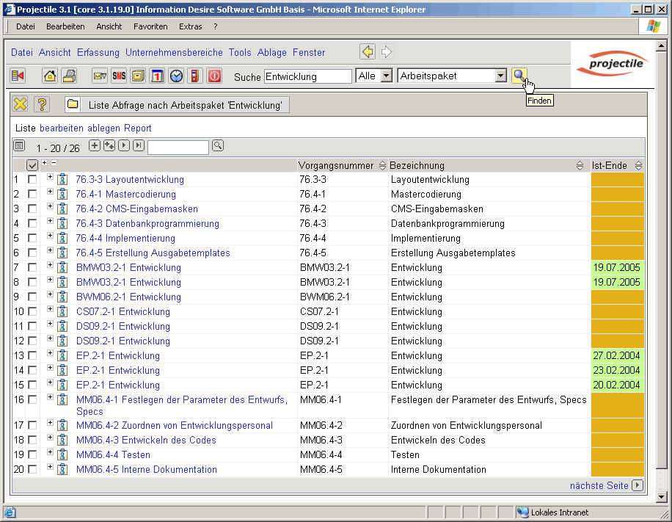
... and all jobs in the result list are displayed, which contain the term development. It is irrelevant if this string is in the description or in any other element of the document.
The search can be further limited within the result list. In the entry field a string can be entered and the be “found” for the row. After clicking on ...
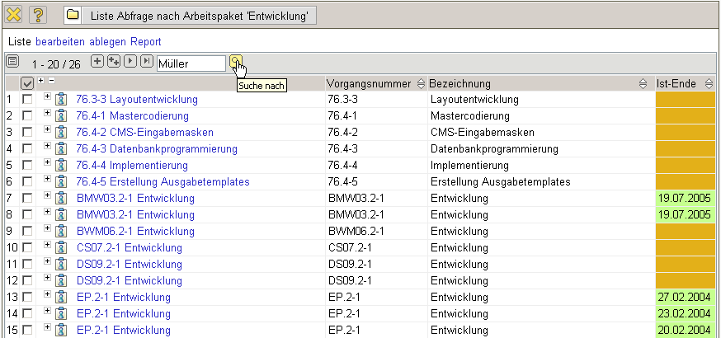
... the system searches within the return list ...
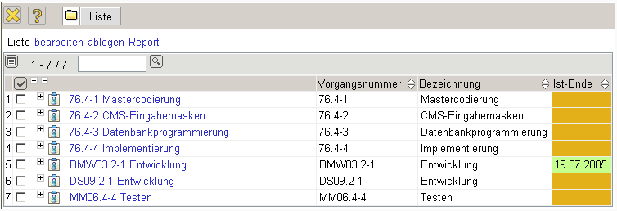
A further possibility to find and open a document, is the personal clipboard. Through clicking on a link from the personal clipboard, a document can be directly opened.


