3.02.04 Alternative Work Areas
Projectile offers the user up to eleven intro screens. The first screen is the standard screen, the second intro screen is the module view and all further views can be configured by the user.
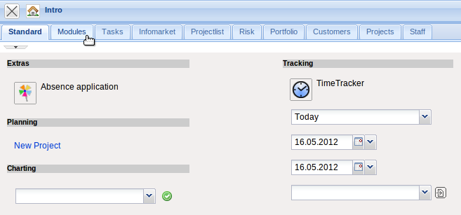
Besides the standard view, the module view is also provided. In this view all available functionalities (which are dependent on the access permissions) are displayed as processes. This view is opened through clicking the tab.
The application can then be used by clicking on the element in the process overview. In the example, the user changes to the “tracking and estimation” view ...
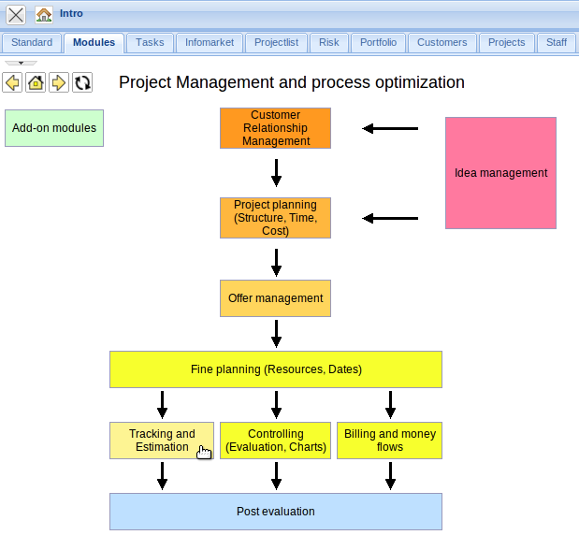
... and to the module “Time tracking” and then ...
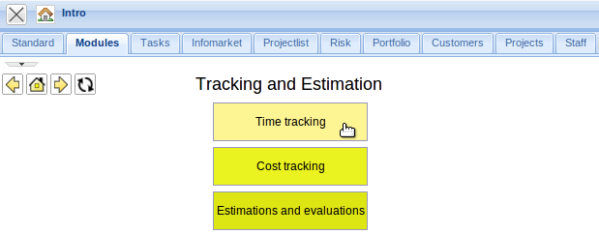
in the functionality “Time tracker - today”.
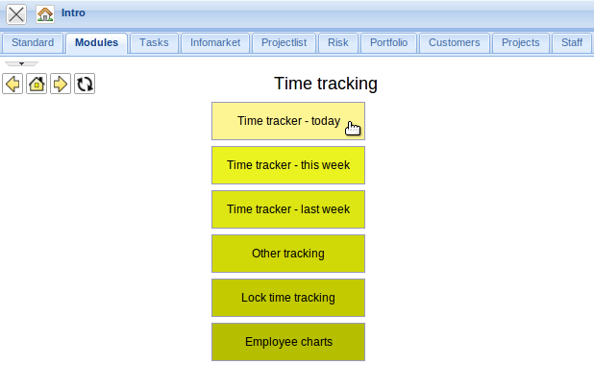
The TimeTracker opens to the current date:
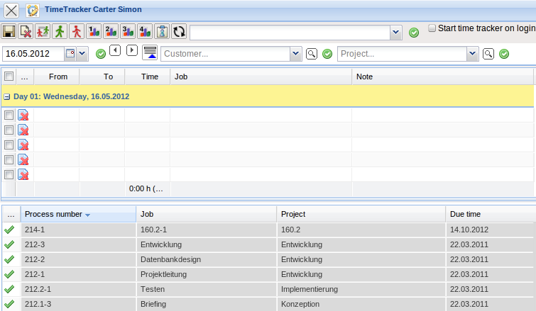

Intro Screens Set-Up
Using the option “My Intro” each user can directly access all important overviews and reports generated from the user. The intro screens can be configured through the properties function. Here, various intro screens can be named and the plug-ins can added. In the current Projectile version, various personalized intro screens and further functionalities for these intro screens are available, for example, for appointments (including actions, milestones and jobs) and queries from advanced search (Profi-Suche).
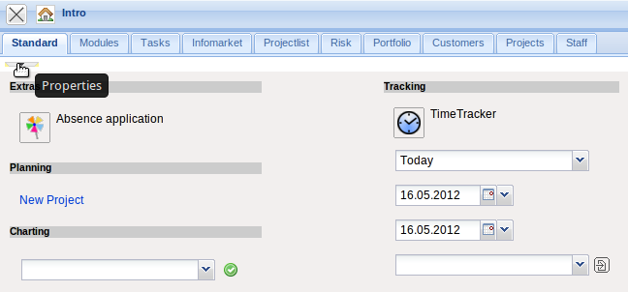
In the beginning, the empty intros look like the following:
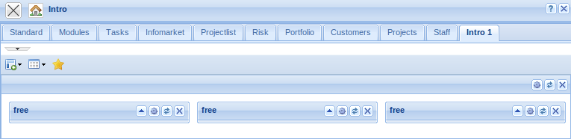

Design-Modus
The individual intros can be configured. Change to the tab to be configured and then click the “properties” button:
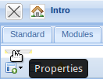
The name can then be changed ...
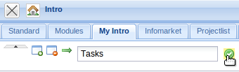
... and the entry is included after clicking the green check mark.
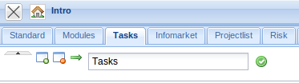

Adding Contents
In the lower part of the intros, contents can be defined, which can then be displayed. Predefined forms as My projects, Your tasks, My dates and the modules Info market and Classic intro can be selected.
Selecting an entry, for example, “Your tasks” ...
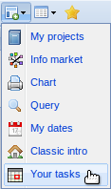
the form is displayed on the left column:
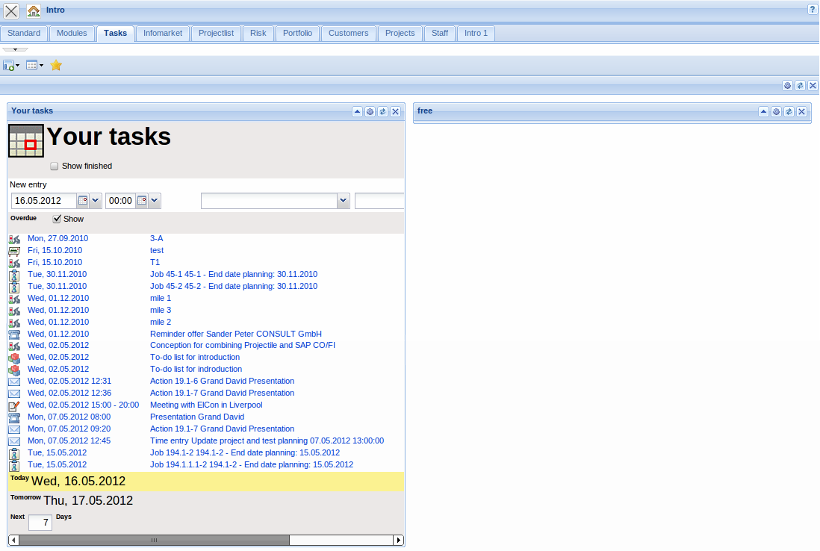
The My project form is added here.
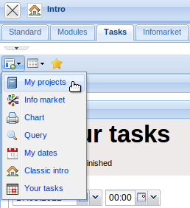
This can be moved per Drag&Drop ...
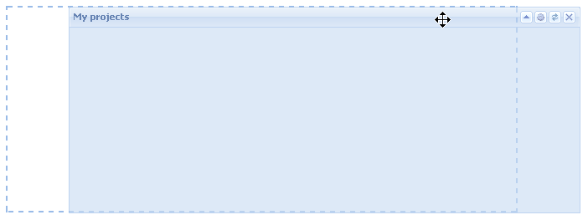
to a different area ...
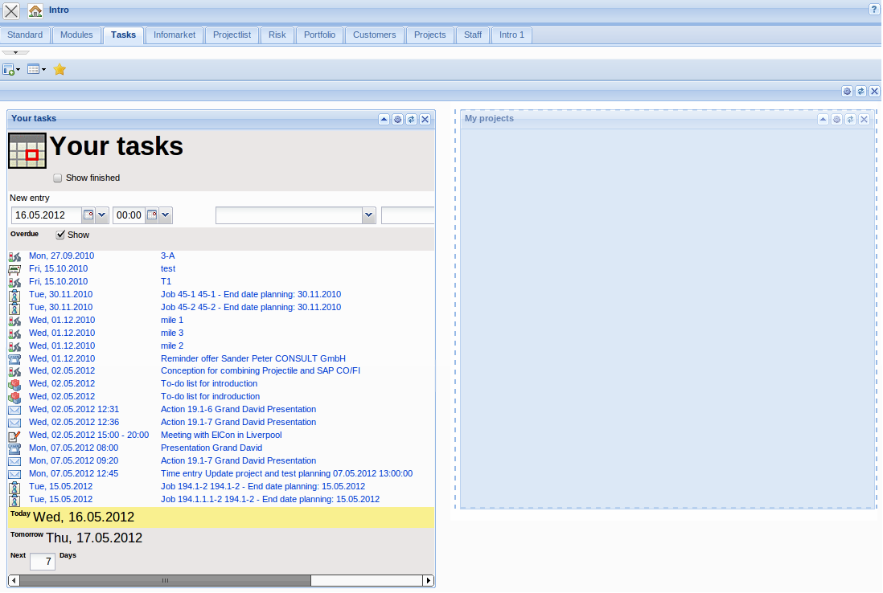
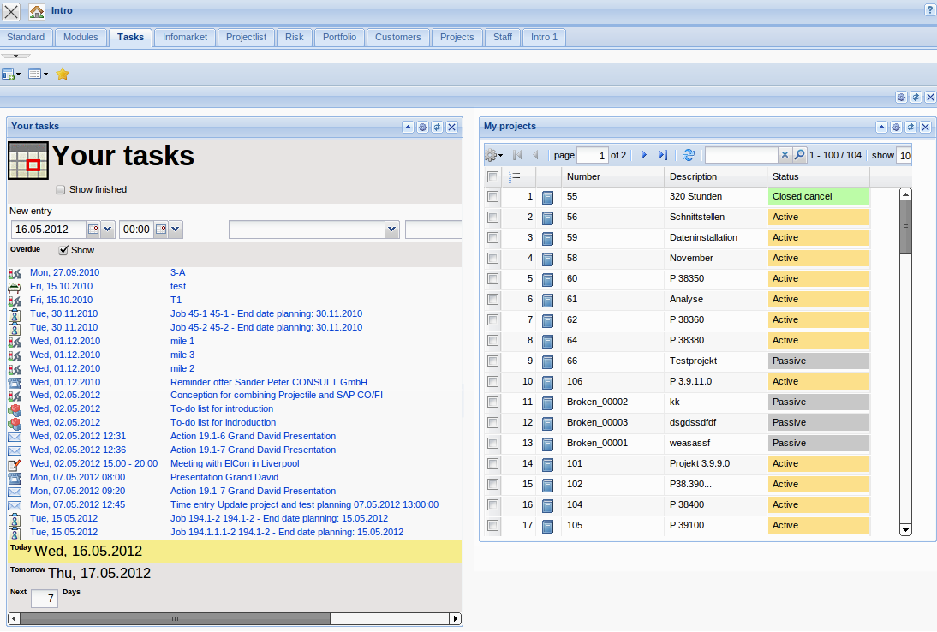

Possible Settings
The 2nd button on the lower toolbar defined the amount of columns which should be displayed.
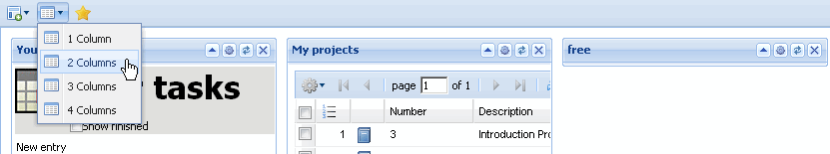
By changing the columns from 3 to 2, the view changes the existing modules:
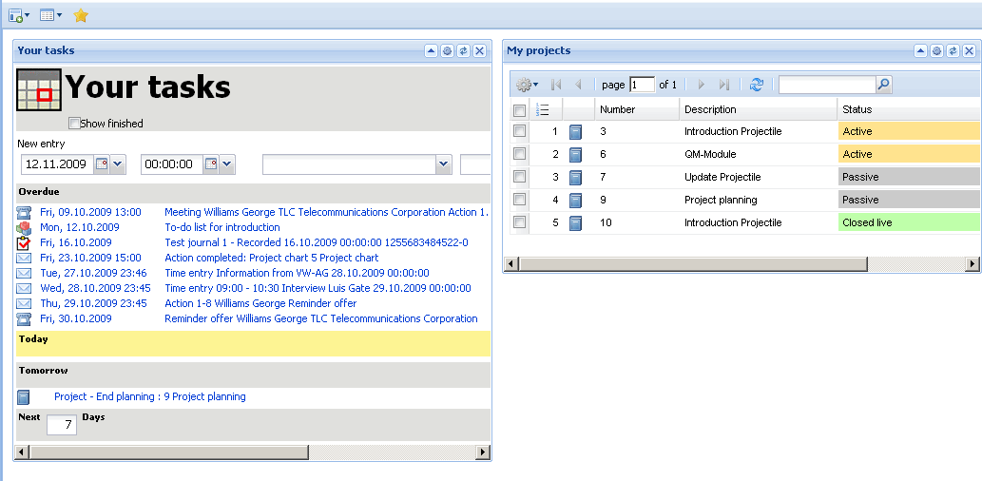
By clicking the favorite button ...
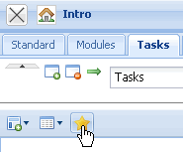
the current tab becomes the standard tab, i.e. when logging in, this tab is always opened first.
In the top menu bar, further tabs can be added ...
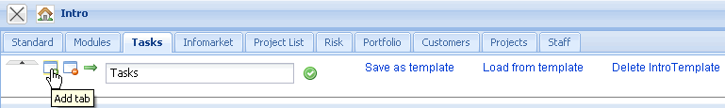
which are included on the right.
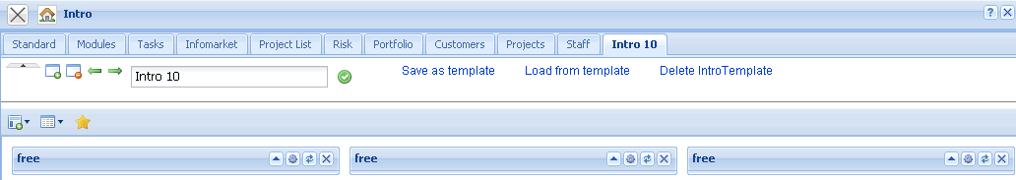
Tabs can also be either deleted ...,
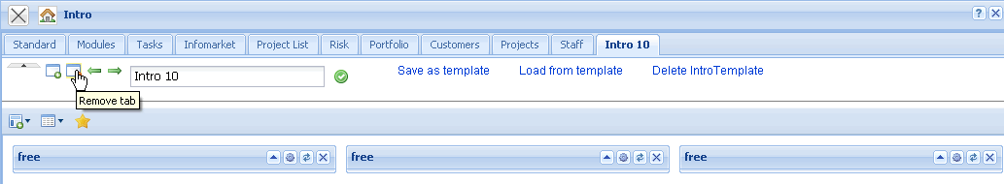
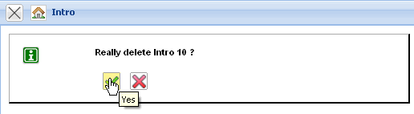
moved to the left ...
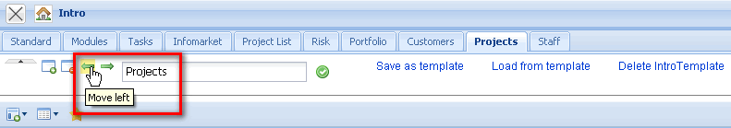
or moved to the right.
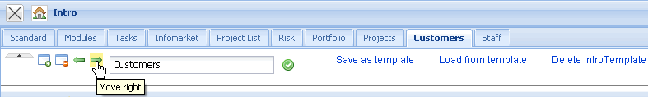
The intro configuration can be saved ...

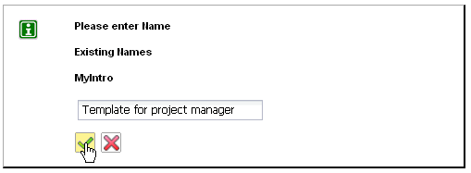
and existing configurations can be loaded ...
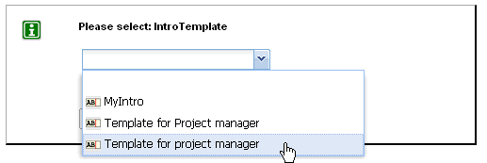

Adding Charts
On the intro screens, charts can be displayed. In the configuration of the intro screen, “Chart” can be selected in the menu bar.
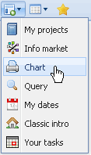
An empty chart screen is then displayed on the left.
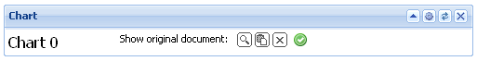
Using the function “Find available documents” all saved charts are displayed ...
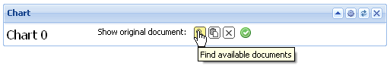
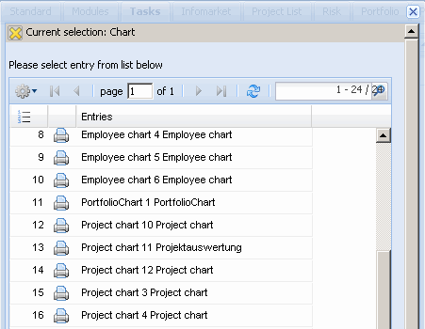
and assigned.
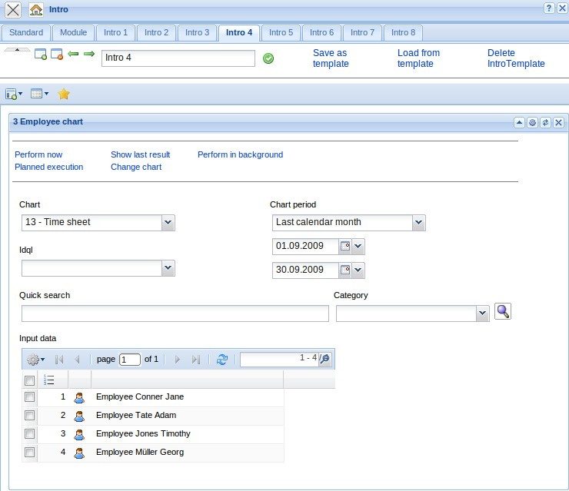
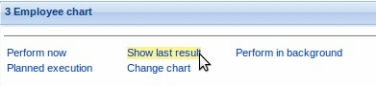
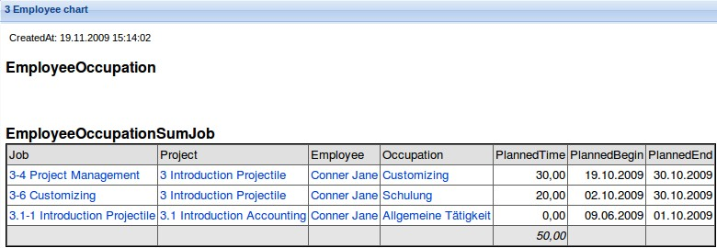

Settings
Click on the gear wheel symbol on the screen at the right ...
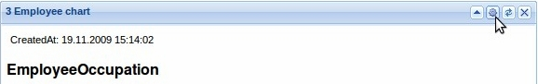
... shows the chart configuration screen again.
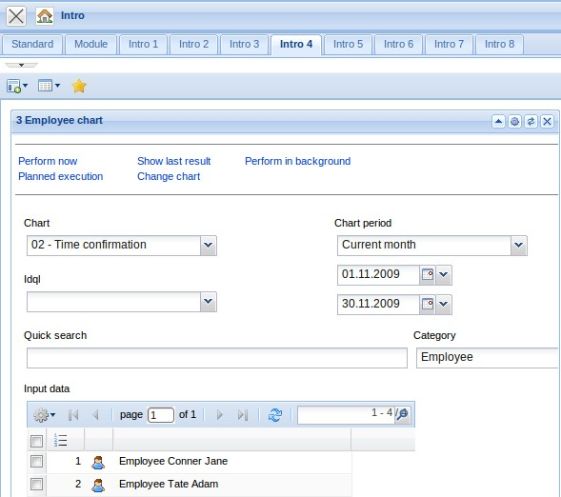
Clicking on the reload button directly next to the right ...
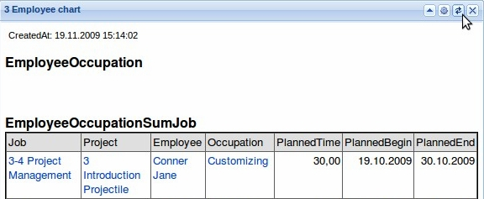
gernerates the chart newly. The x closes the window.
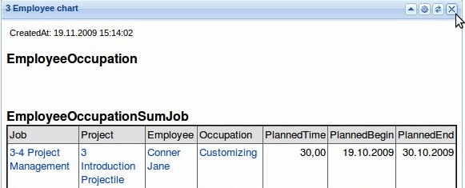

Queries
Using the query selection ...
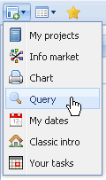
a new screen opens which displays the queries. Here, all existing queries can be directly allocated for which the logged on user has permissions.
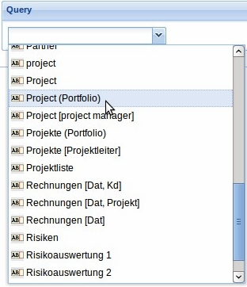
After selecting the query the result is immediately displayed.


