3.02.2 Window Manager
A list of all open screens are in the lower part of the work area - the window manager. The listed screens can be opened directly or through this list. In the example, work area (Intro), are listed in the window manager.
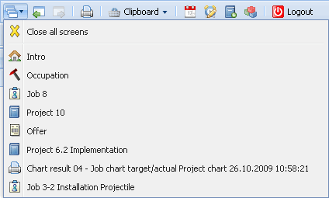
One item in the list consists of the close button for all opened screens and the items for opened screens with a link to the form. Changing to a form in the list, an item link is used ...
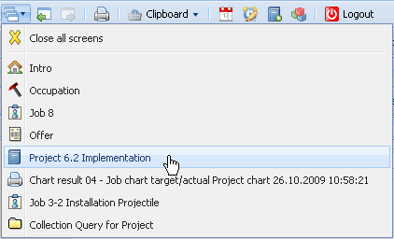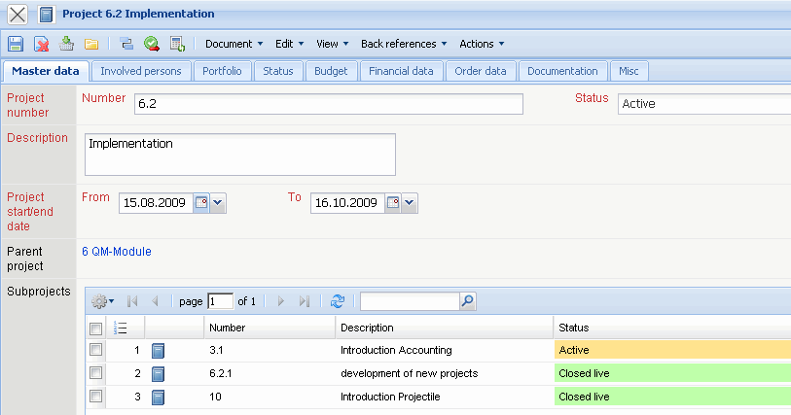
... and the appropriate document (here the project MSP) is opened in the left part of the application.
To close a document in the list, the close button can be used ...
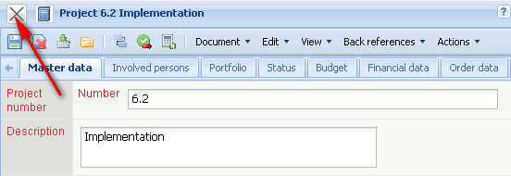
... and the appropriate document is then closed.
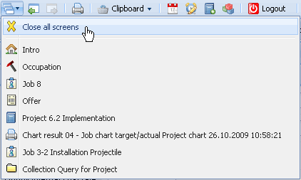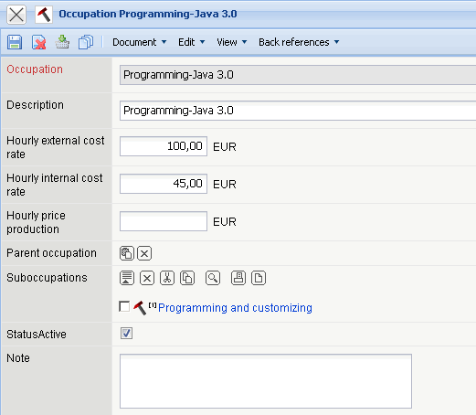
Using “ Close all screens” all opened screens ...
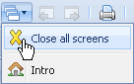
... excluding the work area (Intro) are closed. Alternatively, using the “Home”-Functionality in the top menu bar ...

... or the button , Intro can be opened at any time, without closing all windows.
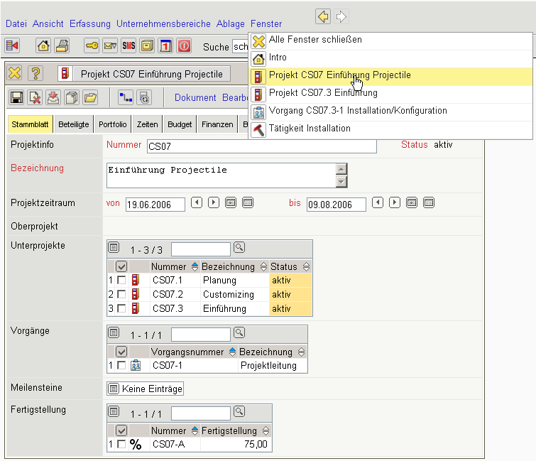
All functions that are available in the menu bar of the window manager:

