3.02.01 Personal Clipboard
The personal clipboard of the logged on user is located in the bottom area of the left navigation menu. Using the personal clipboard, a user can administer his/her data as browser favorites. In the example below, the personal clipboard with the documents (Project 1 Introduction Projectile 2.5, Project 3.1 Introduction Accounting, Project 3.2 Projectplanning, Project 3 Introduction Projectile and Project 7 Update Projectile) are displayed:
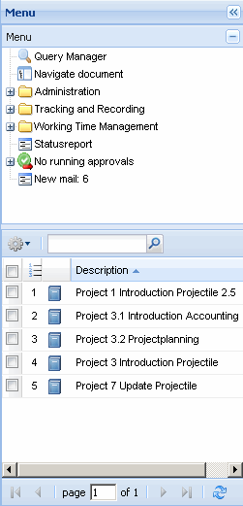
For editing fields with multiple assignments, as in the personal clipboard,there is a central button for all editing functions (delete, cut, paste, create, create report,...) and the search window for full-text search. This button opens with either mouseover (default) or clicking the button.
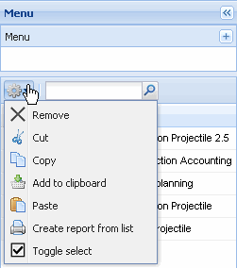
The following tools are available for editing the clipboard:
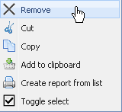
Remove entry (and not copied in the cache memory), cut entry (and copy to the cache memory), copy the entry in the personal clipboard, add entry to clipboard (when data is in cache memory), create report from list (using Report Maker) and invert (toggle) entries (all selected entries are not marked or vice versa).
Entries can be either removed or cut from the clipboard. The difference: Using cut, the entry is copied to the cache memory and is available for the pasting. To remove entries from the clipboard, these entries are marked ...
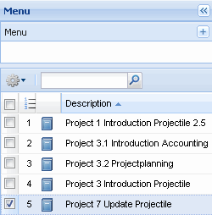
... and then through clicking on remove, the entry ...
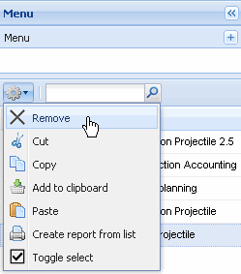
... can be removed (here Project MSP).
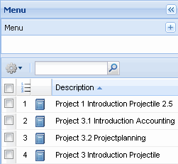
When using cut, the entries are removed, but then held in the cache memory, so these entries are still available for pasting.
Entries in the clipboard (or search queries) can also be copied. When marking the entries ...
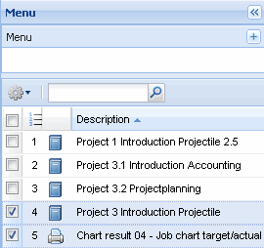
... and copying ...
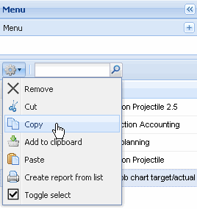
... the appropriate entry is copied and ...
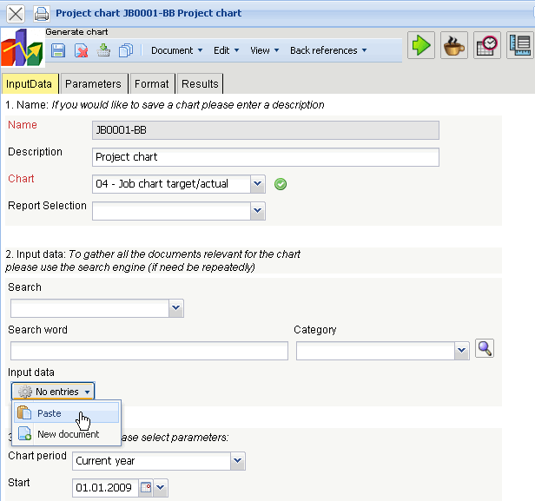
... can be pasted to a different element. When clicking paste, the copied entry is then copied to the selected element.
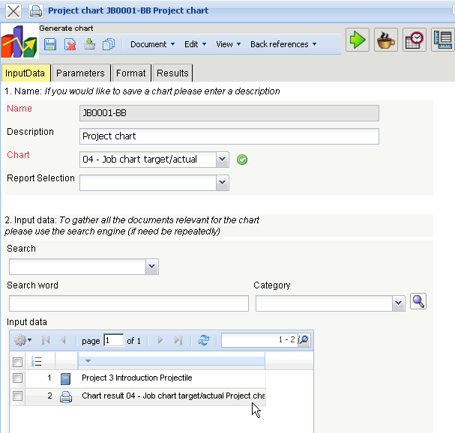
In the example two projects have been transfered from the personal clipboard into project charts.
The functionality inverts the active selection, i.e. all unmarked enteries are marked ...
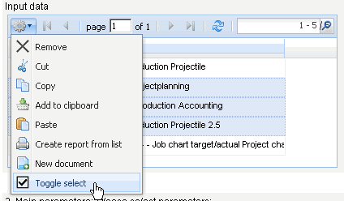
... and vice versa.
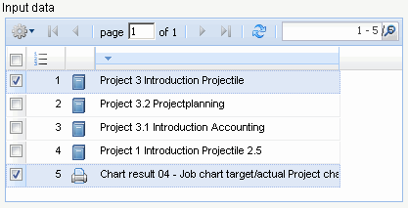
The personal clipboard can be opened in the top menu bar. In the entry “Clipboard” a function ...
... “Open Clipboard” and the contents of the personal clipboard can be found.
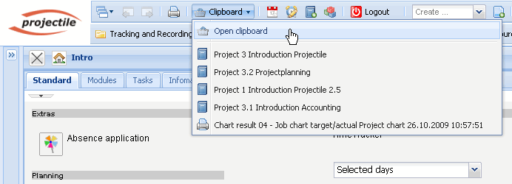
The function “Open Clipboard” opens the personal clipboard of the logged on user ...
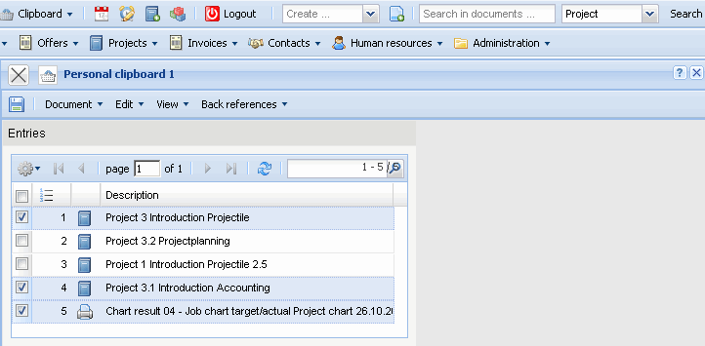
... and clicking the entries of the clipboard (here Project) ...
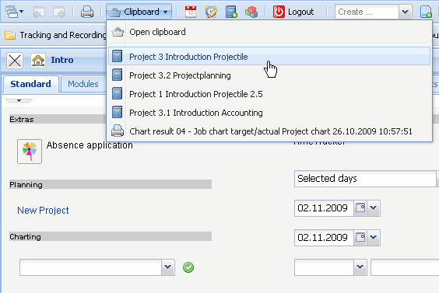
... opens the form of the stored data record directly.
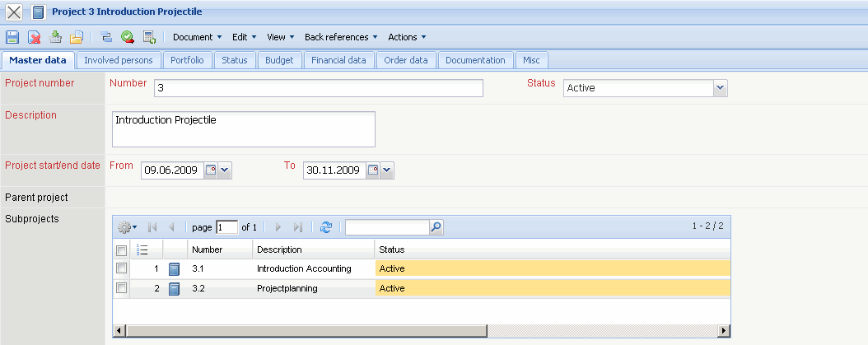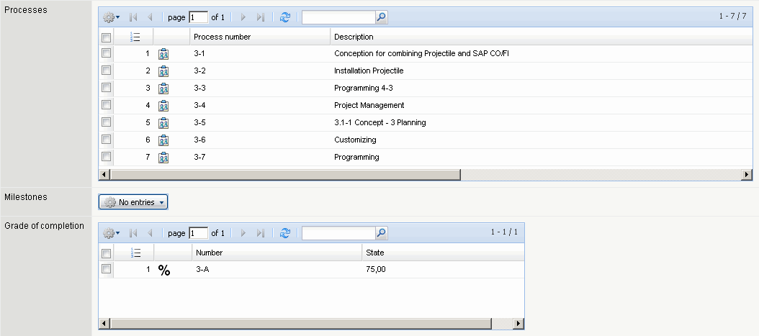
Opened documents can be directly transfered into the personal clipboard using the symbol . In the example a project is directly...
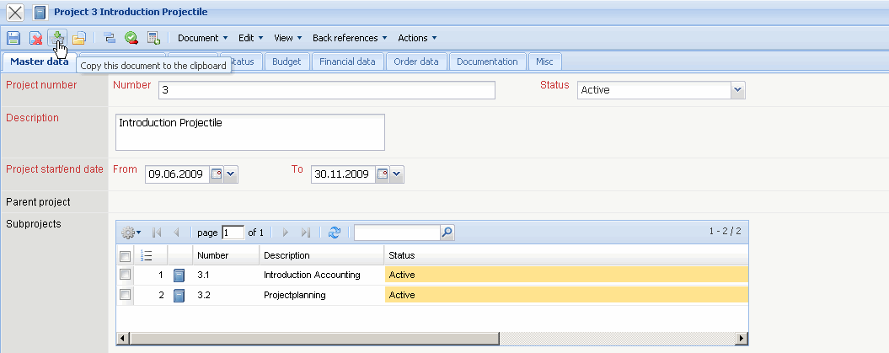
... transfered to the personal clipboard.
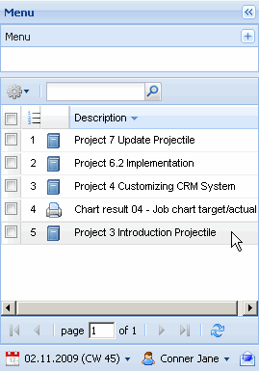
From any amount of select fields (as from the return list in the search machine or directly from the document) ...
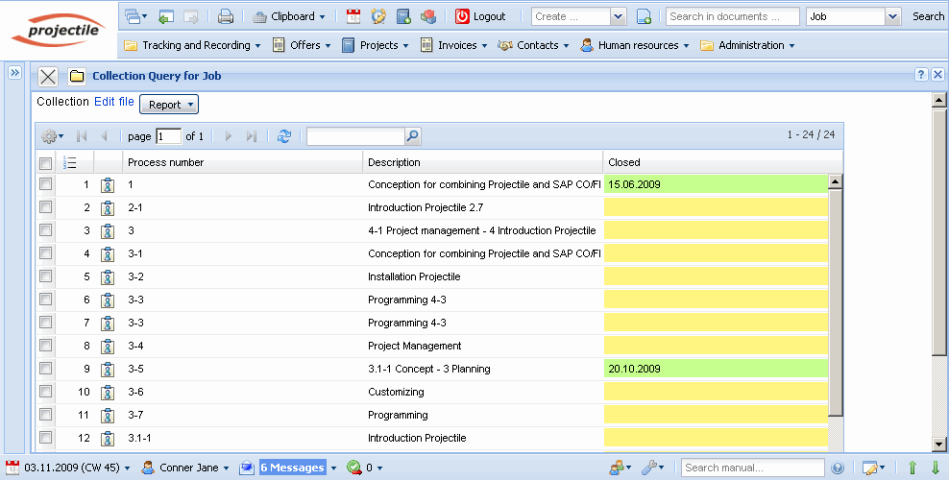
... various entries can be marked, copied and ...
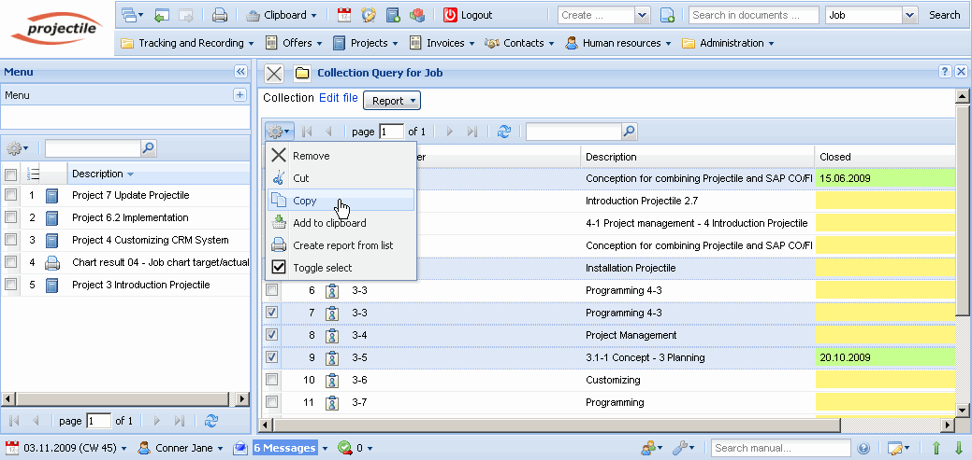
... pasted into the personal clipboard.


