2.05.08 Portfolio Chart
The Portfolio Chart displays combinations of projects (portfolio) through various axes. The basis for this chart is the combination of projects in the portfolio form. In this form, projects can be combined and the axes for the charts can be predefined.
Tip: For more on this subject see chapter 4.12.1 Applying Charts and 3.12.07 Portfolio Chart.
The form consists of the following elements:

1. Name
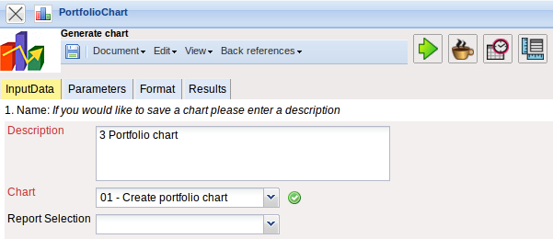
- Name: In this field the name of the chart is defined, if this should be saved (for example, for time services or for administrating the chart results).
- Description: In this field the description of the chart is defined, if this should be saved.
- Chart: The portfolio chart generates tabular or graphical charts regarding the information in the X-, Y-, Z- and color category. Key figures available for the X-, Y- and Z-Axis are offer value, completion, actual time, actual costs, planned revenue, planned duration, planned costs, invoice value and estimation. Up to five project catagories (for example, project catagory), priority and the project status are available as key figures for the color category.

2. Input Data
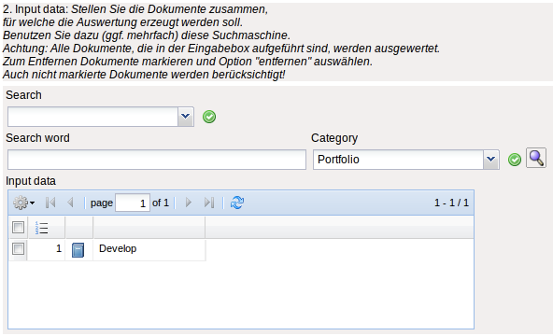
- Search: It is possible to search for data for the chart with this selection box. This search entry must relate to the supported catagories.
- Search machine: Search Word and Category: This element is used to filter the selected data from the categories. Only the document types job, contact, employee, project and unit is available for selection. How to operate the search machine is described in chapter 3.2.2.3 and can be performed, if necessary, a multiple amount of times.
- Input Data: Under this field, the selected selection criteria for the chart are listed. This input data can derive from the „professional search“(Profisuche), the standard search machine or the personal clipboard.

3. Main Parameters
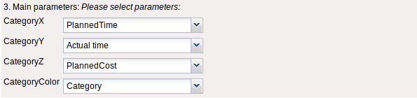
- X-, Y-, Z- and Color Category: These check boxes refer to the chart axes and support the above specified key figures.

5. Adjustment of Chart Display
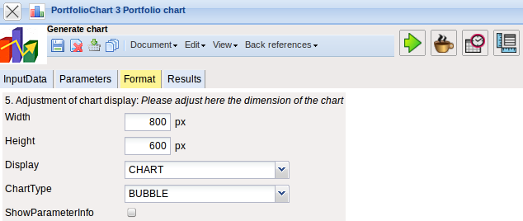
- Width: The width in pixel (px) is determined for the graphical chart in this field.
- Line Height: The size of the font in points (pt) is determined for the graphical chart in this field.
- Display: The generated chart can be generated in various formats with this selection. HTML (standard setting), CSV, XLS (MS Excel), PDF, RTF (text processing) are supported.
- Chart Type: A chart type can be selected for the generated chart with this selection. Projectile offers various types of bar charts (2D, 3D, vertical, horizontal, ...), column charts, line charts, area charts as well as pie charts an bubble charts.

6. Results
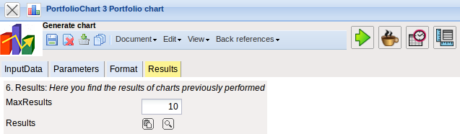
The results of the already processed chart are found in this tab.

