2.5.07 Employee Chart
The Employee Chart processes the employee-related charts and overviews regarding capacity utilisation and capacities. Included are general overviews, time confirmation, occupation chart, target/performance comparison, capacity utilisation evaluations and capacity evaluations and overviews of the absences (vacation, illness, ...).
Tip: For more on this subject see chapter 4.5 Handling with Charts und 4.5.06 Employee Chart.
The form consists of the following elements:

1. Name
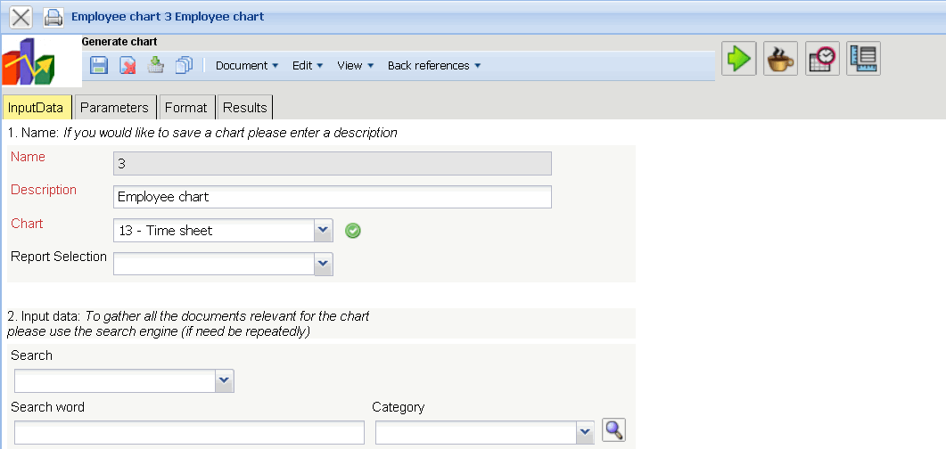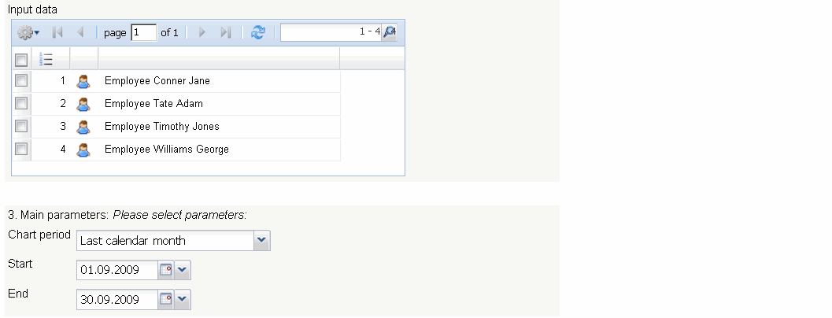
- Name: In this field the name of the chart is defined, if this should be saved (for example, for time services or for administrating the chart results).
- Description: In this field the description of the chart is defined, if this should be saved.
- Chart: The employee charts contain the following charts:
- Employee Overview
- Time Confirmation
- Occupation Chart and Time Chart
- Employee evaluation target/actual
- Presence/Absence overview
- Project time (Internal/External)
and the Capacity Charts:
- Capacity Utilisation Evaluation I, II and III
- Capacity Evaluation I, II and III
- Calendar Overview I and II
Note:According to the version, other charts could be available!

2. Input Data
- Search: It is possible to search for data for the chart with this selection box. This search entry must relate to the supported catagories.
- Search machine: Search Word and Category: This element is used to filter the selected data from the categories. Only the document type job, employee, project, occupations and unit is available for selection. How to operate the search machine is described in chapter 3.2.2.3 and can be performed, if necessary, a multiple amount of times.
- Input Data: Under this field, the selected selection criteria for the chart are listed. This input data can derive from the „professional search“(Profisuche), the standard search machine or the personal clipboard.

3. Main Parameters
- Chart Period: This drop-down box refers to the chart's time span (elements start and end) and allows a parameterised definition of the time span for the time services. This selection (current week, current month, …, next week, last week, …) can be also used to simplify the manual definition of start and end.
- Start and End: In this field a time interval can be entered as selection criteria to limit the given period for the chart.

4. Further Criteria
- Cost Center: Cost centers can be selected as selection criteria with this selection list. These cost centers refer to the cost center of the employee and limits the selection of the given employee (only employees are displayed, which are assigned to this/these cost center(s)).
- Project Category: Project categories can be selected as selection criteria with this selection list. These categories refer to the category of the project and limit the selection of the project (only projects are displayed, which are assigned to this/these project category/categories).
- External Order/Project: This selection refers to the external attribute of the project and limits the selection of the project (only external projects are displayed).
- Period: This check box is used for the capacity chart, in order to define a period (weekly, monthly, ...) for viewing the capacities for the selected employees.
- Include Previous Month and Flexible Time: The option include previous month includes the flexible time (overtime and undertime) of the previous month and the option include flexible time includes all flexible hours (from the first employee contract; see also Working Time Administration).
- Documents without Tracked Time: This option controls if the generated charts should list the rows without time/effort (check box marked) or be suppressed (check box unmarked).
- Jobs in Detail: This option controls if jobs should be displayed in the generated charts (check box marked) or processes (check box unmarked).

5. Adjustment of Chart Display
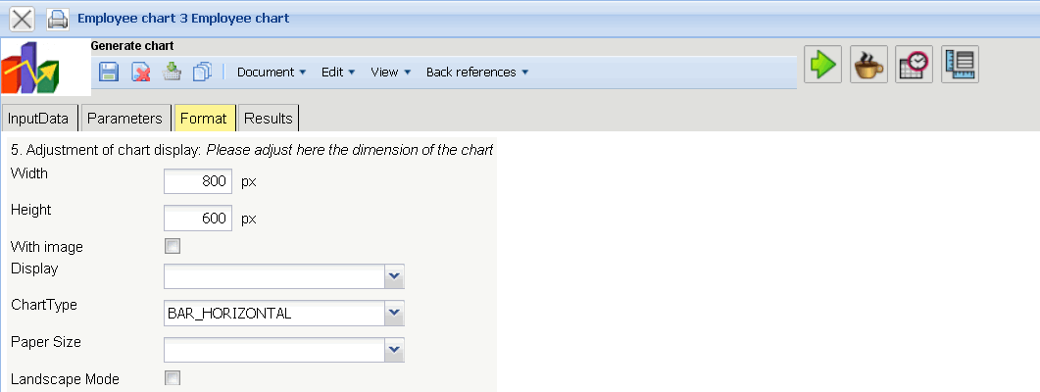
- Width: The width in pixel (px) is determined for the graphical chart in this field.
- Line Height: The size of the font in points (pt) is determined for the graphical chart in this field.
- With Image: In addition to the lists, also graphics for various charts can be generated with this selection.
- Display: The generated chart can be generated in various formats with this selection. HTML (standard setting), CSV, XLS (MS Excel), PDF, RTF (text processing) are supported.
- Chart Type: A chart type can be selected for the generated chart with this selection. Projectile offers various types of bar charts (2D, 3D, vertical, horizontal, ...), column charts, line charts, area charts as well as pie charts an bubble charts.

6. Results
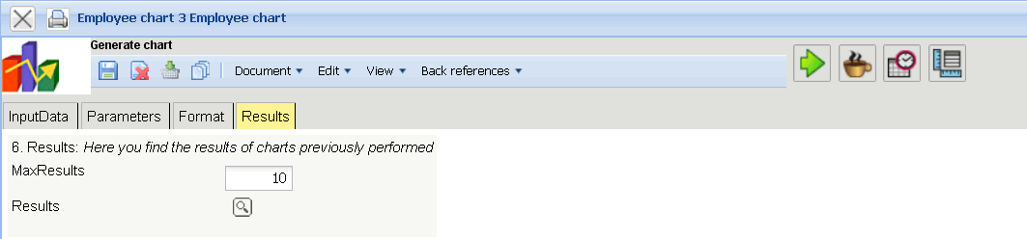
The results of the already processed chart are found in this tab.

