2.5.05 Contact Chart
The contact chart generates contact lists and action lists based on the data of the contact system. For example, all actions of an employee, actions for a customer or all open actions can be listed here.
Tip: For more on this subject see chapter 4.5.05 Contact Chart.
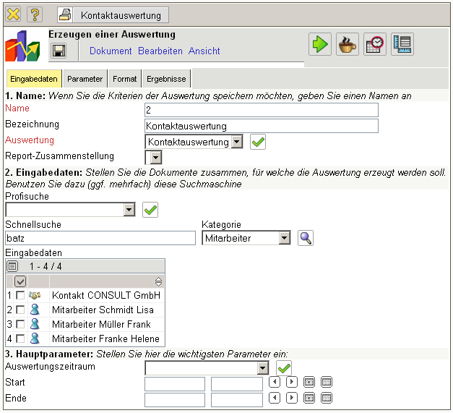
The form consists of the following elements:

1. Name
- Name: In this field the name of the chart is defined, if this should be saved (for example, for time sevices or for administrating the chart results).
- Description: In this field the description of the chart is defined, if this should be saved.
- Chart: The evaluation block contains the contact chart.

2. Input Data
- Search: It is possible to search for data for the chart with this selection box. This search entry must relate to the supported catagories.
- Search Machine: Search Word and Category: This element is used to filter the selected data from the categories. Only the document type contact person, contact, employee and project is available for selection. How to operate the search machine is described in chapter 3.2.2.3 and can be performed, if necessary, a multiple amount of times.
- Input Data: Under this field, the selected selection criteria for the chart are listed. This input data can derive from the „professional search“(Profisuche), the standard search machine or the personal clipboard.

3. Main Parameters
- Chart Period: This drop-down box refers to the chart's time span (elements start and end) and allows a parameterised definition of the time span for the time services. This selection (current week, current month, …, next week, last week, …) can be also used to simplify the manual definition of start and end.
- Start and End: In this field a time interval can be entered as selection criteria to limit the given period for the chart.
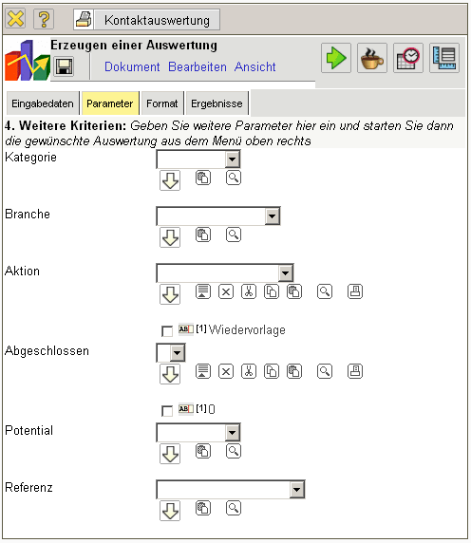

4. Further Criteria
- Category customer : Catagories can be selected as selection criteria with this selection list. These categories refer to the catagory of the contact (customer, prospective customer, ...) and limit the selection.
- Branch: Branches can be selected as selection criteria with this selection list. These categories refer to the branches of the contcat and limit the selection.
- Action: Actions can be selected as selection criteria with this selection list.
- Checked: Checked can be selected as selection criteria with this selection list through the document type action. Fro example, all not completed tasks can be searched for.
- Potential: Potential can be selected as selection criteria with this selection list. These categories refer to the potential of the contact (for example A-, B- or C-Contact) and limit the selection.
- Reference: References can be selected as selection criteria with this selection list. These categories refer to the catagory of the contact and limit the selection.
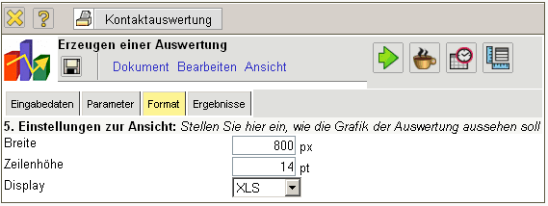

5. Adjustment of Chart Display
- Width: The width in pixel (px) is determined for the graphical chart in this field.
- Line Height: The size of the font in points (pt) is determined for the graphical chart in this field.
- Display: The generated chart can be generated in various formats with this selection. HTML (standard setting), CSV, XLS (MS Excel), PDF, RTF (text processing) are supported.

6. Results
The results of the already processed chart are found in this tab.

