2.5.02 Assessment Chart
The assessment chart generates the financial charts in the system. Included are i.e., cost evaluation (target/performance comparison, i.e. budgets for costs, as well as detailed evaluation), commercial invoice evaluation (offers, budgets, invoices, costs, cash flow and contribution margin, including detailed evaluation), overview of billable and billed services/work, a list of all open entries and the results charts.
Tip: For more on this subject see chapter 4.5 Handling with Charts und 4.5.02 Assessment Chart.
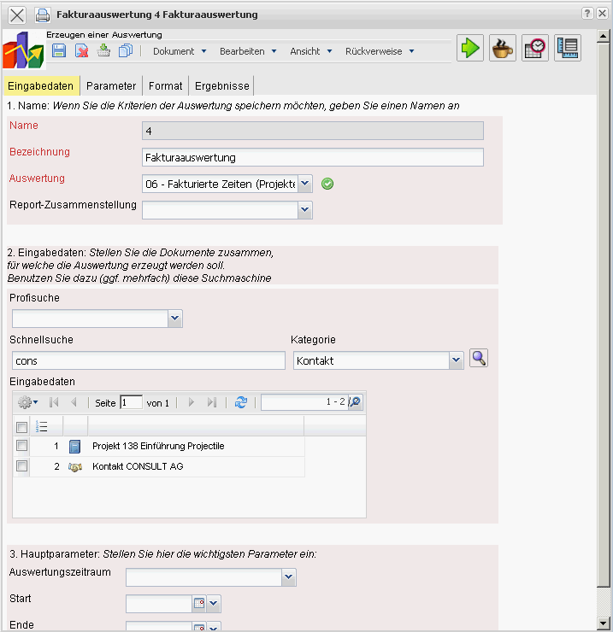
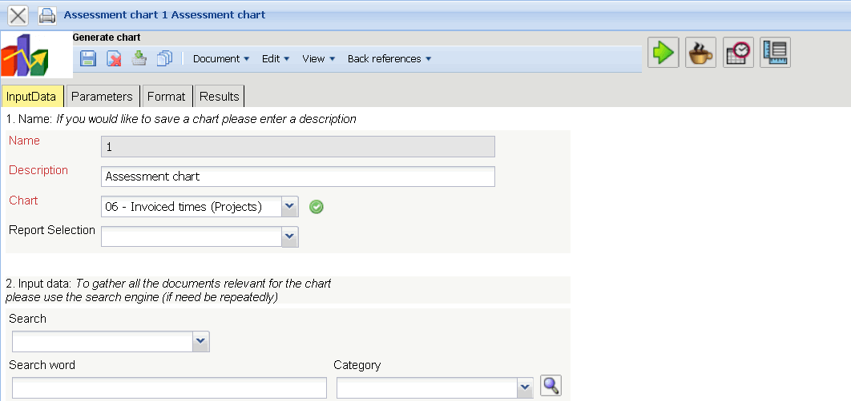
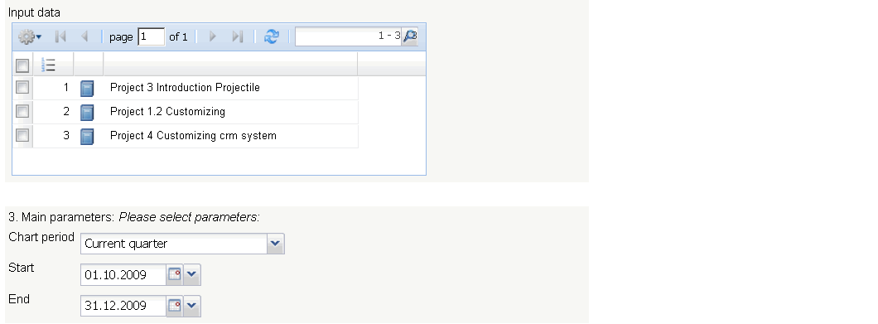
The form consists of the following elements:

1. Name
- Name: In this field the name of the chart is defined, if this should be saved (for example, for time services or for administrating the chart results).
- Description: In this field the description of the chart is defined, if this should be saved.
- Chart: The assessment chart contains the charts:
- Cost evaluation and In-depth cost evaluation
- Commercial invoice evaluation and In-depth commercial invoice evaluation
- Billed time evaluation and Invoiced times (Projects)
- Result evaluation
- Open entries evaluation
- Billed project times evaluation and Billed customer times evaluation

2. Input Data
- Search: It is possible to search for data for the chart with this selection box. This search entry must relate to the supported catagories.
- Search Machine: Search Word and Category: This element is used to filter the selected data from the categories. Only the document type contact, employee, project and unit is available for selection. How to operate the search machine is described in chapter 3.2.2.3 and can be performed, if necessary, a multiple amount of times.
- Input Data: Under this field, the selected selection criteria for the chart are listed. This input data can derive from the „professional search“(Profisuche), the standard search machine or the personal clipboard.

3. Main Parameters
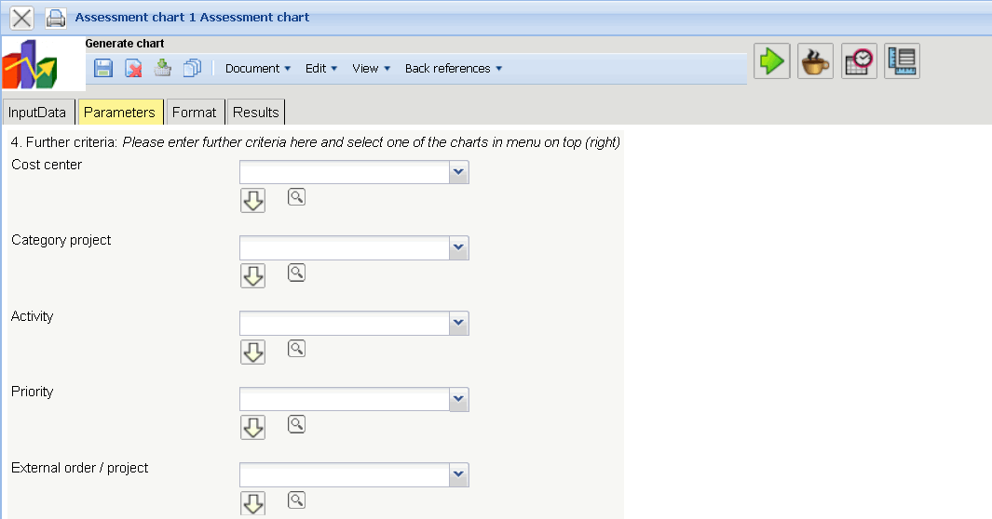
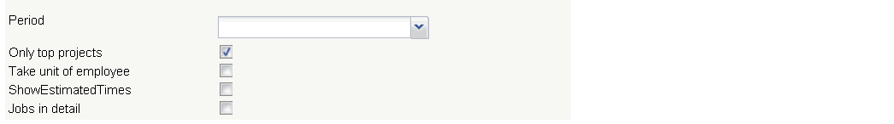
- Chart Period: This drop-down box refers to the chart's time span (elements start and end) and allows a parameterised definition of the time span for the time services. This selection (current week, current month, …, next week, last week, …) can be also used to simplify the manual definition of start and end.
- Start and End: In this field a time interval can be entered as selection criteria to limit the given period for the chart.
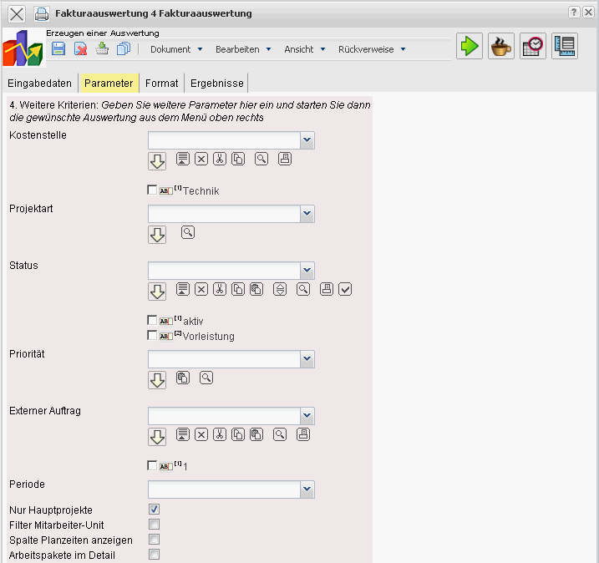

4. Further Criteria
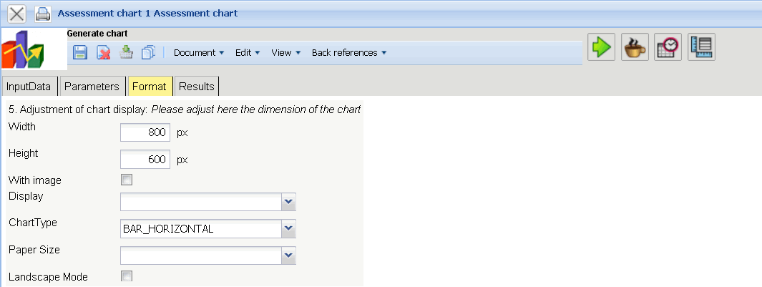
- Cost Center: Cost centers can be selected as selection criteria with this drop-down box. These cost centers refer to the cost centers of the project and limit the selection of the displayed project (only projects are displayed, to which the cost center(s) is/are assigned).
- Category Project : Project categories can be selected as selection criteria with this drop-down box. These categories refer to the catagories of the project and limit the selection of the displayed project (only projects are displayed, to which the project category/categories is/are assigned).
- Status: Status (passiv, active, advance service, ...) can be selected as selection criteria with this drop-down box. This status refers to the entries of the project and limit the selection of the displayed project (only projects are displayed, which have the selected status).
- Priority: Priority can be selected as selection criteria with this drop-down box. These values refers to the priorities of the project(also when in the jobs differing priorities are assigned) and limit the selection of the displayed project.
- External Order/Project: This selection refers to the external attribute of the project and limit the selection of the displayed project (only external projects are displayed).
- Only Top Projects: This check box specifies if in the generated chart should only be displayed for the top projects without the sub-projects.
- Show Estimated Times: This option refers only to the charts 09 and 10 and displays additionally here, the planned values of the jobs and entries.
- Jobs in Detail: This option controls if jobs or processes should be displayed in the chart.
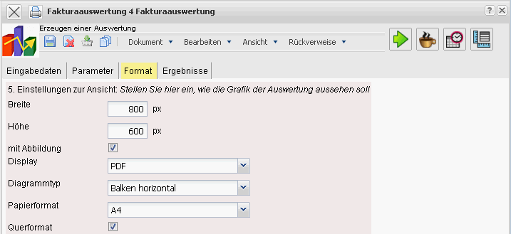

5. Adjustment of Chart Display
- Width: The width in pixel (px) is determined for the graphical chart in this field.
- Height: The height in pixel (px) is determined for the graphical chart in this field.
- With Image: In addition to the lists, also graphics for various charts can be generated with this selection.
- Display: The generated chart can be generated in various formats with this selection. CHART (only graphical chart), CSV, HTML (standard setting), PDF, RTF (text processing), and XLS (MS Excel) are supported.
- Chart Type: A chart type can be selected for the generated chart with this selection. Projectile offers various types of bar charts (2D, 3D, vertical, horizontal, ...), column charts, line charts, area charts as well as pie charts an bubble charts.

6. Results
The results of the already processed chart are found in this tab.

