2.05.01 Earned-Value-Analysis
The chart Earned-Value-Analysis lists the planned and actual time/effort (in hours or person-days) for a project over any time period, as well as the degree of completion (progress for the previous period). From this data Earned Value and further key figures (BCWS, ACWP und BCWP) is determined. With Earned-Value-Analysis, not only the planned and actual values, but also a third value (BCWP, also stated in hours) can be used for the project evaluation.
Tip: For more on this subject see chapter 4.12 Applying Charts and 3.12.01 Earned Value Analysis
The form consists of the following elements:

1. Name
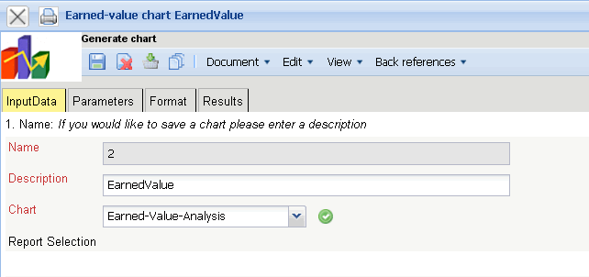
- Name: In this field the name of the chart is defined, if this should be saved (for example, for the time service or for administrating the chart results).
- Description: In this field the description of the chart is defined, if this should be saved.
- Chart: The Earned Value Analysis contains the Earned Value Analysis. This chart generates the Earned Value Analysis for the selected project. With this, the planned values, the actual values and the progress for the project structure or further criteria are plotted. (abgetragen) The Earned Value results form the progress of the periods (difference from the grade of completion from the current periods to the previous periods) and the total planned time/effort. Furthermore, the key figures BCWS, ACWP and BCWP are determined and the results are visualized in two illustrations.

2. Input Data
- Search: With this select list “professional search” can be used for the input data of the chart. This search entry must relate to the supported catagories.
- Search Machine: Search Word and Category This element is used to filter the selected data from the categories. Only the document type project is available for selection. How to operate the search machine is described in chapter 3.2.2.3 and can be performed, if necessary, a multiple amount of times.
- Input Data: Under this field, the selected selection criteria for the chart are listed. This input data can derive from the “professional search”(Profisuche), the standard search machine or the personal clipboard.

3. Main Parameters
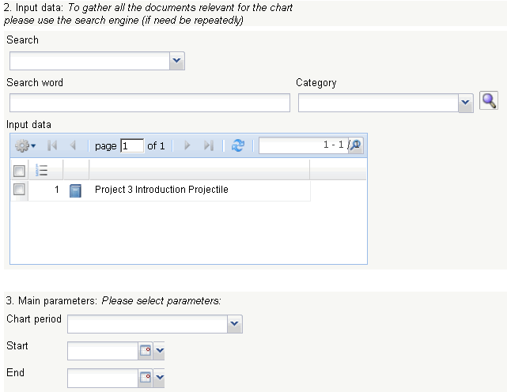
- Chart Period: This drop-down box refers to the chart's time span (elements start and end) and allows a parameterised definition of the time span for the time services. This selection (current week, current month, ..., next week, last week, ...) can be also used to simplify the manual definition of start and end.
- Start and End: In this field a time interval can be entered as selection criteria to limit the given period for the chart.

4. Further Criteria
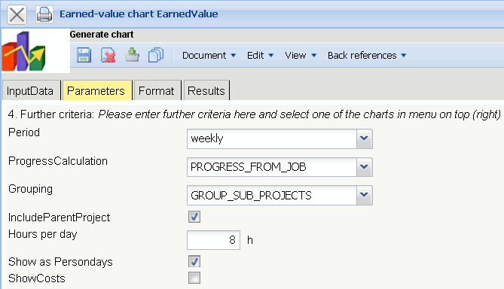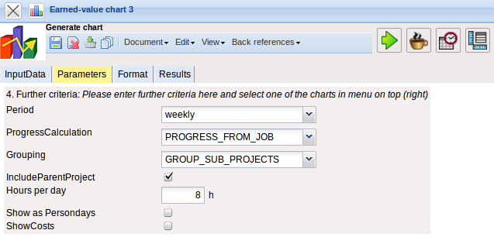
- Period: In this drop-down box the attributes for the column of the tabular chart can be controlled. The periods for planned values, actual values and progress can be generated considering this selection (weekly, monthly and quarterly.
- Progress Calculation: In this drop-down box the progress calculation can be selected. The option from planned values determines the calculative grade of completion (actual time/effort / planned time/effort) for the grouping characteristics (see next element), the option from estimations in the project uses the grade of completion from the project and the option from estimations in time recording uses the estimations from TimeTracker.
- Grouping: This selection can control the row atributes for the tabular chart. The periods for the planned values, actual values and progress are generated considering this selection (by employee, by phase, by occupation and by sub-project).
- Include Parent Project: This check box specifies if when the selection in the option grouping = by sub-project, the parent project should also be considered.
- Hours per Day: If the next option Show as Person-days is used, the conversion factor between work hours and person-days can be entered.
- Show as Person-Days : When this option is active, all time/effort is displayed as person-days in the tabular chart (otherwise as hours).
- Show Costs: When this option is active, all time/effort is displayed as EUR-Amounts in the tabular chart (otherwise as hours).

5. Adjustment of Chart Display
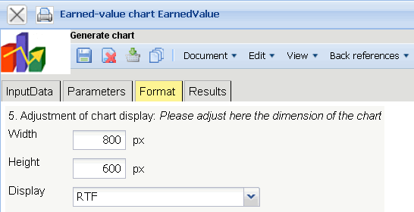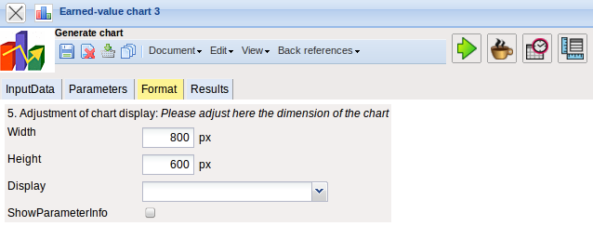
- Width: The width in pixel (px) is determined for the graphical chart in this field.
- Height: The height in pixel (px) is determined for the graphical chart in this field.
- Display: The generated chart can be generated in various formats with this selection. CHART (only graphical chart), CSV, HTML (standard setting), PDF, RTF (text processing), and XLS (MS Excel).

6. Results
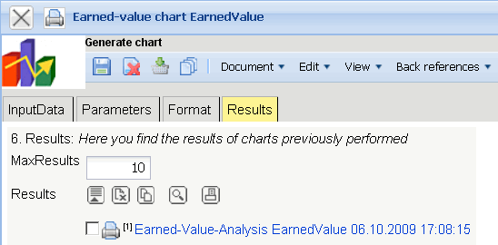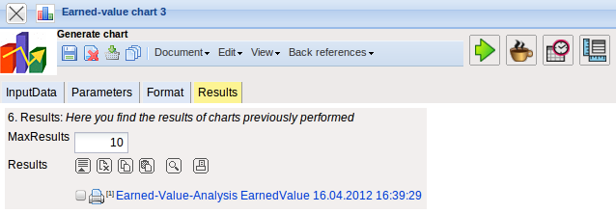
The results of the already processed chart are found in this tab.

