2.04.12 Invoice Position
The Invoice Position form contains information about the invoice position, invoice description, cost type, amount of hours or unit of the invoice position, as well as the external and internal invoice amount for the position.
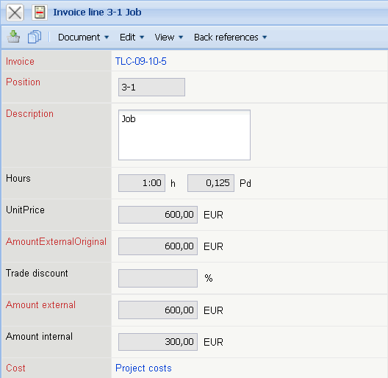
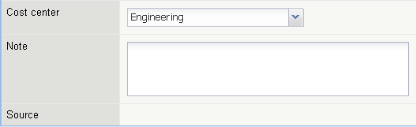
The form consists of the following elements:
- Invoice: This numerical field specifies the invoice, to which the individual invoice positions belong. This number is automatically set by the system.
- Position: This alphanumerical field specifies the number of the invoice position, based on a unique number, which is automatically preset by the system.
- Description: In this field the description of the invoice position is entered. By default, the descriptions based on the jobs and positions from recording of travel costs, trip costs, and real costs are stored by the system.
- Amount of Hours: This field specifies the amount of hours and/or person-days, which are entered into the invoice positions when including jobs. If the hour values are modified, the external amounts of the invoice positions are automatically updated by the system.
- Unit Price: The field unit price is determined through the external amount in the positions divided through the hours. If the data is not modified, the value in the field external amount (with jobs, from the external hourly rate) equal to the valid external hourly rate.
- External Amount before Trade Discount: This field is used as an overview to display the original amount of the position, when a trade discount has been warranted. Therefore, it is easier to reconstruct how the value in the field external amount has been compiled. The difference external amount before trade discount minus the trade discount equals the external amount.
- Trade Discount: This value indicates how high the percentage rate is, if a trade discount has been warrented to a position. This value can be set manually in the position or generated through the action “Add discount to all positions” for all the invoice positions.
- External Amount: This field specifies the amount which is billed to the customer for this position.
- Internal Amount: This field specifies the amount which is used for the internal calculations and charts. From this, the actual internal costs are evident.
- Cost Type: This field specifies the cost type of the invoice position. The cost types can be defined and modified in the cost type form.
- Comments: This field is designated for comments regarding invoice positions.
- Source: This field links to the source document of the invoice position (jobs, receipt, trips, travel, external costs, external/foreign invoice).

