2.4.10 Outgoing Payments
The Outgoing Payments form administers the cash flow regarding the foreign invoices (Foreign/Incoming Invoices). The outgoing payments contain information about the invoice amount, date and amount of the outgoing payment. Also, the difference between the invoice sum and the amount of the outgoing payment is displayed.
Tip: For more on this subject see chapter 4.4.04 Administration of Outgoing Payments 4.4.04 Zahlungsausgänge verwalten.
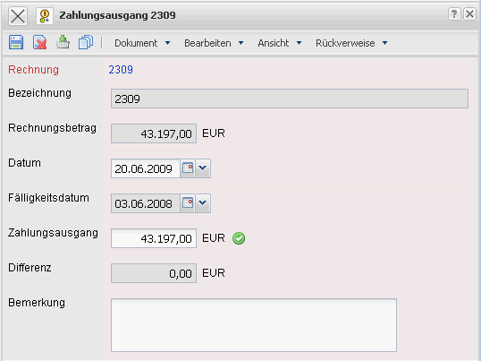
The form consists of the following elements:
- Invoice: This field characterizes the foreign invoice, for which an outgoing payment can be defined.
- Description: This field specifies the foreign invoice and consists generally of an invoice number.
- Invoice Amount: In this field, the total amount of the foreign invoice is entered by the system.
- Date: This field specifies the date of the outgoing payment. If this date is not filled, the outgoing payment has not been made and the correlating foreign invoice is still open.
- Outgoing Payment: The amount of the outgoing payment relating to the selected foreign invoice can be determined here.
- Difference: This field displays the difference between the invoice amount and the amount of the outgoing payment.
- Comments: This field is designated for comments regarding outgoing payments.

