2.4.09 Foreign Invoice Position
The ForeigI invoice Position form administers the positions of the incoming invoices. This document contains information about the project, the net amount and total amount of the position, the value-added tax, the cost type and the information, if a position has already been billed.
Tip: For more on this subject see chapter 4.4.03 Purchase Invoice Recording.
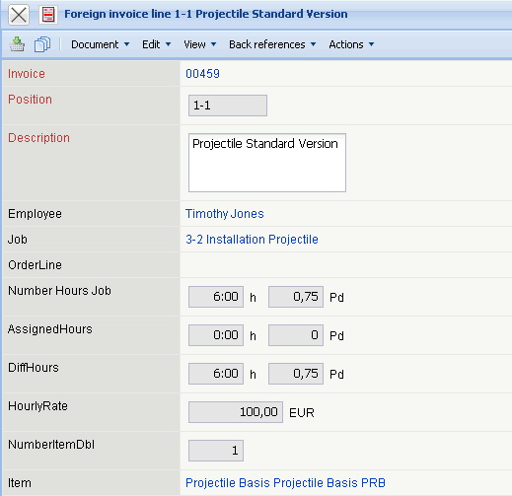
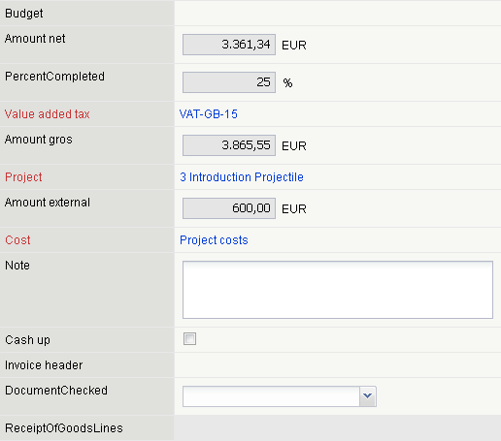
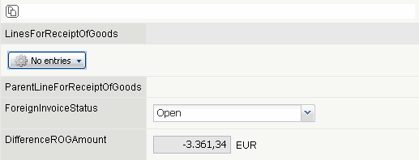
The form consists of the following elements:
- Invoice: This field assigns a unique identification number to the foreign invoice, which is automatically defined from the system.
- Position: This field species the number of foreign invoice positions, based on a unique number preset from the system automatically.
- Description: In this field the description of the foreign invoice position is entered.
- Amount, External Services: The amount and the type of external services can be entered here, if the position is related to the external services (for example, databases, hardware, ...). After clicking the green checkmark, the internal and external budgets are defined from the purchase and sales prices of the external service.
- Net Amount: In this field the net amount of the foreign invoice position is defined. If the total amount and the value-added tax is entered, the system calculates this value automatically.
- Value-Added Tax: By selecting the value-added tax / purchase tax, the total amount of the postition is automatically calculated. The value-added tax can be defined and modified in the value-added tax form.
- Total Amount: This field specifies the total amount of the foreign invoice position. If the net amount and the value-added tax is entered, the system calculates this value automatically.
- Project: In this field the project is assigned for the foreign invoice position.
- Cost Type: This field specifies the cost type of the invoice position. The cost types can be defined and modified in the cost type form.
- Comments: This field is designated for comments regarding the invoice position.
- Billed: This elements specifies, if a foreign position has already been billed. This flag is automatically set from the system when the foreign invoice position is included in the invoice and this invoice is billed.

