2.04.08 Purchase/Foreign Invoice
The Purchase/Foreign Invoice form administers the incoming invoices of the partner and/or suppliers for a certain project. The purchase/foreign invoices contain information about the supplier, invoice status, work/service interval, net amount, total amount, person issuing invoice and date of issuing invoice.
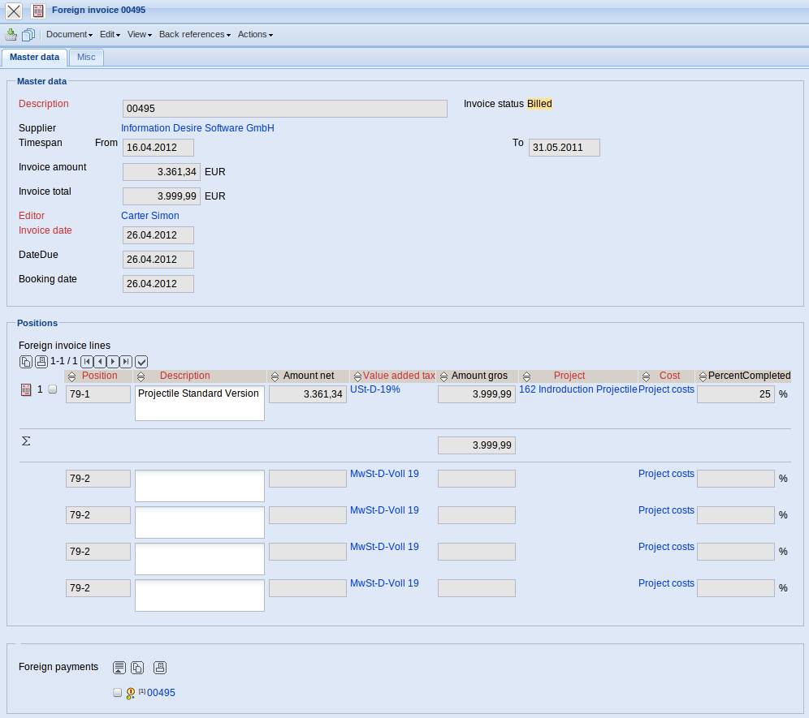
The form consists of the following elements:
On the “Master data” tab:
- Invoice: This field assigns a unique identification number to the foreign invoice, which is automatically defined from the system.
- Description: This field specifies the foreign invoice (generally the invoice number of the incoming invoice).
- Supplier: This field specifies the supplier for the defined foreign invoice. The suppliers can be defined and modified in the contact form (with contact type supplier).
- Status: This field is determined from the system and specifies the status of the foreign invoice, based on the selected action through the action function. After creating a foreign invoice the status “No Foreign Invoice” is automatically set, when the offer is included the status “Foreign Invoice Included” is automatically set and after cancelling the foreign invoice “Foreign Invoice Cancelled” is automatically set.
- Time Span(from/to): These fields specify the work/service intervals for the foreign invoice. With services, the periods are entered in which the billed services of the suppliers are rendered. This information is necessary for the accrual and deferral with the income statement . If this interval is not filled, the invoice date is used from the system.
- Amount: In this field the net amount of the foreign invoice position is automatically entered by the system.
- Total: In this field the total amount of the foreign invoice position is automatically entered by the system.
- Employee: In this field the person who issued the foreign invoice can be entered using the selection list.
- Invoice Date: This field specifies the date of the foreign invoice. By default, the current date is pre-set from the system.
- Booking/Posting Date: This field specifies the booking/posting date. By default, the current date is pre-set from the system here. This field is used for generating posting records to external financial accounting.
- Original Invoice: This field administers the invoice number, if a new foreign invoice was generated from a cancelled foreign invoice.
- Original order: This field administers the order number, if a foreign invoice was generated from an order. Note: The order administration from Projectile does not belong the the standard version of the invoicing module.
- Note: This field is designated for comments regarding a foreign invoice.
- Foreign invoice positions: In this field, foreign invoice positions which belong to a foreign invoice can be entered here.
- Foreign payments: In this field, outgoing payments which belong to a foreign invoice can be entered here.
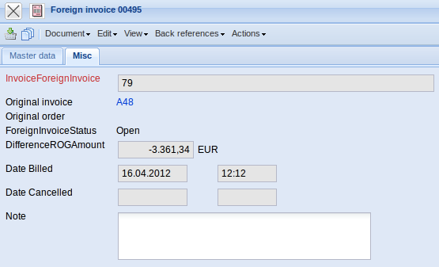
On the “Misc” tab:
- Date billed: This field specifies the billing date of the invoice.
- Date cancelled: This field specifies the date if the invoice is cancelled.
The document type consists of the following actions:
- Finalise external invoice: Using this action, the foreign invoice can be included to the system. In the process, the status of the foreign invoice is adapted accordingly and a document for the outgoing payments can be generated.
- Cancel external invoice: Using this action, the foreign invoice which was included, can be cancelled.
- New External invoice out of cancellation: A new foreign invoice can be created from an already cancelled foreign invoice. This can be necessary if modifications of the billed invoice must be made. For this, the foreign invoice must first be cancelled and then a new invoice can be generated from the cancelled invoice.
- Delete external invoice: Using this action, cancelled invoices can be deleted from the system. Only cancelled foreign invoices can be deleted.
- Remove Link to original invoice: This functionality removes the link to the original document, if the foreign invoice was generated as a copy of a “cancelled” foreign invoice.

