2.4.07 Payment Plan
The Payment Plan form administers the dates for invoicing. The payment plans in Projectile are part of the contract administration (see also contract) and contain information about the date of issuing the invoice or the necessary degree of completion and the percental or absolute prepayment of the partial invoices.
Tip: For more on this subject see chapter 4.4.08 Payment Plan Administration 4.4.08 Zahlungspläne verwalten.
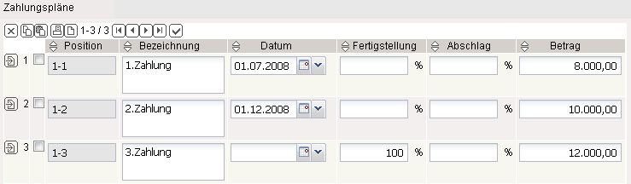
Tip: For more on this subject see chapter 4.4.6 Contract Administration 4.4.6 Verträge verwalten.
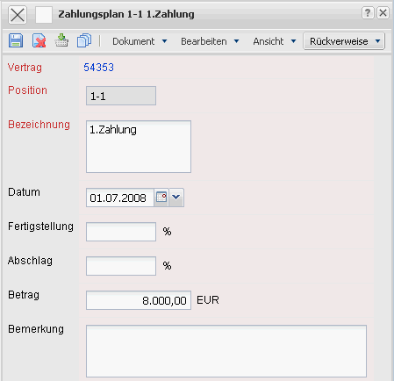
The document type plan type consists of the following elements:
- Contract: This field assigns a unique identification number to the contract, which is automatically defined from the system.
- Position: This field specifies the number of the contract position based on a unique number, which is automatically predefined from the system.
- Description: This field specifies the description of the contract position.
- Date: This field specifies the date of the partial invoicing.
- Completion State: This field can alternatively be used for the date, when a degree of completion is agreed upon and not a fixed deadline.
- Prepayment, Amount: When a deadline for the payment plan is reached, the system generates an advance payment invoice with the prepayment amount (percental part of the total budget from the order comfirmation, offer or the planned time/effort of the project). The basis for the calculation for the total amount ist: first the order value of the project or the order confirmation, then the offer value as the last step for the planned time/effort of the project (“Budget” tab).
- Comments: This field is designated for comments regarding the invoice position.

