2.4.06 Contract Position
The contract position input screen administers the details for periodical invoicing, if the invoice should contain positions. These positions can also contain external services.
Tip: For more on this subject see chapter 4.4.07 Verträge verwalten.
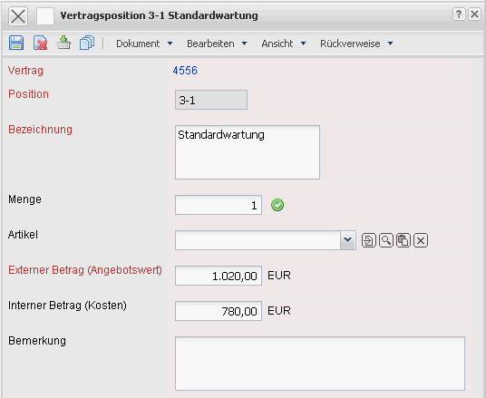
The input screen consist of the following elements:
- Contract: This field assigns a unique identification number to the contract automatically from the system.
- Position: This field specifies the number of the contract position, basedon a unique number, which is automatically pre-occupied from the system
- Description: This field specifies the description of the contract position.
- Amount, External Service: The amount and type of an external service can be specified, if the budget items are related to the external services (for example, databases, hardware, ...). After confirmation using the green checkmark, the internal and external budgets are defined from the purchase and sales prices of the external service.
- External Amount: This field specifies the amount, for which the customer is billed for this position.
- Internal Amount: This field specifies the amount, which is used for internal calculations and evaluation charts. From this, the actual internal costs are apparent.
- Comments: This field is designated for comments regarding invoice positions.

