2.4.03 Order Confirmation
The Order Confirmation form administers the customer's orders. After an offer has been accepted, the order information can either be directly entered into the project or an order comfirmation can be created. This order confirmation is needed by projects, which are not ordered as offered.
Tip: For more on this subject see chapter 4.4.02 Auftragsverwaltung.
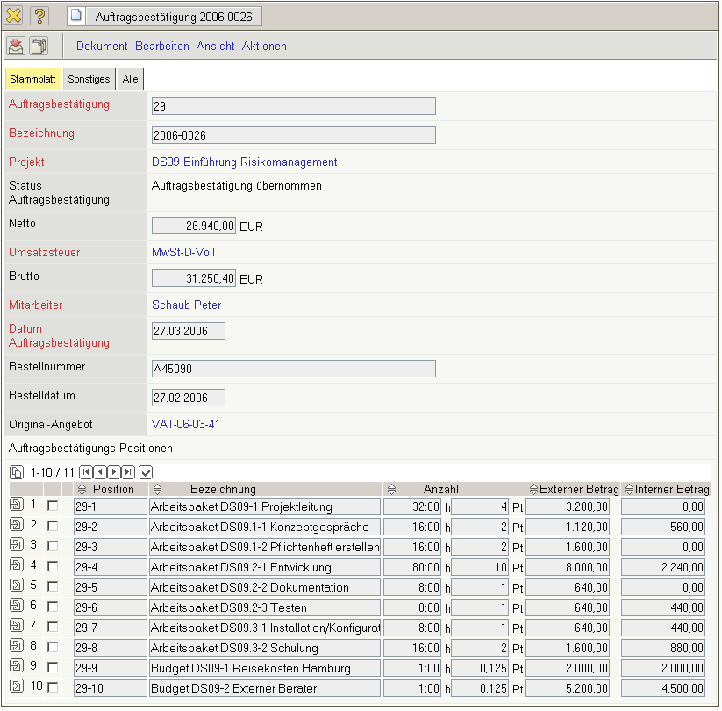
The form consists of the following elements:
- Order Confirmation: This numerical field assigns a unique number to the header of the order confirmation, which is automatically suggested from the system.
- Description: This alphanumerical field specifies the header off the order confirmation and is used as the order number printing the form.
- Project: In this field the project is selected, to which an order confirmation should be created. Projects can be defined and modified in the Project form. An order confirmation can only be created for an external project.
- Status: This field is defined from the system and specifies the status of the order confirmation, based on the selected action through the action function. After creating a new order confirmation, the status is automatically set to “No Order Confirmation”, when including the order confirmation the status is set to “Include Order Confirmation”, and after cancelling the order confirmation the status is set to “Order Confirmation cancelled”.
- Net Order Amount: In this field the net amount of the order confermation is automatically entered from the system.
- Value-Added Tax: In this field the valid value-added tax for this offer is entered through the select list. By default, this field is preset with the tax rate, which is valid using the assigned country defined in the configuration form. The value-added tax can be defined and modified in the value-added tax form.
- Total: In this field the total amount of the order confirmation is automatically entered by the system.
- Employee: In this field the person who created the order confirmation is entered through the selection list. Employees can be administered in the employee form.
- Date of Order Confirmation: This field specifies the date of the order confirmation. By default, the current date from the system is preset here.
- Order Number, Order Date: The order number and the order date can be entered here. This order information can be used for printing the invoice. The order number and the order date are automatically transfered to the project (“Order” tab) from the system, when the order confirmation is included.
- Original Order: This document link is linked, if applicable, to the last valid offer, if the order confirmation was created through the offer.
- Order Confirmation Position: This element consists of a list of all assigned order confirmation positions.
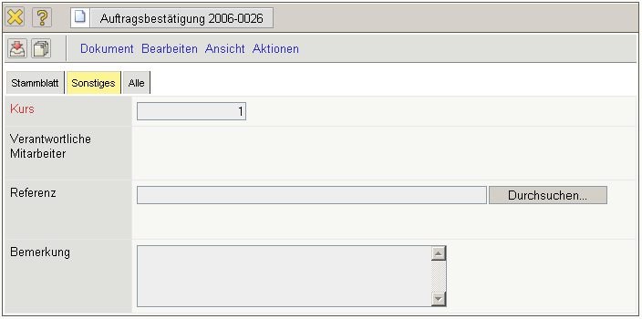
On the “Misc” tab:
- Rate: In this field the rate is defined as local rate. The rate is preset by the system and can be modified according to the general conditions.
- Responsible Employee: In this selection list the employee who signs the order confirmation can be stored here (signature fields in the printout of the order confirmation).
- Reference: Files corresponding to the order confirmation can be attached here.
- Comments: This field is designated for comments regarding an order confirmation.
The document type consists of the following actions:
- Include Jobs: Using this action, all jobs assigned to the defined order confirmation is displayed. After confirming the action, the document jobs including all jobs from the selected projects is opened. After selecting the jobs, these are included to the order confirmation as positions.
- Include Budget Items: Using this action, all budget items assigned to the defined order confirmation are displayed. After confirming the action, the document budget including all items from the selected projects is opened. After selecting the data, these are included to the order confirmation as positions.
- Include External Services: Using this action, all in the system defined external services are displayed. After confirming the action, the document external services including all entries is opened.
After selecting the data, these are included to the order confirmation as positions.
- Include Order Confirmation: Using this action, all order confirmations in the system can be included. This action then sets the status to “Order Confirmation Included”.
- Cancel Order Confirmation: Using this action, the order confirmation can be “cancelled”.
If faulty data is entered, this function can be used to define the order confirmation as invalid.
- Delete Order Confirmation: Using this action, cancelled order confirmations can be cancelled from the system. Warning: All corresponding positions are also deleted here.
- Remove Link From Original Order: This functionality deletes the link to the original document, if the order confirmation was created as a copy of the “cancelled” order confirmation.
- Print Order Header: Using this action an order confirmation can be generated as an RTF file. The generated document can be printed through the browser or through a standard text editor.

