2.04.02 Offer Position
The Offer Position form consists of a link to the offer, as well as information about the position, description, amount of hours or units, the external and internal amounts of the offer position and the cost type. The offer value is determined from the amounts of the individual offer positions.
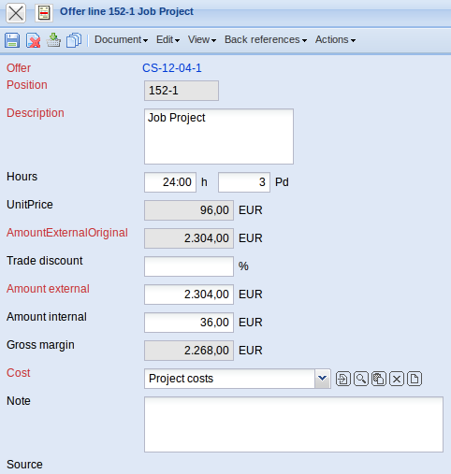
The form consists of the following elements:
- Offer: This field specifies the offer, to which the individual offer positions belong.
- Position: This field specifies the number of the offer positions, based on a unique number pre-selected from the system.
- Description: In this field the description of the offer position is entered. By default, the descriptions based on the jobs or costs are preset.
- Amount of Hours: This field specifies the amount of hours or amount of items, which are entered into the offer positions after the jobs are included. The external amounts of the offer position are automatically refreshed by the system when this value is modified.
- Unit Price: The field unit price is determined from the external amount in the position divided by the hours. If the data has not been modified, the value in the field external amount (external hourly rates with jobs) is equal to the valid external hourly rates.
- External Amount before Discount: This field is used as an overview for the original amount of the position, when a trade discount is warranted to a position. It is easier to comprehend how the value in the field external amount is compiled. The difference of the external amount before discount minus the discount equals the external amount.
- Discount: This value specifies how high the percent rate is, if a discount is warranted to a position. The value can be set manually in the position or generated for all offer positions using the action “Add Discount to all Positions”.
- External Amount: This field specifies the amount which is offered to the customer for this position. This value is pre-set from the system through the plan data.
- Internal Amount: This field specifies the amount which results as the internal costs. This value is preset from the system through the plan data.
- Cost Type: This field specifies the cost tyüe of the offer position.The cost type can be defined and modified in the cost type form.
- Comment: This field is designated for comments regarding offer positions.
- Selection: This field links to the referenced Projectile document of the position (for example, jobs, budget, external services).

